CHEMISTRY PAPER 1 MARKING SCHEME
FORM 3,END YEAR 2023

- Given a mixture of sodium chloride, silver chloride, and ammonium chloride, describe how each component can be obtained. (3 Marks)
- Heat the mixture to sublime ammonium chloride and cool the vapour against a cool surface to deposit it.
- Add water to the remaining mixture and stir to dissolve sodium chloride. Filter the mixture to obtain sodium chloride solution as a filtrate and silver chloride as a residue.
- Dry the residue between fresh filter papers.
- Heat the filtrate to saturation and allow to cool to obtain crystals of sodium chloride.
[marking points at half mark each]
- (a) To remove carbon (IV)oxide gas

(b) 3Mg(s) + N₂(g) → Mg₃N₂(s)

(c) Argon

- (a) A-Hot compressed air

- Molten sulphur and water

- Super heated water

(b) To melt sulphur deposit
(c) sulphur has low melting point

- Give the systematic name of the following compounds (2 Marks)
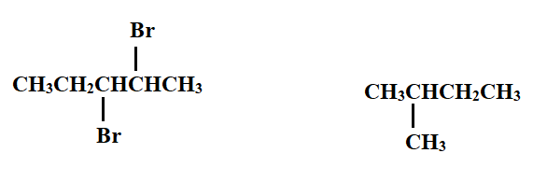
2,3-dibromopentane 2-methylbutane
- (a) Define Gay-Lussac’s law (1 Mark)
When gases react at constant temperature and pressure, they do so in volumes that bear a simple ratio to one another, and to the volumes of the product if all the products are gaseous.
- In an experiment a mixture of 126.0cm³ of nitrogen gas and 120.0cm³ of hydrogen gas was heated in the presence of iron catalyst. Determine the composition of the final gaseous mixture. (2 Marks)
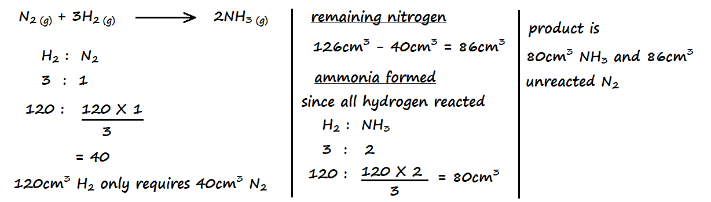

- The table below shows certain properties of substances M, N, K, and L.
Substance | Melting point (ºC) | Solubility in water | Electrical conductivity
M | -119 | Soluble | Solution does not conduct
N | 1020 | Soluble | Solution conducts
K | 1740 | Insoluble | Does not conduct
L | 1600 | Insoluble | Conducts at room temperature

Which of the substances:
- Is a metal (½ Mark) L
- Has a simple molecular structure (½ Mark)
M
- Has a giant covalent structure (½ Mark)
K
- Has a giant ionic structure (½ Mark)
N
- A polymer has the following structure
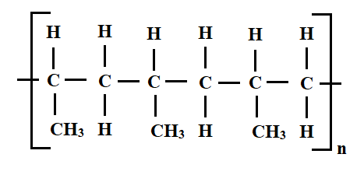
- Draw and name the monomer (2 Marks)
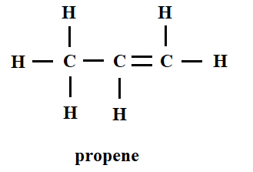

- Draw the repeating unit of the polymer (2 Marks)
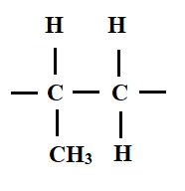
- Draw dot (•) and cross (×) diagrams to show bonding in:
- Magnesium chloride (2 Marks)
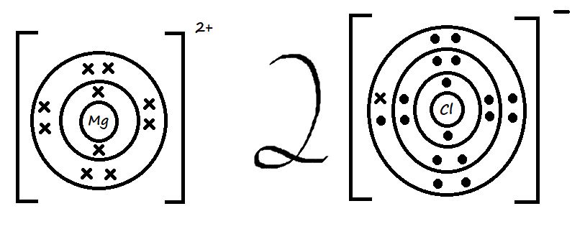 or 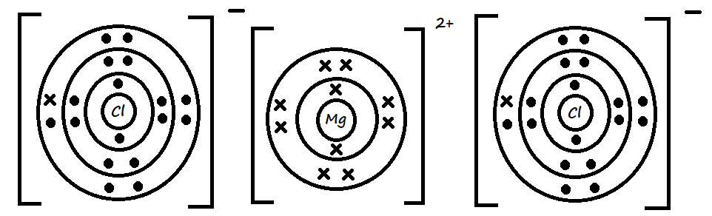

- Phophonium ion (PH₄⁺) (2 Marks)
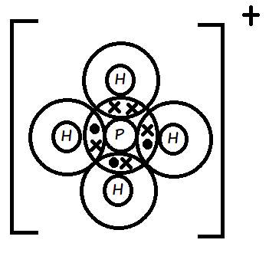

- A piece of burning magnesium was introduced into a jar of nitrogen. State and explain the observation made (2 Marks)
The magnesium continues to burn in nitrogen. Magnesium reacts with nitrogen to form magnesium nitride.
- Water was added to the product of the reaction in a) and the resultant solution tested with red and blue litmus papers. State and explain the observation made (2 Marks)
Red litmus paper turns blue while blue litmus paper remains blue. Magnesium nitride reacts with water to form magnesium hydroxide and ammonia, which are alkaline.

- Briefly describe how sodium carbonate powder can be obtained in the laboratory starting with concentrated sodium hydroxide solution (2 Marks)
Bubble a limited amount of carbon (IV) oxide gas through the sodium hydroxide solution to obtain sodium carbonate solution. Heat the solution to evaporation to allow formation of sodium carbonate powder.
- The sketch graph below shows the relationship between pressure and temperature of a gas in a fixed volume container.
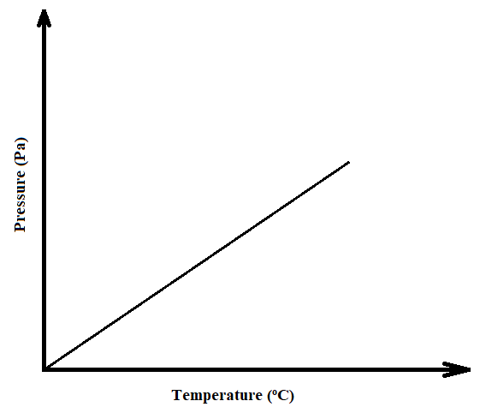
- State the relationship between pressure and temperature that can be deduced from the graph (1 Mark)
An increase in temperature results in an increase in pressure of a fixed mass of gas.
- Using the kinetic theory of matter, explain the relationship shown by the sketch graph (2 Marks)
An increase in temperature results to an increase in kinetic energy of gas particles. The number of collisions between the particles and the walls of the container increases, hence, an increase in pressure.
- (a) Group VIII elements are said to be inert. Explain. (1 Mark)
They have fully occupied outermost energy levels hence do not lose or gain electrons
- In terms of structure and bonding, explain why group VIII elements exist as gases at room temperature (2 Marks)
Their atoms are held together by weak Van der Waal’s forces that require little energy to break. At room temperature, the energy is sufficient to break these forces hence atoms are free to move.
- Nitric (V) acid may be prepared in the laboratory by the action of concentrated sulphuric (VI) acid in a suitable nitrate and distilling off the nitric (V) acid
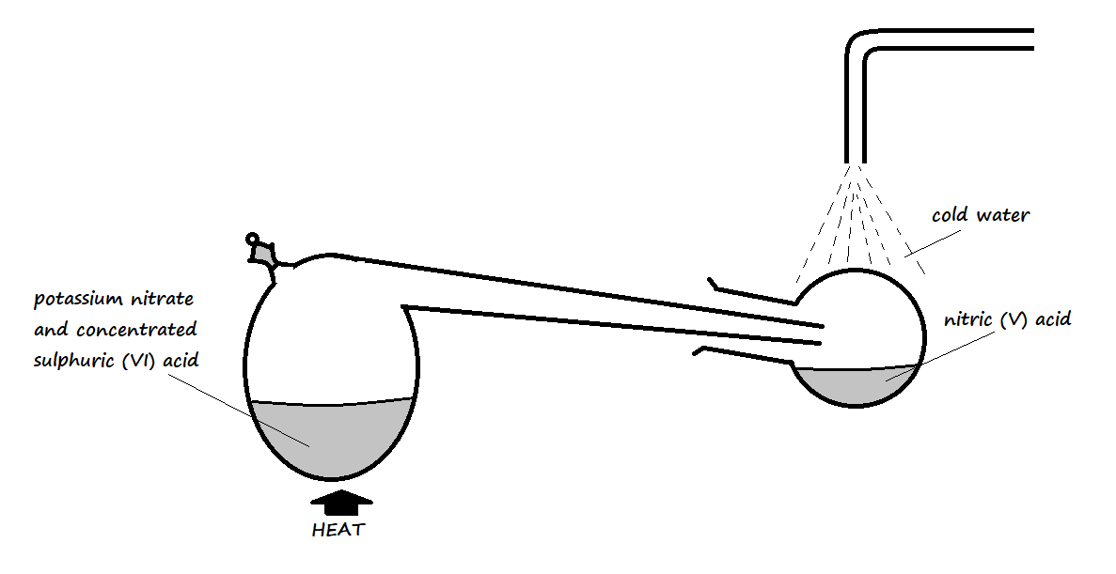
- Why does the setup only consist of apparatus made of glass? (1 Mark)
Nitric acid attacks rubber and other materials but glass is inert.
- Pure nitric (V) acid is colourless but the product in the collection vessel is yellow. Explain (1 Mark)
Some nitric (V) acid decomposes in the presence of heat to yield nitrogen (IV) oxide which is brown and later condenses to form yellow dinitrogen tetra-oxide. The dinitrogen tetra-oxide dissolves in the acid to yield the yellow colouration.
- Why is it possible to separate nitric (V) acid from sulphuric (VI) acid in the setup? (1 Mark)
Nitric (V) acid is volatile and therefore easily vaporises while sulphuric (VI) acid is not volatile and does not easily vaporise.
- Name the catalyst used in the following processes:
- Large scale manufacture of ammonia gas in the Haber process (1 Mark)
Finely divided iron catalyst
- Large scale manufacture of concentrated sulphuric (VI) acid in the Contact process (1 Mark)
Platinum or Vanadium (V) oxide.
- Laboratory preparation of oxygen using hydrogen peroxide (1 Mark)
Manganese (IV) oxide

- What mass of magnesium carbonate would remain if 15.0g of magnesium carbonate reacts with 25cm³ of 4M hydrochloric acid solution? (3 Marks)
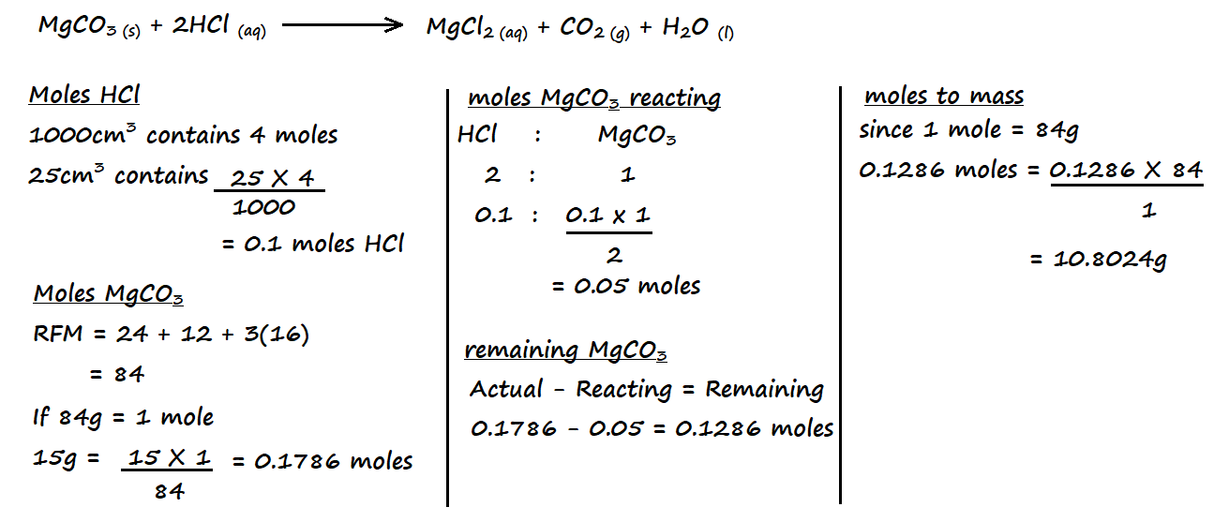
- The setup below was used to investigate the reaction of a certain gas with lead (II) nitrate solution
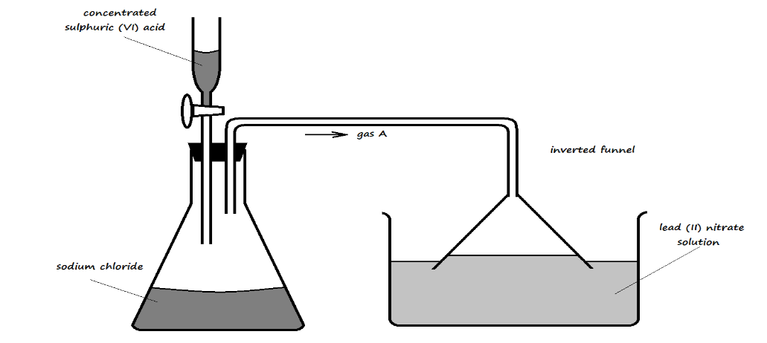
- Identify gas A (1 Mark)
Hydrogen chloride gas

- State the observation made in the trough containing lead (II) nitrate solution (1 Mark)
A white precipitate is formed in the solution
- Write an ionic equation for the reaction occurring in the trough (1 Mark)
Pb²⁺_{(aq)} + 2Cl⁻_{(aq)} PbCl_{2 (aq)}

- Element Q reacts with dilute acids, but not with cold water. Element R does not react with dilute acids. Element S displaces element P from its oxide. P reacts with cold water. Arrange the four elements in order of reactivity, starting with the most reactive element. (2 Marks)
S P Q R
- A fixed mass of a gas occupies 200cm³ at 0ºC and 740mmHg pressure. Calculate its volume at -48ºC and 780mmHg. (3 Marks)
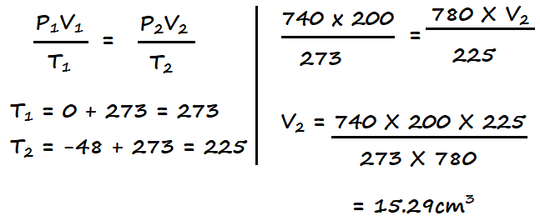
- In an experiment, a sample of an oxide of lead was heated over coke for some time. The following results were obtained:
Mass of the oxide before heating = 8.92g
Mass of residue after heating = 8.28g
- Determine the empirical formula of the oxide of lead (Pb = 207, O = 16) (2 Marks)
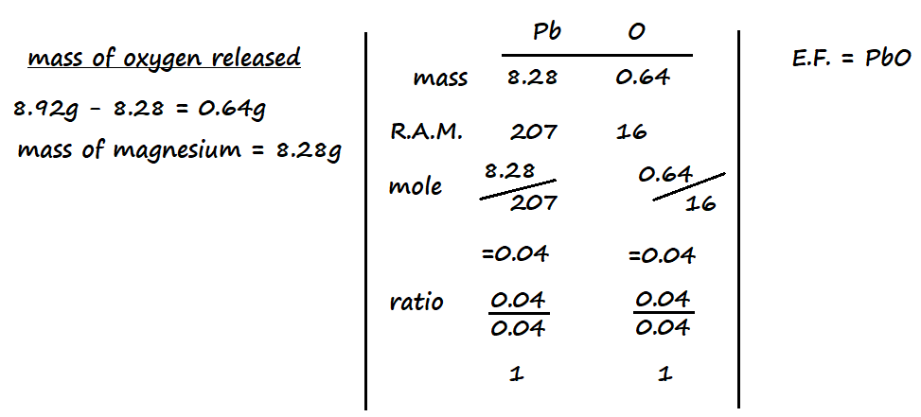

- Write an equation for the reaction in the experiment above (1 Mark)
2PbO _{(s)} + C _{(s)} 2Pb _{(s)} + CO_{2 (g)}

- The information in the table below relates to the physical properties of the chlorides of certain elements.
Formula of compound | NaCl | MgCl₂ | AlCl₃ | SiCl₄ | PCl₃ | SCl₂
Boiling point (ºC) | 1470 | 1420 | Sublimes at 180ºC | 60 | 75 | 60
Melting point (ºC) | 800 | 710 |  | -70 | -90 | -80

- Select two chlorides that are liquid at room temperature (2 Marks)
SiCl₄, PCl₃, SCl₂
[the first two of the candidate’s answer]
- Explain why AlCl₃ has a much lower melting point than MgCl₂, although both aluminium and magnesium are metals. (2 Marks)
AlCl₃ has its atoms bonded covalently to each other to form a simple molecule, while MgCl₂ experiences ionic bonding. AlCl₃ therefore has weak Van der Waal’s forces that require little energy to weaken while MgCl₂ has strong ionic bonds that require a lot of energy to weaken.
- 400cm³ of a gas D diffuses through a porous plug in 50 seconds, while 600cm³ of oxygen gas diffuses from the same apparatus in 30 seconds. Calculate the relative molecular mass of gas D. (O = 16) (2 Marks)
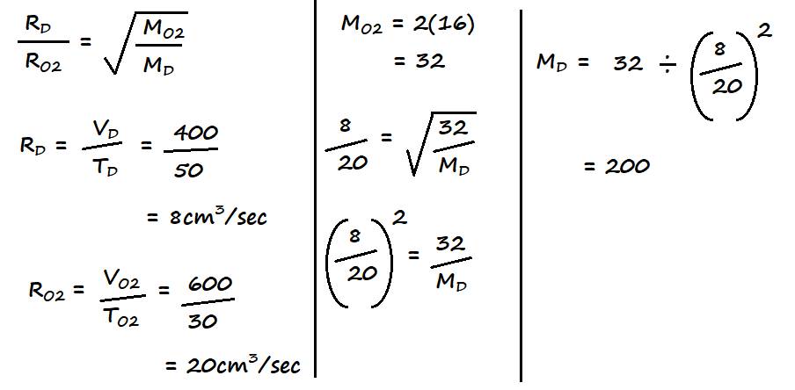

- Calculate the volume of oxygen produced when 10g of silver nitrate was completely decomposed by heating at standard temperature and pressure (Ag = 108, N = 14, O = 16, Molar gas volume at s.t.p. = 22400cm³) (3 Marks)
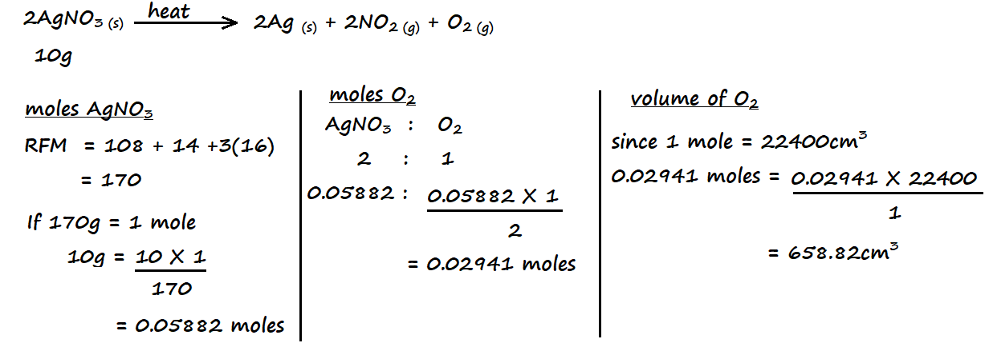
- The electron arrangement of ions W³⁺ and Z²⁻ are 2.8 and 2.8.8 respectively.
- In which groups do elements W and Z belong? (1 Mark)
W – Group III Z – Group VI
- Write the formula of the compound that would be formed between W and Z (1 Mark)
W₂Z₃
- 20cm³ of a solution containing 2.7g/dm³ of an alkali XOH completely reacted with 25cm³ of 0.045M sulphuric (VI) acid. Calculate the relative atomic mass of element X (O = 16, H = 1) (3 Marks)
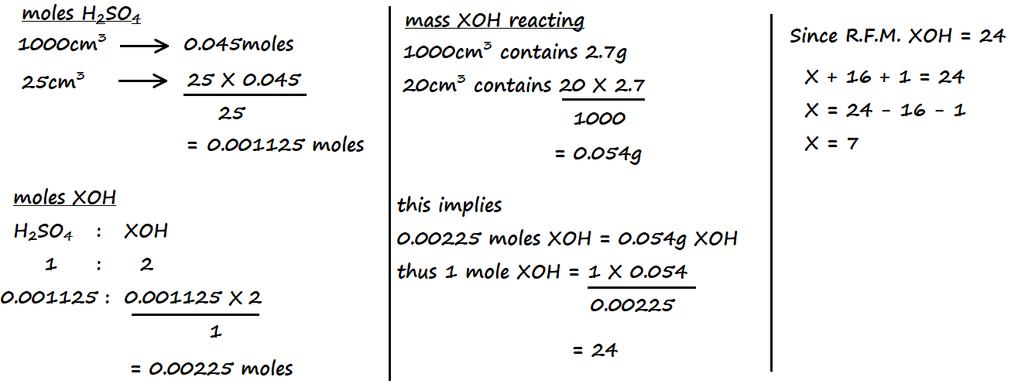

- Calculate the number of sulphate ions in 150cm³ of 0.1M aluminium sulphate, Al₂(SO₄)₃ (3 Marks)
(L = 6.023 × 10²³)
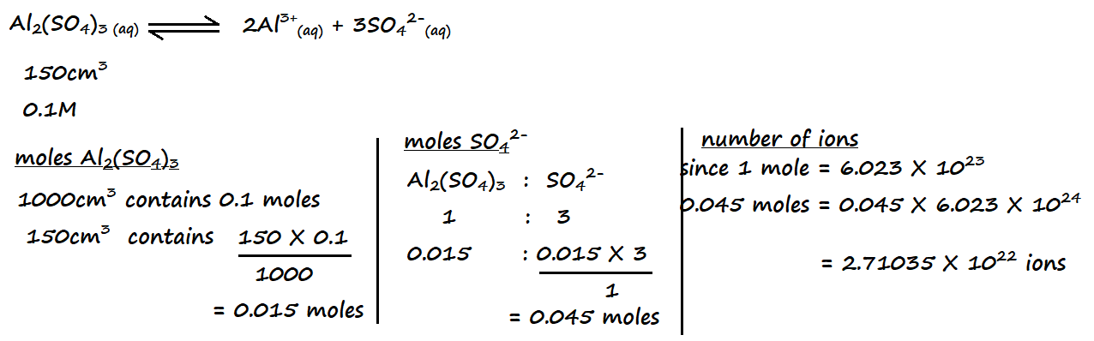

- The following apparatus was set up to investigate the percentage of oxygen in air by slowly passing 100cm³ of air from syringe A to syringe B and then back until the volume of air remained constant. Study it and use it to answer the questions that follow.
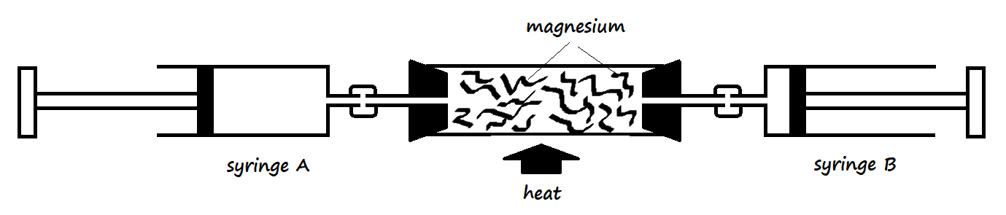
- Identify the mistake in the setup (1 Mark)
Use of magnesium in the combustion tube

- Why was the air moved slowly from syringe A to syringe B and vice versa? (1 Mark)
To ensure most of its active part reacted with the metal in the combustion tube
- Write an equation for the reaction that took place in the combustion tube after the mistake was corrected (1 Mark)
2Cu _{(s)} + O_{2 (g)} 2CuO _{(s)}
- A luminous flame produces bright yellow light. Explain (1 Mark)
Due to insufficient supply of air, unburnt carbon particles heat up and glow to give yellow light

- Magnesium reacts by losing its 2 valence electrons. How does its 1st and 2nd ionization energy compare? Explain (2 Marks)
The 2nd ionization energy is higher than the 1st ionization energy. After losing the first valence electron, there are fewer electrons for the number of protons left, resulting in an increase in the effective nuclear force of attraction that holds the remaining electrons more tightly.
- The apparatus below was used for the preparation of iron (III) chloride in the laboratory. Study it and use it to answer the questions that follow.
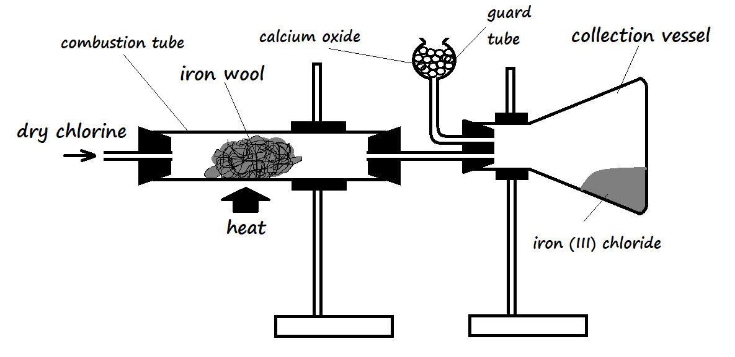
- Why is it preferred to use calcium oxide rather than calcium chloride in the guard tube? (2 Marks)
Apart from preventing moisture from entering the collection vessel, calcium oxide reacts with excess chlorine to minimise its emission to the environment.
- What property of iron (III) chloride makes it possible to be collected as shown in the diagram? (1 Mark)
It sublimes when heated and deposits when cooled

