JOINT EXAMINATION
CHEMISTRY MARRKING SCHEME
PAPER 2
TERM 3 – 2023
1.a. Name the family into which element P belongs to
Inert or noble gases
b. Which two elements forms the most soluble carbonates
k and w
c. With a reason, identify elements in period 3 with the largest atomic radius
Q. atomic radius decreases across the period due to increase in number of protons
d. Write the formula of the compound formed between Q and M
Q₅M₂
e. State two uses of element R and for each use , state property of element R that makes lts possible for the use
Use
Used to make overhead power transmission cables
Property
Its ductile
Use
Used to make parts of aircrafts
Property
Its light and malleable
f. compound formed between R and oxygen
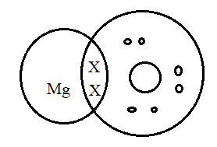
g. In terms of structure and bonding explain why the oxides of element T has relatively low boiling points
T forms an oxide which has a simple molecular structure. Its molecules are held by weak van der Waals forces that require little energy to break hence the low boiling point.
2. (a) name the following compounds
i. Butanoic acid
ii. 2,5- diBromo, 4-Methyl Pent -1,3- diene
iii Ethylpropanote
b (i) Identify each type of the detergent
p- soapy detergent
Q- soapless deterge (ii)Which of the two detergents is the best to use with hard water? Give a reason
Q(soapless) the corresponding salts of calcium and magnesium are soluble hence no scum is formed
(iii) State one advantage of detergent P
Are cheap and biodegradable
(iv) State one disadvantage of detergent Q
Are expensive and nonbiodegradable
C I Identify the hydrocarbon
Ethene
(ii) Name two reagents that can reacted together to generate the hydrocarbon
Concentrated sulphuric vi acid and ethanol
3.(a)Name two apparatuses that can be used for determining mass in a laboratory
Beam balance
Electronic balance
(b) One of the flames produced by Bunsen burner is the luminous flame i) Explain why this flame is very bright it consists mainly of unburnt tiny particles of hot glowing carbon which give out the light
ii) State two disadvantages of the luminous flame
- It’s less hot compared to nonluminous
- Produces soot
C. Air is usually one of the substances that is considered as a mixture
(i) Identify the two most abundant component of air
Nitrogen and oxygen gases
(ii) Give two reasons why the air is considered as a mixture
- Its components can be separated by physical means i.e. by fractional distillation
- Its components are not in fixed proportions
- It properties are a sum of the properties of the components
Iii . One of the components of air is carbon (iv) oxide. Describe an experiment that can be used to prove the presence of carbon (iv) oxide in the air Bubble the air in calcium hydroxide solution (lime water) a white precipitate is formed.
4(a) i) Name the above process used to obtain sulphur from the underground deposits
The Frasch process
(ii) Name the substance passed through pipe
A - hot compressed air at 15atmospheres
B-molten sulphur and water
iii) State two properties of Sulphur that makes it possible to extract using the above process -it has a relatively low density -has a low melting point
b. I) Identify the following:

Substance Q formed in the burner - Sulphur IV oxide gas
Chamber T- catalytic chamber Substance R - concentrated sulphuric VI acid Substance S water
ii) Write the chemical equation occurring in the dilution chamber
H₂S₂O₇ _{(l)} + H₂O _{(l)} 2H₂SO₄ _{(L)}
iii) Why is it necessary to pass substance Q though a purifier
to remove impurities that may poison the catalyst and affect the efficiency of the process
iv) State one use of sulphuric (VI) acid
- manufacture fertilisers - manufacture detergents, dyes and paints,plastics -as an electrolyte in lead acid accumulators
5. (a) (i) Name solid Q.
Anhydrous calcium chloride
(ii) What is the purpose of NaOH(aq)?
To absorb carbon IV oxide gas
(iii) Write an equation for the reaction which took place in tube P.
Cu _{(s)} + O₂ _{(g)} CuO _{( S)}
(iv) Give the name of one impurity in the nitrogen gas obtained
Argon gas
Iv) Why is liquid nitrogen used for storage of semen for artificial insemination
It is an inert liquid at a very low temperature which prevents the destruction of the specimen
I. Give the name of liquid R
Concentrated sulphuric iv acid
II. Write an equation for the reaction which took place in the retort flask.
III. Explain why: -
(a) Nitric acid is not stored in clear/transparent glass.
Its highly volatile, it decomposes in the presence of sunlight to nitrogen IV oxide water and oxygen
(b) The reaction between copper metal with 50% nitric acid (one volume of acid added to an equal volume of water) in an open test tube produces brown fumes
copper reacts with acid to form nitrogen II oxide; nitrogen II oxide is then oxidised by atmospheric oxygen in nitrogen IV oxide which is brown fumes
6 i) State the condition necessary in step 1 heat
ii) Identify: Reagent M- any soluble carbonate, (sodium/ potassium) gas S - oxygen gas product T - Nitric III acid V - nitric V acid
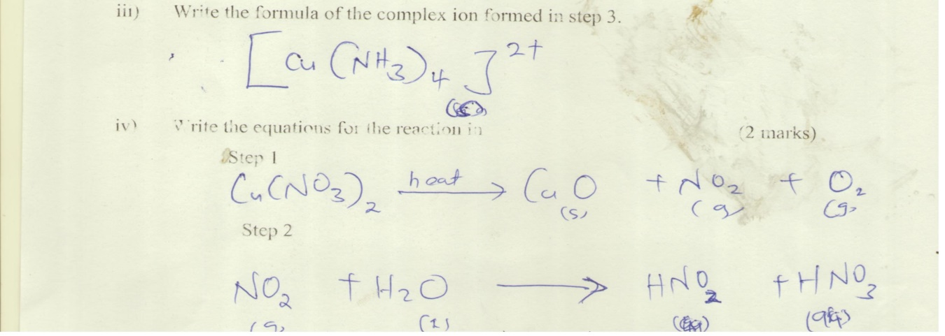
7. (a) Name substances A, B, C and D. (4mks)
A- ammonical brine
B – sodium hydrogen carbonate
C – ammonium chloride
D- calcium chloride
(b) Write equation for the reactions taking place in chamber 2, 3 and 5
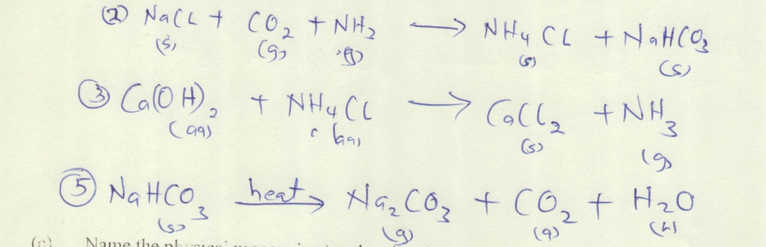
(c) Name the physical process in chamber 4 and 5.
Chamber 4 – filtration
Chamber 5 -heating
(d) Name one source of carbon (IV) oxide for Solvay process.
Heating lime stone or calcium carbonate.
(f) give 2 uses of sodium carbonate
- making of glass - in paper industry softening hard water - making sodium silicate that is used in making detergents

