FORM THREE BUSINESS STUDIES
PAPER 2 MARKING SCHEME
END OF TERM THREE EXAMINATION 2023
- a) Reasons for preparing a business plan.
- It may be a requirement by financiers.
- It assists in allocating resources.
- Assist in determining the financial requirements.
- Acts as a tool of control
- Acts as a motivating factor to the workers in that each one knows what is expected of him
- Assists in identifying the strengths and weaknesses of the business
- Assists in adapting to possible changes that are likely to occur during the implementation period.
- Assists in avoiding mistakes in that such mistakes can be detected and rectified before implementation.

b) Role of stock exchange market.
- It facilitates buying and selling of shares in that it acts as a link between the sellers and the investing public.
- Acts as an indicator of the level of economic activities in a country by looking at the number of shares being transacted.
- Assists in safeguarding investor’s interest in that only those financially sound companies have their shares traded in the market.
- Creates a culture of saving in that those with surplus money can invest in shares.
- Provide useful information that assist in making investment decision in that people know where to invest.
- It creates employment for people in trading of shares
- Acts as a source of government revenue through taxes
- Assist companies to raise revenue
- Assist in determining the prices of shares.

- a) Problems encountered in measuring national income.
- It’s not possible to estimate depreciation on capital goods.
- It’s not easy to determine the value of the subsistent output.
- There is the problem of change in value of money which may give exaggerated information
- There is the problem of double counting
- It’s not easy to estimate the value of free and subsidized services
- Inaccurate data due to use of wrong statistical methods.
- Inventory valuation on stock appreciation
- There is the problem of the output of foreign firms.

b) Factors considered before giving credit.
- Credit worthiness of the buyer
- Repayment period
- The amount of goods that the customer wants
- Availability of adequate stock
- Honesty on the trustworthiness of the customer
- Frequency at which the customer buys
- Seller’s intensions such as retaining customers.

- a) Reasons for using salesmanship.
- When introducing new products in the market
- When the unit value of a product is high
- Where demonstration is required
- Where the feed-back of the customer is needed
- Where the market is concentrated In a small geographical area
- Where the firm has adequate resources to finance the sales force
- Suitability of a product to individual needs as opposed to those of the general public.
b) Sources of business ideas
- Using information from the media
- Using individual talents and strengths
- Spotting market gaps
- Brain storming where people come together and agree on certain idea
- Shows and exhibitions
- Identifying use of wastes product
- Listening to complaints from customers
- Market survey to find out what is on demand
- Hobbies or those activities that people do for pleasure like entertainment.

- a) Ways of creating an enabling and
- carrying out market research and giving advise to entrepreneurs.
- providing infrastructure
- ensuring that there is maximum security
- reducing taxes
- increasing subsidies
- Providing basic services like education and medical care.
- Accessing businessman to sources of capital.

b)
WITU
BALANCE SHEET $1/2$
AS AT 30TH APRIL 2017
FA capital 271, 300
Motor vehicles 273, 000
Furniture 8, 000 $1/2$ LTL
AD is loan 70, 000
CA
Stock 36, 400 CL
Debtors 27, 500 creditors 6, 700
Cash 20, 500 overdraft 36, 500
386, 500 386, 500

1 mrk for each correct entry.

- a)
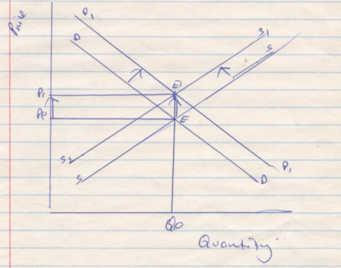 diagram 8mrks
- Equilibrium price will increase. 1 mrk
- The equilibrium quantity remains constant.1mrk

b) Steps followed in seeking compensation
- Reporting to the insurance company in case a risk occurs..
- Filling claim firms.
- Investigation of the claim by the insurer
- Preparation of assessment report
- Payment of the claim.

- a) Factors that contribute to existence of small firms.
- Limited access to sources of finance.
- Limited size of the market
- Limited access to modern technology
- One’s decision due to fear of taking risk
- Government policy where the government encourages the setting up of small scale businesses in order to create self-employment.
- Small firms are easy to manage.

b) Reasons for amalgamation
- Increasing bargaining power
- Avoiding unnecessary competition
- Mobilization of capital
- Controlling the market
- Avoiding wasteful use of resources
- Sharing of ideas
- Reducing the cost of operating
- Ensuring constant supply of raw materials through backward integration.

