BUSINESS STUDIES FORM 3
TERM 3, 2023
PAPER 1
TIME: 2HRS
NAME…………………………………………….CLASS………………………ADM………….
INSTRUCTIONS: Answer all questions in the spaces provided
- State the term given to each of the following descriptions. (4 marks)
 | Description | Term
a) | Study of activities that are carried out in an office
b) | Study of the process of identifying a business opportunity, acquiring the resources to start and run a business
c) | Study of trade and aids to trade
d) | Study of a systematic record keeping

- A survey conducted in Kenya shows an upward trend in entrepreneurial activities among citizens. Highlight four possible factors that may be leading to such a trend. (4 marks)
a)……………………………………………………………………………………………………………………………………………..
b) …………………………………………………………………………………………………………………………………………….
c)……………………………………………………………………………………………………………………………………………..
d)……………………………………………………………………………………………………………………………………………..
- Outline FOUR challenges associated with a high ageing population in a country. (4 Marks)
a)………………………………………………………………………………………………………………………………………
b) …………………………………………………………………………………………………………………………………….
c)………………………………………………………………………………………………………………………………………
d)……………………………………………………………………………………………………………………………………..
- Outline FOUR items that are included when computing national income using the expenditure approach. (4 Marks)
a)………………………………………………………………………………………………………………………………………
b) …………………………………………………………………………………………………………………………………….
c)………………………………………………………………………………………………………………………………………
d)……………………………………………………………………………………………………………………………………..
- Outline FOUR features that constitute a market. (4 Marks)
a)………………………………………………………………………………………………………………………………………
b) …………………………………………………………………………………………………………………………………….
c)………………………………………………………………………………………………………………………………………
d)……………………………………………………………………………………………………………………………………..
- Name the accounts to be debited and credited for each of the transactions shown in the table below. (4marks)
 | Transaction | A/c to debit | A/c to credit
a) | Bought goods on credit from Kamene
b) | Took soda from stock to entertain own children
c) | Paid for office expenses in cash
d) | Sold old motor vehicle and received a cheque

- State four factors that may necessitate re-insurance. (4marks)
a)………………………………………………………………………………………………………………………………………
b) …………………………………………………………………………………………………………………………………….
c)………………………………………………………………………………………………………………………………………
d)……………………………………………………………………………………………………………………………………..
- Name three types of wholesalers according to the goods they handle. (3marks)
a)………………………………………………………………………………………………………………………………………
b) …………………………………………………………………………………………………………………………………….
c)………………………………………………………………………………………………………………………………
9. State four reasons why consumers need protection from unscrupulous traders (4 mks)
a)………………………………………………………………………………………………………………………………………
b) …………………………………………………………………………………………………………………………………….
c)……………………………………………………………………………………………………………………………………..
d)…………………………………………………………………………………………………………………………………….
10. State four merits of a bonded warehouse to the Government (4 mks)
a)………………………………………………………………………………………………………………………………………
b) …………………………………………………………………………………………………………………………………….
c)……………………………………………………………………………………………………………………………………..
d)…………………………………………………………………………………………………………………………………….
11. Identify what is represented by the letters W,X, Y and Z in the diagram below(4 mks)
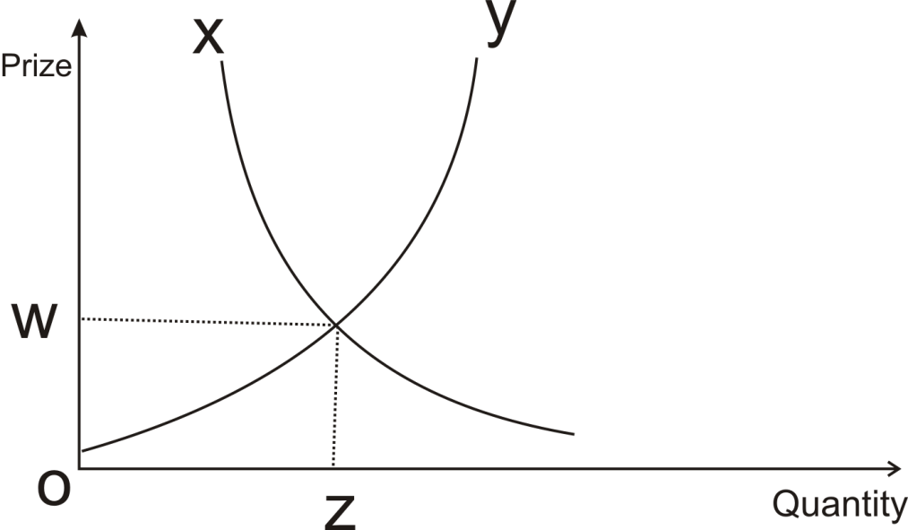
W ____________________________________________________________________

X _____________________________________________________________________

Y _____________________________________________________________________

Z ____________________________________________________________________

12. The following balances were extracted from the books of Mwenge Traders on 30th June
2010.

Shs.
Debtors 120 000
Creditors 240 000
Ten-year loan Loan 400 000
Closing Stock 25 000
Cash in hand 50 000
Drawings 30 000
Furniture 700 000

Required : Prepare a Balance Sheet as at 30th June 2010 (4mks)

13. Identify four circumstances under which face to face communication would be appropriate (4marks)

a)………………………………………………………………………………………………………………………………………
b) …………………………………………………………………………………………………………………………………….
c)……………………………………………………………………………………………………………………………………..
d)…………………………………………………………………………………………………………………………………….

- Outline four factors you would consider before setting up a business (4marks)

a)………………………………………………………………………………………………………………………………………
b) …………………………………………………………………………………………………………………………………….
c)……………………………………………………………………………………………………………………………………..
d)…………………………………………………………………………………………………………………………………….
- State four benefits of a business plan to a business (4marks)

a)………………………………………………………………………………………………………………………………………
b) …………………………………………………………………………………………………………………………………….
c)……………………………………………………………………………………………………………………………………..
d)…………………………………………………………………………………………………………………………………….
- Outline four features of perfect competition market (4marks)
a)………………………………………………………………………………………………………………………………………
b) …………………………………………………………………………………………………………………………………….
c)……………………………………………………………………………………………………………………………………..
d)…………………………………………………………………………………………………………………………………….

- Outline four factors to consider when choosing a method of promoting products (4marks)
a)………………………………………………………………………………………………………………………………………
b) …………………………………………………………………………………………………………………………………….
c)……………………………………………………………………………………………………………………………………..
d)…………………………………………………………………………………………………………………………………….

18. List any four characteristics of services. (4 mks)
a)………………………………………………………………………………………………………………………………………
b) …………………………………………………………………………………………………………………………………….
c)……………………………………………………………………………………………………………………………………..
d)…………………………………………………………………………………………………………………………………….
- Complete the table below by identifying whether the factor is within the internal or external business environment. (4 mks)

FACTOR | ENVIRONMENT
a) Business objectives
b) Goodwill from customers
c) Competitors
d) Marketing strategies

- A TV set was sold for sh.10,000. If the buyer was allowed a trade discount of 5% and a cash
discount of 2% if payment is made within a month. Determine the amount received by the seller if payment is made within 2 weeks. (4 mks)
………………………………………………………………………………………………………………………………………… ………………………………………………………………………………………………………………………………………………………………………………………………………………………………………………………………………………………………………………………………………………………………………………………………………………………………………………………………………………………………………………………………………………………………………………………………………………………………………………………………………………………………………………………………………………………………………..
20. . Highlight four channels of distribution for local agricultural products. (4 mks)
a)…………………………………………………………………………………………...
b) …………………………………………………………………………………………………………………………………….
c)……………………………………………………………………………………………………………………………………..
d)…………………………………………………………………………………………………………………………………….

21.. Enter the following transactions in the relevant journal
a) On 5th may 2001 an old tractor worth shs. 80,000 was sold to wakulima entreprices on credit
b) On 10th may an old furniture worth shs. 80,000 was sold on credit to Bumbere Restaurant for shs 90,000.
c) On 20th may a machine whose book value was shs. 80,000 was sold to Yusuf for shs. 50,000 on credit.
22. State four functions of an office in an organization (4mks)

a)……………………………………………………………………………………………………………………………………
b) …………………………………………………………………………………………………………………………………….
c)……………………………………………………………………………………………………………………………………..
d)…………………………………………………………………………………………………………………………………….

23. Identify four errors that may cause a trial balance to agree (4mks)

a)……………………………………………………………………………………………………………………………………
b) …………………………………………………………………………………………………………………………………….
c)……………………………………………………………………………………………………………………………………..
d)…………………………………………………………………………………………………………………………………….

24.State the four factors that may limit a persons ability to satisfy human wants (4mks)

a)………………………………………………………………………………………………………………………………….
b) …………………………………………………………………………………………………………………………………….
c)……………………………………………………………………………………………………………………………………..
d)…………………………………………………………………………………………………………………………………….
25. Give five differences between a cooperative and a parastatal (5 marks)
 | COOPERATIVE |  | PARASTATAL
a |  | a
b |  | b
c |  | c
d |  | d
e |  | e
f |  | f

