Name……………………………………… Index No………………..… Sign…………….…..
Date………...............
233/3
BIOLOGY
PAPER 3 (PRACTICAL)
TERM 3 2023
Time: 1 Hour 45 Minutes

INSTRUCTIONS TO CANDIDATES

- Write your name and index number in the spaces provided.
- Sign and write the date of examination in the spaces provided.
- Answer ALL the questions in the spaces provided in the question paper
- Spend the first 15 minutes of the time allowed for this paper reading the whole paper before commencing your work.
- ALL working MUST be clearly shown where necessary

FOR EXAMINER’S USE ONLY

QUESTION | MAXMUM SCORE | CANDIDATE’S SCORE
1 | 14
2 | 13
3 | 13
TOTAL | 40

1. a) You are provided with substances labeled M, N, V, U and X and a filter paper. M and N are food substances, while V is Benedict’s solution, U is 10% Sodium Hydroxide solution and X is 1% Copper Sulphate solution. Using the reagents provided, carry out tests determine the food substance(s) in M and N (10 marks)

Substance | Food Substance Being Tested For | Procedure | Observation | Conclusion
M
N

a).State the functions of the food substances found in both M and N. (4marks)
…………………………………………………………………………………………………………………………………………………………………………………………………………………………………………………………………………………………………………………………………………………………………………………………………………..…………………………………………………………………………………………………………………………………………………………………………………………………………………………………………………………………………………………………………………………………………………………………………………………………………..

2. Below are sections of a dicotyledonous plant organs labeled X and Y.

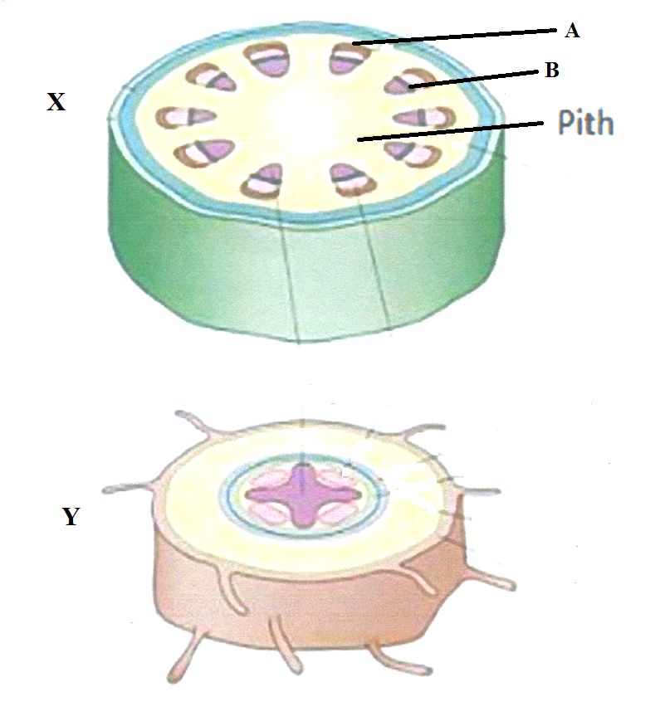
(a) Give three observable differences between the sections. (3 marks)
………………………………………………………………………………………………………………………………………………………………………………………………………………………………………………………………………………………………………………………………………………………………………………………………………………………………………………………………………………………………………………………………………
(b) On the diagram, label any three parts of section Y. (3 marks)

(c) Identify and state the functions of the parts labeled A and B. (4 marks)
A ……………………………………………………….
Function……………………………………………………………………………………………………………………………………………………………………………………………………………………………………………………………………………………………………………
B ………………………………………………………
Function……………………………………………………………………………………………………………………………………………………………………………………………………………………………………………………………………………………………………………
(d) How would section X compare with that of a monocotyledonous plant? (3 marks)
………………………………………………………………………………………………………………………………………………………………………………………………………………………………………………………………………………………………………………………………………………………………………………………………………………………………………………………………………………………………………………………………………………………………………………………………………………………………………………

3. Study the diagrams of fruits below
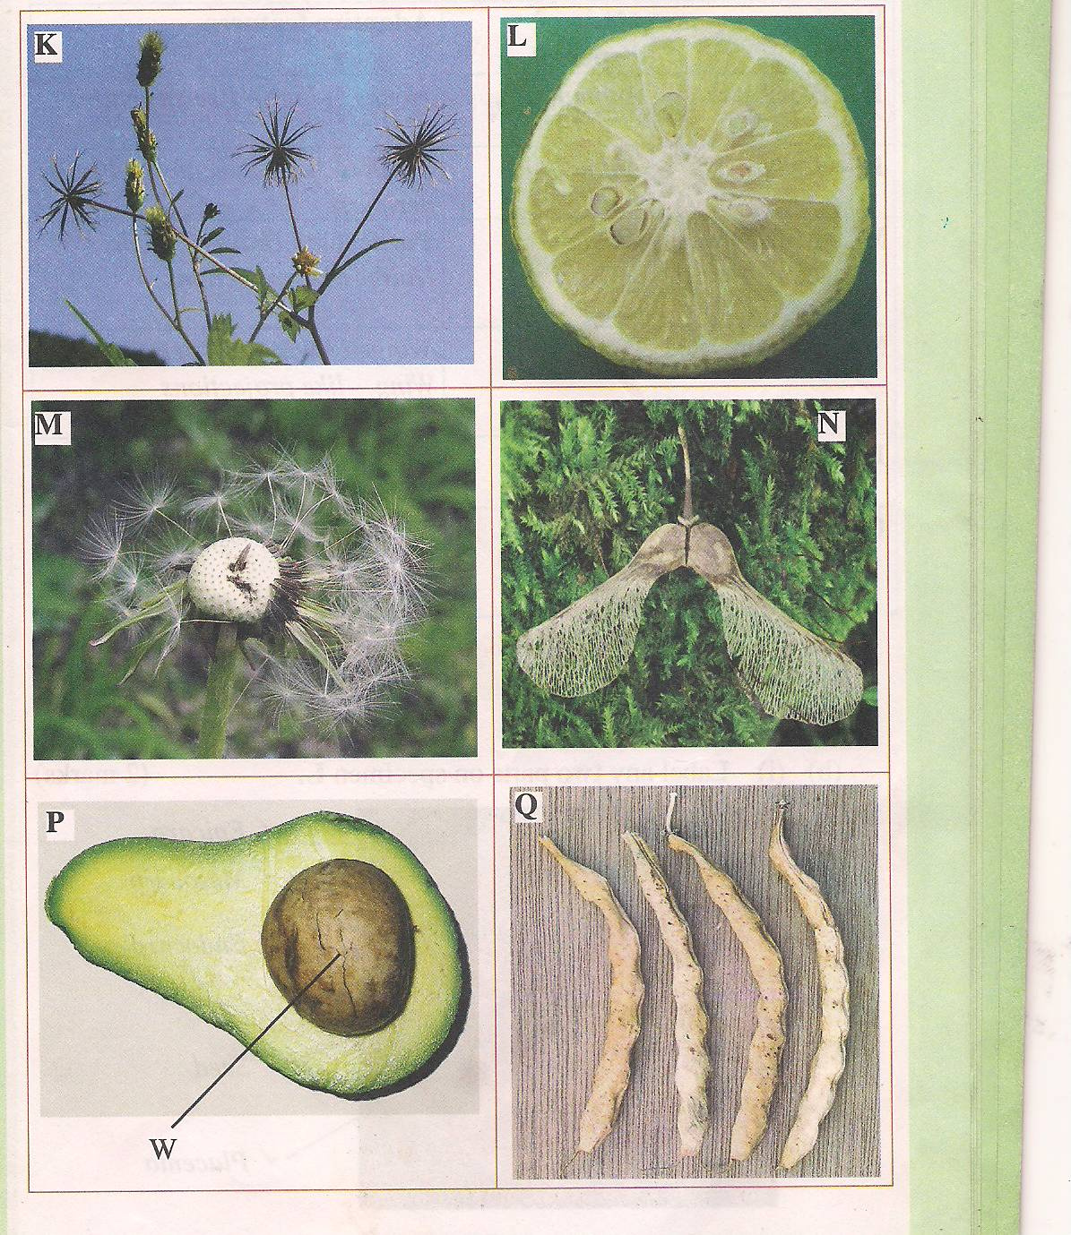

a) Name the type of fruit shown by P (1mks)

b) State the type of dispersion used by fruit M, K and N. Give adaptation for each of them (6mks)

c) Draw a well labeled diagram of diagram L (5mks)

d) State the type of placentation shown by diagram Q (1mk)

