BIOLOGY FORM 3 P2 TERM 3 2023 MARKINGSCHEME
- (a) Guttation: release of waterin droplets by plants through hydathodes;
Transpirations: loss of water in form of vapour through stomata into the
atmosphere.(2mks)
(b) - Through transpiration minerals ions and water are transported in plants.
- cools the plant
- removes excess water especially in aquatic plants
- responsible for turgor in plants. (any 3) (3mks)
(c )
Arteries | Veins
- Narrow lumen  - No valves except at the base of major arteries leaving the heart.  - Thick muscular walls with more elastic fibres | - Wider lumen  - Have valves at intervals  - Walls thin less muscular with less elastic fibres
- (a) gill acc fish gill rej gill fish
(b) Gill arch/bar; Gill rakers; gill filament. (3mks on diagram)
(c) – long and numerous offering large surface area for maximum gaseous exchange
- thin epithelium for respiratory gases to take a short distance by diffusion.
- network of blood capillaries to transport respiratory gases.
-Moist for dissolution of respiratory gases. (4mks)
- (a) (i) B - Seta
D – Rhizoid
(ii) A – produce spores
C _ photosynthesize
(b) (i) Arthropoda; sp
(ii) Segmented body;
Jointed appendages rej Limbs /legs
Presence of an Exoskeleton;
- a) Photosynthesis (1mk)
b) -Light (energy);
-Chlorophyll; (2mks)
c) i. Oxygen - used in respiration;
- released into the atmosphere (2mks)
ii) Glucose - Used in respiration;
-converted to starch for storage;
-Used in formation of cellulose/constituent of cell sap; (3mks)
- a) Reflects light through condenser to the stage;
b) Moves high power objective lens for longer distance; thus breaking the glass slide/ destroying the lens;
c) i) (4mks)
Electron | Light
- higher magnification  - high resolving power  - uses a beam of electrons to illuminate the specimen  - views dead specimen  - uses electromagnetic lenses | Lower magnification  Lower resolving power  Uses light to illuminate the specimen  Views both live and dead specimens  Uses glass lenses

ii) To make the structures clearer/distinct

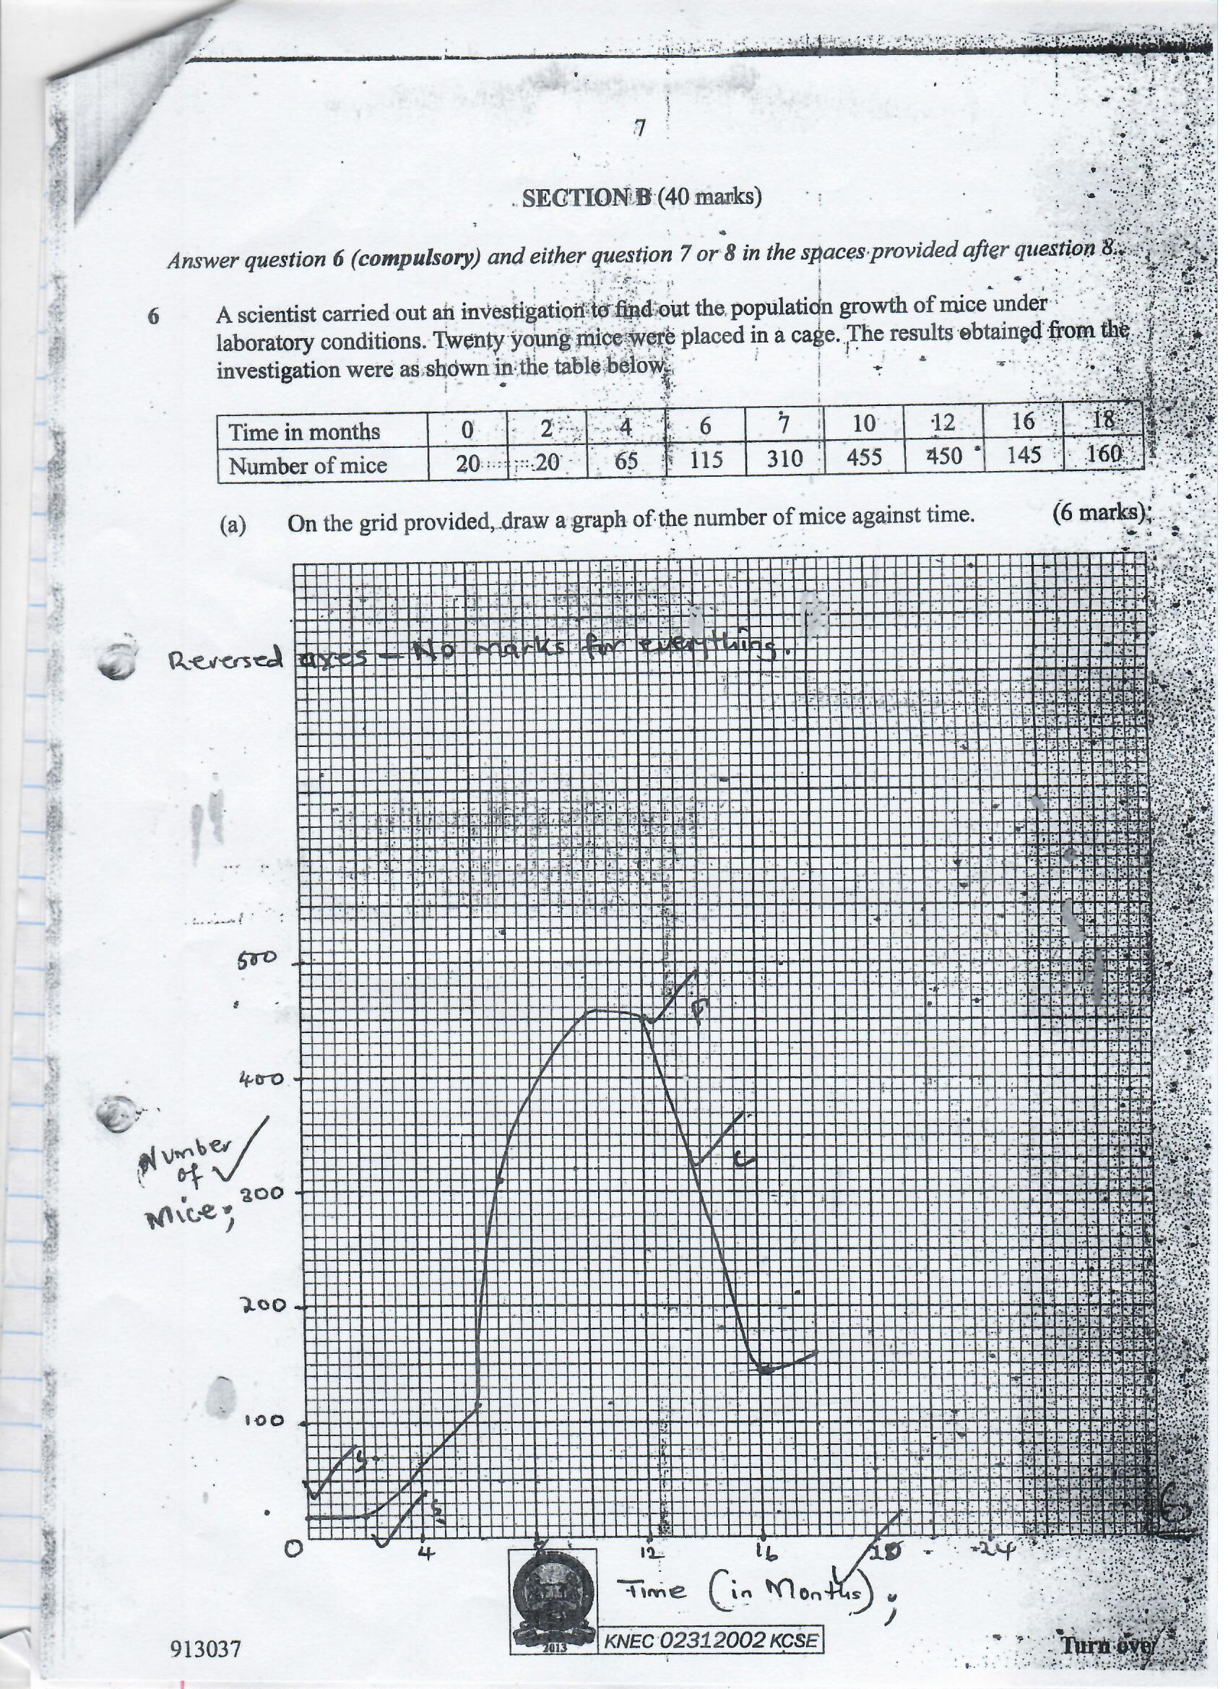
- i) 0 – 2 months

No change in population /population is constant;
Mice still maturing /have not given birth;

ii) 2 to 6 months
gradual /slow population growth ; few mice have reached sexual maturity;

iii. 6 to 10 months
rapid /faster rate of population growth;
many mice sexually mature;

iv) 10 to 12 months
population decline/decrease;
competition is high /food limiting/space is limiting
accumulation of toxic waste/disease outbreak/ death rate is higher than birth rate.

c) (i) 6 and 8;

(ii)
=125 – 130 mice per month
d) population would increase
e) food, space/cage size; water; (mark first 2)
- - Pituitary gland;
- Secrets follicle simulating hormone;
- F.S.H causes graaffian follicle to develop in ovary;
- It also stimulate tissue of ovary;
- To secrete oestrogen;
- Oestrogen causes repair /healing of uterine wall;
- Oestrogen stimulates pituitary gland
- To produce luteinizing hormone;
- L.H causes ovulation
- It also causes graffian follicle to change into corpus luteum;
- L.H stimulates corpus /uteum;
- To secrete progesterone;
- Progesterone causes proliferation of uterine wall;
- In preparation for implantation
- Progresterone /oestrogen inhibits the production of F.S.H
- Thus no more follicles develop ; and oestrogen reduces .
- In the next two weeks progesterone level rises ;
- And inhibits production of L.H’ the corpus luteum stops secretion of progrestrone;
- And menstruation occur when level of progesterone drops ; (total 21 max 20)
`
- a) Diffusion of CO2; and oxygen ; through stomata. Lenticels
- deposition /some wastes are stored in tissues in non-toxic form;
- some of these tissues/organs drop off from plants
- some wastes cleansed by transpiration
- other released by guttation
- other released by exudation (total 8 max 4)
b) -When body temperature is lowered below normal;
- blood vessels in skin constrict;
-blood is diverted to a shunt system;
- Less blood flows to skin hence less heat lost;

- when body temperature is raised above normal;
- blood vessels in skin dilates;
- more blood flows to the skin;
- more heat lost by convection/ raditation;
erector Pili muscles
- when temperature of body is lowered below normal erector pili muscles contract; hair stands erect; more air is trapped ; air is a bad conductor ; and insulates the body against heat loss
- when body temperature is raised above normal erector pili muscles relax; hair lies on the skin; less air is trapped; more heat is lost;
sweat glands
when body temperature is lowered below normal less fluids are absorbed by sweat glands / less sweating; less vaporization of water;
when body temperature is raised above normal sweat glands are more stimulated / more sweat is produced ; water in the sweat evaporates using latent heat of vapourisation ; cooling body. (total 22 max 16)

