Name…………………………………………………………………………………………… ADM………………………………………………..

Class……………………………………………………………………………………………………………………………………………………..

FORM THREE
END OF TERM 3 EXAMINATION 2023
AGRICULTURE PAPER TWO
DURATION: 2 HOURS
INSTRUCTIONS TO THE CANDIDATE
- Write your name and the admission number in the spaces provide above
- This paper consists of three sections A,B, and C
- Answer all the questions in section A and B
- Answer any two questions in section C
For Examiner’s use only

SECTION | QUESTION | MAXIMUM SCORE |  | CADIDATE SCORE
A | 1-12 | 30
B | 13-16 | 20
C | Q 17 | 20
 | Q 18 | 20
 | Q 19 | 20

SECTION 1 QUESTIONS
1. Name three infectious causing organisms. (1 ½)
…………………………………………………………………………………………………………………………………………………………………………………………………………………………………………………………………………………………………………………………………………………………………………………………………………………………………………………………………………………………………………………………………………………………………………………………………………………………………………………………..............
2. State three ways in which livestock diseases are spread. (1 ½ mk)
…………………………………………………………………………………………………………………………………………………………………………………………………………………………………………………………………………………………………………………………………………………………………………………………………………………………………………………………………………………………………………………………………………………………………………………………………………………………………………………………..............
3 (a) what do you understand by the following terms as used in livestock production.
- Nutrients. (1mk)
……………………………………………………………………………………………………………………………………………………………………………………………………………………………………………………………………………………………………………………………………………………………………………………………………………………………………………………………………………………………………………………………………………………………………………………………………………………………………………………
- Starch equivalent (1 mk)
…………………………………………………………………………………………………………………………………………………………………………………………………………………………………………………………………………………………………………………………………………………………………………………………………………………………………………………………………………………………………………………………………………………………………………………………………………………………………………………
- Digestion. ( 1mk)
…………………………………………………………………………………………………………………………………………………………………………………………………………………………………………………………………………………………………………………………………………………………………………………………………………………………………………………………………………………………………………………………………………………………………………………………………………………………………………………

(B) Give factors four that influence the amount of concentrate lactating animal would need. ( 2mks)
……………………………………………………………………………………………………………………………………………………………………………………………………………………………………………………………………………………………………………………………………………………………………………………………………………………………………………………………………………………………………………………………………………………………………………………………………………………………………………………………………………………………………………………………………………………………………………………………………………………………………………………………………………………………………………………………………………………………………………..

4 (i) Give four advantages of using artificial insemination as a method of service in livestock breeding. (2mks)
……………………………………………………………………………………………………………………………………………………………………………………………………………………………………………………………………………………………………………………………………………………………………………………………………………………………………………………………………………………………………………………………………………………………………………………………………………………………………………………………………………………………………………………………………………………………………………………………………………………………………………………………………………………………………………………………………………………………………………..
(II) State 4 signs of heat in a cow.. (2mks)
……………………………………………………………………………………………………………………………………………………………………………………………………………………………………………………………………………………………………………………………………………………………………………………………………………………………………………………………………………………………………………………………………………………………………………………………………………………………………………………………………………………………………………………………………………………………………………………………………………………………………………………………………………………………………………………………………………………………………………..

5.Give four reasons of creep feeding in livestock management principles
……………………………………………………………………………………………………………………………………………………………………………………………………………………………………………………………………………………………………………………………………………………………………………………………………………………………………………………………………………………………………………………………………………………………………………………………………………………………………………………………………………………………………………………………………………………………………………………………………………………………………………………………………………………………………………………………………………………………………………..

6.State four ways used in preservation of fish. (2MKS)
……………………………………………………………………………………………………………………………………………………………………………………………………………………………………………………………………………………………………………………………………………………………………………………………………………………………………………………………………………………………………………………………………………………………………………………………………………………………………………………………………………………………………………………………………………………………………………………………………………………………………………………………………………………………………………………………………………………………………………..

7 .Give for uses of fence in the farm ( 2MKS)
……………………………………………………………………………………………………………………………………………………………………………………………………………………………………………………………………………………………………………………………………………………………………………………………………………………………………………………………………………………………………………………………………………………………………………………………………………………………………………………………………………………………………………………………………………………………………………………………………………………………………………………………………………………………………………………………………………………………………………..
(b) State four procedures followed in the establishment of a permanent farm building. (2mks)
……………………………………………………………………………………………………………………………………………………………………………………………………………………………………………………………………………………………………………………………………………………………………………………………………………………………………………………………………………………………………………………………………………………………………………………………………………………………………………………………………………………………………………………………………………………………………………………………………………………………………………………………………………………………………………………………………………………………………………

8. State four ways through which the health of an animal can be restored. (2mks)
……………………………………………………………………………………………………………………………………………………………………………………………………………………………………………………………………………………………………………………………………………………………………………………………………………………………………………………………………………………………………………………………………………………………………………………………………………………………………………………………………………………………………………………………………………………………………………………………………………………………………………………………………………………………………………………………………………………………………………..
9. Name any four predisposing factors in the health of the animal. (2mks)
……………………………………………………………………………………………………………………………………………………………………………………………………………………………………………………………………………………………………………………………………………………………………………………………………………………………………………………………………………………………………………………………………………………………………………………………………………………………………………………………………………………………………………………………………………………………………………………………………………………………………………………………………………………………………………………………………………………………………………..

10 (i) Name three characteristics considered when selecting a beef calf. (1 ½ mks)
…………………………………………………………………………………………………………………………………………………………………………………………………………………………………………………………………………………………………………………………………………………………………………………………………………………………………………………………………………………………………………………………………………………………………………………………………………………………………………………..
(ii) State three factors that contribute to the distribution of livestock in Kenya. (1 ½ mks)
……………………………………………………………………………………………………………………………………………………………………………………………………………………………………………………………………………………………………………………………………………………………………………………………………………………………………………………………………………………………………………………………………………………………………………………………………………………………………………………………………………………………………………………………………………………………………………………………………………………………………………………………………………………………………………………………………………………………………………..

11A) state one use of each of the following tools
(i)Spade. (1/2 mk)
……………………………………………………………………………………………………………………………………………………………………………………………………………………………………………………………………………………………………………………………………………………………………………………………………………………………………………………………………………………
(ii) Shovel. (1/2 mk)
…………………………………………………………………………………………………………………………………………………………………………………………………………………………………………………………………………………………………………………….

(b)Give two reasons for proper maintenance of farm tools. (1 mk)
…………………………………………………………………………………………………………………………………………………………………………………………………………………………………………………………………………………………………………………………………………………………………………………………………………………………………………………………………………………………………………………………………………………………………………………………………………………………………………………..
12. Give two methods used to restrain animals .(1mk)

SECTION B (30 MARKS ) ANSWER ALL THE QUESTIONS
13.The illustrating below shows a practice in layer birds . use them to answer the questions that follow

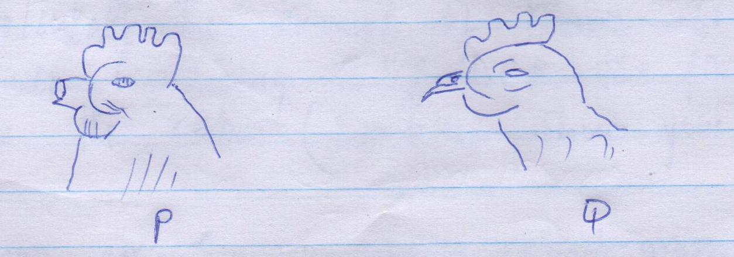

- What practice is represented above. (1MK)

………………………………………………………………………………………………………………………………………………………………………………………………………………………………………………………………………………………………………………………..

- Which illustration shows the right way of carrying out the practice. (1mk)
………………………………………………………………………………………………………………………………………………………………………………………………………………………………………………………………………………………………………………………

© state three reasons for carrying out the practice. (3 mmks)
…………………………………………………………………………………………………………………………………………………………………………………………………………………………………………………………………………………………………………………………………………………………………………………………………………………………………………………………………………………………………………………………………………………………………………………………………………………………………………………………………………………………………………………………………………………………………………………………………………………………………………………………………………………………………………………………………………………………………………….

14. A farmer wanted to prepare 200kg of calf rearing ration containing 20 % DAP , using the peason square method calculate the amount of maize containing 18% DCP and sunflower containing 35% DCP the framer would need to prepare. (5MKS show your working)

15.Fill the table below

Disease cause characteristics preventive measures
Coccidiosis
Black quarter
Rinder pest | virus |  | vaccination
Milk fever

16. The diagram below shows an internal livestock parasite. Sturdy it and use it to answer questions that follow.

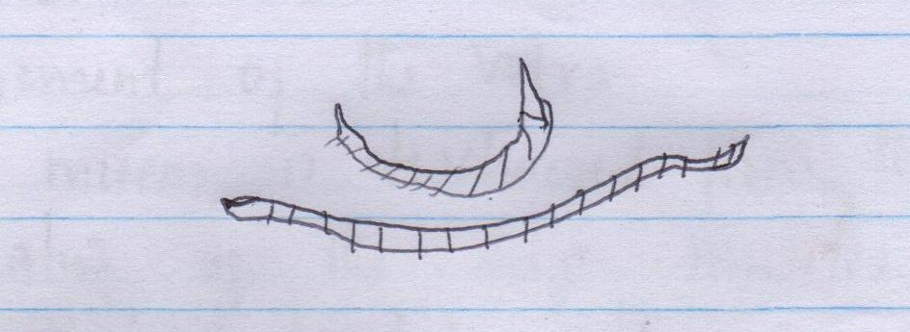

- Identify the parasite . (1mk)
……………………………………………………………………………………………………………………………………………………………………………………………………………………………………………………………………………………………………………………………………

- Name two types of animals that are affected by the parasite shown. (1mk)
………………………………………………………………………………………………………………………………………………………………………………………………………………………………………………………………………………………………………………………………….

©Name tree control measures of the parasite above
……………………………………………………………………………………………………………………………………………………………………………………………………………………………………………………………………………………………………………………………………………………………………………………………………………………………………………………………………………………………………………………………………………………………………………………………………………………………………………………………………………………………………………………………………………………………………………………………………………………………………………………………………………………………………………………………………………………………………………..

SECTION C 40 MARKS (ANSWER ANY TWO QUESTIONS)
17. (a) Outline 5 signs of parturition in cattle . (5mks)_
………………………………………………………………………………………………………………………………………………………………………………………………………………………………………………………………………………………………………………………………………………………………………………………………………………………………………………………………………………………………………………………………………………………………………………………………………………………………………………………………………………………………………………………………………………………………………………………………………………………………………………………………………………………………………………………………………………………………………………………………………………………………………………………………………………………………………………………………………………………………………………………………………………………………………………………………………………………………………………..……………………………………………………………………………………………………………………………………………………
(C)Sate 5 reasons for carrying out inbreeding in livestock. (5mks)
………………………………………………………………………………………………………………………………………………………………………………………………………………………………………………………………………………………………………………………………………………………………………………………………………………………………………………………………………………………………………………………………………………………………………………………………………………………………………………………………………………………………………………………………………………………………………………………………………………………………………………………………………………………………………………………………………………………………………………………………………………………………………………………………………………………………………………………………………………………………………………………………………………………………………………………………………………………………………………..…………………………………………………………………………………………………………………………………………………………………………………………………
- Give five effects of parasites on livestock. (5mks)
………………………………………………………………………………………………………………………………………………………………………………………………………………………………………………………………………………………………………………………………………………………………………………………………………………………………………………………………………………………………………………………………………………………………………………………………………………………………………………………………………………………………………………………………………………………………………………………………………………………………………………………………………………………………………………………………………………………………………………………………………………………………………………………………………………………………………………………………………………………………………………………………………………………………………………………………………………………………………………..…………………………………………………………………………………………………………………………………………………………………………………………………

(d)Describe the difference between ruminant and non-ruminant s digestive system (5mks)

………………………………………………………………………………………………………………………………………………………………………………………………………………………………………………………………………………………………………………………………………………………………………………………………………………………………………………………………………………………………………………………………………………………………………………………………………………………………………………………………………………………………………………………………………………………………………………………………………………………………………………………………………………………………………………………………………………………………………………………………………………………………………………………………………………………………………………………………………………………………………………………………………………………………………………………………………………………………………………..…………………………………………………………………………………………………………………………………………………………………………………………………
………………………………………………………………………………………………………………………………………………………………………………………………………………………………………………………………………………………………………………………………………………………………………………………………………………………………………………………………………………………………………………………………………………………………………………………………………………………………………………………………………………………………………………………………………………………………………………………………………………………………………………………………………………………………………………………………………………………………………………………………………………………………………………………………………………………………………………………………………………………………………………………………………………………………………………………………………………………………………………..…………………………………………………………………………………………………………………………………………………………………………………………………

- a) Describe precautions to be observed when using workshop tools. (5mks)
………………………………………………………………………………………………………………………………………………………………………………………………………………………………………………………………………………………………………………………………………………………………………………………………………………………………………………………………………………………………………………………………………………………………………………………………………………………………………………………………………………………………………………………………………………………………………………………………………………………………………………………………………………………………………………………………………………………………………………………………………………………………………………………………………………………………………………………………………………………………………………………………………………………………………………………………………………………………………………..…………………………………………………………………………………………………………………………………………………………………………………………………
………………………………………………………………………………………………………………………………………………………………………………………………………………………………………………………………………………………………………………………………………………………………………………………………………………………………………………………………………………………………………………………………………………………………………………………………………………………………………………………………………………………………………………………………………………………………………………………………………………………………………………………………………………………………………………………………………………………………………………………………………………………………………………………………………………………………………………………………………………………………………………………………………………………………………………………………………………………………………………..…………………………………………………………………………………………………………………………………………………………………………………………………

(b)State five characteristics of merino sheep (5mks)
………………………………………………………………………………………………………………………………………………………………………………………………………………………………………………………………………………………………………………………………………………………………………………………………………………………………………………………………………………………………………………………………………………………………………………………………………………………………………………………………………………………………………………………………………………………………………………………………………………………………………………………………………………………………………………………………………………………………………………………………………………………………………………………………………………………………………………………………………………………………………………………………………………………………………………………………………………………………………………..…………………………………………………………………………………………………………………………………………………………………………………………………

- Explain five factors considered in selecting construction materials. (10mks)
………………………………………………………………………………………………………………………………………………………………………………………………………………………………………………………………………………………………………………………………………………………………………………………………………………………………………………………………………………………………………………………………………………………………………………………………………………………………………………………………………………………………………………………………………………………………………………………………………………………………………………………………………………………………………………………………………………………………………………………………………………………………………………………………………………………………………………………………………………………………………………………………………………………………………………………………………………………………………………..………………………………………………………………………………………………………………………………………………………………………………………………………………………………………………………………………………………………………………………………………………………………………………………………………………………………………………………………………………………………………………………………………………………………………………………………………………………………………………………………………………………………………………………………………………………………………………………………………………………………………………………………………………

19 (a) Describe new castle disease under the following sub-headings.
- Causal organism.( 1mk)
………………………………………………………………………………………………………………………………………………………………..
- Animals affected. (1mk)
……………………………………………………………………………………………………………………………………………………………………………………………………………………………………………………………………………………………………………………………………
- Symptoms. (5mks)
………………………………………………………………………………………………………………………………………………………………………………………………………………………………………………………………………………………………………………………………………………………………………………………………………………………………………………………………………………………………………………………………………………………………………………………………………………………………………………………………………………………………………………………………………………………………………………………………………………………………………………………………………………………………………………………………………………………………………………………………………………………………………………………………………………………………………………………………………………………………………………………………………………………………………………………………………………………………………………..…………………………………………………………………………………………………………………………………………………………………………………………………

- Control measures. (5mks)
………………………………………………………………………………………………………………………………………………………………………………………………………………………………………………………………………………………………………………………………………………………………………………………………………………………………………………………………………………………………………………………………………………………………………………………………………………………………………………………………………………………………………………………………………………………………………………………………………………………………………………………………………………………………………………………………………………………………………………………………………………………………………………………………………………………………………………………………………………………………………………………………………………………………………………………………………………………………………………..…………………………………………………………………………………………………………………………………………………………………………………………………………………………………………………………………………………………………………………………………………………………………………………………………………………………………………………………………………………………………………………………………………

b ) (i) outline procedure for processing wax in bee keeping (8mks)
………………………………………………………………………………………………………………………………………………………………………………………………………………………………………………………………………………………………………………………………………………………………………………………………………………………………………………………………………………………………………………………………………………………………………………………………………………………………………………………………………………………………………………………………………………………………………………………………………………………………………………………………………………………………………………………………………………………………………………………………………………………………………………………………………………………………………………………………………………………………………………………………………………………………………………………………………………………………………………..…………………………………………………………………………………………………………………………………………………………………………………………………
………………………………………………………………………………………………………………………………………………………………………………………………………………………………………………………………………………………………………………………………….
(ii) Give any two ways in which vaccines are administered. (2mks)
……………………………………………………………………………………………………………………………………………………………………………………………………………………………………………………………………………………………………………………………………………………………………………………………………………………………………………………………………………………………………………………………………………………………………………………………………………………………………………………

