NAME……………………………………………………………..ADM/NO……………………

DATE…………………………. ………………… ………….CLASS……………………………

JOINT EXAMINATIONS
FORM 2
TERM THREE 2023
PHYSICS 232
TIME: 2HRS
MARKING SCHEME

SECTION A (25 MARKS)
Answer all questions in the spaces provided

- The micrometer screw gauge below has a zero error of - 0.19mm.

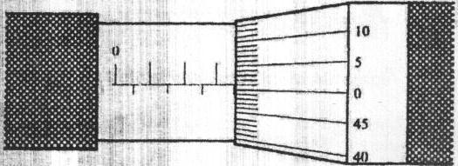

Determine the actual thickness of the object. (2mks)

Reading shown is 3.50
+ 0.01
3.51mm

Actual thickness = 3.51
+ 0.19
3.70mm

- Two mirrored walls stand at an angle to each other. A student standing in the room counts nine images of himself in the mirrors. Determine the angle between the walls.
(3mks)
n =$\frac{360}{Ѳ}$– 1 9=$\frac{360}{Ѳ}$– 1

Ѳ=$\frac{360}{10}$

=36⁰

- a) What is meant by the term anomalous expansion of water? (1mks)
Anomalous expansion of water is defined as the unusual behavior of water in which it contracts when heated and expands when cooled between 0 and 4⁰C

b) Explain any two applications of contraction and expansion in solids. (2mks)
- Expansion joints in Steam Pipes
Pipes carrying steam are fitted with loops or expansion joints to allow for expansion when steam is passing through them and contraction when they are cooled Fixing of Railway Line
- Railway lines are constructed in sections with expansion gaps and the sections held together by fishplates. The bolt holes in the rails are oval to allow free expansion and contraction of rails as the bolts move freely in the holes.
A modern method of allowing for expansion and contraction in railways is to plane slant the rails so that they overlap
- Installation of Telephone/ Electric Wires
They are loosely fixed to allow for contraction. Telephone or electric wires appear to be shorter and taut in the morning. When it is hot, the wires appear longer and slackened
- Fixing of Steel Bridges
In bridges made of steel girders, one end is fixed and the other end placed on rollers to allow for expansion and contraction.
1
- A body weighs 600N on the surface of the earth and 450N on the surface of another planet. Calculate the value of g in that planet (g on the earth = 10N/Kg) (3mks)
Mass on the earth’s surface = 600
10
= 60Kg

Value of g in the other planet = 450
60

= 7.5N/Kg

- State two applications of electrostatic charges (2mks)

- Electrostatics precipitators
- Finger printing
- Spray painting
Photocopying

- 200 coulombs of charge passes through a point in a circuit for 0.6 minutes. What is the magnitude of the current flowing? (3mks)

Q=It
200=I×0.6×60

I=$\frac{200}{36}$

=5.556A
- While heating water in a beaker, a wire gauze is placed below the beaker explain.(2mks)

The vessel is placed on a wire gauZe because the gauZe is a good conductor of heat it therefore spreads the heat to a large area of the vessel.Without gauze heat will concentrate at one point which may lead to uneven expansion of glass hence break.
- What is the relationship between physics and technology (2mks)

- Machines used in the field of medicine such as x-rays, body scanners and lasers are all applications of physics.
- Manufacture and use of satellites and microwave dishes used in information technology to relay information is based on physics knowledge
- Physics knowledge is also used in defense industry in the manufacture and use of most modern and complex machines.

- Using the domain theory distinguish between magnetic material and a magnet (2mks)

- For a magnet the dipoles in all domains align towards a common direction while in magnetic magnetic material dipoles in every domain are aligned in different direction.
- State two application of convection in fluids (2mks)
- Domestic hot water system
- Cooling system of car engine
- Ventilation
- Land and sea breeze

- Convert a temperature of 234K to degree celsious (1mk)

T= Ѳ +273
234= Ѳ+273
Ѳ= 234-273= -39c

SECTION B (55 MARKS)

- (a) State Hooke’s law (1mk)

For a helical spring or other elastic material, the extension is directly proportional to the stretching force, provided elastic limit is not exceeded.

(b) In an experiment to verify Hooke’s law, a piece of rubber was fixed to a rigid support and the other end pulled with a force of ranging magnitude. The values of force and the extension were recorded as in the table below:-

Force (N) | 0 | 0.20 | 0.55 | 0.75 | 1.00 | 1.30 | 1.40
Extension(cm) | 0 | 1.5 | 2.5 | 3.5 | 4.5 | 6.0 | 7.0

- Plot a graph of force ( Y axis) against extension (X-axis) on the gird provided
(5mks)
Plotting=2mk
Scale=1mk
Line=1mk
Axes= 1mk
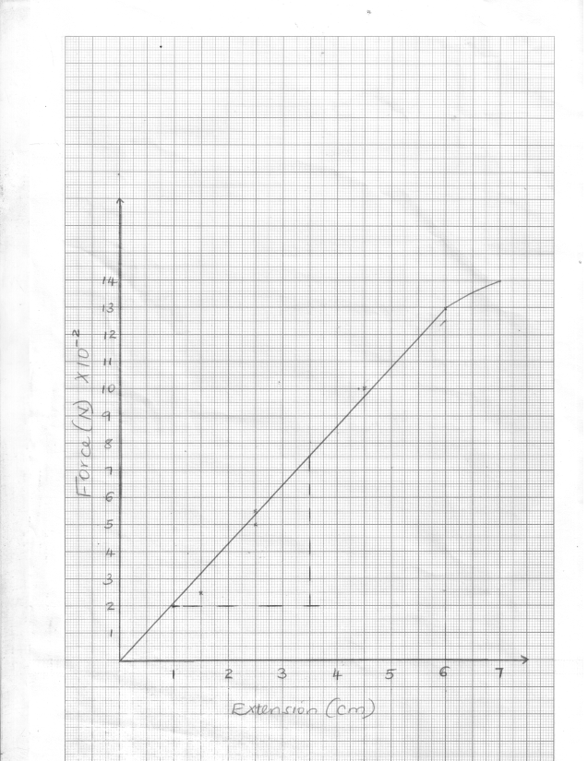
- From the graph, determine the spring constant of the rubber within elastic limit
(3mks)

K = F/E
Gradient = 0.75 - 0.2
3.5 - 1.0

= 0.5
2.5

= 0.2N/cm

- What is the size of force at the elastic limit (1mks)

1.3 N -check on student graph where the straight line starts a bend

- (a) State one characteristic of a brake fluid. (1mk)
-must be incompressible
-should not corrode the parts of break system
-have high boiling point
-have low freezing point
(b) The height of a mercury barometer at a particular place is 70cm. given that the density of mercury is 13600kgm³, determine;
(i) The atmospheric pressure at the place. (3mks)

Pa = 0.7×13600×10

=95200N/m²

(ii) The height of a water barometer at the same place. (Density of water=1g/cm³) (2mks)

95200=h×1000×10
h = $\frac{95200}{1000×10}$
=9.52m

(iii) Give a reason why mercury is preferred as a barometric liquid. (1mks)

Mercury is much denser than water. It also supports a small and measurable column

(c) Calculate the minimum pressure a block of dimensions 3cm by 10cm by 15cm and mass 12kg could exert on a horizontal surface. (3mks)

Pmin=$\frac{120}{0.015}$

=8000N/m²

- a) Differentiate between transverse waves and longitudinal waves.(2mks)

Transverse waves, the vibration of the particles is a right angles to the direction of wave travel while longitudinal waves, the vibration of the particles is in a direction parallel to the direction of the wave travel.

b) The figure below shows a wave form in a string.
5
-5
5
10
20
30
40
50
602
70
(m)
(m)

Given that the speed of the wave is 10m/s. With reference to this wave motion, determine;
- Wavelength. (1mk)
50-10= 40m

- Amplitude. (1mk)

5m
- Frequency. (2mks)

f= velocity/wavelength
=10/40 = 0.25Hz

- Period (2mks)

t= 1/f =1/0.25 = 4s

- A person standing 49.5m from the foot of a cliff claps his hands and hears an echo 0.3 seconds later. Calculate the velocity of the sound in air. (3mks)

$$v=\frac{2d}{t}=\frac{49.5×2}{0.3}$$
$$v=330m/s$$

- (a) What property of light is suggested by the formation of shadows? (1mk)

Rectilinear propagation of light/light travels in a straight line

(b) A building standing 200m from a pinhole camera produces on the screen of the camera an image 2.5cm high 5.0cm behind the pinhole.
Determine the actual height of the building (3mks)

hi = v
ho u

ho =2.5 x 20000
5
= 10000cm or 100m

(c) An object of height 2.0cm is placed 5.0cm in front of a convex mirror of focal length 10.0cm
(i) On the grid provided, draw to scale a ray diagram to locate the position of the image.(4mks)

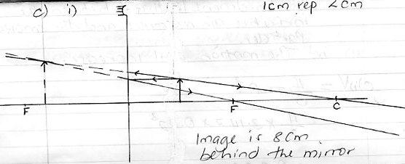

ii) State two applications of concave mirrors (2mks)
-shaving mirrors
-By dentist to examine teeth

- (a) When is an object said to be in stable equilibrium? (1mk)

A body is said to be in a stable equilibrium if it returns to the original position after being displaced slightly.

(b) A uniform metal rod of length 80cm and mass 3.2kg is supported horizontally by two vertical spring’s balances C and D balance C is also from one end while balance D is 30cm from the other end. Find the reading on each balance (4mks)

32N
D
C
30cm
50cm
20cm
30cm
20cm

When pivot at C:
Then C.M = (30 x 32) Ncm
A.C.M = 50D
C.M = A.C.M =>$\frac{960}{50}=\frac{50D}{50}$
D = 19.2N

C + D = 32N
C = 32 – 19.2
= 12.8N
Reading on C = 12.8N
Reading on D = 19.2N

- (a) The figure below shows an electric bell. Briefly explain how it works. (4mks)

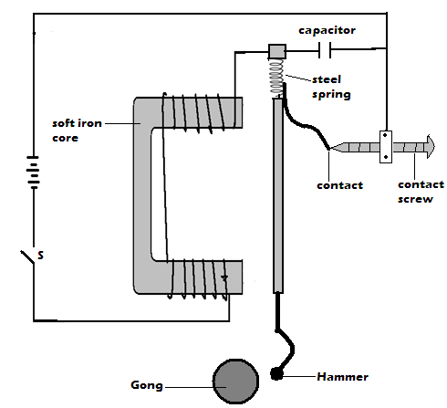

When circuit is closed, soft iron core gets magnetized and attracts the soft iron ammarture.The hammer being attached to the armature thus strikes the gong. the contacts breaks, core looses magnetism and armature returns to normal position. The process repeats.
- State the right hand grip rule for straight conductor carrying current (1mks)

When a straight conductor is held with right hand,with thumb showing the direction of current then the fingers show direction of magnetic field
- a) State the equation of continuity (1mk)

AV= constant / A₁V₁=A₂V₂
a-area v- velocity

b) The velocity of glycerin in a 5cm internal diameter pipe is 1.00m/s. Find the velocity in a 3cm internal diameter pipe that connects with it, both pipes flowing full. (3mks)

A₁₌ 22/7*2. 5*10⁻⁴
A₂₌ 22/7* 1.5*10⁻⁴

A₁V₁=A₂V₂
_{V2=} A₁V_{1/} A₂

22/7*2. 5²*10^{-4 *}1 )/ 22/7* 1.5²*10⁻⁴
=2.778M/S

