MATHEMATICS
TERM 3
2023

NAME: …………………………………………………ADM NO……………….
CLASS……………….. DATE…………………
FORM TWO
MATHEMATICS
TIME: 2 ½ HOURS
Instructions
- Write your name, adm no. class and date in the spaces provided above.
- The paper consists of two sections: section I and section II.
- Answer all the questions in section I and any five in section II
- Section I has sixteen questions and section II has eight questions
- All answers and working must be written on the question paper in the spaces provided below each question.
- Show all the steps in your calculations, giving your answers at each stage in
the spaces below each question
- KNEC Mathematical table and silent non-programmable calculators
may be used.

FOR EXAMINER’S USE ONLY

SECTION I

1 | 2 | 3 | 4 | 5 | 6 | 7 | 8 | 9 | 10 | 11 | 12 | 13 | 14 | 15 | 16 | Total

SECTION II
GRAND TOTAL
17 | 18 | 19 | 20 | 21 | 22 | 23 | 24 | Total

This paper consists of 14 printed pages

SECTION 1 (50 MARKS)
Answer any FIVE questions in this section in the spaces provided
1.Evaluate: $\frac{1}{2}$ +$\frac{1}{3}$ (3mks)
$\frac{1}{7}$ of ( $\frac{2}{5 }$ +$\frac{1}{24}$)

2.Express as a fraction. (2mks )
0.$\dot{1}\dot{5}$

3.Simplify (3mks)
$\frac{ay-ax}{bx-by}$

4. Fifteen tractors each working eight hours a day take eight days to plough a piece of land. How long would it take 24 tractors each working 10 hours a day to plough the same piece of land 3mks)

5. The shaded region below shows the area swept out on a flat windscreen by a wiper. Calculate the area of the shaded region. (4mks)

4cm

16cm 120º

6.The mass of two bags of beans and three bags of salt is 410kg. If the mass of three bags of beans and two bags of salt is 390kg, find the mass of each bag. (3mks)

7.The interior angle of a regular polygon is twice the exterior angle.
- Find the number of sides of the polygon. (3mks)

- What is the name of the polygon? (1mks)

8. The angle of elevation of a church tower from a point A, 50 metres away from the foot of the church is 24º. Find the distance between A and B if the angle of elevation of the tower from B is 20º. (4mks)

9.The figure below is a cross section of a swimming pool 8m wide. Calculate the capacity of the pool in litres. (3mks)

30m

1m
3m

10. Three litres of water (density 1g/cm³) is added to twelve litres of alcohol (density 0.8/cm³).What is the density of the mixture? (3mks)

11. The volume of two similar solid spheres are 4752cm³ and 1408cm³. If the surface area of the small sphere is 352cm², find the surface area of the larger sphere. (3mks)

12. Solve for x in the equation = 32 (3mks)

13. Momanyi spent one eight of his February Salary on farming, half on school fees and two thirds of the remainder on food. Calculate his February salary and the amount he spend on school fees if he spent sh. 3200 on food. (3marks)

14. Form three inequalities that satisfy the unshaded region R. (3marks)
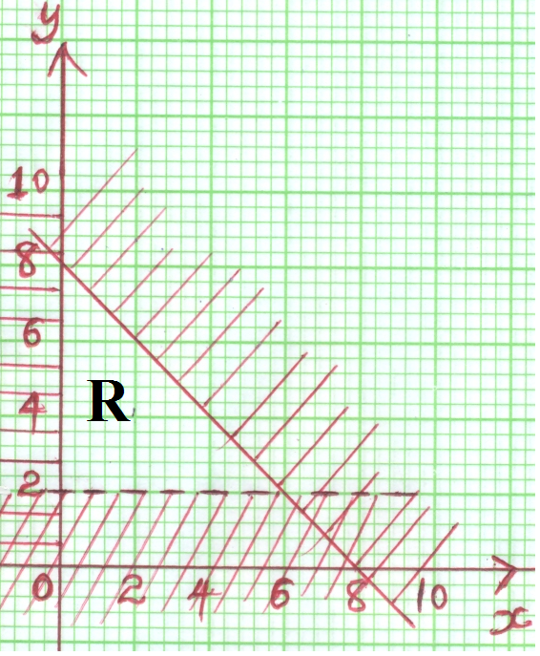

15. A Kenyan tourist in US borrowed 10,000 US dollars to pay for his son’s examination.
He is expected to pay either in Kenyan shillings or through an account in the United Kingdom in
sterling pounds. If he decided to pay through United Kingdom, how much would he save given
that
1 US dollar = 82.4 Kenyan shillings
1 Sterling pound = 1.4 US dollar
1 Sterling pound = 105 Kenyan shillings (3mks)

16. Solve for X in the equation. (3mks)

SECTION II (50MKS)
Answer any FIVE questions in this section in the spaces provided
17. The figure below shows a glass in form of a frustrum of a cone whose top and bottom diameter of 7cm and 3.5cm respectively. Its depth is 10cm. Taking $π=\frac{22}{7}$,
Calculate;
a) Its total surface area. (5 marks)

b). Its capacity in litres. (5 marks)

18.Two friends Jane and Tom live 40km apart. One day Jane left her house at 9.00am and cycled towards Tom’s house at an average speed of 15km/hr. Tom left at 10.30am on the same day and cycled towards Jane’s house at an average speed of 25km/hr.
- Determine;
- The distance from Jane’s house, where the two friends met. (4 marks)

- The time they met. (2 marks)

- How far Jane was from Tom’s house when they met? (2 marks)

- The two friends took 10 minutes at the meeting point and they cycled to Tom’s house at an average speed of 12km/hr. Find the time they arrived at Tom’s house. (2 marks)

19. Town Q is 180km on bearing of 050º from town P. Another town R is on a bearing 110º from P and also on compass bearing S 30ºE from Q. Town S is South of P and also West of R.
Using scale 1 cm rep. 20 km;
- Draw the scale diagram to show the positions of the four towns. (6 marks)

- Use your scale diagram in (a) above to find;
- The distance of R from P. (1 mark)

- The bearing of Q from S. (1 mark)

- The distance of Q from S. (1 mark)

- How far P is North of S. (1 mark)

20. The mark of 100 candidates for mathematics examination were distributed as follows.
marks | No of candidates(f) | Mid-point(x) | fx | c.f
30-34  35-39  40-44  45-49  50-54  55-59  60-64 | 5  24  26  24  13  6  2

(a)Calculate
(i) The mean mark (2mks)

(ii) The median (3mks)

(b) On the grid provided, draw a histogram. (3mks)

(c) On the same graph, draw a frequency polygon. (1mk)

(d) Find the modal mark. (1mk)

21. The figure below shows two circles of radii 10.5 and 8.4cm and with centres A and B respectively. The common chord PQ is 9cm.
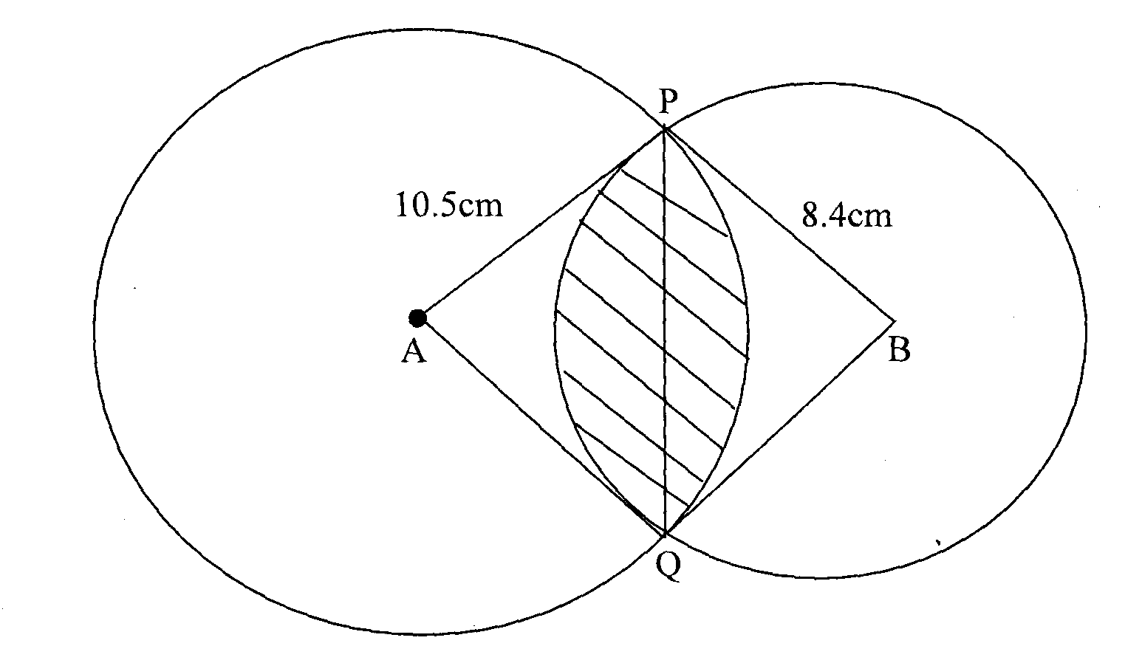
(a) Calculate angle PAQ. (2 mks)

(b) Calculate angle PBQ. (2 mks)

(c) Calculate the area of the shaded part. (6 mks)

22. Three business partners; Kamau, Tatwa and Makau contributed Ksh. 100,000, Ksh. 80,000 and Ksh. 50,000 respectively to start a business. After one year, the business realized a profit which they shared in the ratio of their contributions.
  - If Makau’s share of profit was Kshs. 20,000, how much was the total amount of profit?
(3mks)

  - At the beginning of the second year, Makau boosted his shares by Ksh. 10,000. If the business profit increased by 20% at the end of the second year, calculate:-
    - Kamau’s share of the profit. (4mks)

    - The difference between Kamau’s and Tatwa’s share of profit. (3mks)

23. (a) Show by shading the unwanted region, the region which satisfies the following inequalities (8mks)

Y > -3
4y ≤5x + 20
2y < - 5 x + 10
4y≤ -3x – 12

(b) Calculate the area of this region in a square units (2mks)

24. Triangle ABC has the vertices A (3, 1), B (2, 2) and C (3, 4).
(a) On the grid provided draw triangle ABC and its image A¹B¹C¹ under a rotation of negative quarter turn about the point (0,0) (3 marks)

(b) (i) Draw triangle A¹¹B¹¹C¹¹ the image of $∆$ A¹B¹C¹ under a reflection in the line y = -x (2 marks)
(ii) Describe fully the transformation that maps $∆$A¹¹B¹¹C¹¹ onto $∆$ABC (2 marks)

(c) (i) On the same axes draw triangle A¹¹¹B¹¹¹C¹¹¹ the image of $∆$ A¹¹B¹¹C¹¹ under a translation given by translation Vector $\left[\begin{matrix}-6 \\ 1\end{matrix}\right]$
(iii) State the co ordinates of $∆$A¹¹¹B¹¹¹C¹¹¹ (2 marks)

