NAME…………………………………………..……………….. ADM.NO……………………..

CANDIDATES SIGN…………………..……………………….. DATE……………...………….

**GEOGRAPHY**

**FORM TWO**

**TERM 3 2023**

**TIME: 2 $\frac{1}{2}$ HOURS**

***INSTRUCTIONS TO CANDIDATES***

1. Write your **name** and **ADM** number in the spaces provided above.
2. **Sign** and indicate the **date** on the spaces provided.
3. Answer **all** the questions in this question paper.

**SECTION A**

Answer all the questions in this section:

1. a) Define the term environment (2 mks)

…………………………………………………………………………………………….

……………………………………………………………………………………………

……………………………………………………………………………………………

b) Name **two** branches of Geography (2 mks)

……………………………………………………………………………………………..

…………………………………………………………………………………………….

…………………………………………………………………………………………….

1. a)

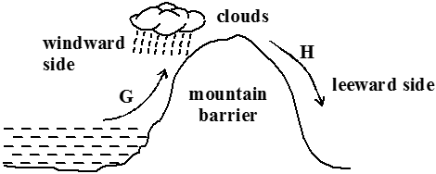

1. Identify the type of rainfall shown in the diagram above (1 mk)

………………………………………………………………………………………………………………………………………………………………

1. State the difference in characteristics of the winds marked G and H

(2 mks)

……………………………………………………………………………..

……………………………………………………………………………..

……………………………………………………………………………..

b) State **three** factors that determine the amount of solar radiation reaching the earth’s

surface (3 mks)

…………………………………………………………………………………………

………………………………………………………………………………………….

………………………………………………………………………………………….

………………………………………………………………………………………….

1. a) Differentiate between weather and climate (2 mks)

…………………………………………………………………………………………..

………………………………………………………………………………………….

………………………………………………………………………………………….

b) Explain how the following factors influence climate

i) Distance from the sea (3 mks)

………………………………………………………………………………………….

…………………………………………………………………………………………..

………………………………………………………………………………………………………………………………………………………………………………………………

ii) Altitude (3 mks)

………………………………………………………………………………………………

………………………………………………………………………………………………………………………………………………………………………………………………

………………………………………………………………………………………………………………………………………………………………………………………………

………………………………………………………………………………………………………………………………………………………………………………………………

1. a) Differentiate between epicenter and seismic focus (2 mks)

…………………………………………………………………………………………...

…………………………………………………………………………………………...

……………………………………………………………………………………………

b) State **any two** major earthquake seismic zones of the world (2 mks)

………………………………………………………………………………………….

………………………………………………………………………………………….

………………………………………………………………………………………….

………………………………………………………………………………………….

1. Give **two** ways in which minerals occur (2 mks)

…………………………………………………………………………………………….

……………………………………………………………………………………………..

……………………………………………………………………………………………..

1. ***SECTION B (Answer all the questions in this section***

The table below shows the area under different species of trees in forest cover in Kenya. Study the table and answer the questions that follow.

|  |  |  |  |  |
| --- | --- | --- | --- | --- |
|  | In ‘000 hactares | | | |
| Tree Year  cover | 2013 | 2014 | 2015 | 2016 |
| Mahogany | 100 | 85 | 60 | 40 |
| Pine | 120 | 100 | 120 | 140 |
| Meru oak | 140 | 120 | 100 | 80 |
| Comphor | 80 | 60 | 40 | 20 |
| Total | 420 | 365 | 320 | 280 |

1. i) Using a scale of 1 cm to represent 20,000 hectares, draw a comparative line graph to represent the data shown (7 mks)

ii) Explain the difference between forestry in Kenya and Canada on

i) Transporting of logs (2 mks)

…………………………………………………………………………………….

……………………………………………………………………………………..

……………………………………………………………………………………..

……………………………………………………………………………………..

ii) Distribution of softwood forests (2 mks)

……………………………………………………………………………………

……………………………………………………………………………………..

…………………………………………………………………………………….

…………………………………………………………………………………….

iii) Harvesting (2 mks)

…………………………………………………………………………………….

……………………………………………………………………………………..

…………………………………………………………………………………….

…………………………………………………………………………………….

1. a) Name **three** types of faults (3 mks)

……………………………………………………………………………………….

……………………………………………………………………………………….

……………………………………………………………………………………….

1. i) With the aid of a well labeled diagram, describe how rift valley is formed by tensional forces (6 mks)

ii) Explain **three** ways in which faulting may influence drainage system (6 mks)

…………………………………………………………………………………………

…………………………………………………………………………………………

………………………………………………………………………………………….

…………………………………………………………………………………………..

…………………………………………………………………………………………..

…………………………………………………………………………………………………………………………………………………………………………………….

1. Explain **three** ways in which faulting is of significance to human activities (6 mks)

…………………………………………………………………………………………..

………………………………………………………………………………………….

…………………………………………………………………………………………

………………………………………………………………………………………….

…………………………………………………………………………………………..

…………………………………………………………………………………………..

1. a) What is a natural vegetation (2 mks)

……………………………………………………………………………………….

………………………………………………………………………………………..

b) Describe any **three** characteristics of equatorial vegetation (3 mks)

…………………………………………………………………………………………..

…………………………………………………………………………………………..

………………………………………………………………………………………….

…………………………………………………………………………………………..

c) Draw a diagram to show the vegetation zones on a mountain in Africa (4 mks)

d) Student from a local secondary school carried out a field study on vegetation around

their school.

1. State **two** follow-up activities after the field study (2 mks)

……………………………………………………………………………….

………………………………………………………………………………..

………………………………………………………………………………..

1. a) State **two** methods of representing relief on Topographical maps (2 mks)

……………………………………………………………………………………….

……………………………………………………………………………………….

b) Convert the following scales into statement scale

i) 1:50,000 (1 mk)

ii) 1:250,000 (1 mk)

c) Study the map of Naivasha below and answer the questions that follow.

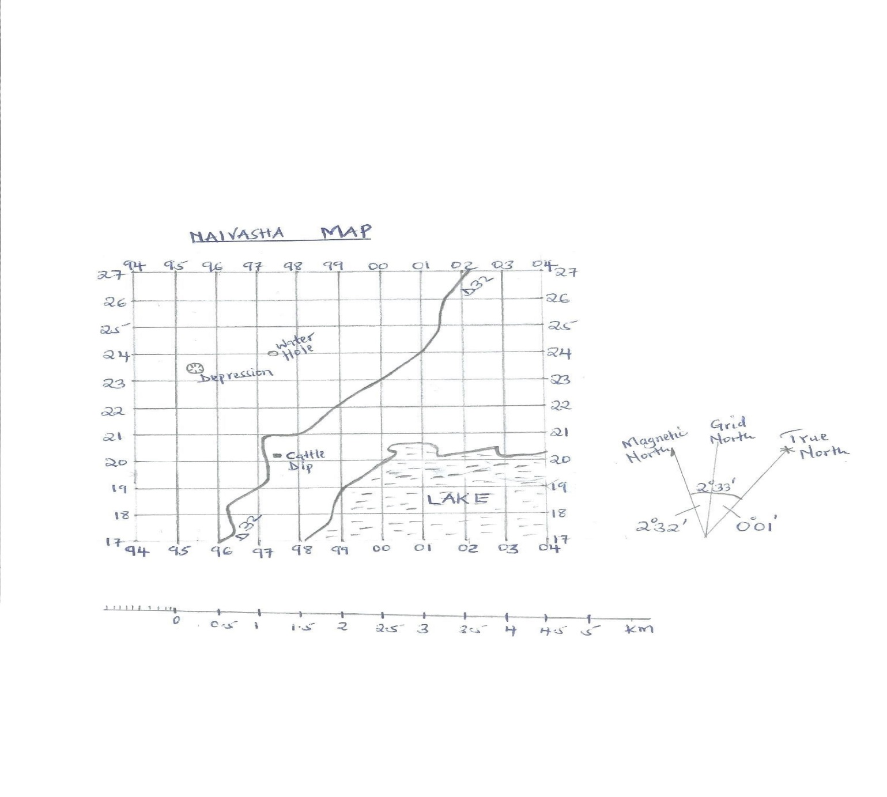

1. Measure the distance of the road D32 and give your answer in kilometres (2 mks)

………………………………………………………………………………….

…………………………………………………………………………………..

1. Give the **six** figure grid reference of the cattle dip (1 mk)

……………………………………………………………………………………

……………………………………………………………………………………

1. Calculate the area of the lake using the Grid Square method (2 mks)

……………………………………………………………………………………

……………………………………………………………………………………

……………………………………………………………………………………

1. Give any two uses of maps (2mks)

…………………………………………………………………………………………………………………………………………………………………………

1. Give the magnetic variation/declination of Naivasha map (1 mk)

…………………………………………………………………………………………………………………………………………………………………………

1. Study the diagram below



1. i) Name the features marked X,Y and Z (3 mks)

X…………………………………………………………………………………………

Y………………………………………………………………………………………….

Z……………………………………………………………………………………………

1. Explain how a sill is formed (4 mks)

…………………………………………………………………………………………….

……………………………………………………………………………………………..

…………………………………………………………………………………………….

…………………………………………………………………………………………………………………………………………………………………………………………….

…………………………………………………………………………………………….

1. Explain **four** ways in which volcanic mountain positively influence human activities

(8 mks)

…………………………………………………………………………………………….

…………………………………………………………………………………………….

……………………………………………………………………………………………..

………………………………………………………………………………………………………………………………………………………………………………………….

……………………………………………………………………………………………..

…………………………………………………………………………………………………………………………………………………………………………………………

……………………………………………………………………………………………..

………………………………………………………………………………………………………………………………………………………………………………………….

……………………………………………………………………………………………..

…………………………………………………………………………………………………………………………………………………………………………………………

……………………………………………………………………………………………..

………………………………………………………………………………………………………………………………………………………………………………………….

1. Students carried out a field study on volcanic rocks
2. State **two** problems they are likely to encounter (2 mks)

…………………………………………………………………………………..

…………………………………………………………………………………..

……………………………………………………………………………………

1. State **two** objectives for the study (2 mks)

……………………………………………………………………………………..

………………………………………………………………………………………………………………………………………………………………………….

……………………………………………………………………………………..