JOINT EVALUATION TERM 3 2023
CHEMISTRY FORM 2
- Distinguish between a dropping funnel and a thistle funnel (2mks)
Dropping funnel has a tap while thistle funnel has no tap/dropping funnel is used to add controlled amounts of liquids into vessels while thistle funnel is used for delivering liquid substances

- What is a fume chamber/cupboard and give its use (2mks) is a special enclosed room in the laboratory where experiments in which poisonous gases are produced are carried out.

- The setup below was used to prepare and collect hydrogen gas

- write an equation for the reaction that produces hydrogen gas (2mks)
Zn _{(s)}+ 2Hcl _{(aq)} ZnCl_{2(s)} +H_{2(g)}

- Why is hydrogen gas collected over water (1mk) because it is insoluble in water/slightly soluble in water
- State what is observed when a few drops of phenolphthalein indicator were added to the solution of wood ash (1mk)
A pink colour is seen.
- Fractional distillation of liquid air is a method used to separate various gaseous mixture in air. State how to (3mks)
i)remove carbon(IV) oxide –by passing through a solution of concentrated sodium hydroxide/potassium hydroxide
ii) remove water-by cooling to -25⁰
iii) obtain nitrogen-fractional distillation of liquefied air

- The following apparatus and chemicals are used to investigate the percentage of air used when iron rusts: iron fillings100ml measuring cylinder, trough and water.
a) Draw a setup of the experiment (2mks)

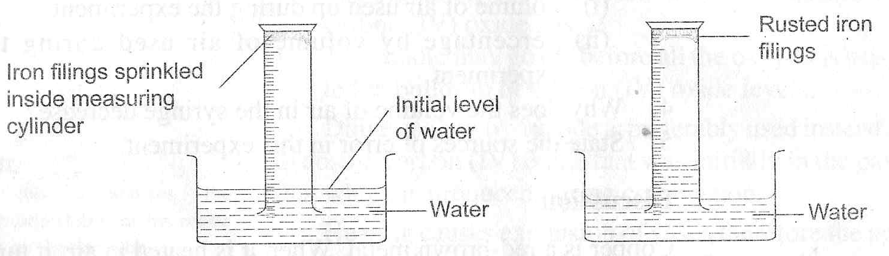

6. What is the method used to obtain sunflower oil from sunflower seeds (1mk)
Solvent extraction
7 why should a non luminous flame be put off or adjusted to a luminous flame after use (2mks)

luminous flame is yellow hence it can easily be seen and minimizes fire accidentss in the lab and also to save on fuel.
8. Draw and show the electron arrangement of phosphorus (atomic number 15) 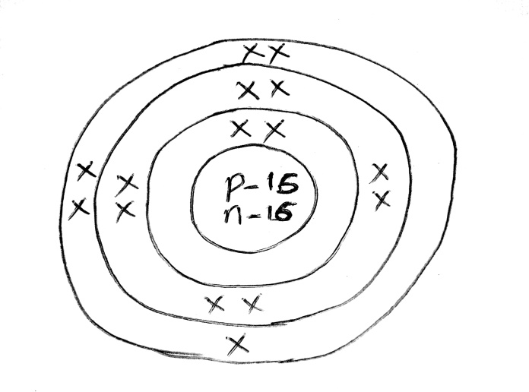 (2mks)

9 Atoms are made up of subatomic particles.name them (3mks)
Protons
Electrons
neutrons
10.In an experiment hydrogen gas was passed over heated copper (II)Oxide as shown.

i) State the observations made in the combustion tube after the experiment (2mks)
The black copper(II)oxide change into a brown solid and colourless liquid collects on the cooler parts off the tube.

ii) Write the equation for the reaction between copper (II)oxide and hydrogen gas (1mk)
CuO_{(s)} +H_{2(g)} Cu_{(s)} + H₂O_{(l)}
iii) Explain why heat is necessary in this experiment. (1mk) To speed up the reaction
11.The curves below represent the variation in temperature with time when pure and impure samples of a solid were heated separately.

i) Which curve shows variation in temperature of a pure solid .Explain (2mks) curve B.It has a sharp melting and boiling point.
ii) State the effect of a an impurity on the melting and boiling points of (2mks)
a pure substance impurities raise the boiling points of liquids and lower the melting points of substances
12. The table below gives the atomic number of elements M,N,P,Q,R,S and T. The letters are not the actual symbols of the elements.

i) Write the electron arrangement of element P 2,8,4 (1mk)
ii) The stable ion of N 2,8 (1mk)
b) Write the formula of the compound formed between N and S NS₃ (2mks)
c) Using dot (.) and cross (x) diagram show how bonding occurs between P and S (2mks)
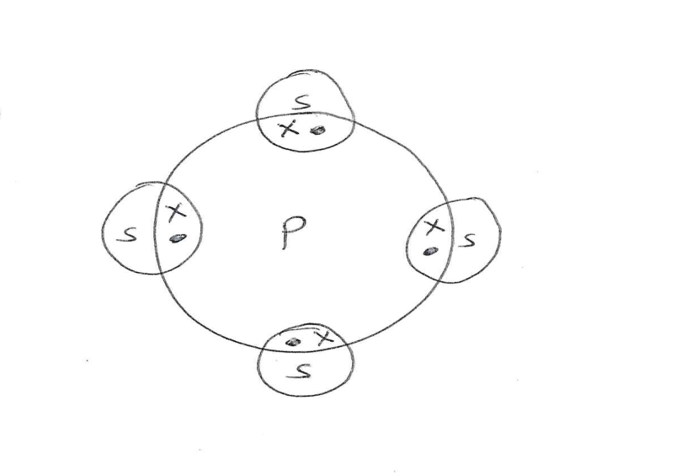
d) Using dot (.) and cross (x) diagram show how bonding occurs in water molecule.H₂ (2mks)
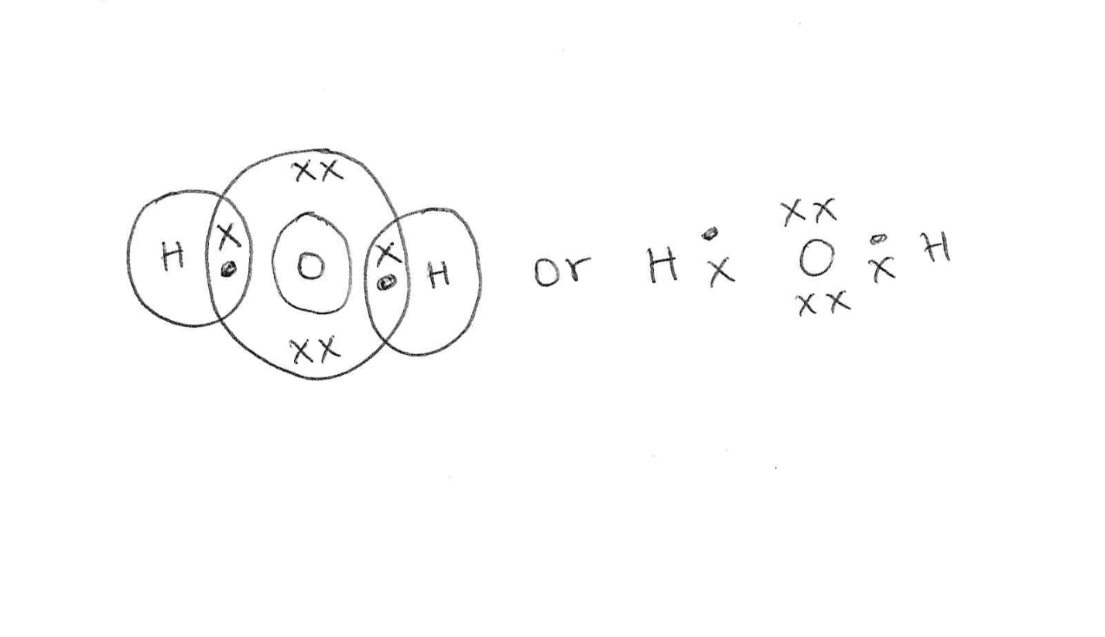
13 .Explain the following observations
- Noble gases are generally unreactive (1mks)
This because they neither gain nor loose electrons
- Atomic radius of alkali metals increase down the group (1mk)
This is because of the increase in number of occupied energy levels
- Aluminium is a better conductor of electricity than sodium (1mk)
Conductivity increase with increase in number of delocalized electrons.

14. An element Q consists of three isotopes with mass number of 22,24 and 25 with percentage abundance of 89.6%,6.4% and 4% respectively. Find the relative atomic mass of element Q. (2mks)
$\left(\frac{22×89.6+6.4×24+4×25}{100}\right)$
Ram= 19.712+1.536+1
=22.248

15. Write the formula of the of the compounds below. (3mks)

NAME | FORMULA OF COMPOUND
Copper(II) oxide  Iron(II)sulphate  Sulphur(IV)oxide | CUO  FeSO₄  SO₂
16 .List any 3 elements that belong to group (VIII) of the periodic table (3mks)
Helium
Neon
argon
17. The following diagrams show the structures of two allotropes of carbon .Study them and answer the questions that follow.

i) Name allotrope (2MKS)
M-diamond
N-graphite
ii) Give one use of N (1mk)
used as an electrode
iii) Which allotrope conducts electricity? Explain (2mks) N-it has delocalized electrons in its structure.
18 .Below is a structure of Aluminium chloride.
i) Identify the bonds labelled A and B (2mks)
A-covalent
B-Dative/Coordinate
ii) Aluminium oxide is said to be an amphoteric oxide ,what is an amphoteric oxide(2 mks)
it is an oxide that reacts with both acids and alkalis
19 study the diagram below and use it to answer the questions that follow.

- Differentiate between electrolyte and non-electrolyte (2mks)
electric current and gets decomposed while non electrolytes are composed of molecules hence do not conduct an electric current when dissolved or melted.
- Identify electrode A and B (2mks)
A-Anode
B-Cathode

- Write the electrode half equation at electrode A (1mk)
2Br –_{(aq)} Br_{2(l)} + 2e⁻
Iv) state any two applications of electrolysis (2mks) extraction of metals like sodium
Purification of metals
Electroplating of metals
Manufacture of pure chemicals
20 Write the chemical equation for the effect of heat on
I) PbCO_{3(S)} heat PbO_{(s)} + CO2_{(g)} (2mks)
II) state two uses of carbon(IV)oxide (2mks)

Used as a refrigerating agent for perishable goods
Used as a fire extinguisher
Manufacture of sodium carbonate in the solvay process.
21. (a). it can lose or gain one electron to become stable (2mks)
(b) alkaline earth metals (1mk)
(c) P+V PV₂ (1mk)
(d). Q has a higher melting point than V because Q has strong metallic bonds while V has weak vanderwaals forces (2mks)
(e)T+O₂ TO₂ (1mk)
(f). it is used in light bulbs to provide an inert environment to prevent oxidation of the filament
It is used as an insulator in arch welding (2mk)
22. it is a process where a salt lose some water of crystallization when exposed to air (2mks)

