Name:……….………………………………………………..Class:………Adm No:……..
JOINT EXAMINATION
PHYSICS
FORM 1
TERM 3 – 2023
TIME: 2HRS

INSTRUCTION.
Answer all questions in the spaces provided.

- a) Mechanics is one of the branches of physics state what it deals with. (1mk)
……………………………………………………………………………………………….
b) Name the branch of physics that deals with:
i) Propagation of energy through space. (2mks)
……………………………….

ii) Behaviour of light as it traverses various media.
…………………………………………………………
c) One basic laboratory rule is proper dressing. Give an example of proper dressing. (1mk)
…………………………………………………………………………………………
- Name two instruments for measuring volume of liquids. (2mks)
………………………………………………
………………………………………….
- Fig 1 shows a measuring cylinder.

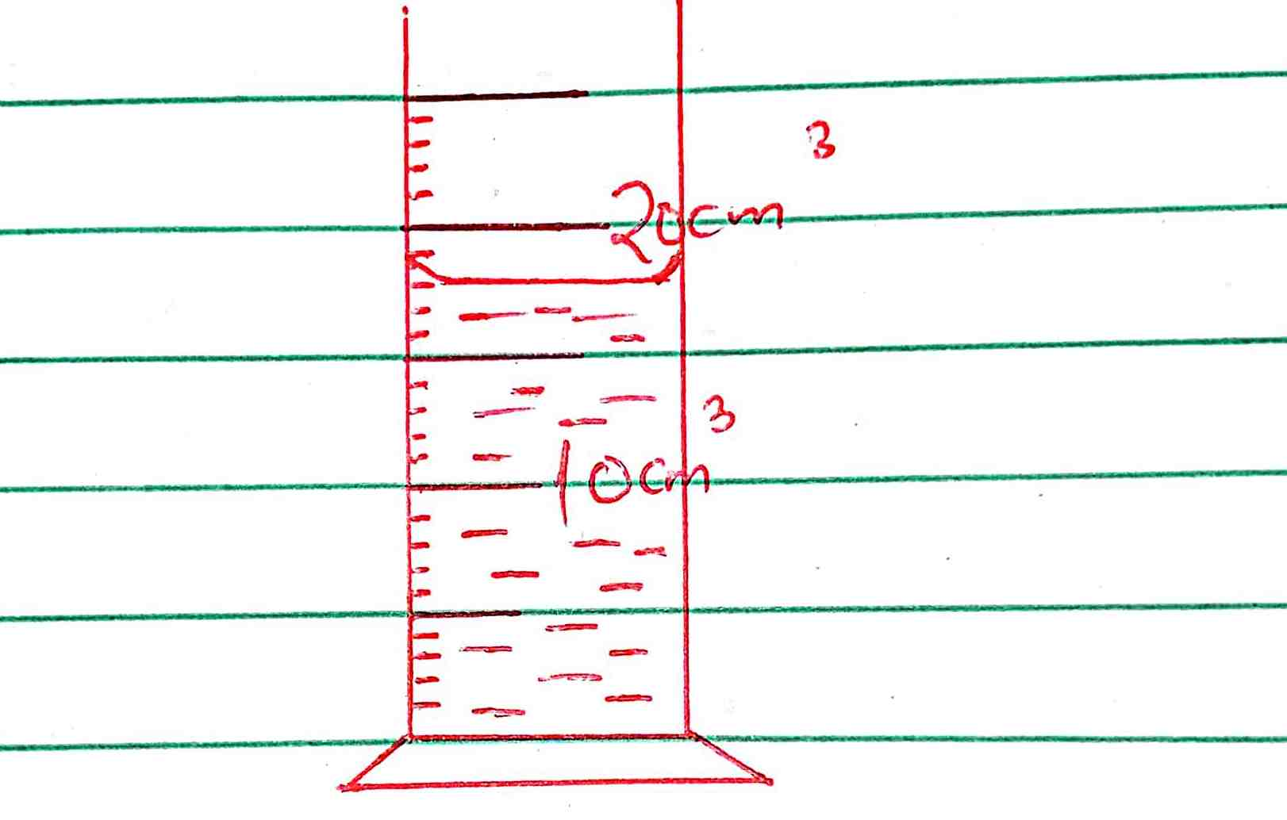

- Record the reading of volume, V₁ of liquid in the measuring cylinder. (1mk)

- Determine the reading on the measuring cylinder after 5 drops of water each of volume 0.6cm³ are added. (2mks)

- Mark the new reading of volume, V₂ on the diagram. (1mk)
- The mass of a density bottle is 20g when empty and 45g when full of water. When full of mercury its mass is 360g.
a) i. Calculate the mass of water that fills the density bottle. (2mks)

ii. Calculate the mass of mercury that fills the density bottle. (1mk)

b) i. Given that the density of water is 1g/cm³, calculate the volume of water that fills the density
bottle. (2mks)

ii. Give the volume of mercury that fills the density bottle. (1mk)

iii. Calculate the density of mercury. (2mks)

- a) Define force and state its SI unit. (2mks)
…………………………………………………………………………………………………………………………………………………………………………………………………………….

b) Differentiate between cohesive and adhesive forces. (2mks)
……………………………………………………………………………………………………………………………………………………………………………………………………………………………………………………………………………………………………………………………………………………………………………………………………………………………….
- List two factors affecting surface tension. (2mks)
…………………………………………………………………………………………………………………………………………………………………………………………………………

- A body weighs 65N. Calculate its mass (g= 10N/Kg) (2mks)

- Define pressure giving its SI unit. (2mks)
……………………………………………………………………………………………………………………………………………………………………………………………………………………………………………………………………………………………………………………
- Fig 2. Below shows a liquid manometer being used to measure gas pressure contained in a small bag.

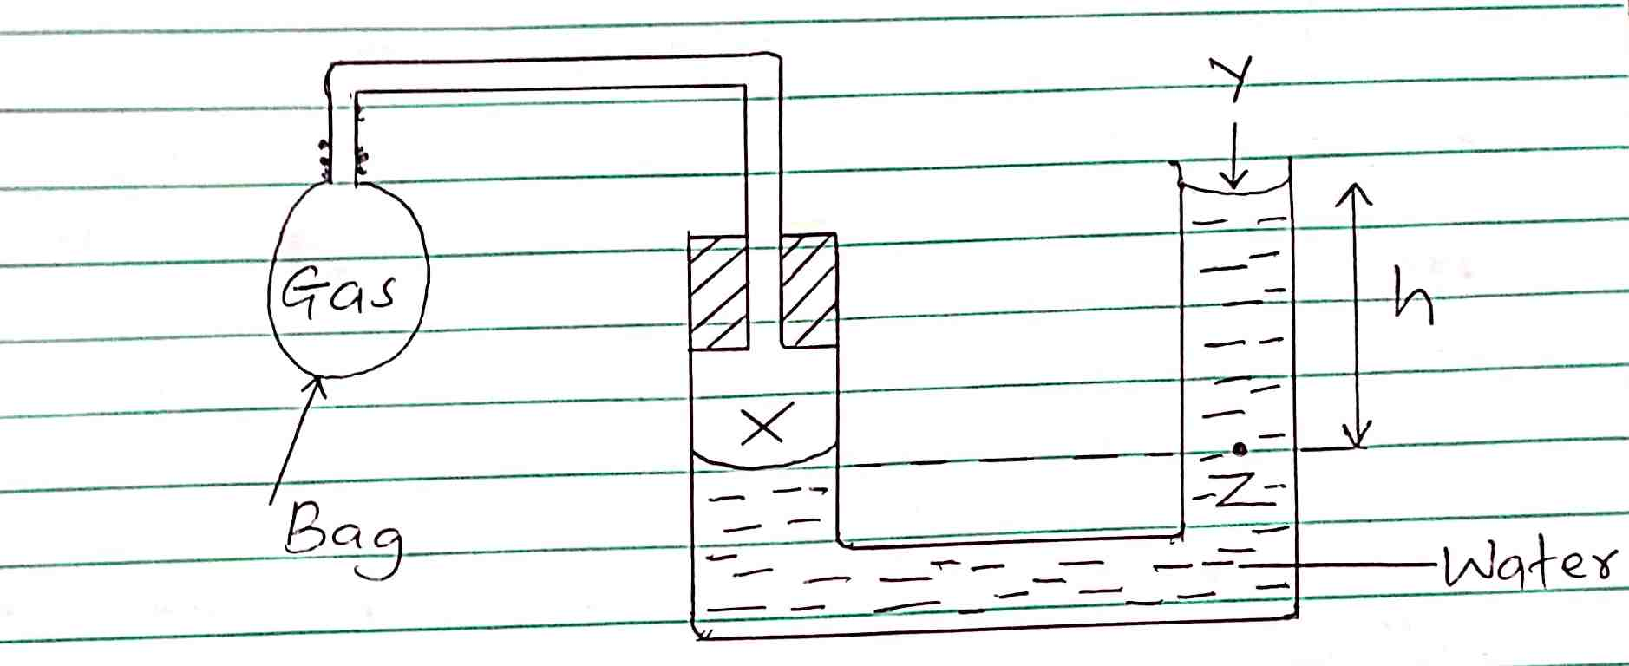

- Name the pressure acting on surface of water at: (2mks)
X …………………………………………

Y ………………………………………….

- State why pressure at X is equal to pressure at Z. (1mk)
………………………………………………………………………………………………………………………………………………………………………………………………………..
- If h=10cm, atmospheric = 103000N/m² and density of water is 1000kg/m³, determine the pressure of the gas in the small bag. (3mks)

- State two properties of the hydraulic brake fluid. (2mks)
…………………………………………………………………………………………………………………………………………………………………………………………………………..

- Figure below shows a lift pump.
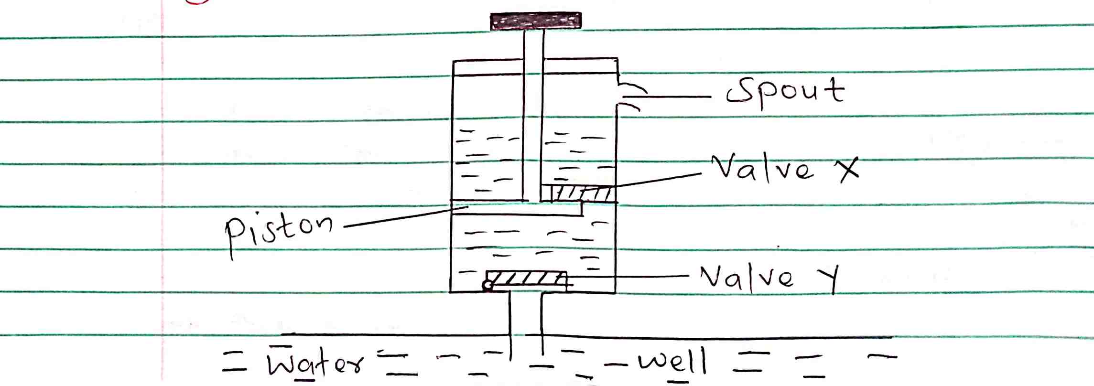
- Name the valve that opens and the one that closes when the piston is pulled upwards. (2mks)
Opens ………………………………

Closes……………………………..

- Explain why valve Y closes when the piston is pushed downwards. (2mks) ………………………………………………………………………………………………………………………………………………………………………………………………………………………………………………………………………………………………………………………….

- a) State the kinetic theory of matter. (1mks)
………………………………………………………………………………………………………………………………………………………………………………………………………………………………………………………………………………………………………………………

The figure below shows a set up used to study motion of smoke particles in air.
State the purpose of:

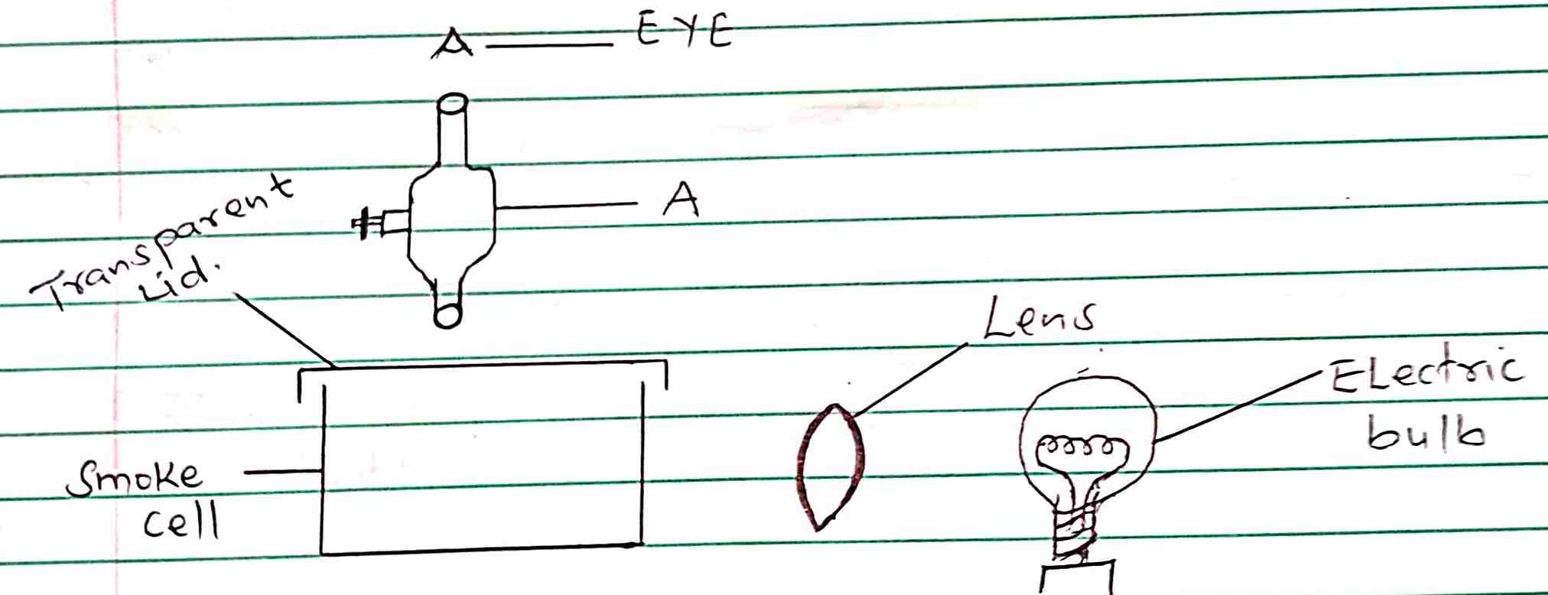

- Apparatus A…………………………………………………………………… (2mks)
……………………………………………………………………………………………

- Lens …………………………………………………………………………..
…………………………………………………………………………………………………….
b) Give two reasons why smoke particles are preferred in this experiment. (2mks)
………………………………………………………………………………………………………
…………………………………………………………………………………………………….
c) State and explain the nature of observed motion of the smoke particles. (2mks)
……………………………………………………………………………………………………………………………………………………………………………………………………………………………………………………………………………………………………………………

- Figure below shows bimetallic strip at room temperature and the same strip at 100ºC.

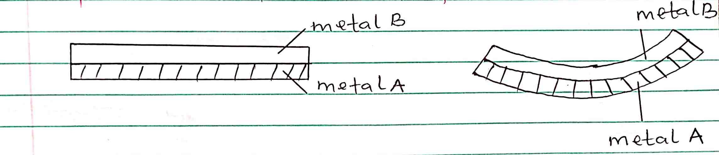

- Compare linear expansivity values of the two metals. (2mks)

……………………………………………………………………………………………………………………………………………………………………………………………..

- State how the two metals are joined together. (1mk)
………………………………………………………………………………………………

- State one application of the bimetallic strip. (1mk)
…………………………………………………………..
- Give a reason for each of the following.
- In building and construction steel metal is used to reinforce concrete. (2mks)
………………………………………………………………………………………………………………………………………………………………………………………………

- Ordinary glass tumbler breaks when hot water is poured in it. (2mks)
……………………………………………………………………………………………
………………………………………………………………………………………………………………………………………………………………………………………………………………………………………………………………………………………………………………………………………………..

- State one advantage of alcohol over mercury when used as a thermometer liquid. (1mk)
………………………………………………………………………………………….

- Convert the following; (3mks)
  - 298K to ºC.

  - -10⁰C to K

  - 0⁰C to K

- State the three modes of heat transfer. (3mks)
…………………………………
……………………………………
…………………………………………

- State three factors that affect rate of heat transfer by conduction of a given metal conductor. (3mks)
………………………………………………………………………………………………
……………………………………………………………………………………………….
……. ………………………………………………………………………………………..

- Explain why metals conduct heat faster than non-metals. (2mks)

…………………………………………………………………………………………………………………………………………………………………………………………………………………………………………………………………………………………………………..

- Give a reason why two thin blankets are warmer than one thick blanket. (1mk)
……………………………………………………………………………………………………………………………………………………………………………………………………………………………….

- Give two differences between mass and weight. (4mks)
…………………………………………………………………………………………………………………………………………………………………………………………………………………………………………………………………………………………………………………….
…………………………………………………………………………………………………….
…………………………………………………………………………………………………….

- Complete the following basic physical quantities table. (3mks)
Basic physical quantity | SI unit | Symbol
Electric current | Ampere | A
Amount of substance |  | mol
Thermodynamic temperature

- The figure below, ammonia gas and an acid gas diffuse and react to form a white deposit on the walls of the glass tube, the deposit forms nearer end B.

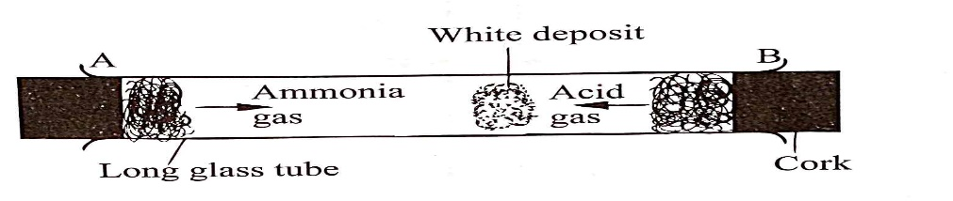
- State which gas diffused faster. (1mk)
……………………………………………………………..

- Explain how the rate of diffusion depends on the density of a gas. (2mks)
……………………………………………………………………………………………………………………………………………………………………………………………………………………………………………………………………………………………………………………
- Explain the effect of performing the experiment above at a higher temperature
(2mks)
………………………………………………………………………………………………………………………………………………………………………………………………………………………………………………………………………..

