FORM 1 MATHEMATICS TERM 3 2023
MARKING SCHEME
- a) BODMAS  Numerator:  = 80+10$÷-5×6$  = 80-2 $×$ 6  =80-12  =68 M1  Denominator  =6$×$ 9-2+12  =54-2+12  =64M2  =$\frac{68}{64}=1\frac{1}{16} or \frac{17}{16}$Ans | 2. Numerator  0.24+0.243  =0.483M1  Denominator  0.08$÷$ 0.4  =0.2M2  =$\frac{0.483}{0.2}$  =2.415Ans
- a)  2 36 54  3 18 27  3 6 9  2 3  2$×$3$×$3=18Ans | b) The other number =$\frac{G.C.D × L.C.M}{Given number}$  = $\frac{6×216}{36}$ M1 =36Ans  ‘or’  $\frac{6×216}{54}$ M1 =24Ans
a) $\frac{3\left(3x+4\right)+6\left(x+1\right)-4\left(2x+8\right)}{12}$M1  - $\frac{9x+12+6x+6-8x-32}{12}$ M2  $\frac{7x-14}{12}$ | b) 2x+8=14M1  2x=14-8  2x=6  X=3Ans
- 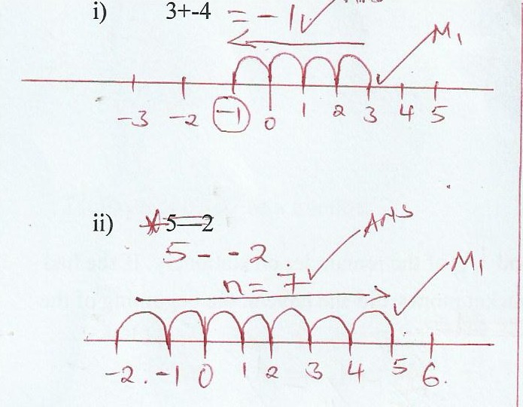
- Length of an arc =$\frac{θ}{360} 2πr$  88 cm=$\frac{144}{360}$ $×2×\frac{22}{7}×r$M1  88$×10=\frac{88}{7}r$  r=$\frac{880×7}{88}$ M2  r =70cm Ans | - Men length days  4 32 12  8 ? 8  Ratio of men; 8: 4= 2: 1M1  Ratio of days 8 : 12=2:3M1  Length of the wall= $\frac{2}{1}×\frac{2}{3}×32$  =$\frac{128}{3}=42.67$Ans
- 80% =960  100  $\frac{100×960}{80}=1200$M1  $1500-1200=300$M2  $\frac{300}{1200}×100=25\%$Ans | - Bread =$\frac{2}{5}$  $\frac{5}{5}-\frac{2}{5}=\frac{3}{5}$M1  Stationery =$\frac{1}{6}of \frac{3}{5}=\frac{1}{10}$M2  $$\frac{2}{5}+\frac{1}{10}=\frac{1}{2}$$  $\frac{1}{2}$=200  $\frac{2×200}{1}$=400Ans
- 1 US dollar=90.45  7500  $\frac{7500×90.45}{1}$=678,375M1  678,375-638,676=39,699 M2  1 sterling pound=132.33  =39699  $\frac{39699}{132.33}$=300 sterling poundAns | - a: b =a:b:c  5(2:3)=10:15M1  b:c  3(5:9)=15:27  a:c=10:27Ans
- Let r=0.4074………(i)  10r=4.0740……….(ii)  100 r =40.7407……(iii) M1  1000r=407.4074……(iv)  1000r=407.4074  -  r=0.4074 M2  99r=407  R=$\frac{407}{999}=\frac{11}{27}$Ans | - Time used=45$×$ 2=90mins  Break=15mins  Extra=15 mins  Penalties=15mins  90+15+15+15=135minsM1  1hr=60min  135  $\frac{135×1}{60}$=2.15minM1  + $11:50$  2:15  14.05 or 2.05pmAns
- Bh=36${cm}^{2}$  4b=36M1  B=9cm M2  P=6+9+6+9=30cm Ans | - Now future  Man=3x 3x+5  Son=x x+5  3x+5+x+5=74M1  4x+10=74  4x=64M2  X=16yrs  Son= 16yrs  Man=48yrs Ans
- ${\left(7.21×{10}^{-1}\right)}^{2}+\sqrt{16.24×{10}^{2}}$  $51.$98$×{10}^{-2}$+4.0298$×{10}^{1}$M1  $=0.5198+40.298$M2  $=40.8178$Ans | - a) 20% of the profit =running the business  $\frac{20}{100}×$ 43200M1  $=Kshs 8,640$Ans
17.b) 15% of profit=shared equally  $\frac{15}{100}×43200=6,480$M1  Mue $\frac{6480}{2}$ =3240M2  43200-8640-6480=28080M3  28,080=shared as per the ratio of contribution  Ratio= Korir : Mue  40,0000 : 64,000  5 : 8  Mue $\frac{8}{13}×$28,080=17,280M4  3240+17280=20,520Ans | 17.c)Kori received  $\frac{5}{13}×$28,080  =10,800  10800+3240=14040M1  1cow=1800  14040  $\frac{1×14040}{1800}$M2  =7.8  7 cowsAns
- a) volume=L$×W×H$  =36$×25×9$  =8100$m^{3}$M1  $\frac{1}{2}×\frac{22}{7}×7×7×36={2772m}^{3}$M2  $volume of concerete=8100-2772$M3  =${5328m}^{3}$Ans | 18.b) Density=$\frac{mass}{volume}$  Mass=density$×$ volume  =1500$×$5328  =7,992,000kgM1  Ratio 1:4:4  Mass of cement=$\frac{1}{9}×$ 7,992,000  =888,000kgA1  Mass of sand=$\frac{4}{9}×$ 7,992,000  =3,552,000kgA2  Mass of ballast= $\frac{4}{9}×$7992000  =3,552,000kgA3
18c) 10,000=${111m}^{3}$  =${5328m}^{3}$  $\frac{10,000×5328}{111}$M1  =Ksh 480,000Ans | 19.a) 1930h  -1230M1  700  =7hrsAns
19b) arrival=1455h  Departure=1830  1830  - 1455  3.35M1  =3hrs 35minsAns | 19d) station y 1445  - 1350  00.55M1  =55mins  Station n 1830  -1455  3 hr 35min  Station yAns
- e) average speed=$\frac{Distance}{Time}$  =$\frac{420}{7}$M1  =60km/hAns | 20.a) let b be bull  Let g be goat  5b+30g=117000  4b+25g=94,750M1  4(5b+30g=117,000  5(4b+25g=94750)  =20b+120g=468,000M2  20b+125g=473750 -  - - 5g=-5750  g=1150A1  5b=82500  b=16,500A2
- b) abdul :  40% profit per bull  30% profit per goat  $\frac{40}{100}×$16500  $=6600$  16500+6600=23,100M1  $\frac{30}{100}×1150=345$  $1150+345=1495 per goat$M2  Abdul had 5 bulls and 30 goats  (5$×$231000+(1495$×$ 30)  =115,500+44850  =160,350M3  Ali  50% profit per bull  40% profit per goat  $\frac{50}{100}×16500$=8250  $16500+8250=24,750$  $\frac{40}{100}×1150=460$  $460+1150=1610$M4  Ali had 4 bulls and 30 goats  (4$×$ 24750)+(25$×$1610)  99000+40250  =139,250  Abdul =160,350-117000  =43350  Ali=139-94750=44500M5  Hs AliAns | - a)(i) $\frac{1}{2}×\frac{22}{7}×140=220m$M1  220+200+220+200=840mAns  (ii) 200$×140=28000m^{2}$  $\frac{22}{7}×70×70=15400m^{2}$M1  28000-15400  =12600$m^{2}$  1ha=10,000$m^{2}$  12600$m^{2}$M2  $\frac{12600×1}{10000}$  =1.26haAns  b(i) 1ha =5,000,000  1.26ha  1.26$×$5000000M1  =6,300,000 shillingsAns  B(ii) 14,760,000-6,300,000  =8,460,000M1  $\frac{8,460,000}{6,300,000}×100$M2  134.28  =134.3%Ans

