MARKING SCHEME FORM ONE GEOGRAPHY Term 3 2023
- a) i) P – Stratosphere
ii)Characteristics of zone P
- falls above troposphere
- contains very little water vapour/dust
- has a negative lapse rate
- contains the ozone gas
- pressure decreases with increase in altitude

b)Processes by which solar radiation is lost in the atmosphere
- Reflection mainly by clouds
- Absorption mainly by gases and water vapour
- Scattering mainly by aerosols

- a) Solar system is made up of the sun with the planets orbiting around it, and other heavenly bodies
b)Rotation is the movement of the earth on its own axis once in 24 hours in an anticlockwise direction, while revolution is the movement of the earth round the sun on its own orbit in 365$\frac{1}{4}$ days 366

- a) Involves all the external conditions surrounding a living organism and influences it behaviour.
b)One will be able to learn and explain the origin of the earth, solar system and internal structure of the earth.
- Helps learners to develop the skills of observation, reading, analyzing and interpreting maps, photographs etc
- Creates awareness in the significance of management and conservation
- It is a career subject e.g teaching, surveying and photogrammentry
-One acquires basic skills and knowledge which contribute to local, regional and national development

- a) Physical geography
Human geography
b)Nebula cloud theory
Passing star theory
c)Produces its own light
- largest member of the solary system
-Radiates solar energy to the earth
-Rotates on its axis in an anti-clockwise direction

- Circum-navigation
Satellite photographs
Ship’s visibility
Shape of other planets
Eclipse of the moon
Earth’s curved horizon
Sunset and sunrise
- a) Bar graph
- title - 2 mks
- archs – 2 mks
- highest bar – 1 mk
- lowest bar – 1 mk
- correct use of scale – 1 mk
- labelling the axis – 1 mk
b) Annual temp range for the station
29.9⁰C – 16.8⁰C = 13.1⁰C (2 mks)

c) Formation of relief rainfall
- Moist air is forced to rise over a hill/mountain
- The temperature and air pressure decreases making it to expand
- Air cools due to decreased temperature and decreased pressure causing it to expand
- Moisture condenses forming tiny water droplets
- The tiny water droplets in clouds merge and become too heavy to be suspended in air and fall as rain
- Air proceeds to the leeward side with low moisture content
- Since its heavier due to being cool it descends over that side and gets warmed making it to hold onto the little moisture it had causing that side to receive low rainfall

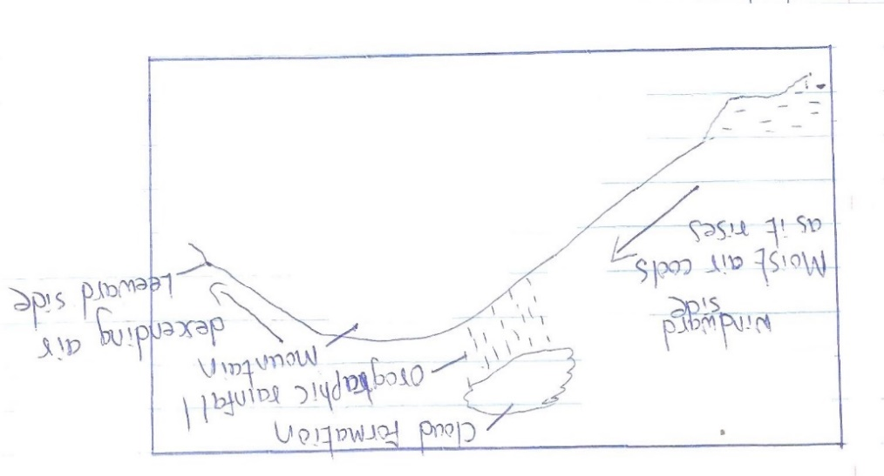

d) Radiation Hill steam (4 mks)
-Advection Frontal
-Frontal
-Hill
-Steam
- Radiation
e) i)Preparations
- Stating objectives and formulating hypothesis
- Selecting suitable method and data collection and recording
- Making a reconnaissance/pre-visit
- Draw a route map
- Conducting literature review
- Organizing the class into groups
- Holding class discussion
- Gathering the necessary materials
- Seeking permission from relevant authorities
iii)Rainy/hot/cold
- Un co-operative respondents
- Attack by insects
- One may fall sick

- a) Minerals are naturally occurring organic or inorganic substance with definite chemical composition and physical properties on or below the earth surface.
Rocks are combination of mineral particles cemented together to make the solid part of earth’s crust
b)Colour – different minerals show different specific colours
Cleavage – minerals break into patterns/shapes
Hardness – minerals have different degrees of hardness
Hardest – industrial diamonds
Softest – Talc

c)Classifications of rocks – igneous rocks
-Sedimentary rocks
-Metamorphic rocks

d)Examples of plutonic rocks
- granite
- peridodite
- diorite
- gabbro
e)i)Geological hammer
- Hitting to break rocks into portable pieces
- Hitting to determine its hardness
Polythene bags
- For carrying/storing rock samples to school for further analysis
Route map – As a guide to locate various types of rocks
b) Data recording methods
- Taking photographs
- Taking notes
- Drawing sketches
- Tape recording

c)How rocks contribute to the economy of Kenya
- Rocks weather to form soil for agriculture
- Rocks weather to form features that creates scenery that attract tourism(foreign exchange)
- Some rocks are source of gemstones for ornamental value
- Some rocks are used to make fertilizers important for agriculture
- a) Types of maps – Atlas maps
-Sketch maps
- Topographical maps

b) Marginal information
- Name of the map
- Sheet title
- Grid system numbers
- Map series, sheet number, index and edition
- Latitudes and longitudes
c)Convert 1:50,000
1 cm rep 50,000 cm
50,000 cm = 0.50,000
100,000
- cm rep 0.5 km

d)Uses of scales
- Measure distances on maps
- Calculate areas on maps
- Helps in estimating areas
- Helps in reduction and enlargement of map areas

e)i)The value of minerals
- The size of the mineral deposit
- The quality of ore
- The mining method
- Technology
- Capital
- Market
- Transport

ii) Problems facing exploitation of soda-ash in Kenya
- Stiff competition from developed countries
- The low value of salt
- High labour cost
iii) Economic contributions of gold and diamonds to the economy of South Africa
- Earns the country foreign exchange
- Offers employments
- Led to urbanization
- Formed a broad-based market for other industrial operations
- Led to development of modern infrastructure and amenities

