BIOLOGY FORM ONE TERM 3 YEAR 2023

NAME………………………………………………ADM.NO………………CLASS………..

INSTRUCTIONS
- Write your name and admission number in the spaces provided.
- Answer all questions in the space provided
- This paper consists of all printed pages and ensure no blank pages.

- Differentiate between Botany and Zoology (2 mks)
- Botany – study of plants
- Zoology – study of animals
(mark as whole)
- Motor vehicle move, use energy and produce carbon iv oxide and water similar characteristics occur in living organisms yet motor vehicles are not classified as living organism. Explain (3 mks)
- Growth and development
- Reproduction
- Irritability

- List skills that are gained on studying Biology (3 mks)
- Observing
- Identifying
- Recording
- Measuring
- Classifying, analyzing and evaluating data
- Give three difference between the light and electron microscopes
Light microscope Electron microscope (3 mks)

- Has low magnification power - Has very high magnification power
- Has low resolving power - Has very high resolving power
- Uses glass lenses for magnification - Uses electromagnetic lenses for
magnification
- Uses light to illuminate the specimen – Uses a beam of electrons to illuminate
specimen
- Specimens are stained using normal dyes – Specimens are stained using complex
-Stains (dyes containing heavy metals)

C
B

A

- The diagram above was obtained from a certain organism.
- Identify the structure (1 mk)
- Animal cell
- Which type of microscope was used to view the structure (1 mk)
- Light microscope
Name the parts labelled (2 mks)
B Nucleus

C Cytoplasm

- State the function of the part labelled A (2 mks)
- Encloses the cell content
- Regulate the movement of materials in and out of the cell
- State the functions of the following parts of a light microscope
- Diaphragm - Regulates the amount of light passing through the condenser (1 mk)
- Objective lens –Magnifies the image of the specimen (1 mk)

- Explain the importance of doing the following when testing a leaf for starch (4 mks)
- Boiling the leaf – in water
- To kill the leaf cells so as to stop cellular functions
- To break the starch granules so as to release starch
- Boiling the leaf in methlylated spirit - To decolourise the leaf
- Boiling the methylated spirit in water bath- Methylated spirit is highly flammable and this is a precautionary measure.
- Placing a potted plant in the sun for 5 hours- To photosynthesis leading to formation of starch
- Describe what happens during the light stage of photosynthesis (3 mks)
- During this process the light absorbed by chlorophyl molecule is used to split water(photolysis) molecules into oxygen and hydrogen atoms
- The hydrogen atoms produced by the splitting of water enter the dark stage
- O₂ is released to the atmosphere some is used by the plant for respiration
- Formation of energy rich Adenosine is Triphosphate
- Accept a well balanced equation (2H₂0 Sunlight 4H + 0₂ + ATP
Chlorophyl

- Explain two factors that affect enzymatic activities (2 mks)
- Temperature
- Substrate concentration and enzyme concentrated
- Enzyme co-factors and co-enzymes
- Enzyme inhibitors
- State a function of the large intestine in humans (1 mk)
- Reabsorption of water
- State the role of
- Vitamin C in human (1 mk)
- Protection against infection
- It is an antioxidant
- Aids in detoxification
- Iron in humans (1 mk)
- Involved in formation of haemoglobin in R.B.C
- State two roles of HCL in the stomach (2 mks)
- Provide an acidic medium suitable for action of pepsi/renirr
- Activates the inactive forms of enzymes
- Kills bacteria that may be present in food
- a) Complete the table given below (3 mks)
Eye –piece lens magnification | Objective lens magnification | Total magnification
X 5  X 10  X10 | X4  X5  X10 | X20  X50  X100
- State four activities of the cell that are controlled by nucleus (4 mks)
- - Cell division
- - Protein synthesis
- - Cell respiration
- - Cell secretion
- - Excretion
- - Cell growth
b) Identify the specialized cell illustrated in the diagram below. (1 mk)

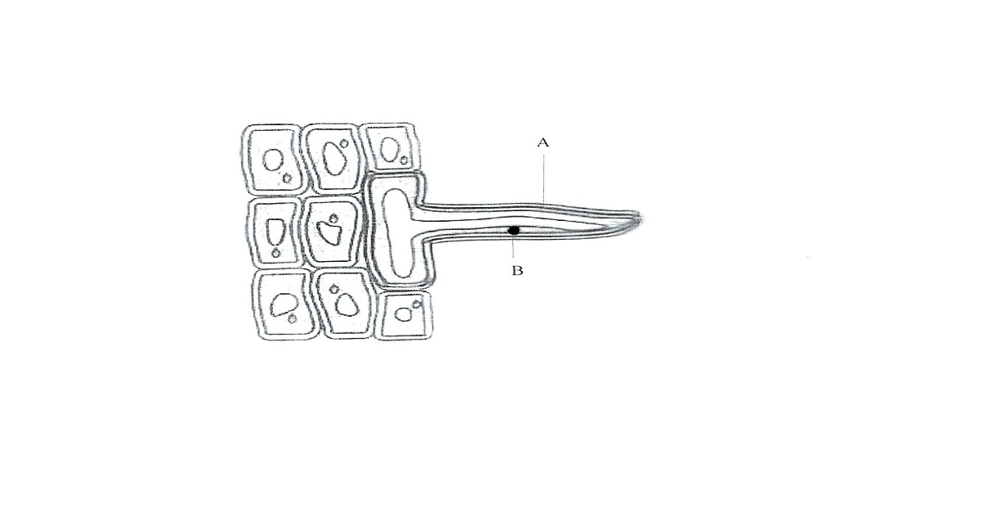

Root hair cell
- Name the parts labelled (2 mks)
A-Root hair

B- Nucleus

- Name two other specialized cells and in each case explain how they are modified to perform their functions efficiently (4 mks)
- Red blood cell – Biconcaved shape and lack nucleus to maximize surface area
for oxygen absorption
Contains haemoglobin, that transport oxygen
Flexible and elastic to squeeze through capillaries
- Sperm cell – Head contains lytic enzymes to help penetrate the ovum’s membrane
Long tail enables swimming
- What is Binomial nomenclature (1 mk)
- Double naming of organisms where the organism is given generic and specific name
- Name the organelles that would be found in large numbers in cells of a:
- Rapidly respiring tissue (1 mk)
- Mitochondria
- Secretory gland (1 mk)
- Golgi bodies
- State the function of each of the following tissues
- Meristematic (1 mk)
- Cell division and growth
- Blood (1 mk)
- Transport respiratory gases
- White blood cell protect the body against infection of pathogenic organisms
- Plasma regulates blood PH
- Differentiate between plasmolysis and crenation (2 mks)
- Plasmolysis is the process by which plants cells lose water and become flaccid when it is placed in hypertonic solution
- Crenation is the shrinking of an animal cell when placed in hypertonic solution
- The scientific name of an onion is Allium cepa Identify the genus and the species to which the organism belongs (2 mks)
- Genus-Allium

Species-Cepa

- Outline three functions of carbohydrate in living organism (3 mks)
- Source of energy
- Storage forms of food
- Components of structures that provide mechanical support in organs
- What are the building blocks of proteins (1 mk)
-Amino acids
- Give two factors that determine energy requirement in human beings (2 mks)
- Basal metabolic rate (B.M.R) – sex
- Everyday activity/occupation – lactation and pregnancy
- Age
- Body size
- Name the monosaccharides that make up the following substances
- Sucrose- Glucose +Fructose (1 mk)

- Lactose – Glucose + Glucose (1 mk)

- The table below shows the number of teeth in the jaws of an animal
 | Canines | Incisors | Premola | Molars
Upper jaw | 0 | 0 | 6 | 4
Lower jaw | 8 | 0 | 6 | 6

- Write the dental formula of the organism (1 mk)
2(i 0 C 0 pm3 M2) = 30
4 0 3 3
- i) State the mode of feeding of this animal (1 mk)
- Herbivorous
- Give two reasons for your answer (2 mks)
- Have diastema gap
- Have a horny pad
- Name two dental diseases (2 mks)
- Periodental diseases
- Dental carriers

- The diagrams below represents common equipment used by Biologists
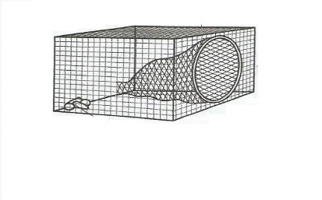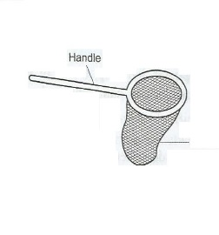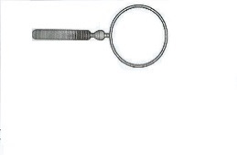
Q
P
O

- Identify the equipment
O-Bait trap (1 mk)

P- Sweep net (1 mk)

Q – Hand lens (1 mk)

- a) Give the uses of the following apparatus (2 mks)
- Specimen bottle
- Keeping collected specimen
- Pooter
- Sucking small animals from rock surface/bark of trees
b) State two necessary precautions to be observed when collecting specimens (3 mks)
- Collect only the number of specimens needed to avoid waste
- Do not harm specimens during collection exercises
- Do not destroy the natural habitat of the specimens
- Name the carbohydrate that is
- Stored in plant seeds (1 mk)
- Starch
- Stored in mammalian muscles (1 mk)
- Glycogen
- Most abundant in human blood (1 mk)
- Glucose

- A group of students set up the experiment below to investigate a certain physiological process

Set up A

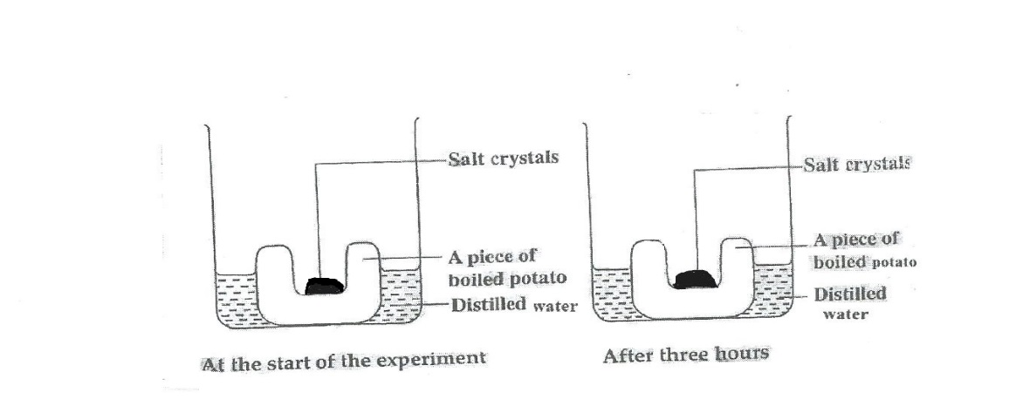

Set up B
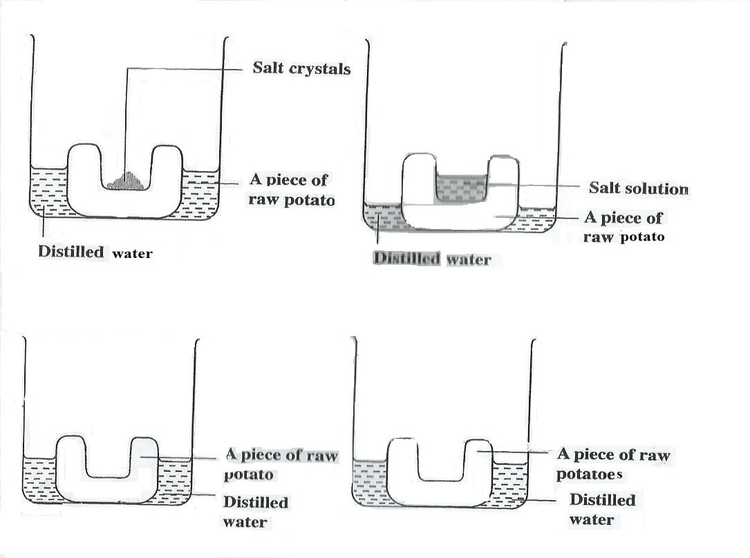
At the start of the experiment After three hours
Set up C

At the start of the experiment After three hours
Set up C
At the start of the experiment After three hours

- Name the physiological process being investigated (1 mk)
- Osmosis
- Account for the results in set-up A and B
- There is no change on salt crystals because osmosis did not take place. Boiling kills the cells destroying the cell membrane
- Water moves from cells of the potato into the cavity containing salt crystals by osmosis, the cells become hypertonic and drew water from petri dish by osmosis
- What was the purpose of set-up C? (1 mk)
- To act as a control experiment
- Name two structures found in plant cells that are absent in an animal cell (2 mks)
- Cell wall
- Chloroplast
- Large sap vacuole
- Tonoplast
- Define active transport
- It is the movement of molecules across cell membrane against concentration gradient
- What is the significance of active transport in living organisms
- Absorption of the products of digestion from the ileum into the bloodstream
- Excretion of waste products from body cell into the surrounding medium
- Absorption of mineral salt from the soil by the root hair cells
- Selective reabsorption of certain substances in the kidney such as glucose and salt

