END OF TERM TWO – 2024

451/2 COMPUTER STUDIES
Paper 2 (PRACTICAL)
2 ½ hours
JULY/AUGUST 2024
FORM THREE

NAME_____________________________________ADM NO_____________CLASS_____
INSTRUCTIONS TO CANDIDATES
- Indicate your name and index number at the right hand corner of each printout
- Write your name and index number on the CD/removable storage medium provided
- Write the name and version of the software used for each question attempted in the answer sheet provided
- Answer all the questions
- All questions carry equal marks
- Passwords should not be used while saving in the CD/removable storage Medium
- Marked printout of the answers on the sheet
- Arrange your printouts and staple them together
- Hand in all the printouts and the CD/removable storage medium used
- All the work should be saved at the desktop of your computer in a folder named with our name and index number. All the work in your folder should be burned to the CD/WR provided

1. The Management of a company owning a chain of hotels intend to use a spreadsheet program to compute the revenues in thousands of Kenya Shillings for the hotels during the 1st, 2nd, 3rd and 4th quarters. The hotels are rated as 2 star, 3star, 4 star and 5 star. Figure 1 below shows an extract of the worksheet.

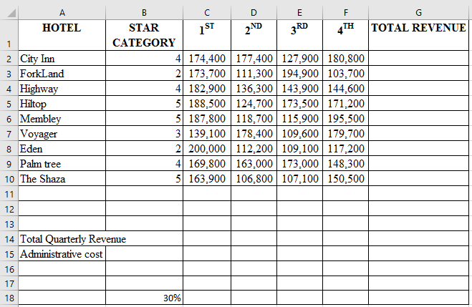

Figure 1

- Open a spreadsheet program and create the worksheet extract as it appears in Figure 1. Save the workbook as Task 1
(11 marks)
- Use a function and cell addresses to calculate:
- Total revenue for each quarter; (2 marks)
- Total revenue for each hotel. (2 marks)
- (i) Insert two rows above row 1 and type the title "MBALAMBALA GROUP
HOTELS" in cell Al (2 marks)
(ii) Merge the cells in the range Al: G1. (l mark)
(iii) Apply bold and font size 15 to the title. (1 mark)
- Using cell addresses only, compute the administrative cost for each quarter given that the cost is a percentage of total revenue and the percentage rate is in cell B18. (3 marks)
- Apply thick outside borders and regular inside borders to cells in the range A3:G18
(2marks)
- (i)Copy all the contents of the current worksheet to a new worksheet. (2marks)
(ii)Rename the old worksheet as original and the new worksheet as formatted
(2 marks)

- (i) Change the page layout orientation of the formatted worksheet to landscape and the page size scaled to 80%. (2 marks)
(ii) Enter the values 2, 3, 4 and 5 in the cell range B20: B23 respectively representing the hotel star category ratings. (1 mark)
(iii) Using a function and cell references:
I compute the total revenue for each hotel references;
II compute the total revenue for each hotel category in the 1st quarter using reference values in the range B20: B23 in cells C20: C23. (5 marks)
(iv) Sort the revenues from the hotels in descending order of hotels. (2 marks)
- (i) Create a column chart that compares the revenues of the hotels in star category 4 for the 1st and 2nd quarter. (4 marks)
(ii) Format the chart created as follows:
- Chart title "FIRST AND SECOND QUARTER REVENUES" (2 marks)
- Move the chart to a new sheet and rename the sheet as FourStar Revenues.
(2marks)

(i) Save the changes and print later each of the following:
(i) original worksheet showing the column and row headings; | (2 marks)
(ii) formatted worksheet; | (l mark)
(iii) FourStar Revenues chart. (2marks)

2. Popo City planners intend to use a Desktop Publishing program to draw a plan for a section of a city. Assume you have been given the task.
(a) (i) Open a desktop publishing program and set the page layout orientation to portrait and
and paper size to A4. (2 marks)
(ii) Save the publication as Task 2 (l mark)
- Create the city plan as it appears in Figure 2 ensuring that the design covers the entire
printable area of the page. | (46 marks)
(c) Save the changes and print the publication later. | (l mark)
142
POPO CITY PLAN
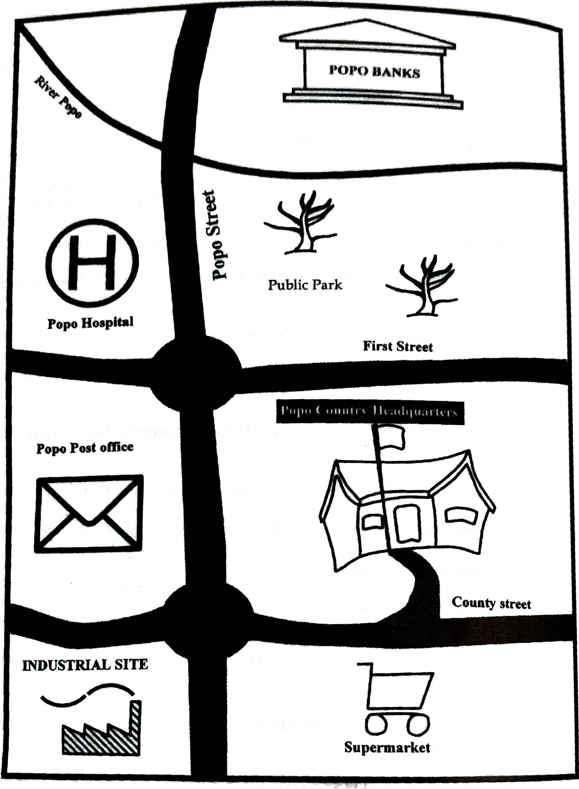
Figure 2

