JUNIOR SCHOOL

2024 Answers

COMPUTER STUDIES

Clearly define a computer

- A computer is an electronic device that operates (works) under the control of programs stored in its own memory unit

- An electronic device that accepts data, as input and transforms it under the influence of a set of special instructions called programs, to produce the desired output (referred to as information)

Give one reason why a computer is referred to as an electronic device

- It uses electrical signals to process data

- It is made up of electronic components and uses electric energy to operate

Explain the following terms as used in computer science

(i) Data

A collection of raw facts, figures or instructions that do not have much meaning to the user

(ii) Program

A computer program is a set of related instructions which specify how data is to be processed

A set of instructions used to guide a computer through a process

(iii) Data processing

It is the process of collecting all terms of data together & converting them into information

(iv) Information

Data which has been refined summarized & manipulated in the way you want it, or into a more meaningful form for decision- making

Identify the following computer components
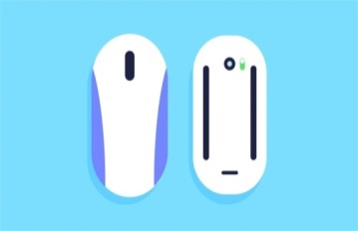
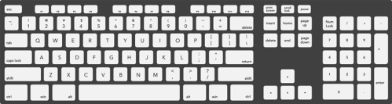

Mouse
Keyboard
Monitor

Identify the following components contained in a computer case

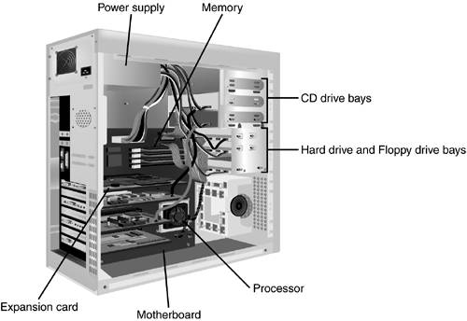

`

What are the functions of the motherboard

The motherboard acts as the central backbone of a computer on which other modular parts are installed such as the CPU, RAM and hard disks.

The motherboard also acts as the platform on which various expansion slots are available to install other devices / interfaces.

The motherboard is also responsible to distribute power to the various components of the computer.

They are also used in the coordination of the various devices in the computer and maintain an interface among them.

Name three buses of computer system

Address bus

Data bus

Control bus

3. State any three functions of a computer

Accepting data

Processing the data

Producing information

4. Explain the following input/ output terms as used in computer systems. Give an example for each

(a) Read - To transfer data from an input device to the computer, e.g. the computer reads data from a disk, a keyboard, etc

- To move or copy data from backing storage to the main Storage

(b) Write - To transfer information from the computer to an output Device e.g. the computer writes output on a printer or onto a disk.

- To move or copy data from the main storage to a backing storage

5. State four different parts that make up a computer (2 mks)

System unit

Monitor

Keyboard

Mouse

Printer

Modem

Scanner

Speakers

Graph plotters

6. (a) Explain the term system Unit

This is the casing that houses the internal components of the computer such as the CPU and storage devices

(b) List four devices located under the cover of the system unit

Central processing Unit (CPU)

Motherboard

Power supply unit

Main memory

Hard disk

Disk drives

Battery

Buses

Input/ output ports

Video card

Expansion slots

(c) Give two differences between tower – style and desktop system units

Tower style system unit is designed to stand alone or to be placed on the floor, desktop units lie on the desk with the monitor placed on top

Tower style units have more space for expansion than the typical desktop units

7. Computers have evolved through a number of generations. List any 4 characteristics of the first generation of computers.

Large in physical size

Relied on thermionic valves (vacuum tubes) to process and store data

Consumed a lot of power

Produced a lot of heat

The computers constantly broke down due to the excessive heat generated; hence were short- lived, and were not very reliable

Their internal memory capacity/ size was low

Processing speed was very slow

Very costly

Used magnetic drum memory

8. Briefly explain the classification of computer according to historical development (generations)

First generation computers

Used vacuum tubes in their memory

Large in physical size

consumed a lot of power

Produced a lot of heat

The computers constantly broke down due to the excessive heat generated; hence were short- lived and were not very reliable

Their internal memory capacity/ size was low

Slow in processing data

Very costly

Used magnetic drum memories

Cards were sued to enter data into the computers

Second generation computers

Used transistors in their memory

They consumed less power & produced less heat than the first generation computers

They were relatively faster than the 1st generation computers

Used magnetic core memories

Were less costly than first generation computers

RAM memory capacity was 32 KB

Third Generation computers

Used integrated circuits in their memory

They were faster than second generation computers

RAM memory capacity was 2 GB

Slightly smaller in size than 1st & 2nd generation computers

They used a wide range of peripheral devices

Could support remote communication facilities/ more than one user at the same time

Magnetic disks were introduced for storage purposes

Fourth generation computers

Used large scale integrated (LSI) circuits & very large scale integrated (VLSl) circuits in their memory

They were small & very fast

Had storage (memory) capacity

Magnetic disks, bubble memories & optical disks were used for storage

The first operating system was introduced

Fifth generation computers

Are the modern computers

Are designed/ constructed using parallel architectures, 3 –D circuit design & superconducting materials

Are very powerful, with very high processing speeds

The computers can perform multiprocessing

Have virtually unlimited ( very high) memory sizes

Can support complex programs

Use advanced hard disks and optical disks for storage, e.g. DVDs

Use of zip disks

Use of multi user operating systems & advanced application programs

9. State four factors used to classify computers

Physical size & processing power

Power

Functionality (mode/ method of operation)

Type of processor (CPU)

10. State the differences between desktop computers and laptop computers

Desktop is designed to be used when placed on a desk in an office environment.

A laptop can be used comfortably when placed on the User’s lap

A laptop is small & portable; desktop computers are not portable

11. (a) Explain the emerging trends in microcomputer technology in relation to size

- PCs are becoming small and portable, e.g. personal Digital Assistant (PDA).

(b) Give two reasons why smaller computers like Laptops tend to be more expensive than Desktop computers

The technology of producing smaller devices is expensive

They are convenient because they are portable

They have advanced power management capabilities (they consume less power since a laptop can operate on rechargeable batteries

12. Which category of computers would you place an N- series Nokia phone

- Microcomputer/ palmtop

13. Give three reasons why a mobile phone is regarded to be a computer

It is electronic * uses electric energy to operate

It has a display unit (screen)

It has a keypad

It has a memory for storage

It is programmable

14. (a) Mention three Analogue devices

Computer used to control a flight Simulator for training pilots

Bathroom scale

Thermometer

Speedometer

Post- office scale

A radio with a knob that slides in a slot to increase volume

(b) Give three example of special – purpose computers

Robots

Mobile phones used for communication only

Calculators that carry out calculations only

Computers used in digital watches & in petrol pumps

Computers used in petrol pumps

Computers used in washing machines

An automatic pilot

A word processor

15. State a specific example where each of the following types of computers can be used

(a) Supercomputer

Weather forecasting

Petroleum research

Defense and weapon analysis

Aerodynamic design and simulation

(b) Mainframe computer ( 1 mk)

Banks for preparing bills, payrolls, etc

Hospitals

Airports (i.e., in Airline reservation systems for booking & storing flight information)

Communication networks as servers

(c) Minicomputer (1 mk)

Scientific laboratories & research institutions

Engineering plants for controlling chemical or mechanical processes

Space industry

Insurance companies & banks for accounting purposes

Communication centers as servers

(d) Microcomputer / personal computer ( 1 mk)

Training & Learning institutions, e.g. schools

Communication centers as terminals

Small business enterprises e.g. shops, small offices and homes

16. (a) Define a microcomputer ( 1 mk)

- A computer who’s CPU (processor) has been implemented with a microprocessor

(b) Differentiate between a microcomputer and a personal computer ( 2 mks)

A microcomputer is larger in physical size than a PC

A microcomputer is more powerful than a PC

A PC was designed to be used by one person only

(c) List three factors to be considered when purchasing a microcomputer (3 mks)

Type of processor

Processing speed

Amount of main memory (RAM)

Storage capacity of the hard disk

Cost of the computer

Speed of output devices

Number of users who can access the computers at the same time

17. Explain four reasons which make microcomputers suitable for personal computing work

Reduced cost, i.e. Are cheaper than the minicomputers & mainframe computers

Have high processing speed

Are small in size (occupy less office space)

Are more energy efficient (i.e. consume less power)

Are more reliable in doing various functions than the early mainframe computers

Are versatile (i.e. can be used for many different tasks)

18. (a) Identify and explain five areas where computers are used to process data ( 10 mks)

Supermarkets

For stock control i.e. records of what is in store, what has been sold, and what is out of stock

For calculating customer’s change

For production of receipts

It can be used as a barcode reader

Banks

- Manage financial transactions through the use of special cash dispensing machines called ATMs used for cash deposit & withdrawal services

Processing of cheques

For preparation of payrolls

Better record keeping & processing of documents

Provide electronic money transfer facilities

