NAME………………………………………………INDEX NO:.…ADM NO………
SCHOOL………………………………………SIGNATURE…….…. DATE………

233/2
CHEMISTRY Paper 2
THEORY
JULY 2024
2 HOURS

FORM 4
Kenya Certificate of Secondary Education (K.C.S.E)

INSTRUCTIONS TO CANDIDATES
- Write your name and index in the spaces provided.
- Sign and write the date the examination is done.
- Answer all the questions in the spaces provided.
- Mathematical tables and electronic calculators may be used.
- ALL workings MUST be clearly shown where necessary.

- Study the flow chart below and answer the questions that follow.

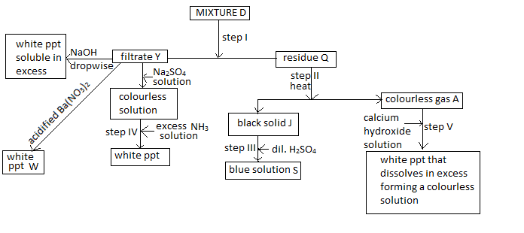
a) Identify the following; (2mk)
i) Residue Q-
ii) gas A-
iii) Filtrate Y-
iv) solid J-
b) Name the process taking place in step 1 (1mk)

c) Write balanced chemical equations for the following;
i) an ionic equation that led to the formation of the white precipitate formed in step IV. (1mk)

ii)an equation of the reaction that led to the formation of white precipitate W (1mk)

d) Explain the observations that were made in step V (2mk)

e) State the observations that would be made if the product of step III is added ammonia solution drop wise till in excess. (1mk)

f) 100cm³ of the blue solution formed in step III was placed in a plastic beaker, its initial temperature was recorded. Excess magnesium powder was then added and the mixture stirred and the highest temperature attained recorded. State and explain the observation made in the above reaction apart from the change in temperature. (2mk)

2. a) The set up below was used on a sample of an iron iii oxide. Study it and answer the questions that follow.
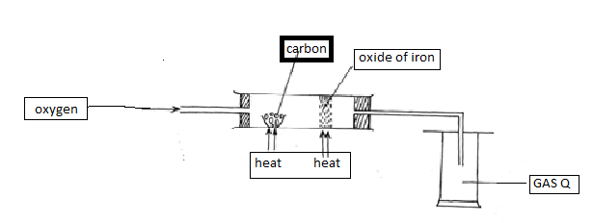
i)Identify the gas Q collected ( ½ mk)

ii) What observation is made on the excess iron (III) oxide? (1 mk)

iii) Write equations for the two reactions that take place in the combustion tube (2mk)

b) Diamond and graphite are both allotropes of carbon explain using structure and bonding why diamond is hard while graphite is soft. (2mk)

c) The diagram below was used by a form I student from Rami secondary school to prepare a certain gas. Study it and answer the questions that follow.
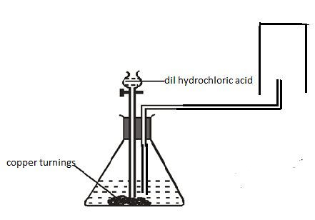
i) Identify two mistakes in the set up above. (2mk)

ii) Identify one of its physical properties apart from its solubility in water and one of its uses (1mk) (1mk)
Property-

Use –

d) A student was supplied with a colourless liquid suspected to be water describe one chemical test that could have been used to show that the liquid was water (1½ mk)

3. a)Study the set-up below and answer the questions that follow.
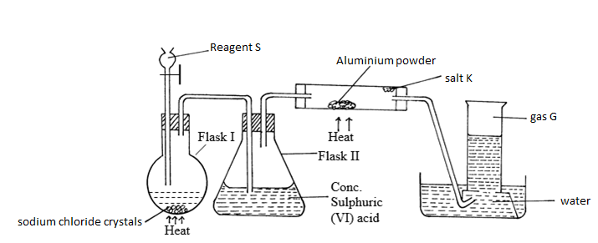
i) Identify the following
ii)Reagent S (½ mk)

iii) Gas G ( ½ mk)

iv) Salt K ( ½ mk)

v) Write balanced chemical equations for reactions that occur at:
Flask I (1mk)

Combustion tube. (1mk)

vi) Name the process that formed salt K as shown in the diagram. (1mk)

vii) Both blue and red litmus papers had been placed in the water in the trough, state and explain the observations made at the end of the experiment. (1 ½ mk)

b)i) State Graham’s Law of diffusion of gases (1mk)
ii) 100cm³ of carbon (IV) oxide gas takes 75 seconds to diffuse through a porous plate. How long would it take 120cm³ of nitrogen gas to diffuse through the same plate under the same conditions.(N=14, O=16, C=12) (2mk)

c)A mixture of 70cm³ of chlorine gas and 110cm³ of hydrogen gas were exploded. Calculate the total volume of the resulting gaseous mixture. (2mk)

4.The following is an extract of the periodic table. Study it and answer the questions that follow.(The letters are not the actual symbols of the elements.
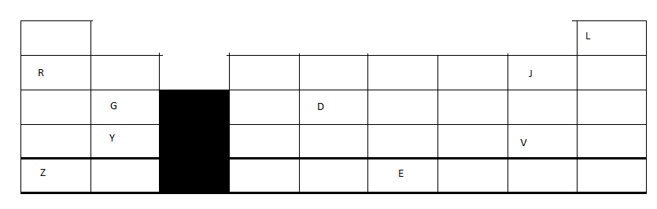
a) What name is given to the group of elements where G and Y belongs? ( ½ mk)

b) i)Write the formulae of the compound formed when elements Y and J reacts. ( ½ mk)

ii) Comment on the electrical conductivity of the compound formed above. (1mk)

c) Compare
i)The atomic radius of elements Z and E (1 ½ mk)

ii)The reactivity of element J with magnesium metal and that of V with magnesium ( 1 ½ mk)

d) The melting point the chloride of G is much higher than that of the chloride of D. Explain this observation
(2mk)

e) Use letter T to show the position of an element that forms a trivalent anion that with three occupied energies levels. (1mk)

f) An element M with a relative atomic mass of 15.2 was found to have 2 isotopes, M- 16 and M-12. Calculate the percentage abundance of each isotope. (2mk)

5. a) Define the term enthalpy of formation (1mk)

b) Use the information below to answer the questions that follow:-
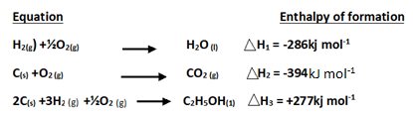
i) Draw an energy cycle diagram linking the above enthalpy changes and the enthalpy of combustion of ethanol (2mk)

ii)Use the energy cycled diagram to calculate the enthalpy of formation of ethanol. (1mk)

c) In order to determine the molar of neutralization of sodium hydroxide, 100cm³ of 2M sodium hydroxide and 100cm³ of 2M hydrochloric acid both at the same initial temperature were mixed and stirred continuously with a thermometer. The thermometer of the resulting solution was recorded after every 30 seconds until the highest temperature of the solution was attained. Thereafter the temperature of the solution was recorded for a further two minutes.
(i) Write an ionic equation for the reaction which took place (1mk)

(ii) The sketch below was obtained when the temperature of the mixture were plotted against time. Study and answer the questions that follow.
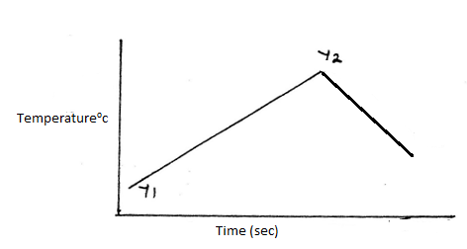
What is the significance of point Y₂? (1mk)

iii). If the heat change in the above reaction was 10,500Joules, and the initial temperature for both solutions was 22.5⁰C calculate;

I) The highest temperature attained by the mixture.(specific heat capacity of the solution = 4.2Jg ⁻¹K⁻¹ and the density of the solution = 1.0g/cm³ ) (2mk)

II) The molar heat of neutralization of sodium hydroxide. (1½ mk)

III) Explain how the value of the molar heat of neutralization obtained in this experiment would compare with the one that would be obtained if the experiment was repeated using 100cm³ of 2M ethanoic acid instead of hydrochloric acid. (2mk)

6. The following are reduction potentials of some elements, study them and answer the questions that follow.
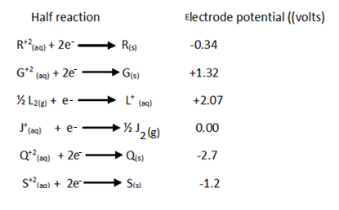
a) What is the reduction potential of the strongest reducing agent ( ½ mk)

b) Which element is most likely to be substance J.Explain your answer (1 mk)

c) i)Draw a well labelled diagram for the electrochemical cell that would be formed when elements G and S are combined . (3mk)

ii)Calculate the electromotive force of the cell formed above. (1mk)

d)During the electrolysis of dilute sodium chloride solution using graphite electrodes, a current of 0.8 ampheres was passed through the cell for two and a half hours.
i)Write an ionic equation for the reaction that occurred at cathode (1mk)

ii)Calculate the volume of the gas produced at anode in cm³ .(1F= 96500coulombs,1 mole of gas at RTP=24dm³) (3mk)

7. Study the scheme and answer the questions that follow.
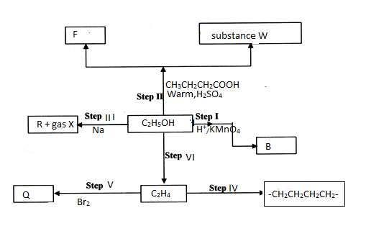
a) Name the following substances (1mk)
i) F -
ii) R –
b) Give the names of the processes taking place in the following steps (2mk)
i) Step IV-
ii) Step I-
c) Draw the structural formulae of compound W and give its name (2mk)

d) State the conditions necessary for step VI to take place. (1mk)

e) Draw any two possible isomers of substance Q (2mk)

f) State any two uses of the product of step IV. (1mk)

8. A student reacted excess dilute hydrochloric acid with 12.5grams of an impure calcium carbonate. The volume of carbon (iv) oxide produced was recorded after every thirty seconds .The data obtained was recorded in the table below. Study it and answer the questions that follow.

Time in  seconds | 0 | 30 | 60 | 90 | 120 | 150 | 180 | 210 | 240 | 270
Volume of carbon iv oxide in cm³ | 0 | 440 | 840 | 1230 | 1530 | 1720 | 1840 | 1860 | 1860 | 1860

a) Draw a graph of the volume of carbon (iv) oxide produced against time. (3mk)

b) Use the graph to determine;
i) The time at which the volume of the gas is 1640cm³ ( ½ mk)

ii)The volume of the gas at the 48th second ( ½ mk)

c) Calculate the rate of the reaction at the 165th second (2mk)

d) Calculate percentage purity of the calcium carbonate used ( C=12, O=16,Ca=40, 1 mole of gas at RTP=24 dm³) (3mk)

