**CHEMISTRY FORM 4 PAPER 2**

**END TERM 2 2024**

**MARKING SCHEME**

1. Study the flow chart below and answer the questions that follow.

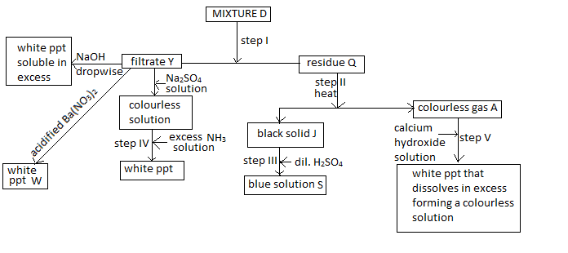

a) Identify the following; (2mk)

i) Residue Q- Copper Carbonate\CuCO3  1\2

ii) Gas A-Carbon IV oxide \CO2

iii) Filtrate Y-Aluminum Sulphate\AL2(SO4)3

iv) Solid J-Copper II oxide \Cuo

b) Name the process taking place in step 1 (1mk)

Filtration

c) Write balanced chemical equations for the following;

i) an ionic equation that led to the formation of the white precipitate formed in step IV. (1mk)

Alaq+3 + 3OH-aq --------------- Al(OH)3 S

ii)an equation of the reaction that led to the formation of white precipitate W (1mk)

Ba+2aq + SO4 aq  ------------- BaSO4 S

d) **Explain** the observations that were made in step V (2mk)

CO2 Passed for a short time formed insoluble Caco3 1mk

In excess soluble Ca(HCO3)2 is formed 1mk

e) State the observations that would be made if the product of step III is added ammonia solution drop wise till in excess. (1mk)

A blue PPt ½ that dissolves in excess forming a deep blue soln ½

f) 100cm3 of the blue solution formed in step III was placed in a plastic beaker, its initial temperature was recorded. Excess magnesium powder was then added and the mixture stirred and the highest temperature attained recorded. **State** and **explain** the observation made in the above reaction apart from the change in temperature. . (2mk)

Blue Colour fade 1\2 Brown solid is formed ½.

Magnesiumbeingmorereactivethancopperdisplacesitfromsolution1.

2. a) The set up below was used on a sample of an iron iii oxide. Study it and answer the questions that follow.

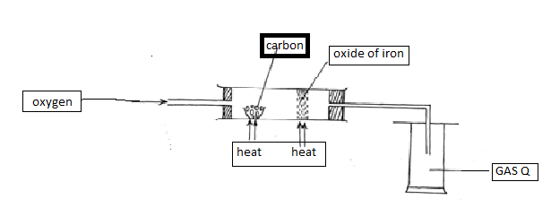

i)Identify the gas Q collected CO2 ( ½ mk)

ii) What observation is made on the excess iron (III) oxide? (1 mk)

Turns from brown to grey

iii) Write equations for the two reactions that take place in the combustion tube (2mk)

2C (S) + O2( g) ------2COg

Fe2o3 + 3COg ----- 2Fe(s)+ 3CO2 (g)

b) Diamond and graphite are both allotropes of carbon explain using structure and bonding why diamond is hard while graphite is soft. (2mk)

Diamond is hard due to the presence of multiple covalence bonds throughout the structure 1mk

Graphite has hexagonal layers that slide making it soft 1mk

c) The diagram below was used by a form I student from Rami secondary school to prepare a certain gas. Study it and answer the questions that follow.

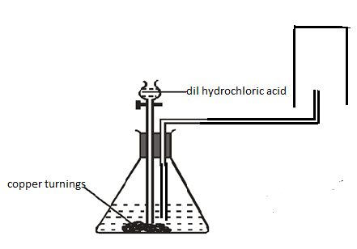

i) Identify two mistakes in the set up above. (2mk)

Use of copper turnings 1mk

The gas’s delivery tube is immersed in the reaction mixture 1mk

ii) Identify one of its physical properties apart from its solubility in water and one of its uses (1mk) (1mk)

Property- coloureless\odourless\ less dense than air\Neutral to litmus ½

Use – Manufucture of HCL/NH3 /hardening of oil to fats /as a rocket fuel etc ½

d) A student was supplied with a colourless liquid suspected to be water describe one chemical test that could have been used to show that the liquid was water (1½ mk)

Add a sample of the liquid to anhydrous CUSO4 1mk changes from white to blue ½

Or add a sample of the liquid to anhydrous cobalt ii chloride 1mk changes from blue to pink 1/2

NB/REAGENT=1MK CORRECT COLOUR CHANGE = ½ MK (BOTH COLURS MUST BE CORRECT) 3. a) Study the set-up below and answer the questions that follow.

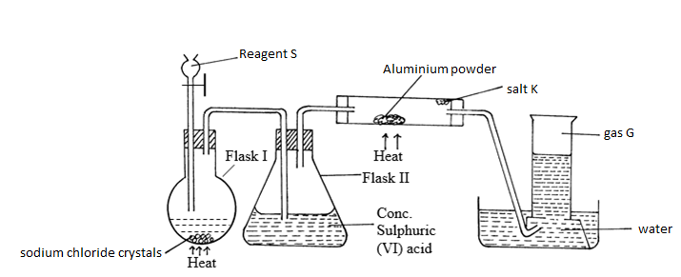

i) Identify the following

ii)Reagent S CONC H2SO4 ( ½ mk)

iii) Gas G Hydrogen gas ( ½ mk)

iv) Salt K Aluminum chloride \ ALCL3 ( ½ mk)

v) Write balanced chemical equations for reactions that occur at:

Flask I (1mk)

H2SO4 (L) + NaCl (S) -------HCL (g) + NaHSO4 (aq)

Combustion tube. (1mk)

2Al (s) + 6HCl (g) -------- 2ALCl3 (s) + 3H2 (g)

vi) Name the process that formed salt K as shown in the diagram. (1mk)

Sublimation

vii) Both blue and red litmus papers had been placed in the water in the trough, state and explain the observations made at the end of the experiment. (1 ½ mk)

Red litmus remained red ½ Blue litmus turned red ½ Excess HCL dissolved in water forming Hydrochloric acid ½

b)i) State Graham’s Law of diffusion of gases (1mk)

The rate of diffusion of a gas is inversely proportional to the square root of its density provided temperature and pressure remains constant

ii) 100cm3 of carbon (IV) oxide gas takes 75 seconds to diffuse through a porous plate. How long would it take 120cm3 of nitrogen gas to diffuse through the same plate under the same conditions.(N=14, O=16, C=12) (2mk)

RCO2= 100/75 = 1.3333 1.333/Y =√28/44 X=√(1.3332 X 44)/28 = 1.67Cm3/sec

Rate CO2 /Rate N2 = √N2/C02 1.3332 X 44=Y2 X 28 if 1.67cm3 takes 1 sec

120cm3= ?

120 x 1/1.67=71.85 sec

Or

If 100cm3 of Co2 takes 75 secs then 120 cm3 takes ? (120 x 75)/100=90 Y=√(902 X 28)/44 = 71.79

90/Y =√44/28 90 x 28 =Y2 X 44

c)A mixture of 70cm3 of chlorine gas and 110cm3 of hydrogen gas were exploded. Calculate the total volume of the resulting gaseous mixture. (2mk)

H2 + Cl2 ------ 2HCl ½ Unreacted H2=110-70=50 ½

1 : 1 : 2 Products =140 ½

70 70 140 140 + 50=190cm3

4.The following is an extract of the periodic table. Study it and answer the questions that follow.(The letters are not the actual symbols of the elements.

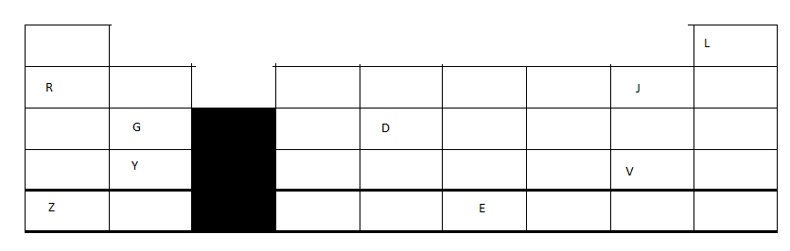

a) What name is given to the group of elements where G and Y belongs? ( ½ mk)

Alkaline earth metals

b) i)Write the formulae of the compound formed when elements Y and J reacts. ( ½ mk)

YJ2 | CaF2

ii) Comment on the electrical conductivity of the compound formed above. (1mk)

Will only conduct in molten or aq state but not in solid state

c) Compare

i)The atomic radius of elements Z and E (1 ½ mk)

E shorter than Z/ Z larger than E 1MK

E has more protons hence nuclear attraction ½

ii)The reactivity of element J with magnesium metal and that of V with magnesium ( 1 ½ mk)

J more reactive than V 1mk readily gains electrons since it has a shorter atomic radius ½

d) The melting point the chloride of G is much higher than that of the chloride of D. Explain this observation

(2mk)

D has simple molecular structure with weak vander waal forces while chloride of G has a giant ionic structure with strong ionic bonds

e) Use letter T to show the position of an element that forms a trivalent anion that with three occupied energies levels. (1mk)

Period 3 ,Group IV

f) An element M with a relative atomic mass of 15.2 was found to have 2 isotopes, M- 16 and M-12. Calculate the percentage abundance of each isotope. (2mk)

{(16 X Y ) + 12 X (100-4)}/100 = 15.2 16y + 1200 – 12y = 1520 y= 320/4 = 80%

16y – 12y= 1520-1200 M-16—80%

4y = 320 M-12—20%

5. a) Define the term enthalpy of formation (1mk)

It’s the enthalpy change when one more of a substance is formed from its consistent elements.

b) Use the information below to answer the questions that follow:-

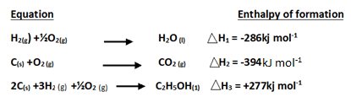

i) Draw an energy cycle diagram linking the above enthalpy changes and the **enthalpy of combustion** of ethanol (2mk)

2C + 3H2 + ½O2 ---------- C2H5OH

2O2 3/2O2 3O2

2CO2  + 3H2O

ii) Use the energy cycle diagram to calculate the enthalpy of formation of ethanol. (1mk)

2(-394) + 3(-286) = +277 + DHC

-692 + -858 – 277 = X

c) In order to determine the molar of neutralization of sodium hydroxide, 100cm3 of 2M sodium hydroxide and 100cm3 of 2M hydrochloric acid both at the same initial temperature were mixed and stirred continuously with a thermometer. The thermometer of the resulting solution was recorded after every 30 seconds until the highest temperature of the solution was attained. Thereafter the temperature of the solution was recorded for a further two minutes.

(i) Write an ionic equation for the reaction which took place (1mk)

OH- (aq) + H+(aq) ---- H2O (l)

(ii) The sketch below was obtained when the temperature of the mixture were plotted against time. Study and answer the questions that follow.

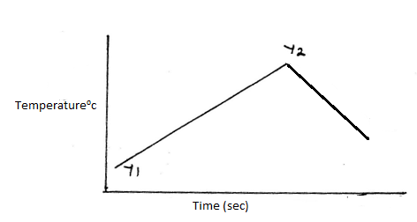

What is the significance of point Y2? (1mk)

It’s the end point/neutralisation took place

iii). If the heat change in the above reaction was 10,500Joules, and the initial temperature for both solutions was 22.50C calculate;

I) The highest temperature attained by the mixture.(specific heat capacity of the solution = 4.2Jg -1K-1 and the density of the solution = 1.0g/cm3 ) (2mk)

MCDT 200 X4.2 X DT= 10,500 Joules 22.5 + 12.5 = 35.0 0C

DT= 10,500/(200 X4.2) = 12.5

II) The molar heat of neutralization of sodium hydroxide. (1½ mk)

Moles of NaOH 2 X 100/1000=0.12 If 0.12 moles ---- 10500 1x 10500/0.2=52500Joules|mole

Then 1 mole ---- ?

III) Explain how the value of the molar heat of neutralization obtained in this experiment would compare with the one that would be obtained if the experiment was repeated using 100cm3 of 2M ethanoic acid instead of hydrochloric acid. (2mk)

It would be lower 1mk ,some of energy would be used to ionize the unionized molecules of ethanoic acid 1mk

6. The following are reduction potentials of some elements, study them and answer the questions that follow.

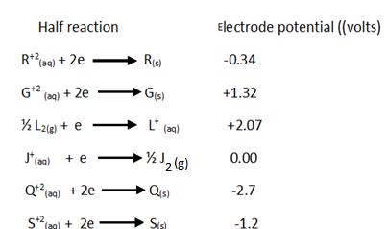

a) What is the reduction potential of the strongest reducing agent ( ½ mk)

-2.7v

b) Which element is most likely to be substance J.Explain your answer (1 mk)

Hydrogen ½ mk it has a reduction potential of 0.0v

c) i)Draw a well labelled diagram for the electrochemical cell that would be formed when elements G and S are combined . (3mk)

NB--- Salt bridge ----1mk

Each electrode – ½ mk

Each electrolyte – ½ mk

Penalyse 1mk if circuit is not complete

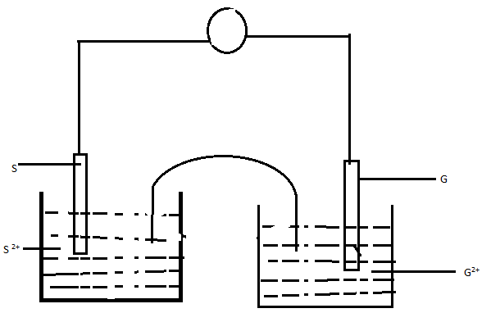

ii)Calculate the electromotive force of the cell formed above. (1mk)

+1.32- - 1.2 = +2.52v

d)During the electrolysis of dilute sodium chloride solution using graphite electrodes, a current of 0.8 ampheres was passed through the cell for two and a half hours.

i)Write an ionic equation for the reaction that occurred at cathode (1mk)

2H+(aq)+ 2e ----------- H2 (g)

ii)Calculate the volume of the gas produced at anode in cm3 .(1F= 96500coulombs,1 mole of gas at RTP=24dm3) (3mk)

4OH- (l)-----------2H2O (l) + O 2(g) + 4e-

1mole 4x96500

Q= It = 0.8 x 2.5 x 60 x60= 7200C

If 4x96500 -------- 24000

7200 ----------- ? 7200x 24000/4x96500= 447.66cm3

7. Study the scheme and answer the questions that follow.

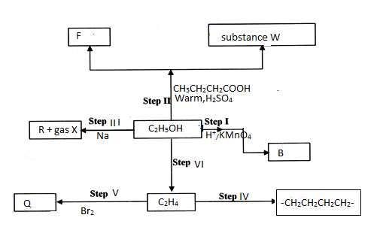

a) Name the following substances (1mk)

i) F - water ½

ii) R – sodium ethoxide ½

b) Give the names of the processes taking place in the following steps (2mk)

i) Step IV- polymerization 1mk

ii) Step I- oxidation 1mk

c) Draw the structural formulae of compound W and give its name (2mk)

Ethylbutanoate 1mk

d) State the conditions necessary for step VI to take place. (1mk)

heating/temperature 160-1800c ½

conc H2SO4

e) Draw any two possible isomers of substance Q (2mk)

f) State any two uses of the product of step IV. (1mk)

packaging material/crates/bottles/water pipes/cups etc

8. A student reacted excess dilute hydrochloric acid with 12.5grams of an **impure** calcium carbonate. The volume of carbon (iv) oxide produced was recorded after every thirty seconds .The data obtained was recorded in the table below. Study it and answer the questions that follow.

|  |  |  |  |  |  |  |  |  |  |  |
| --- | --- | --- | --- | --- | --- | --- | --- | --- | --- | --- |
| Time in  seconds | 0 | 30 | 60 | 90 | 120 | 150 | 180 | 210 | 240 | 270 |
| Volume of carbon iv oxide in cm3 | 0 | 440 | 840 | 1230 | 1530 | 1720 | 1840 | 1860 | 1860 | 1860 |

a) Draw a graph of the volume of carbon (iv) oxide produced against time. (3mk)

scale- ½ mk each MUST START AT 0’0(ORIGIN)

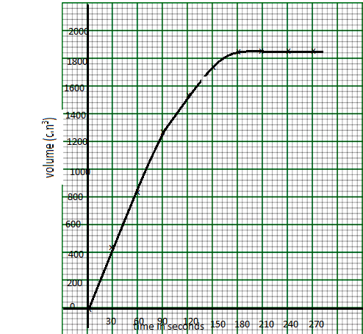

b) Use the graph to determine;

i) The time at which the volume of the gas is 1640cm3  ( ½ mk)

value read from the graph with units ½ mk

ii)The volume of the gas at the 48th second ( ½ mk)

value read from the graph with units ½ mk

c) Calculate the rate of the reaction at the 165th second (2mk)

tangent—1mk dy/dx --- ½ mk correct answer with units cm3/sec– ½ mk

d) Calculate percentage purity of the calcium carbonate used ( C=12, O=16,Ca=40, 1 mole of gas at RTP=24 dm3) (3mk) CaCO3 + 2HCl--------------CaCl2 +CO2 + H2O 1mk moles of CO2 =1860/24000=0.0775 ( ½ ) moles of CaCO3; CO2 1;1 0.0775moles ( ½ )

mass of CaCO3 present .0775x(40+12+48)= 7.75g ½ mk %purity 7.75/12.5x100= 62% ½ mk