NAME………………………………………………INDEX NO:.…ADM NO………
SCHOOL………………………………………SIGNATURE…….…. DATE………

233/1
CHEMISTRY Paper 1
THEORY
JULY 2024
2 HOURS

FORM 4
Kenya Certificate of Secondary Education (K.C.S.E)

INSTRUCTIONS TO CANDIDATES
- Write your name and index in the spaces provided.
- Sign and write the date the examination is done.
- Answer all the questions in the spaces provided.
- Mathematical tables and electronic calculators may be used.
- ALL workings MUST be clearly shown where necessary.
- This paper contains 12 printed pages.
- Candidates should check the question paper to ascertain that all pages are printed as indicated and that no question is missing.
- Candidates should answer questions in English.

For Examiner’s Use Only
Question | Maximum score | Candidates score
1-27 | 80

- Below is a Bunsen burner flame. Study it and answer the questions that follow.
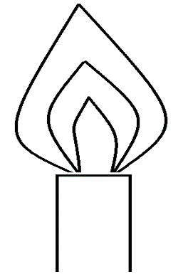
- How is this type of flame is produced? (1 mark)
………................................................................................................................................................
………................................................................................................................................................
- Label on the diagram the least hot part of the flame. (1 mark)
- Name the gas produced by a burning candle that is a non-pollutant. (1 mark)
………................................................................................................................................................
- a) A hydrocarbon consists of 92.3% carbon. Its molecular mass is 26. Calculate its molecular formula. (2 marks)
………................................................................................................................................................
………................................................................................................................................................
………................................................................................................................................................
………................................................................................................................................................
b) Draw the structure of the hydrocarbon. (1 mark)
………................................................................................................................................................
………................................................................................................................................................
………................................................................................................................................................
- Hydrogen sulphide gas is slightly soluble in water. The reaction is given by equation below.
H⁺_{(aq)}+HS⁻_{(aq)}
State and explain the effect of addition of Potassium hydroxide pellets on the concentration of hydrogen sulphide. (3 marks)
………................................................................................................................................................
………................................................................................................................................................
………................................................................................................................................................
………................................................................................................................................................
- In the presence of U.V light, ethane gas undergoes substitution reaction with chlorine.
- What is meant by the term Substitution reaction? (1 mark)
………................................................................................................................................................
………................................................................................................................................................
- Give the structural formula and the name of the organic product formed when equal volumes of ethane and chlorine react together. (2 marks)
………................................................................................................................................................
………................................................................................................................................................
………................................................................................................................................................
- The diagram below shows the bonding between aluminium chloride and ammonia.
H Cl

H N Al Cl

H Cl

- Name the types of bonds that exist in the molecule (1 mark)
……………………………………………………………………………………………………………………………………………………
……………………………………………………………………………………………………………………………………………………

- How many electrons are used for bonding in the molecule? (1mark)

……………………………………………………………………………………………………………………………………………………
- State one commercial use of dry ice (1 mark)
………................................................................................................................................................
- a) Give one advantage of universal indicator over other indicators. (1 mark)
………................................................................................................................................................
………................................................................................................................................................
- Describe how a mixture of barium sulphate and lead (II) chloride be separated in to pure solids. (2 marks)
………................................................................................................................................................
………................................................................................................................................................
………................................................................................................................................................
………................................................................................................................................................
………................................................................................................................................................
- Substance Q has a melting point of 15ºC and boiling point of 70ºC.
- On the same axes, draw the heating curve for Q if temperature started rising from 0ºC.
(2 marks)
- State the physical state of substance Q at room temperature (room temperature =25ºC)
(1 mark)
………................................................................................................................................................
- The set-up below is used to investigate the properties of ammonia.

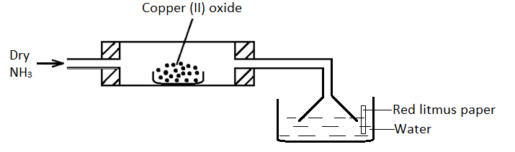

i) On the diagram, indicate what should be done for the reaction at the combustion tube to occur. (½ mark)
ii) Name another gas that can be used instead of ammonia gas. (½ mark)

………................................................................................................................................................
iii) State and explain what happens to the red litmus paper. (1 mark)
………................................................................................................................................................
iv) Explain the observation made in the combustion tube. (1 mark)
………................................................................................................................................................
- a) What is a binary electrolyte? (½ mark)

………................................................................................................................................................
………................................................................................................................................................
- In an experiment, the quantity of electricity passed to deposit 1.2g of metal Q from its salt, was 3860 coulombs. (RAM of Q=120, 1 faraday = 96500 coulombs)
- How many faradays of electricity are required to deposit 1mole of Q? (2 marks)
………................................................................................................................................................
………................................................................................................................................................………................................................................................................................................................………................................................................................................................................................
- One of the ions present in the solutions of the salt of Q has the formula Q^{y+.} What is the numerical value of y? (½ marks)
………................................................................................................................................................
………................................................................................................................................................

- Study the diagram below which shows an energy level diagram.

Na⁺_{(g)} + Cl⁻_{(g)}
ΔH₂ = - 680kJmol⁻¹
ΔH₃ = +20kJmol⁻¹
Na⁺_{(aq)} + Cl_{(aq)}
ΔH₁
NaCl_{(s)}

Enthalpy

Reaction path

- Name enthalpy (1½ mark)
ΔH₁ ………............................................................................................
ΔH₂ ………............................................................................................
ΔH₃ ………............................................................................................
- Calculate the ΔH₁ from the energy level diagram (1½ mark)

………................................................................................................................................................
………................................................................................................................................................
- Below is a table of 1st ionization energies for elements A, B, C, and D which are metals.

Elements | A | B | C | D
Ionization energies kJmol⁻¹ | 494 | 418 | 519 | 376

a) What is meant by 1st ionization energy? (1 mark)
………................................................................................................................................................
………................................................................................................................................................
b) With an explanation, arrange the elements in order of increasing reactivities. (2 marks)
………................................................................................................................................................
………................................................................................................................................................
- In the manufacture of Sulphuric (VI) acid by contact process Sulphur (IV) oxide is made to
react with air to form Sulphur (VI) oxide as shown: -

2SO₂(g) + O₂(g) 2SO₃(g) ΔH = -196KkJ

(i) Name the catalyst in this reaction (1 mark)

………................................................................................................................................................
(ii) State effect of the following changes on the yield of Sulphur (VI) oxide
I. Increasing the pressure (½ mark)

………................................................................................................................................................
II. Using a catalyst (½ mark)

………................................................................................................................................................
(iii) Explain why Sulphur (VI) oxide gas is absorbed in concentrated Sulphur (VI) acid before dilution (1 mark)

………................................................................................................................................................
………................................................................................................................................................
- a) What are isotopes? (1 mark)
………................................................................................................................................................
………................................................................................................................................................
- Determine the number of neutrons in ${}_{8}^{18}O$ (1 mark)
………................................................................................................................................................
………................................................................................................................................................
- An isotope of element E has 34 neutrons and its mass number is 64. E forms a cation with 28 electrons. Write the formula of the cation formed by the element E. (1 mark)
………................................................................................................................................................
………................................................................................................................................................
- The standard electrode potentials of four half-reactions are: -
I. Sn²⁺ _{(aq)} + 2e⁻ → Sn_{(s)} E^{θ} = -0.14V
II. Fe³⁺_{(aq)} + e⁻ → Fe²⁺_{(aq)} E^{θ} = + 0.77V
III. V²⁺_{(aq)} + 2e⁻ → V_{(s)} E^{θ} = -1.20V
IV. Br_{2(aq)} + 2e⁻ → 2Br⁻_{(aq)} E^{θ} = + 1.07V
- Identify the strongest oxidizing agent. (1 mark)
………................................................................................................................................................
- Calculate the electrode potential for the electrochemical cell constructed from half-cell III and IV (1 mark)
………................................................................................................................................................
………................................................................................................................................................
- State two applications of electrolysis (1 mark)
………................................................................................................................................................
………................................................................................................................................................
- A sample of river water is suspected to contain magnesium salt. Describe how the presence of Mg²⁺ ions can be established. (3 marks)
………................................................................................................................................................
………................................................................................................................................................
………................................................................................................................................................
- The solubility curve of potassium nitrate is shown below.
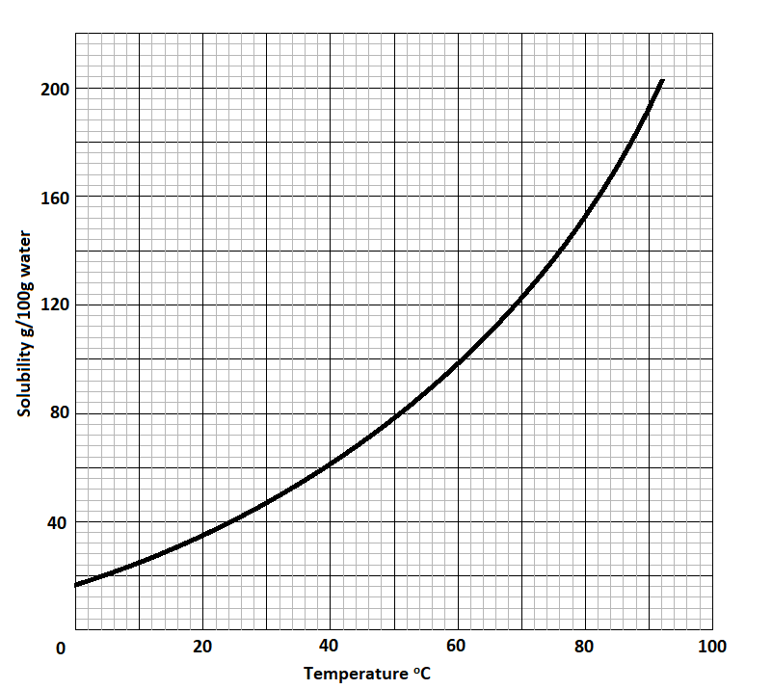
  - Determine the solubility of potassium nitrate at 80°C. (1 mark)

………................................................................................................................................................
  - Determine the molar concentration of saturated potassium nitrate at 50°C. (K = 39.0, O = 16.0, N = 14.0 and density of water = 1 g/cm³). (2 marks)

………................................................................................................................................................
………................................................................................................................................................
………................................................................................................................................................
………................................................................................................................................................
- Galvanization is an example of the efficient methods used in preventing rusting.
- What is meant by galvanisation? (1 mark)
………................................................................................................................................................
………................................................................................................................................................

- Other than galvanisation, name 2 methods of preventing rusting. (1 mark)
………................................................................................................................................................
………................................................................................................................................................
- State the use of the mixture of hydrazine with oxygen. (1 mark)
………................................................................................................................................................
- a) Name 2 gases that are collected during fractional distillation when the temperature of liquefied air is raised from -200℃ to -185℃of the distillation chamber. (1 mark)
………................................................................................................................................................
………................................................................................................................................................
- Name 2 gases that are removed at the temperature between 25℃ and -25℃ (1 mark)
………................................................................................................................................................
………................................................................................................................................................
- Why is it necessary to remove the gases named in (b) above before the cooling dust free air to -200℃? (1 mark)
………................................................................................................................................................
………................................................................................................................................................
- The structure of protein is shown below. Study it and answer the questions that follow.
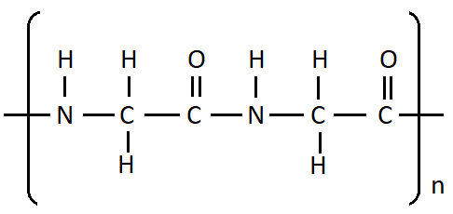
- Draw the structure of the monomer that undergoes polymerization to form protein.
(1 mark)
………................................................................................................................................................
………................................................................................................................................................
………................................................................................................................................................
- Which type of polymerization is the formation of protein? Explain. (2 marks)
………................................................................................................................................................
………................................................................................................................................................
………................................................................................................................................................

- Study the flow chart below and answer the question that follows.

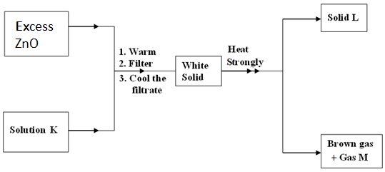
Identify: (3 marks)
a) Solution K
………................................................................................................................................................
b) Solid L
………................................................................................................................................................
c) Gas M
………................................................................................................................................................
- 50cm³ of oxygen gas diffused through a porous plug in 80 seconds. How long will it take 100cm³ of Sulphur (IV) oxide to diffuse through the same plug? (S = 32, O = 16). (3 Marks)
………................................................................................................................................................
………................................................................................................................................................
………................................................................................................................................................
………................................................................................................................................................
………................................................................................................................................................
………................................................................................................................................................
- 15.0cm³ of ethanoic acid (CH₃COOH) was dissolved in water to make 500cm³ of solution. Calculate the concentration of the solution in moles per litre. (C=12.0; H=1.0; O=16.0; density of ethanoic acid is 1.05 g/cm³) (3 marks)
………................................................................................................................................................
………................................................................................................................................................
………................................................................................................................................................
………................................................................................................................................................
………................................................................................................................................................
- When excess chloride gas is bubbled through dilute sodium hydroxide solution the resulting solution acts as a bleaching agent.
- Write an equation for the reaction between chlorine gas and sodium hydroxide solution.
(1 mark)
………................................................................................................................................................
………................................................................................................................................................
………................................................................................................................................................
- Explain how the resulting solution acts as a bleaching agent. (2 marks)
………................................................................................................................................................
………................................................................................................................................................
………................................................................................................................................................
- Calcium oxide can be used to dry ammonia gas.
a) Explain why calcium oxide is not used to dry hydrogen chloride gas. (2 marks)
………................................................................................................................................................
………................................................................................................................................................
………................................................................................................................................................
b) Name one drying agent for hydrogen chloride gas. (1 mark)
………................................................................................................................................................
- a) Explain why it is not advisable to prepare a sample of carbon(IV)oxide using barium carbonate and dilute Sulphuric(VI) acid. (2 marks)

………................................................................................................................................................
………................................................................................................................................................
………................................................................................................................................................

b) State a method that can be used to collect dry carbon(IV)oxide gas. Give a reason.
(1 mark)
………................................................................................................................................................
………................................................................................................................................................
- Study the information in Table 3 and use it to answer the questions that follow.
Elements | Na | Mg | Al | Si | P | S | Cl
Atomic Numbers | 11 | 12 | 13 | 14 | 15 | 16 | 17
Atomic radii(nm) | 0.157 | 0.136 | 0.125 | 0.117 | 0.110 | 0.104 | 0.099
  - Explain the trend in atomic radii from sodium to chlorine. (1 mark)
………................................................................................................................................................
………................................................................................................................................................

  - Explain how the chloride of aluminium differs from those of other metals in the period. (2 marks)
………................................................................................................................................................………................................................................................................................................................
- When solid magnesium carbonate was added to a solution of hydrogen chloride in methylbenzene, there was no apparent reaction. On addition of water to the resulting mixture, there was vigorous effervescence. Explain these observations (2 marks)
………................................................................................................................................................
………................................................................................................................................................
………................................................................................................................................................………................................................................................................................................................
………................................................................................................................................................

The Last Printed Page

