**NAME………………………………………………INDEX NO:.…ADM NO………**

**SCHOOL**…………………………………………………………….…. **DATE**………

**233/1**

**CHEMISTRY**

**THEORY**

**JULY 2024**

**2 HOURS**

**FORM 4**

**Kenya Certificate of Secondary Education (K.C.S.E)**

**MARKING SCHEME**

**For Examiner’s Use Only**

|  |  |  |
| --- | --- | --- |
| **Question** | **Maximum score** | **Candidates score** |
| 1-27 | 80 |  |

1. Below is a Bunsen burner flame. Study it and answer the questions that follow.

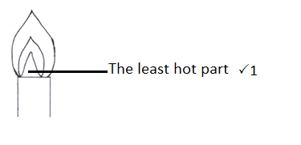

1. How is this type of flame is produced? (1mark)

**By opening the air hole completely 🗸1**

1. Label on the diagram the least hot part of the flame. (1mark)
2. Name the gas produced by a burning candle that is a non-pollutant. (1mark)

**Water vapour (steam) 🗸1 (Reject water)**

1. a) A hydrocarbon consists of 92.3% carbon. Its molecular mass is 26. Calculate its molecular formula. (2 marks)

**C H**

**92.3 7.7**

**12 1**

**7.69 7.7 🗸½**

**7.69 7.69**

**1 1**

**E.F = CH 🗸½**

**(CH)n = 26**

**13n = 26**

**n = 2 🗸½**

**M.F = C2H2 🗸½**

b) Draw the structure of the hydrocarbon. (1 mark)

**H – C ≡ C – H 🗸1**

1. Hydrogen sulphide gas is slightly soluble in water. The reaction is given by equation below.

H2S(aq) H+(aq)+HS-(aq)

State and explain the effect of addition of Potassium hydroxide pellets on the concentration of hydrogen sulphide. (3 marks)

**It reduces the concentration of H2S🗸1. KOH react i.e., OH- reacts with H+🗸½ to form water. Equilibrium shifts to the right🗸½ H2S dissociates🗸½ to produce or replace H+ that was consumed🗸½**

1. In the presence of U.V light, ethane gas undergoes substitution reaction with chlorine.
2. What is meant by the term Substitution reaction? (1 mark)

**A reaction where one hydrogen atom of an alkane is replaced by another atom (halogen).**

1. Give the structural formula and the name of the organic product formed when equal volumes of ethane and chlorine react together. (2 marks)

**H H**

**I I**

**H C C Cl 🗸1 or. CH3CH2Cl Chloroethane🗸1 ║Ethylchloride**

**I I**

**H H**

1. The diagram below shows the bonding between aluminium chloride and ammonia.

H Cl

H N Al Cl

H Cl

1. Name the types of bonds that exist in the molecule (1mk)

**Dative bond.**

**Covalent bond.**

1. How many electrons are used for bonding in the molecule? (1mark)

**7 bonds = 7x2 = 14 electrons**

1. State one commercial use of dry ice (1 mark)

**It is used by ice cream vendors.**

1. a) Give one advantage of universal indicator over other indicators. (1 mark)

**It shows the strength of acidic or alkaline solution.**

1. Describe how a mixture of barium sulphate and lead (II) chloride be separated in to pure solids. (2 marks)

**Add warm/hot distilled water to the mixture🗸½.**

**Filter to obtain barium sulphate as the residue and lead (II) chloride as the filtrate🗸½.**

**Wash the residue with warm/hot distilled water dry it between filter papers🗸½.**

**Heat the filtrate to evaporate the water and obtain solid lead(ii) chloride🗸½ OR cool the filtrate and filter, dry the solid lead (II) chloride between filter paper.**

1. Substance Qhas a melting point of 15oC and boiling point of 70oC.
2. On the axes below, draw the heating curve of Q if temperature if the substance was heated from 0oC.

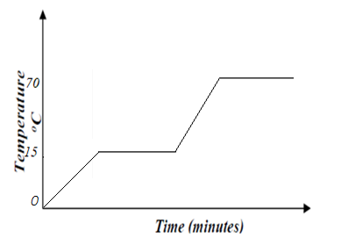

(b) State the physical state of substance **Q** at room temperature (room temperature =25oC)

**Liquid** (1 mark)

1. The set-up below is used to investigate the properties of hydrogen.

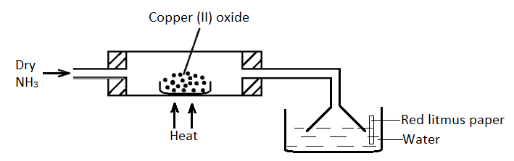

i) On the diagram, indicate what should be done for the at the combustion tube to occur. (**½** mark)

ii) Name another gas that can be used instead of hydrogen gas. (½ mark)

**Hydrogen gas, carbon(ii) oxide**

iii) State and explain what happens to the red litmus paper. (1 mark)

**Red litmus paper turns blue🗸½.; the excess ammonia reacts with water to form ammonium hydroxide solution which is alkaline🗸½.**

iv) Explain the observation made in the combustion tube. (1 mark)

**Black copper(II)oxide turns brown****🗸½. Copper(II)oxide is reduced to copper metal🗸½.**

1. a) What is a binary electrolyte? (**½** mark)

**An electrolyte that contains one type of cation and one type of anion only.**

1. In an experiment, the quantity of electricity passed to deposit 1.2g of metal Q from its salt, was 3860 coulombs. (RAM of Q=120, 1 faraday = 96500 coulombs)
2. How many faradays of electricity are required to deposit 1mole of Q? (2 marks)

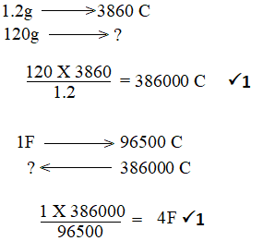

1. One of the ions present in the solutions of the salt of Q has the formula Q**y+**. What is the numerical value of y? (**½** marks)

**4**

1. Study the diagram below which shows an energy level diagram.

Na+(g) + Cl-(g)

ΔH2 = - 680kJmol-1

ΔH3 = +20kJmol-1

Na+(aq) + Cl(aq)

ΔH1

NaCl(s)

Enthalpy

Reaction path

1. Name enthalpy (1½ mark)

**Δ H1 - Lattice energy**

**Δ H2 - Hydration energy**

**ΔH3 - Heat of solution**

1. Calculate the ΔH1 from the energy level diagram (1½ mark)

**ΔH1 =-ΔH2 + ΔH3**

**= -(-680) + 20 🗸½**

**= -680 – 20 🗸½**

**= +700kJmol-1 🗸½**

1. Below is a table of 1st ionization energies for elements A, B, C, and D which are metals.

|  |  |  |  |  |
| --- | --- | --- | --- | --- |
| Elements | A | B | C | D |
| Ionization energies kJmol-1 | 494 | 418 | 519 | 376 |

a) What is meant by 1st ionization energy? (1 mark)

**The minimum amount of energy required to remove the FIRST electron from the outermost energy level of an atom in gaseous state.**

b) With an explanation, arrange the elements in order of increasing reactivities. (2 marks)

**C, A, B, D; 🗸1 The force of attraction between the positive nucleus and the valence electron is strongest in C and weakest in D 🗸1 due to the increase in atomic radius down the from down the group from C to D.**

**(Acc C< A<B<D OR D> B> A> C; reject D< B< A< C)**

1. In the manufacture of Sulphuric (VI) acid by contact process Sulphur (IV) oxide is made to

react with air to form Sulphur (VI) oxide as shown: -

2SO2(g) + O2(g) 2SO3(g) ΔH = -196KkJ

(i) Name the catalyst in this reaction (1 mark)

**Vanadium (v) oxide or platinum**

(ii) State and explain the effect of the following changes on the yield of Sulphur (VI) oxide

I. Increasing the pressure (**½** mark)

**Increases the yield of SO3**

II. Using a catalyst (**½** mark)

**No effect**

(iii) Explain why Sulphur (VI) oxide gas is absorbed in concentrated Sulphur (VI) acid before

dilution (1 mark)

**The reaction is highly exothermic thus forms a mist of acid droplets of Sulphuric acid in the air.**

1. a) What are isotopes? (1 mark)

**Atoms of the same element with the same atomic number but different mass numbers.**

**OR**

**Atoms of with the same number of protons but difference in the neutrons.**

**(Reject; ELEMENTS with same atomic number but different mass numbers.)**

1. Determine the number of neutrons in ${}_{8}^{18}O$ (1 mark)

**18-8 = 10**

1. An isotope of element E has 34 neutrons and its mass number is 64. E forms a cation with 28 electrons. Write the formula of the cation formed by the element E. (1 mark)

**E2+**

1. The standard electrode potentials of four half-reactions are: -

I. Sn2+ (aq) + 2e- → Sn(s) Eθ = -0.14V

II. Fe3+(aq) + e-  → Fe2+(aq) Eθ = + 0.77V

III. V2+(aq) + 2e- → V(s) Eθ = -1.20V

IV. Br2(aq) + 2e-  → 2Br-(aq) Eθ = + 1.07V

i) Identify the strongest oxidizing agent. (1 mark)

**Br2**

ii) Calculate the electrode potential for the electrochemical cell constructed from half-cell III and IV (1 mark)

**+1.07 – -1.20 🗸½**

**= + 2.29 V** **🗸½**

iii) State one application of electrolysis (1 mark)

* **Extraction of metals such as sodium, magnesium and aluminum by electrolysis of their molten compounds.**
* **Purification of metals.**
* **Electroplating of metals such as iron to improve their appearance and prevent corrosion.**
* **Manufacture of pure chemicals such as hydrogen gas, chlorine gas and sodium hydroxide.**

**(Any correct 🗸1)**

1. A sample of river water is suspected to contain magnesium sulphate salt. Describe how the presence of Mg2+ ions can be established. (3 marks)

**- Add aqueous ammonia dropwise until in excess. 🗸½**

**- Formation of white ppt which is insoluble dissolve in excess 🗸½ shows presence of zinc ions. 🗸½**

**- Add aqueous sodium hydroxide dropwise until in excess. 🗸½**

**- A white ppt insoluble in excess 🗸½ is formed confirms the presence of Mg2+ ions. 🗸½**

1. The solubility curve of potassium nitrate is shown below.

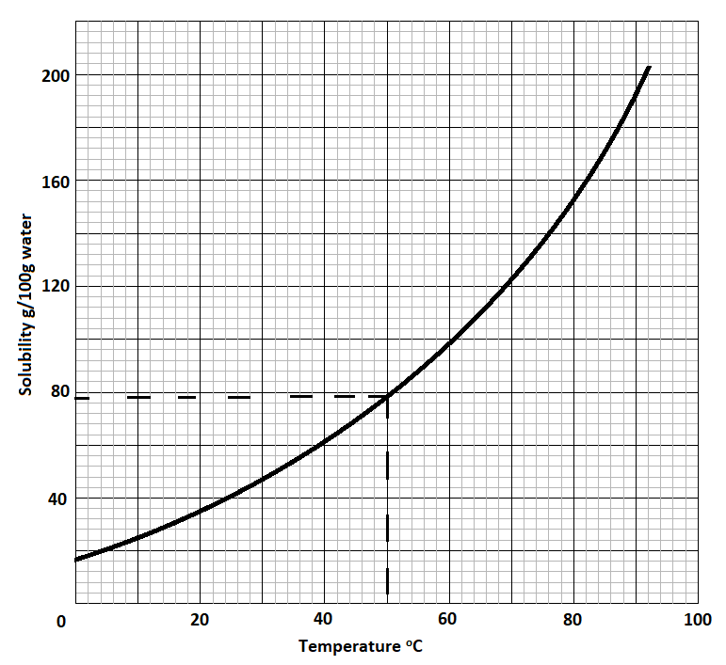

* 1. Determine the solubility of potassium nitrate at 80°C. (1 mark)

**To be read from graph = 153g/100g water ± 2g/100H2O**

* 1. Determine the molar concentration of saturated potassium nitrate at 50°C. (K = 39.0, O = 16.0, N = 14.0 and density of water = 1 g/cm3). (2 marks)

**R.M.F. of KNO3 = 101 🗸½**

**Molar concentration = 79.5 x 1000 🗸½**

**101 x 100**

**= 7.81M 🗸½**

1. Galvanization is an example of the efficient methods used in preventing rusting.
2. What is meant by galvanisation? (1 mark)

**Applying a protective zinc coating to steel or iron to prevent rusting.**

1. Other than galvanisation, name 2 methods of preventing rusting. (1 mark)

* **Painting.**
* **Oiling &greasing.**
* **Sacrificial protection.**
* **Alloying.**
* **Electroplating.**
* **Plastic coating.**

1. Name a gas, that when mixed with oxygen is used to fuel rockets. (1 mark)

**To propel rockets**

1. a) Name 2 gases that are collected during fractional distillation when the temperature of liquefied air is raised from -200℃ to -185℃of the distillation chamber. (1 mark)

**Nitrogen, Argon.**

1. Name 2 gases that are removed at the temperature between 25℃ and -25℃ (1 mark)

**Carbon (IV) oxide, Water vapour.**

1. Why is it necessary to remove the gases named in (b) above before cooling dust free air to -200℃? (1 mark)

**They easily turn into a solid, causing blockage of pipes.**

1. The structure of protein is shown below. Study it and answer the questions that follow.

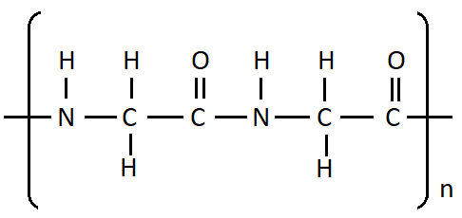

1. Draw the structure of the monomer that undergoes polymerization to form protein.

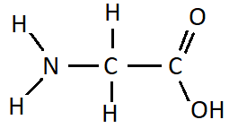 (1 mark)

1. Which type of polymerization is the formation of protein? Explain. (2 marks)

**Condensation polymerization. Water molecules are lost. (Accept; small molecules)**

1. Study the flow chart below and answer the question that follows.

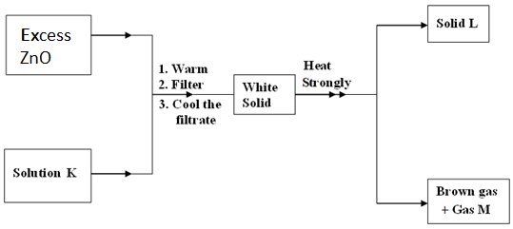

Identify: (3 marks)

a) Solution K **Dilute nitric (V) acid**

b) Solid L **Zinc oxide**

c) Gas M **Oxygen**

1. 50cm3 of oxygen gas diffused through a porous plug in 80 seconds. How long will it take 100cm3 of Sulphur (IV) oxide to diffuse through the same plug? (S = 32, o = 16). (3 Marks)

**50cm3 of O2(g) take sec**

**100cm3 of O2(g) take sec?**

$\frac{80secx 100 }{50}$**= 160secs 🗸½**

**M/mass of O2 = 32 🗸½**

**SO2 = 32 + 32 = 64 🗸½**

**=**

**= 🗸½**

**=**

**=**

**TSO2= x160 🗸½**

**TSO2= 226.27 sec 🗸½**

1. 15.0cm3 of ethanoic acid (CH3COOH) was dissolved in water to make 500cm3 of solution. Calculate the concentration of the solution in moles per litre. (C=12.0; H=1.0; O=16.0; density of ethanoic acid is 1.05 g/cm3) (3 marks)

**Mass in 500cm3 = 15 x 1.05 = 15.75g 🗸1**

**Mass in 100cm3 = 15.75 x 2 = 31.5 🗸1**

**Molarity = 315 = 0.103 🗸1**

**60**

1. When excess chloride gas is bubbled through dilute sodium hydroxide solution the resulting solution acts as a bleaching agent.
2. Write an equation for the reaction between chlorine gas and sodium hydroxide solution.

(1 mark)

**Cl2(g) + NaOH(aq) → NaCl (aq) + NaOCl(aq) + H2O (I)**

1. Explain how the resulting solution acts as a bleaching agent. (2 marks

**NaOCl decomposes to give oxygen (O) that bleaches.**

1. Calcium oxide can be used to dry ammonia gas.

a) Explain why calcium oxide is not used to dry hydrogen chloride gas. (2 marks)

**Hydrogen chloride reacts with calcium oxide in the presence of water to form calcium chloride.**

**CaO(s) + 2HCl (g) →CaCl2(aq) + H2O(l)**

b) Name one drying agent for hydrogen chloride gas. (1 mark)

**Concentrated sulphuric(VI) acid**

1. a) Explain why it is not advisable to prepare a sample of carbon(IV)oxide using barium carbonate and dilute sulphuric(VI) acid. (2 marks)

**The reaction starts but soon stops. This is because the insoluble barium sulphate formed coats the surface of barium carbonate preventing further reaction and evolution of carbon(IV)oxide.**

b) State a method that can be used to collect dry carbon(IV)oxide gas. Give a reason.

(1 mark)

**Downward delivery. CO2 is denser than air.**

1. Study the information in Table 3 and use it to answer the questions that follow.

|  |  |  |  |  |  |  |  |
| --- | --- | --- | --- | --- | --- | --- | --- |
| **Elements** | **Na** | **Mg** | **Al** | **Si** | **P** | **S** | **Cl** |
| Atomic Numbers | 11 | 12 | 13 | 14 | 15 | 16 | 17 |
| Atomic radii(nm) | 0.157 | 0.136 | 0.125 | 0.117 | 0.110 | 0.104 | 0.099 |

* 1. Explain the trend in atomic radii from sodium to chlorine. (1 mark)

**Atomic radii decrease across the period from sodium to chlorine due to increase in the number of protons which increases the nuclear attraction for the outermost electrons to decrease the atomic radii.**

* 1. Explain how the chloride of aluminium differs from those of other metals in the period. (2 marks)

**AlCl3 is molecular; it exists as a dimer; it has covalent and coordinate bonds while chlorides of other metals are ionic; they have ionic bonds.**

**OR**

**AlCl3 hydrolyses in water while other metal chlorides do not.**

1. When solid magnesium carbonate was added to a solution of hydrogen chloride in methylbenzene, there was no apparent reaction. On addition of water to the resulting mixture, there was vigorous effervescence. Explain these observations (2 marks)

**Hydrogen chloride dissolves in methylbenzene but remains molecular. When water is added it ionizes hence reacts with carbonate to form carbon (IV) oxide gas.**