233/1
CHEMISTRY PAPER 1
FORM 3 EXAMS
END OF TERM II EXAM
YEAR 2024
TIME: 2HOURS

MAME……………………………………………………………………………………………………………………………..ADM NO………….

Answer all the questions in the spaces provided.
Write your name in the spaces provided above.
Mathematical tables and electronic calculators may be used for calculations.
All workings must be clearly shown where necessary

For Examiner’s Use only:

QUESTION | MAXIMUM SCORE | CANDIDATE’S SCORE
1 – 29 | 80

- a) What is meant by allotropy? (1 mark)

b). The diagram below shows the structure of one of the allotropes of carbon

- Identify the allotrope. ( 1 mark)

- State one property of the above allotrope and explain how it is related to its structure. (2marks)

- (a) State Graham’s law of diffusion (1mk)

(b).60cm³ of oxygen gas diffused through a porous hole in 50 seconds. How long will it take 80cm³ of sulphur (IV) oxide to diffuse through the same hole under the same conditions? (3 marks)
(S= 32.0. O=16.0)

- The table below gives the atomic numbers of element w, x, y and z. The letters do not represent the actual symbols of the elements.
Element | w | x | y | Z
Atomic number | 9 | 10 | 11 | 12

- Which one of the elements is least reactive? Explain. (1 mark)

- Which two elements would react most vigorously with each other? (1 mark)

- Give the formula of the compound formed when elements in (i) above react. (1 mark)

- Draw using dots (•) and crosses (x), diagram to show the bonding between y and w (2mks)

- The following are observations made from two solid substances x and y.

Solid | Electrical conductivity in solution form | Solubility in water | Boiling point
X | Poor | Insoluble | Sublimes
y | good | soluble | high

- State the most likely type of bonding in

- Solid x ……………………………………………………. (1/2 mark)

- Solid y……………………………………………………. (1/2 mark)

- When air is bubbled through pure water (PH=7) the PH drops to 6.0. Explain. (2 marks)

- The set-up below shows laboratory preparation of hydrogen gas, use it to answer the questions that follow.

Dilute
Sulphuric Acid

Zinc granules Conc. H₂SO₄

- Identify two mistakes in the set-up (2 marks)

- Why is dilute nitric acid not used in preparation of hydrogen gas? (1 mark)

- Starting with copper (II) oxide, describe how you can prepare copper (II) sulphate crystals.
(3 marks)

- The set-up below shows the products formed when solid lead (ii) nitrate is heated.

Heat gas y

Lead II Nitrate
Crystals-

Liquid x ice cold mixture

- Identify:
(i) Liquid x (1 mark)

(ii) Gas y ( 1 mark)

b). Write an equation for the reaction that takes place when lead (ii) nitrate is heated. (1 mark)

- Study the set-up below and answer the questions that follow.

Gas x

- -
- -
- -
- - - - - - - - - - - - - - - Chlorine water
- - - - - -- - - - - - - - -

a). Name gas x (1 mark)

b). State the condition which is not indicated on the diagram for gas x to be formed. (1 mark)

- (a). Aluminium chloride sublimes. State two other substances that sublime. (2 marks)

b) Aluminium is reactive metal yet utensils made of aluminium do not corrode easily.
Explain. (1 mark)

- Spots of three pure pigments A, B and mixture Z were placed on a filter paper and allowed to dry. The paper was then dipped in a solvent. The results obtained were as on the paper chromatogram.
- Identify;
- Baseline. (1/2 mark)

- Solvent front. (1/2 mark)

- Which pure pigment was component of Z.? (1 mark)

- When excess ammonia solution is added to a solution of copper (ii) ions, a deep blue solution forms. Write the formula of the complex ions formed. (1 mark)

- 22.2cm³ of sodium hydroxide solution containing 4.0g per litre sodium hydroxide were required for complete neutralisation of 0.1g of a dibasic acid. Calculate the relative formula mass of the dibasic acid. (Na = 23, O=16, H=1) (3 marks)

- The diagram below shows the set-up that was used to prepare and collect sulphur (iv) oxide gas.
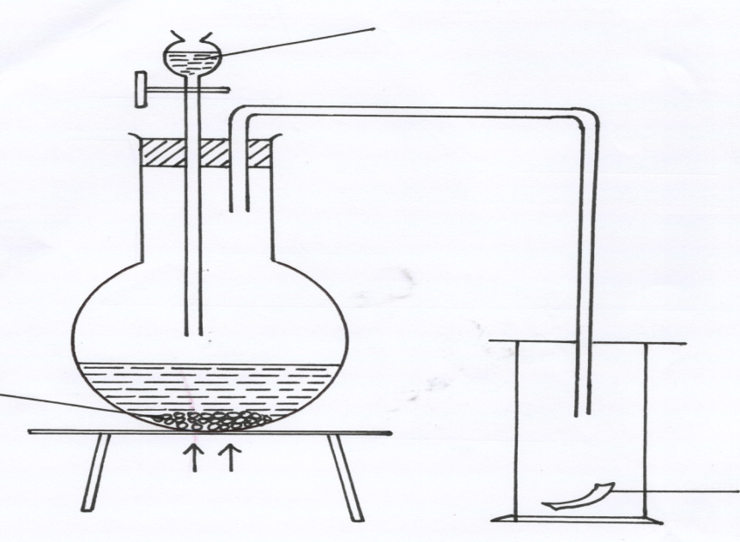
Hydrochloric acid

Solid P

Moist red flower
Heat

( a). Identify solid P. (1mk)

(b) (i) Why is it possible to collect sulphur (IV) Oxide as shown? (1mk)

(ii) What happened to the red flower? (1mk)

- The set-up show how small pieces of magnesium are heated in carbon (IV) Oxide.
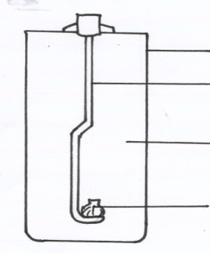
Gas jar

Deflagrating spoon

Carbon (IV) oxide

Burning magnesium

a) Write an equation for the reactions which occur in the gas jar. (2mks)

b) Give two observation made in the gas jar. (2mk)

- A mixture contains iron (III) chloride, zinc (II) oxide and potassium chloride. Describe how each of the substance can be obtained from the mixture. (3mks)

- a) Name two types of flame of the Bunsen burner. (1mk)

b) Which flame is better for heating in the laboratory? Give two reasons. (2mks)

- a) Both iodine and bromine belong to the same group and family in the periodic table, Name the family. (1mk)

- A compound contains carbon 40%, hydrogen 6.71% and the rest is oxygen. The relative molecular mass of the compound is 60. (H=1.0, O=16, C=12)
a) Determine its empirical formula. (3mks)

b) Find the molecular formula of the compound. (1mk)

- Given below are pH values of different solutions P, Q and S. Study it and answer the questions that follow.

Solution | PH
P | 1
Q | 7
S | 14

a) Which two solutions would react together to give a pH of 7.0. (1mk)

b) Which solution can be considered to be sodium chloride? (1mk)

- The table below gives properties of four substances.
Substances | Melting points | Boiling points | Electrical conductivity
 |  |  | Solid | Liquid
A | 1083 | 2567 | Good | Good
B | -182 | -164 | Poor | Poor
C | 1723 | 2230 | Poor | Good
D | 993 | 1695 | Poor | Poor

- State with a reason which of the above is:-
i). An ionic compound. (1mk)

ii). A metallic structure. (1mk)

Iii). A giant atomic structure. (1mk)

- The set up below was used to obtain a sample of iron.

Carbon
Excess Iron (II) oxide
Oxygen
Heat
Heat
Gas Q

i) Write two equations for the reaction which occur in the combustion tube. (2mks)

ii) Identify gas Q. (1mk)

- A student set up the apparatus as shown below to prepare and collect dry ammonia.
Ammonium chloride + calcium hydroxide
Drying agent
Heat

i) Identify two mistakes in the set up and give a reason for each mistake. (2mks)

ii) Name a suitable drying agent for ammonia (1mk)

- Explain why there is general increase in the first ionization energies of the elements in period 3 of the periodic table from left to right (2mks)

- 24.0cm³ of a solution of 0.1M KOH were exactly neutralized by 30cm³ of a solution of Sulphuric acid. Find the molarity of the acid. (3 marks)

- In temperate countries, salt is sprayed on roads to defrost and clear roads but the long term effect on this practice is costly to motorist.
- Explain the role of salt in defrosting the ice. (1mk)

- Explain why the long term effect is costing to motorist. (1mk)

- The set-up represented below can be used to separate ethanol from its mixture with water.

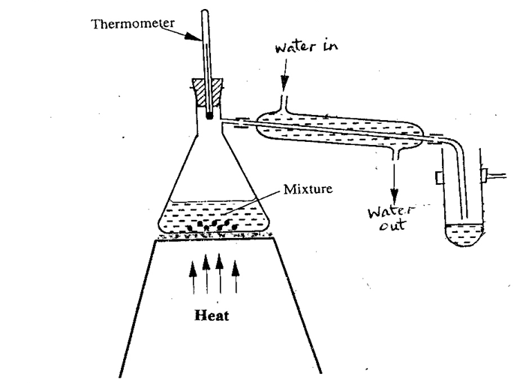

(a) Identify an error in the set-up. (1 mark)

(b) Name this method of separation. (1 mark)

(c) What properties make it possible to separate ethanol from water by this method? (1 mark)

- (a) On the grid provided sketch a graph of pressure against volume for fixed mass of gas at constant temperature. (1mk)

(b) 50dm³ of a gas at 1 atmosphere was compressed to 4 atmospheres at Constant temperature. Calculate the volume occupied by the gas (3mks)

- Carbon (ii) oxide gas was passed over heated iron (iii) oxide as shown below
Flame
Tube P
copper (ii)oxide
HEAT
Carbon (ii)oxide
oxide

(a) Give one observation made in tube P (1mk)

(b) Write an equation for the reaction which takes place in test tube P (1mk)

