**CHEMISTRY**

**FORM 2 EXAM**

**END OF TERM II, 2024**

**TIME: 2HOURS**

**Name: ……………………………………………………… Adm no: ……………………..……**

School: …………………………………………………….. Candidate’s Signature……………………

Date: ……………….………………..

1. *Answer* ***all*** *the questions in the spaces provided.*
2. *Write your* ***name*** *and* ***index number*** *in the spaces provided above.*
3. *Mathematical tables and electronic calculators may be used for calculations.*
4. *All workings* ***must*** *be clearly shown where necessary*

**For Examiner’s Use only:**

|  |  |  |
| --- | --- | --- |
| **QUESTION** | **MAXIMUM SCORE** | **CANDIDATE’S SCORE** |
| 1 – 19 | **80** |  |

1. (a) Define chemistry ( 1mrks)

(b) state three roles of chemistry in the society. (3mrks)

1. Putting out flames after use is one of the laboratory rules, state three other laboratory rules. (3mrks)
2. List two differences between temporary physical change and permanent chemical change.

(4mrks)

1. The set up below was used to study some properties of air

State and explain two observations that would be made at the end of the experiment.

(4mks)

1. The table below gives information about ions of **P** and **Y**

|  |  |  |
| --- | --- | --- |
| Ion | P+ | Y2- |
| Electron arrangement | 2.8 | 2.8.8 |
| Number of Neutrons | 12 | 16 |

1. Write the electron configuration for the atom of Y (1mk)

b) How many protons are there in the nucleus of (2mks)

(i)  **P**

(ii) **Y**

(c) Write the formula of the compound formed when **P** and **Y** reacts (2mks)

6. Diamond and graphite are allotropes of carbon.

1. What are allotropes? (1mk)
2. In terms of structure and bonding explain why diamond is used in drilling through hard rocks while graphite is a lubricant (2mks)
3. The diagram below is a set up for the laboratory preparation of gas F. 

(i) Name gas **F (1mrk)**

(ii) At the end of the experiment, the solution in the round bottomed flask was found to be

a strong base. Explain why this was so (2mrks)

(iii)Which property of gas **F** makes it be collected by the method used in the set-up?(1mrk)

**(iv)**Give **one** industrial use of gas **F (1mrk)**

1. Oxygen exists naturally as isotopes of mass number 16, 17 and 18 in the ratio 96:2:2 respectively. Calculate its R.A.M**. (3 mrks)**

9. The grid given below represents part of the periodic table. Study it and answer the questions that follow. The letters are not the actual symbols of the elements.

|  |  |  |  |  |  |  |  |  |
| --- | --- | --- | --- | --- | --- | --- | --- | --- |
|  |  |  |  | | | | | **A** |
| **B** |  |  | **G** |  | **H** | **E** |  |
|  | **J** | **I** | **L** |  |  |  | **C** |
| **D** |  |  |  |  |  | **M** |  |
| **Y** |  |  |  |  |  |  |  |
|  |  |  |  |  |  |  |  |

(i) What name is given to the family of elements to which A and C belong? **(1 mrk)**

(ii) Write the chemical formula of the sulphate of element D. **(1 mrk)**

(iii ) Which letter represents the most reactive **(2mrks)**

(a) Metal

(b) Non-metal

(iv) Select one element that belongs to period 4. **(1mrk)**

(v) Explain why the Ionic radius of element E is bigger than the atomic radius. **(2mrks)**

(vi) The electron configuration of a divalent anion of element N is 2.8.8. Indicate the position of element N on the periodic table drawn above. **(1mrk)**

(vii) How do the atomic radii of I and C compare. Explain. **(2mrks)**

(vii) Explain the trend in the 1st ionization energies of the elements J, I and L. **(1mrk)**

10. The following is a cooling curve of a certain substance.

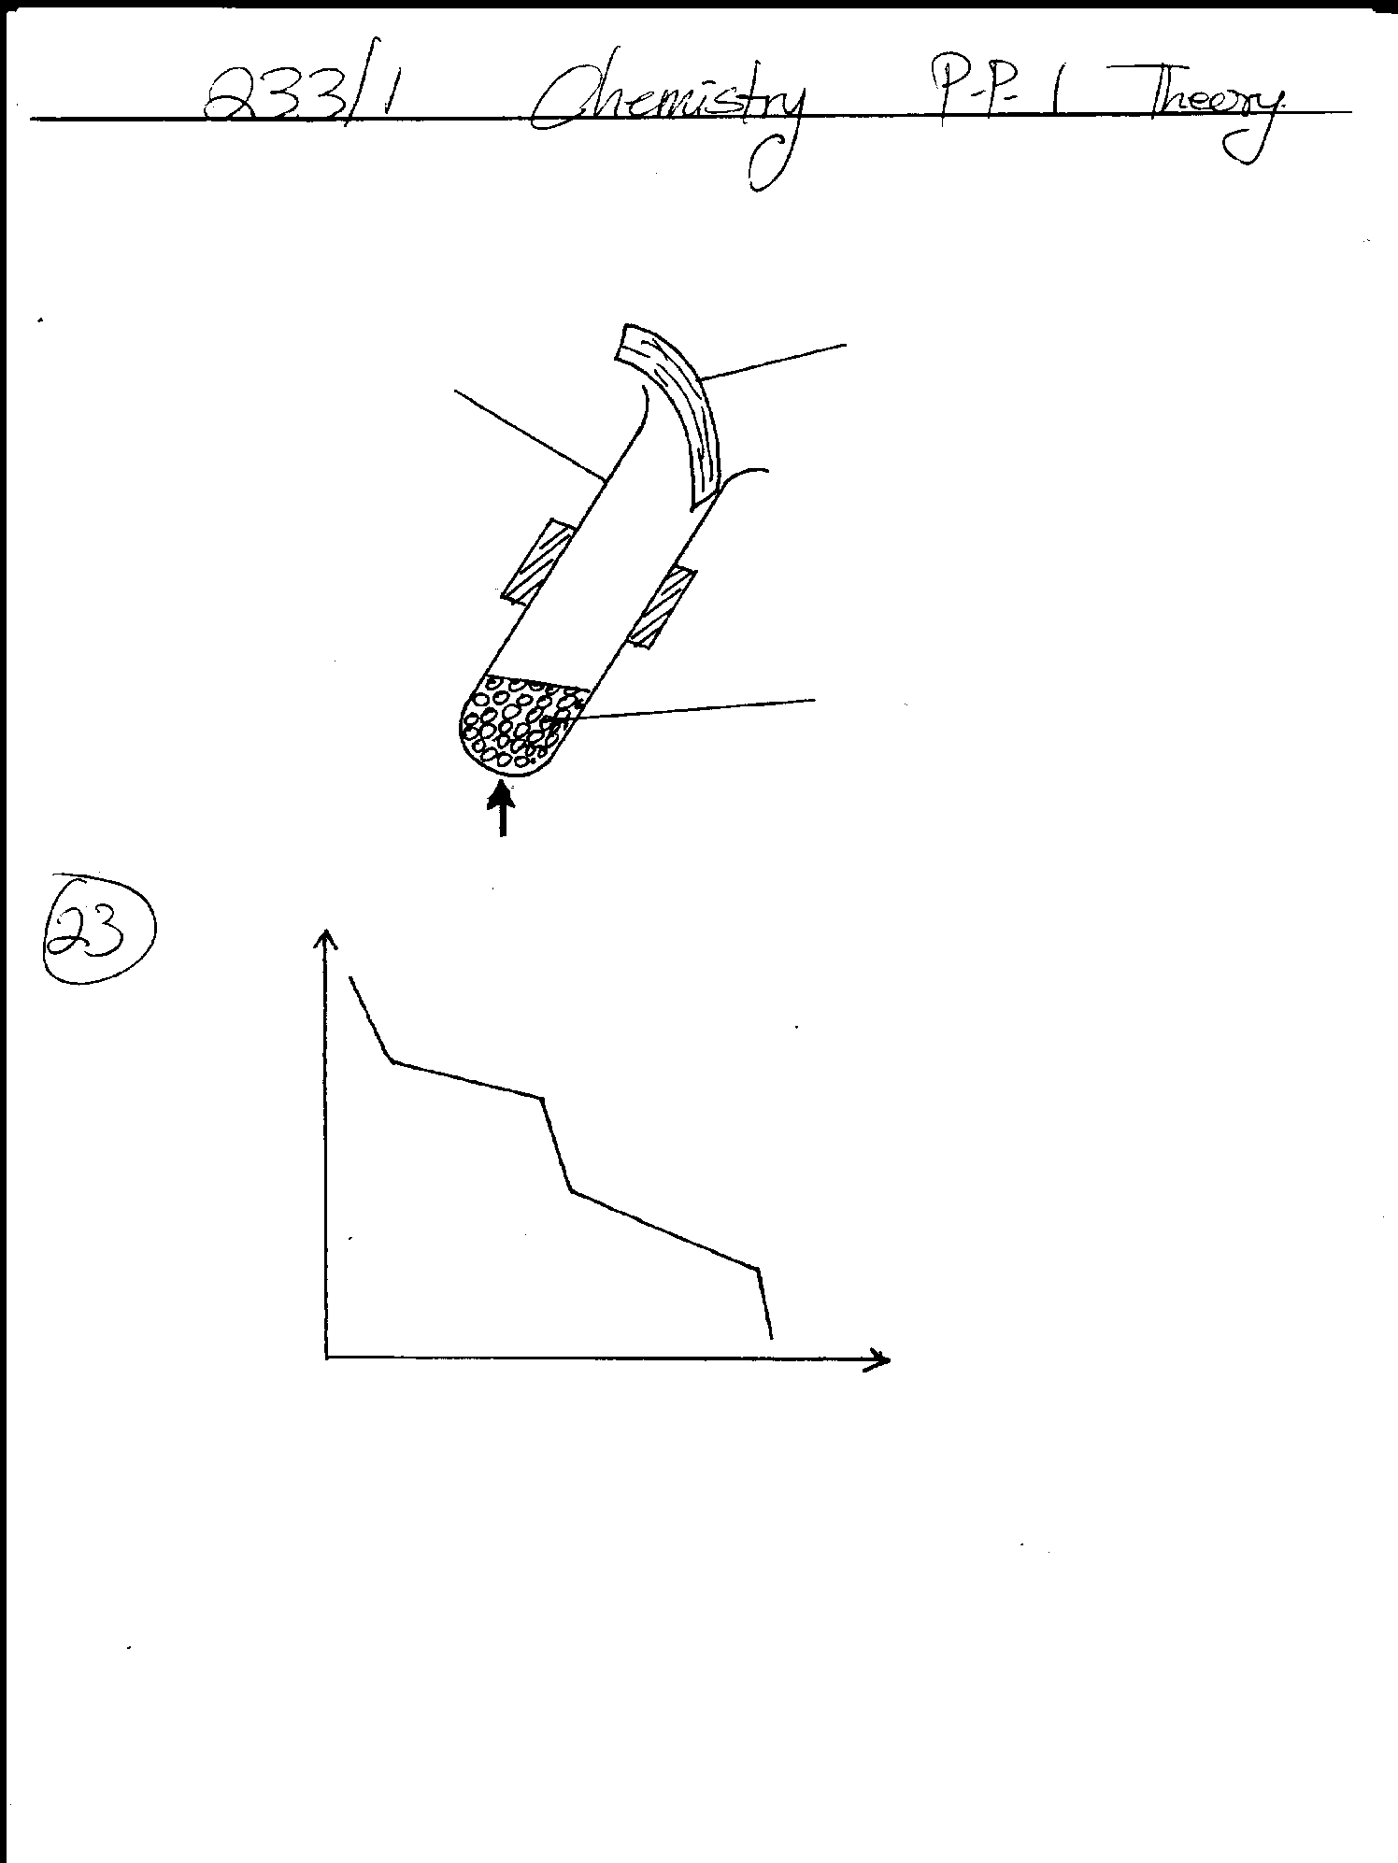

**B**

**A**

Time (min)

Tem (0C)

**(a)** Is this a pure or impure substance? Explain **(2mrks)**

**(b)** Explain using kinetic theory what happens in region **A**  **(2mrks)**

11.The following is a list of pH values of some substance:

|  |  |  |  |  |  |
| --- | --- | --- | --- | --- | --- |
| Substance | **M** | **N** | **V** | **X** | **Z** |
| pH | 10.6 | 7.2 | 13.2 | 5.9 | 1.5 |

Identify:

**(i)** Strong acid **(1mrk)**

**(ii)**Weak base **(1mrk)**

12**.** Briefly explain the following:

**(a)** Alkaline earth metals are generally less reactive than-alkali metals. **(2mrks)**

**(b)** Though sodium and aluminum are in the same period and are both metals, aluminum is a better conductor of electricity.  **(2mrks)**

13. Two papers **A** and **B** were placed at different levels of a non-luminous flame. Paper **A** was placed at the lowest part of the flame while **B** was placed at the tip.

(a) Indicate **below** the observations made on each paper. (2mrks)

Paper **A** Paper **B**

(b) Explain the observations made on paper **A**. (1mrk)

14**.** Balance the following equations. **(4mrks)**

**i.** Cl2 (g) + NaOH (aq) NaCl (aq)+ NaOCl(aq) + H2O(l)

**ii**. Cl2(g) + KOH(aq) KCl(aq) + KClO3(aq) + H2O(l)

**iii.** Fe Cl2(aq) + Cl2( g) FeCl3(aq)

**iv**. Mg(s) + Cu SO4(aq) MgSO4(aq) + Cu(s)

15. You are provided with water, lead carbonate, dilute nitric (V) acid and solid sodium chloride. Describe in very clear steps how you would prepare a sample of lead chloride.

(3 mrks)

16. The set up below was used to obtain a sample of iron.

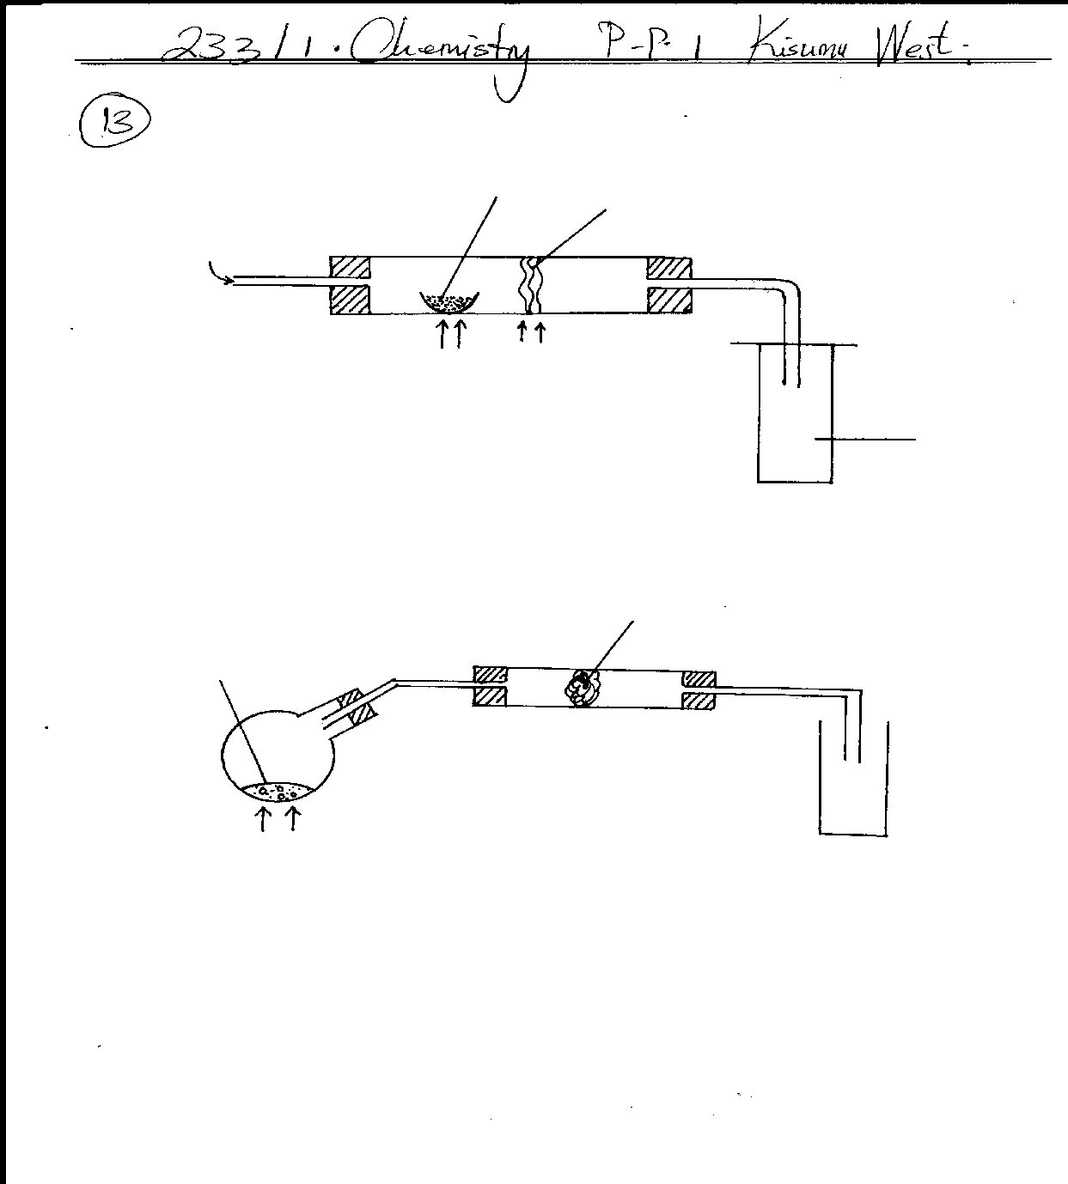

**Carbon**

**Excess Iron (II) oxide**

**Oxygen**

**Heat**

**Heat**

**Gas Q**

i) Write **two** equations for the reaction which occur in the combustion tube. (2mks)

ii) Identify gas **Q** (1mrk)

17. The diagram below shows a set up which was used by a student to investigate the effect of electricity on molten lead (II) iodide. 

(a) Explain what happens to the lead iodide during the electrolysis. (2mrks)

(b) Why does solid lead (II) iodide not allow the passage of electricity? (1mrk)

(c) Write equations to show the reaction taking place:

(i) At the cathode. (1mrk)

(ii) at the anode (1mrk)

18. Write balanced equations for the following reactions: (8mrks)

(a)Calcium carbonate and hydrochloric acid.

(b)Magnesium and Sulphuric (VI) acid.

(c)Copper (II)Oxide and Nitric (V)acid.

(d)Sodium Hydroxide solution and Hydrochloric Acid.

19. State three applications of carbon (iv) oxide (3mrks)