CHEMISTRY
FORM 1 EXAM
END OF TERM II 2024 EXAM
TIME: 2HOURS

Name: …………………………………… Adm no: ………………

Class: …………………………………..

- Answer all the questions in the spaces provided.

- Write your name and index number in the spaces provided above.

- Mathematical tables and electronic calculators may be used for calculations.

- All workings must be clearly shown where necessary

For Examiner’s Use only:

QUESTION | MAXIMUM SCORE | CANDIDATE’S SCORE
1 – 16 | 80

1. Define the following terms
a) Drug (1mrks)

b) Prescription (1mrks)

c) Drug abuse (1mk)

2.Nekesa visited a hospital and was given a syrup whose prescription was 2×3. .How should she take the syrup? (2mrks)
3. (a) Why are most of the apparatus in chemistry laboratories made of glass? (2mrks)

(b) Name two apparatus used for accurate measurement of volume. (2mrks)

4. The flow-chart below shows the physical changes of states matter. Study it and answer the questions that follow.

A
C E
Solid D Liquid F Gas

B
Name the processes. (6mks)
A

D

E

F

B

C

5. Differentiate between physical and chemical changes. (2mks)

6. State three differences between a luminous and non-luminous flame. (6mrks)

7. Define the following terms (4mrks)
a) An atom

b) A molecule

c) An element

d) A compound

8. Complete the following table (6mrks)
Element | Symbol
potassium
 | Na
Silver
 | Au
Iron
 | Pb
Copper
Mercury

9. Name the elements present in the following compounds.
a) Sodium Bromide (2marks)

b) Magnesium nitride (2marks)

c) magnesium carbonate (3mrks)

10. Write a word equation for the reaction between:
a) Carbon and oxygen (1mrks)

b) Sulphur and fluorine (1mrks)

(c) Zinc and bromine (1mrks)

v) Potassium and chlorine (1mrks)

11. (a) Complete the table below. (3mrks)

Indicator name | Colour in
 | Acid | Base | Neutral
Litmus | Red
Phenolphthalein |  |  | colourless
Methyl orange | Pink

(b) Five solutions were tested with universal indicator and their PH values recorded.
Solution | pH value
A  B  C  D  E | 11  2  6  7  13

i) Which solution is a strong acid? (1mrk)

ii) Which solution is a weak acid? (1mrk)

iii) Which solution is neutral? (1mrk)

iv) Which solution is a strong base? (1mrk)

v) Which solution is a weak base? (1mrk)

12. When a student was stung by a stinging nettle plant, a teacher applied an aqueous solution of ammonia to the affected area of the skin and the student was relieved of pain. Explain why the student was relieved off the pai9n and state the importance of the aqueous solution of Ammonia in the affected area of the skin. (2 mks)

13. Spots of three pure pigments A, B and mixture Z were placed on a filter paper and allowed to dry. The paper was then dipped in a solvent. The results obtained were as on the paper chromatogram.
- Identify;
- Baseline. (1 mark)

- Solvent front. (1 mark)

- Which pure pigment was component of Z? Explain. (2 mark)

14. Classify the following as either physical or chemical changes. (5mks)
a) Freezing of water.

(b)Rusting of iron

(c)Heating of glass until it melts

(d)Burning a candle.

(e)Heating copper (II) nitrate

15. The apparatus below were used to determine the volume of oxygen in air. About 200cm³ of air was passed repeatedly from syringe A to syringe B over heated copper turnings as shown in the diagram. After sometime, the volume of air in the syringe A was 160cm³ and syringe B 0cm^{3.}
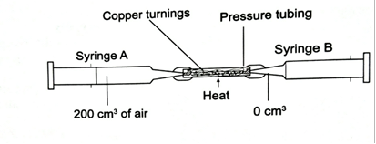

- Write a chemical equation for the reaction that took place in the combustion tube. (1mk)

- Calculate the percentage of oxygen in the initial sample of air. (3mks)

- State two possible sources of errors in the experiment. (2mks)

16.A form one class carried out an experiment to determine the active part of air. The diagram below shows the set-up of the experiment and also the observation made.
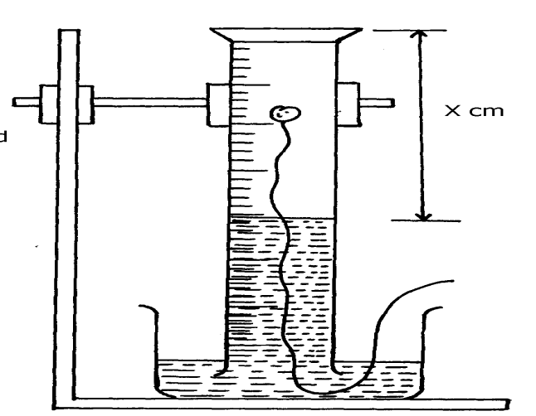
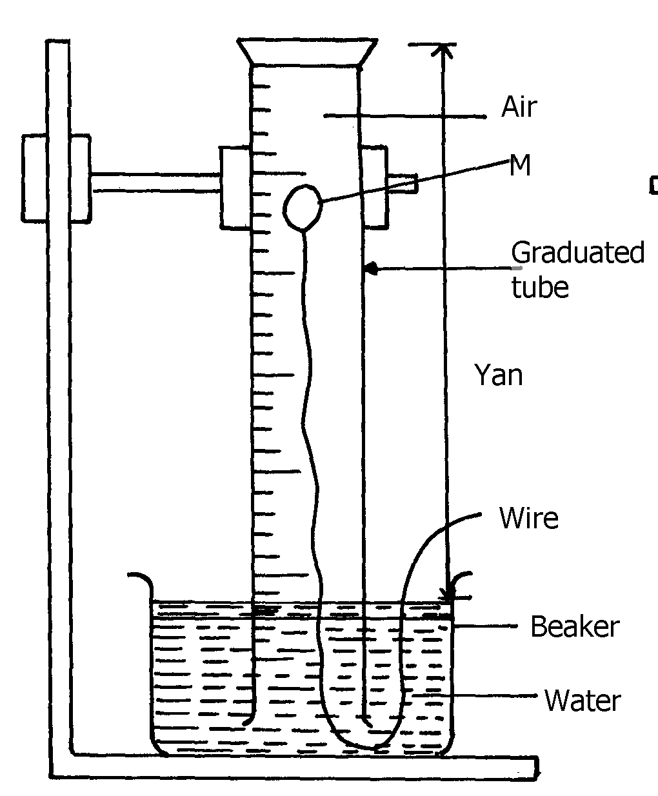
(i) At the beginning (ii) observation at the end of the experiment

y cm

Air

(i) Identify substance M (1mrk)

(ii) State two reasons why substance M was preferred in this experiment. (2 mks)

(b) Write the equation for the reaction of substance M and the active part of air (1mrk)

(c) (i) Using the letters Y and X write an expression for the percentage of the active part of air(2mrks)

(ii) The expression in (c)(i) above gives lower value than the expected. Explain (2mrks)

(d) (i) Explain the observation made when red and blue litmus paper is dipped into the beaker at the end of the experiment (2mrks)

(ii) Name the active part of air (1mrk)

