GRADE 7 BUSINESS STUDIES NOTES TERM 1,2,3
STRAND ONE
BUSINESS AND MONEY MANAGEMENT SKILLS
- Introduction to Business Studies
- Business: Any activity that is carried out by an individual or an
organization concerning provision of goods and services with a view
to making profit.
- Business studies: Is the study/examination of the business activities in society. These activities are related to the production of goods and
provision of services.
-It can also be defined as the study of activities that are carried out in
and around production, distribution and consumption of goods and
services.
Components of Business studies
Business studies consist of the following disciplines
a. Commerce
b. Accounting
c. Economics
d. Office practice
e. Entrepreneurship
- Commerce
This is the study of trade and aids to trade. Trade refers to the exchange of goods and services for other goods and services or money. Aids to trade are human activities (services) that assist trade to take place.
- Economics
This is the study of how human beings strive to satisfy their endless wants using the available scarce resources.
- Accounting
This refers to a systematic way of recording business activities which all used
for decision making.
- Office practice
This refers to all activities that are carried out in an office e.g. communication, filling, clerical work, reproduction of documents etc.
- Entrepreneurship
This is the study of activities involved in the process of identifying a business opportunity and acquiring the necessary resources to start and run a business. The person who carries out these activities is referred to as an entrepreneur.
Importance of Business studies
Some of the benefits of learning business studies include:
i. Assists the learners/members of the society to acquire knowledge and awareness of business terminologies which are necessary when discussing business issues such as profit and loss.
ii. Assists the individuals in appreciating the role of business in society/in provision of goods and services.
iii. It enables the learners to acquire basic knowledge, skills and attitudes necessary for the development of self and the nation by starting and operating business.
iv. Equips the members of society with knowledge and skills necessary to start and run a business comfortably.
v. Makes the members of society to appreciate the need for good business management practices
vi. Assists individual to acquire self-discipline and positive attitude towards work
vii. Equips individual with abilities to promote co-operation in society through trade
viii. Enables the individual to understand the role of government in business activities
ix. Equips individuals with abilities to understand the role of communication and information technology in modern business management
x. Helps the individuals to develop positive attitudes towards the environment
xi. Equips the individual with knowledge and skills required to evaluate business performance
xii. It helps individual to develop various intellectual abilities such as inquiry, critical thinking, analysis, interpretation, rational judgement, innovation and creativity.
xiii. It enables learners to acquire skills for wise buying and selling.
xiv. It creates a firm foundation for further education and training in business and other related fields.
xv. It enables one to understand and appreciate the basic economic issues that affect the society such as increase in prices of goods and services.

Career opportunities in the field of business studies
- Auditor.
- Logistics analyst.
- Human resources specialist.
- Accountant.
- Operations analyst.
- Marketing manager.
- Financial advisor.
- Financial analyst
- Entrepreneur
- Money
- whatever serves society in four functions: as a medium of exchange, a store of value, a unit of account, and a standard of deferred payment.
- Money is power if you utilize it with knowledge. Money is dangerous if you are greedy for money and utilize it without thought. – Vijay Sharma
Uses of Money in daily life
- First, money serves as a medium of exchange, which means that money acts as an intermediary between the buyer and the seller. Instead of exchanging accounting services for shoes, the accountant now exchanges accounting services for money. This money is then used to buy shoes. To serve as a medium of exchange, money must be very widely accepted as a method of payment in the markets for goods, labor, and financial capital.
- Second, money must serve as a store of value. In a barter system, we saw the example of the shoemaker trading shoes for accounting services. But she risks having her shoes go out of style, especially if she keeps them in a warehouse for future use—their value will decrease with each season. Shoes are not a good store of value. Holding money is a much easier way of storing value. You know that you do not need to spend it immediately because it will still hold its value the next day, or the next year. This function of money does not require that money is a perfect store of value. In an economy with inflation, money loses some buying power each year, but it remains money.
- Third, money serves as a unit of account, which means that it is the ruler by which other values are measured.
- Money fulfills your personal and family needs and desires:
Money has the power to buy goods and services. With money, a person can fulfill his daily living needs and desires. With money, you can buy food, clothes, a home, a car, holiday tour packages, and gifts. With money, you can buy a high-speed internet connection and good quality equipment for work and business.
Key security features of the Kenyan Currency
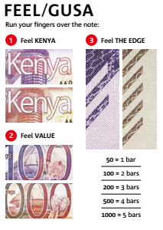
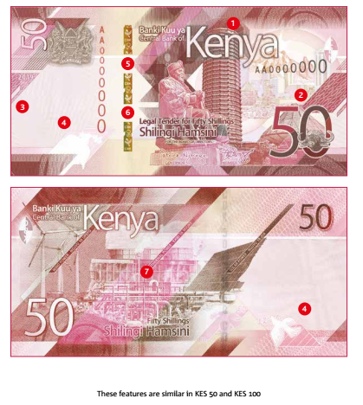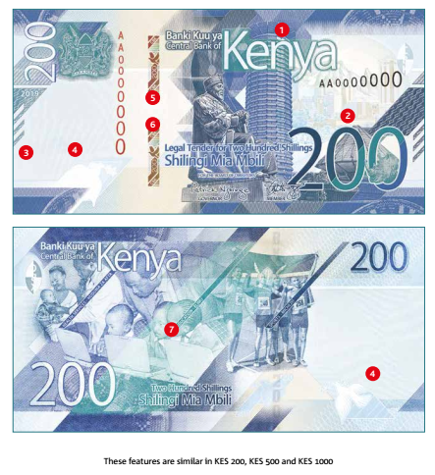

Themes and symbols in the Kenyan currency
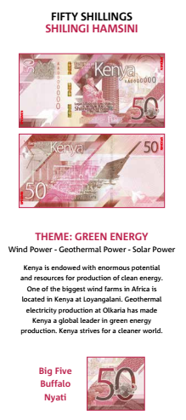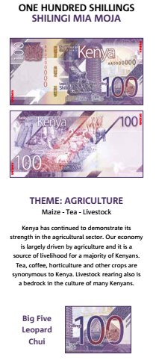

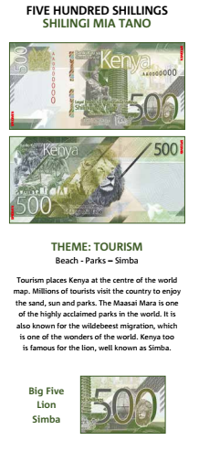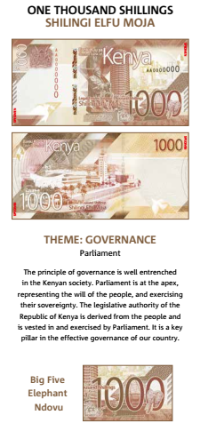

- Personal Goals
- Goals are defined as the desired states that people seek to obtain, maintain, or avoid. Personal goals are goals related to your work, relationship, finances, and other aspects of life.
There are three types of goals- process, performance, and outcome goals.
- Process goals are specific actions or ‘processes’ of performing. For example, aiming to study for 2 hours after dinner every day. Process goals are 100% controllable by the individual.
- Performance goals are based on personal standard. For example, aiming to achieve a 3.5 GPA. Personal goals are mostly controllable.
- Outcome goals are based on winning. For a college student, this could look like landing a job in your field or landing job at a particular place of employment you wanted. Outcome goals are very difficult to control because of other outside influences.
Process, performance, and outcome goals have a linear relationship. This is important because if you achieve your process goals, you give yourself a good chance to achieve your performance goals. Similarly, when you achieve your performance goals, you have a better chance of achieving your outcome goal.
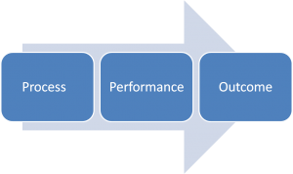
General Goal Setting Tips
- set both short- and long-term goals
- set SMART goals
- set goals that motivate you
- write your goals down and put them in a place you can see
- adjust your goals as necessary
- Recognize and reward yourself when you meet a goal
Set all three types of goals- process, performance, and outcome – but focus on executing your smaller process goals to give you the best chance for success!
- specific – highly detailed statement on what you want to accomplish (use who, what, where, how etc.)
- Measurable- how will you demonstrate and evaluate how your goal has been met?
- Attainable- they can be achieved by your own hard work and dedication- make sure your goals are within your ability to achieve
- Relevant- how do your goals align with your objectives?
- Time based- set 1 or more target dates- these are the “by whens” to guide your goal to successful and timely completion (include deadlines, frequency and dates)
Be Clear About Your Purpose in Life
First, be clear about your purpose in life. Having a clear vision in life gives you direction. You know where you are coming from and where you are going. The destination is definite, and this gives you a foundation for your goal setting.
Why These Goals?
Having a foundation for goal setting gives you a destination. The next step is to look at the goals you have in mind and ask yourself why these goals in specific. Let’s say you want to get from Nairobi to Mombasa. You can walk, run, hire a taxi, take a bus, take a train or take a flight.
In the end, you will have to choose one means of transport to get you to Mombasa. If you take a bus, ask yourself why the bus? Why not walk or take a flight? If you can answer the why in your goals. And hopefully, your answer will not be because everyone is doing it, then you are on the right path.
Do The Goals Motivate You?
Do you get motivated when you look at your goals? Remember your why. If the answer to your why is because everyone is doing it, the motivation is going to low. When challenges set in and everyone gives up, you will give up with them or give up when others are still on the move.
Set goals that motivate you. Motivation has to come from the heart. Remember, this is a journey. It is not a destination in itself. Your inner drive will keep you moving when the going gets tough.
You Goals Must Be Specific To You
Your goals have to be specific to you. Do not set random goals just because that is what is expected from you. Let’s say you have a target to meet at the end of the month set by your company. The targets are not specific to you. In most cases, they are distinct to your department but general to you and your colleagues.
A successful person will take the targets set and personalize them. What is it you want to achieve at the end of the month as far as the goals set for your team are concerned? Do you want to meet the exceptions, or do you want to exceed them? Set your weekly and daily goals to reflect what you want to achieve as an individual.
Goals Have To Be Relevant To Your Higher Purpose In Life
Your goals must be relevant to your higher purpose in life. If not, you will deviate from your purpose or vision. Set goals to reflect, and feed your cause. The danger in working on plans that don’t align with your purpose or mission, you end up working for other people.
Proverbs 16:3 New International Version (NIV)
Commit to the Lord whatever you do, and he will establish your plans.

Starting to Set Personal Goals
You set your goals on a number of levels:
- First you create your "big picture" of what you want to do with your life (or over, say, the next 10 years), and identify the large-scale goals that you want to achieve.
- Then, you break these down into the smaller and smaller targets that you must hit to reach your lifetime goals.
- Finally, once you have your plan, you start working on it to achieve these goals.
This is why we start the process of setting goals by looking at your lifetime goals. Then, we work down to the things that you can do in, say, the next five years, then next year, next month, next week, and today, to start moving towards them.

Step 1: Setting Lifetime Goals
The first step in setting personal goals is to consider what you want to achieve in your lifetime (or at least, by a significant and distant age in the future). Setting lifetime goals gives you the overall perspective that shapes all other aspects of your decision making.
To give a broad, balanced coverage of all important areas in your life, try to set goals in some of the following categories (or in other categories of your own, where these are important to you):
- Career – What level do you want to reach in your career, or what do you want to achieve?
- Financial – How much do you want to earn, by what stage? How is this related to your career goals?
- Education – Is there any knowledge you want to acquire in particular? What information and skills will you need to have in order to achieve other goals?
- Family – Do you want to be a parent? If so, how are you going to be a good parent? How do you want to be seen by a partner or by members of your extended family?
- Artistic – Do you want to achieve any artistic goals?
- Attitude – Is any part of your mindset holding you back? Is there any part of the way that you behave that upsets you? (If so, set a goal to improve your behavior or find a solution to the problem.)
- Physical – Are there any athletic goals that you want to achieve, or do you want good health deep into old age? What steps are you going to take to achieve this?
- Pleasure – How do you want to enjoy yourself? (You should ensure that some of your life is for you!)
- Public Service – Do you want to make the world a better place? If so, how?
Spend some time brainstorming these things, and then select one or more goals in each category that best reflect what you want to do. Then consider trimming again so that you have a small number of really significant goals that you can focus on.

- Talents and Abilities
For many people, the words “talent” and “ability” are interchangeable. Understanding the difference between them can make all the difference in how we live and work. Here at Pro/spur, one of the first lessons we share with our players is recognizing their talent vs. their ability. So what is the difference?
Talent is what you’ve been given.
Ability is how you grow the talent you’ve been given.
Right now, there are more than 8,000 pro players in Minor League baseball. Do you know how many of those players have enough talent alone to make it to the Big Leagues and stay there? The answer: not that many.
Ways of Nurturing talents
Create an Open Culture
Firms are a product of multiple people’s contributions. Each worker should feel like their words have weight and that their input is valued.
Everything starts with the workplace culture, which gives new starters the confidence to stick around and keeps more experienced personnel grounded and loyal. Encourage employees to speak up if they have any concerns or thoughtful ideas.

Develop Mentoring Schemes
Mentoring is an enormous part of nurturing talent. However, finesse is required in how your company approaches it. Vague instances of encouragement aren’t enough to keep workers motivated and performing well.
Introduce Automation
Workers with many responsibilities can soon become overwhelmed. The most overworked staff members may find little time to focus on their own professional development.
Automation can ease these burdens somewhat. These technologies can assume many of the admin tasks a worker needs to do. Signing paperwork, scheduling updates, responses to routine emails – these are all tasks automation can oversee instead of the employee. Work-related stress can be reduced as a result.
Offer Flexibility
Nurturing talent can’t be done under overly rigid work practices. Employees need to grow both personally and professionally and to do so effectively, they need a level of control.
Keep Innovating
Your business needs to aspire to be greater constantly. Only then can you expect your workers to adopt a similar attitude.
Of course, your business may be more concerned about surviving rather than thriving these days. Irrespective of your circumstances or the economic conditions you’re facing, your company must keep pushing to innovate and excel within its industry.
Personal Talents and Abilities
Communication.
Interpersonal skills.
Leadership.
Problem-solving.
Time management.
Adaptability.
Critical thinking.
Organization.

Five kinds of talent categories:
- Self-conceptual talents – like self-awareness, self-regulation, self-motivation, and self-confidence.
- Social talents – like social awareness, communication, relationship management, collaboration, and influence.
- General talents – like language skills, mathematical abilities, reasoning, visual-spatial processing, and learning abilities.
- Specific expertise – like strategic thinking, arts, writing, research, sports, design, storytelling, and kinesthetic abilities.
- Fun talents – any cool talents such as exceptional taste, ventriloquism (ability to make your voice appear from somewhere else or with delay), and hypermobility, to name a few.
Ethical Issues related to use of talents and abilities in business
Ethical issues in business occur when a decision, activity or scenario conflicts with the organization’s or society's ethical standards. Both organizations and individuals can become involved in ethical issues since others may question their actions from a moral viewpoint.
1. Discrimination and harassment
Two of the most significant ethical issues that HR professionals and managers face are discrimination and harassment. The consequences of discrimination and harassment in the workplace can negatively impact the finances and reputation of the organization. Many countries have anti-discrimination laws to protect employees from unfair treatment. Some anti-discrimination areas include:
- Age: Organizations and internal policies cannot discriminate against employees who are older.
- Disability: To prevent disability discrimination, it's important to accommodate and provide equal treatment for employees with mental or physical disabilities.
- Equal pay: Equal pay focuses on ensuring that all employees receive equal compensation for similar work, regardless of religion, gender or race.
- Pregnancy: Pregnant employees have a right not to be discriminated against on account of their pregnancy.
- Race: Employees should receive equal treatment, regardless of ethnicity or race.
- Religion: Employees' religious beliefs should not affect how anyone within the organization treats them.
- Sex and gender: An employee's sex and gender identity should not influence their treatment while working at an organization.
2. Ethics in accounting practices
Laws require organizations to maintain accurate bookkeeping practices. Unethical accounting practices are a serious issue, especially for publicly traded companies. The legislation specifies financial report requirements aimed at protecting shareholders and consumers. All organizations have to keep accurate financial records and pay taxes to attract investment and business partners regardless of the size of the company.
3. Nepotism or favoritism
As a hiring manager or HR professional, you may want to employ an acquaintance or family member because of your connection to them. Even if you adhere to recruitment policies to ensure a fair process, some employees may still consider this as nepotism or favoritism. Favoritism occurs when managers treat some employees better than others for no professional reason. This can reduce productivity and job satisfaction in other employees, which may negatively impact the entire organization.
4. Workplace health and safety
All employees have a right to a safe working environment and work conditions.
Importance of Nurturing talents and abilities
Nurturing internal talent can benefit your business in many ways:
Facilitate success. Nurturing the talent you already have allows you to facilitate opportunities for cross-training, career development and networking.
Create a culture of innovation and empowerment. Nurturing your existing talent creates a culture of innovation and empowerment, in which employees know they are valued and they are motivated to strive for excellence
Open leadership opportunities. Nurturing the talent of your teams enables you to foster a culture in which leadership opportunities abound.

STRAND TWO
BUSINESS AND ITS ENVIRONMENT
  - Business activities
Needs and wants
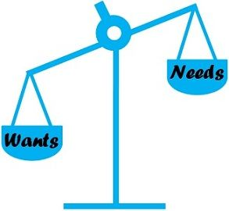
BASIS FOR COMPARISON | NEEDS | WANTS
Meaning | Needs refers to an individual's basic requirement that must be fulfilled, in order to survive. | Wants are described as the goods and services, which an individual like to have, as a part of his caprices.
Nature | Limited | Unlimited
What is it? | Something you must have. | Something you wish to have.
Represents | Necessity | Desire
Survival | Essential | Inessential
Change | May remain constant over time. | May change over time.
Non-fulfillment | May result in onset of disease or even death. | May result in disappointment

Scarcity, Choice, Scale of preference and opportunity cost
The basic concept or elements of economics are:
- wants,
- scarcity,
- scale of preference,
- choice and
- opportunity cost.
Wants
Wants simply means the desire or wish to own goods or services that give satisfaction. Goods include things such as cars, radios, food, houses, books, etc., (that is tangible commodities), while services includes hair dressing, the services of an actor, etc(that is intangible commodities). Want s are also called ENDS.
As these basic needs are satisfied, other needs will arise. That is why we say that human wants are insatiable. This is because human wants are unlimited while resources used in satisfying them are limited.
SCARCITY
Scarcity refers to the limited available resources used in satisfying the unlimited human wants.
These resources are scarce relative to their demand. It is as a result of scarcity of resources that needs the study of economics very essential in order to find alternative uses of these scarce resources. The available resources cannot satisfy all human wants. Since human wants are unlimited or insatiable relative to the available resources, we have to choose the most pressing ones and leave others that are less important because resources are scare.
As a student you will need to buy school materials, e.g exercise books worth #100.00 but you have only #50.00. it can be seen that the money you have (#50.00), which is your resources, will not be sufficient to buy all you need. The available resources within the environment can never at any time be in abundance to satisfy all human wants.
If resources were to be unlimited or abundant, no economics problem would arises and there would be no need for a study of economics. Scarcity is the central or basic economic problems
SCALE OF PREFERENCE
Scale of preference refers to a list of unsatisfied wants arranged in order of their relative importance.
A scale of preference refers to a list of unsatisfied wants arranged in order of priority or importance. This aids decision-making. The most pressing needs are ranked first followed by the less pressing ones. In other words, it is a list showing the order in which we want to satisfy our wants arrange in order of priority.
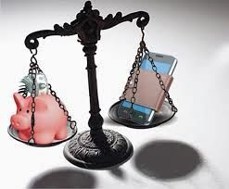
The drawing of scale of preference will make it easier for choice to be made. In order to achieve maximum satisfaction with limited resources at their disposal, an individual, firm and unsatisfied wants in order of priority.
Each individual is assumed to have a scale of preference. This is because economics theory assumes that people always behave rationally and would satisfy their most pressing want first.
For example, a student might rank his wants in following order according to their level of importance:
- Pair of school uniform
- Exercise books
- Wrist watch
- Dictionary
- Scientific calculator
- An arm chair
If he is to choose between items 1 and 4, he chooses the first. Scale of preference of individuals, firms and the government differ from time to time.
IMPORTANCE OF SCALE OF PREFERENCE
- Ranking of needs
- Financial prudence
- Identification of highest priority
- Rational choice
- Efficient utilization of limited resources
- Optimum allocation of resources
- Maximization of satisfaction
The importance of scale of preference can be paraphrased this way also:
- It helps individuals to rank their needs in order of importance.
- It helps us to manage our resources properly.
- It helps both individuals and government to identify the most important needs.
- It enhances optimum allocation of resources.
- It helps individuals, firms and government in the efficient utilization of resources.
- It helps economic agents to maximize their satisfaction.
- It helps individuals to make rational decision.
CHOICE
Choice can be defined as a system of selecting or choosing one out of a number of alternatives. Human wants are many and we cannot satisfy all of them because of our limited resources.
We therefore, decide which of the wants we can satisfy first. Choice arises as a result of numerous human wants and the scarcity of the resources used in satisfying these wants.
OPPORTUNITY COST
Opportunity cost is also known as a real cost or time cost.
The concept of opportunity cost is used in economics to express cost in terms of foregone or sacrificed alternatives. Opportunity cost means the alternative foregone or sacrifice made in order to satisfy another want. It is the satisfaction of one’s want at the expense of another want.
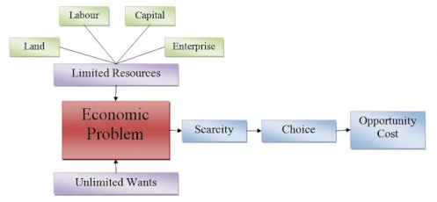
Types of Business activities
People carry out different business activities in order to earn income.
Business activities are activities which involve the provision of goods or services with an aim of earning a profit.
Activities done without the intention of making profit are referred to as
non-business activities. Business activities may be grouped into the following seven categories:
a) Extraction
This involves obtaining goods from their natural setting e.g. mining, farming, lumbering, fishing, quarrying e.t.c
b) Processing-This involves the conversion of raw materials into more
useful products without combining it with other goods. Examples here
include milling/grinding flour, refining oil, tanning of skins and hides,
conversion of iron into steel e.t.c
c) Manufacturing-This involves combining different raw materials to
come up with one final product. Such activities include bread baking,
making a table e.t.c
d) Construction-This involves building of structures such as
bridges, ships, aeroplanes, houses, roads, railways e.t.c
e) Distribution of goods-This refers to the activities involved in moving
goods from where they are produced to where they are needed. People
who carry out distribution are called distributors. Examples of
distributors are wholesalers and retailers.
f) Trade-Activities in this category involve the buying and selling of
goods with a view of making a profit. People involved in trade are called
traders.
g) Provisions of Services-Activities in this category involve human acts which could be mental or physical. These include activities such as haircutting, hair styling, car-washing, nursing, teaching, driving, and entertaining e.t.c.
Purpose of Business activity
- Provides goods and services from limited resources to satisfy unlimited wants
- Scarcity is the result of the economic problem – limited resources and unlimited wants
- Choice is necessary for scarce resources. This leads to opportunity costs
- Specialization is required to make the most out of sources
Business activity
- Combines factors of production to create goods and services
- Goods and services satisfy peoples’ wants
- Employs people and pays them wages so they can consume other products
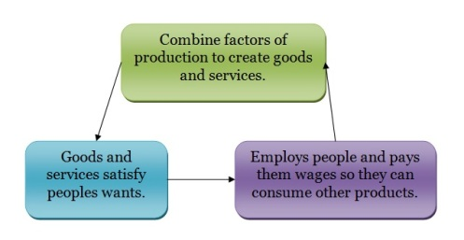

Business objectives
All businesses have objectives or aims to achieve. Their objectives may vary depending on the type of business and the situation the business is in. The most common objectives are:
- Profit: Profit is what keeps a company going and is the main objective of most businesses. Normally a business will try to obtain a satisfactory level of profits so they do not have to work long hours to pay too much tax.
- Increase added value: Value added is the difference between the price and material costs of a product. E.g.: If the price when selling a pen is Ksh. 3 and it costs Ksh.1 in material, the value added would be Ksh.2. However, this does not take in account overheads and taxes. Added value could be increased by working on products so that they become more expensive finished products. One easy example of this is a mobile phone with a camera would sell for much more than one without it. Of course, you will need to pay for the extra camera but as long as prices rise more than costs, you get more profit.
- Growth: Growth can only be achieved when customers are satisfied with a business. When businesses grow they create more jobs and make them more secure when a business is larger. The status and salary of managers are increased. Growth also means that a business is able to spread risks by moving to other markets, or it is gaining a larger market share. Bigger businesses also gain cost advantages, called economies of scale.
- Survival: If a business do not survive, its owners lose everything. Therefore, businesses need to focus on his objective the most when they are: starting up, competing with other businesses, or in an economic recession.
- Service to the community: This is the primary goal for most government owned businesses. They plan to produce essential products to everybody who need them.
These business objectives or aims can conflict because different people in a business want different things at different times.
  - Goods and services
Types of goods and services
We desire to have all the things to satisfy our present and future wants. Thus, our desire is for all those things that satisfy our wants.
All these things are either material goods or services. If something is not wanted by anybody it will not be called a good or service.
Therefore, we can divide the things that we wants into two categories:
(i) Goods and
(ii) Services.
Goods are material things wanted by human beings. They can be seen or touched. Services are non-material things. These cannot be seen or touched only their effects are felt. When we are hungry, we take food. When we fall sick, we take medicines. When we study, we use book, notebook, pen, paper etc. All these are examples of goods which satisfy some of our wants. All the things which satisfy human wants are good.
However, wants for haircut, washing of cloths, mending of shoes, stitching of cloths, studying in a school or a college etc. are not satisfied by goods. These are satisfied by the services performed by a barber, washer man, cobbler, tailor and teacher etc. So some of our wants are satisfied by goods and some by services. Hence, all the human wants can be satisfied by goods and services.
Classification of Goods and Services:
Goods and services are of many types. However, these can be classified into some broad groups.
These are discussed below:
(i) Free Goods and Economic goods:
The goods which have unlimited supply and are provided as free gift of nature. The goods which are not man-made and do not have to pay anything to get them. These goods are known as ‘Free Goods’. For example, air, sea, water, sunlight, sand in the desert etc. On the other hand, goods like vegetables, grains, minerals, fruits, fishes etc. which are neither man-made nor unlimited supply of nature are known as ‘Economic Goods’ All these goods are sold and purchased in the market only.
(ii) Free Services and Economic Services:
Services which cannot be bought in the market and which are only rendered out of love, affection etc. are known as ‘Free Services’. For example, all services given by the parents to their children are free services. However, all the services that can be bought in the market are ‘Economic Services’. Services rendered by doctors, teachers, lawyers, barbers, cobblers etc. are the example of economic services.
(iii) Consumer Goods and Capital Goods:
The goods which are directly used by the consumer for the purposes of consumption are known as ‘Consumer Goods’ The example of consumer goods are bread, biscuit, butter, jam, rice, fish, egg, shoes, shirts, fan, book, pen, cooking gas etc. On the other hand, all the goods which are not directly used to satisfy consumption but which are used in further production are called ‘Producer Goods’ or ‘Capital Goods’. The examples are seeds, fertilizers, tools, machines, raw materials etc.
(iv) Consumer Services and Producer Services:
When services are used directly by consumers to satisfy their wants, they are called consumer services. When services are used by producers to produce other goods and services, they are called producer services. When the tailor stitches our shirt, it is a consumer service However when the tailor stitches a shirt for a readymade garments shop, the service rendered by him is a producer service.
(v) Single Use and Durable Use Goods:
Goods (both consumer goods and producer goods) which are only used or consumed for single time or only once are known as single use goods. Bread, milk, fruits, vegetables etc. are the example of single use consumer goods. On the other hand, seeds, fertilizers, raw materials etc. are the example of single use producer goods.
Some goods (both consumer goods and producer goods) can be used for a considerable period, that is, they can be used again and again. They are called durable use goods. For example, table, chair, cloths, shoes etc. are the durable use consumer goods. On the other hand, tube wells, tractors, pump-sets etc. are the example of durable use producer goods,
(vi) Private Goods and Public Goods:
On the basics of ownership goods can be classified into two groups. All the goods which are owned by private bodies are called private goods. For example, a car, a house, a motor­bike, a mobile phone, books, a television set etc. are the private goods.
There are large number of goods which are collectively owned by the society, the public or the government. These are called public or government goods. For example, roads, bridges, hospitals, government schools etc. are the public goods or the social goods or the government goods.
  - Economic Resources
Characteristics of economic resources
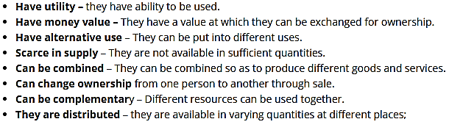
Types of economic resources in Kenya
What Are Economic Resources?
Economic resources are the different factors of production used to produce all goods and services in the economy. Economic theory is primarily concerned with allocating these resources so that the production of goods and services is done most efficiently and effectively.
There are four general types of economic resources:
- Land or natural resources
- Labor
- Capital
- Entrepreneurial ability
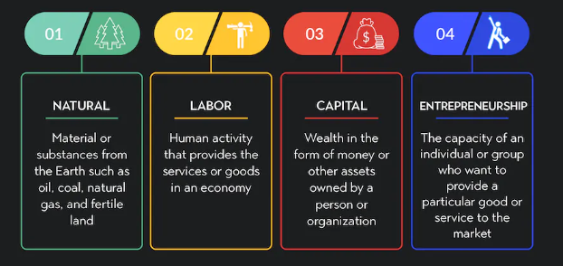
Sustainable ways of using economic resources
Economic sustainability is the practice of conserving natural and financial resources to create long-term financial stability. A system that's sustainable can last far into the future with minimal negative impacts.
In finance, this can mean reducing the worldwide consumption of valuable resources to ensure they're available to future generations to create financial stability and wealth. For example, by reducing the usage of fossil fuels and focusing on alternative fuel sources, companies, governments and consumers can help reduce the global impact of emissions and pollution from fossil fuels.
Here are some examples of economic stability:
Alternative energy
Alternative energy sources, such as wind power, solar power and hydropower, can offer a more sustainable, clean and affordable solution to energy needs. Much of the world depends on fossil fuels like coal, oil and gasoline, which have a limited supply and create greenhouse gas emissions.
Alternative energy sources depend on infinite natural processes or resources, which may make them more sustainable and affordable in the long term. Reducing fossil fuel consumption can help reduce tax burdens for consumers, decrease the costs of environmental impacts and create more energy equity among low-income populations, which can increase economic productivity.
Sustainable agriculture
Many farms are adopting sustainable agricultural practices to reduce soil degradation, which occurs from over-farming, and to reduce animal product consumption. Reducing food consumption and focusing on regenerative farming can help improve soil health, crop yields and the quality of farmed food and resources.

Regenerative farming is a practice farmers use to rotate crops for better soil health, instead of farming the same crops, like corn, all year. Improving soil health and reducing animal product consumption can help keep food costs low, reduce carbon emissions and environmental damage and encourage better habits.
Recycling and pollution reduction
Recycling and reducing pollution is a common economic and environmental stability practice that can help increase the value of materials. For example, a company producing aluminum cans can sustain operations by recycling used cans and creating molten aluminum for recasting, instead of mining for aluminum ore.
This practice can reduce the company's environmental impact, saving the region both cleanup and restoration costs and reducing the organization's mining costs. Reducing pollution can also help reduce worldwide cleanup and restoration costs and the costs of climate change.
Sustainable fisheries
Creating more sustainable fisheries can help reduce the environmental and economic impact of overfishing the oceans. Side effects of overfishing can include population declination, bycatch, or catching other species along with fish, and fishing equipment made of plastics and other materials discarded in waterways.
Adopting more sustainable practices, like reducing fish consumption worldwide and reducing bycatch and fishing pollution, could create a more sustainable fishing environment, resulting in more stable profits and economic health for the fishing industry. It can also help ocean populations recover, which is crucial for ecosystems across the globe.
Resource Mapping
Resource mapping is a strategy for identifying and analyzing the programs, people, services, and other resources that currently exist in the country. This information can help leaders better assess the needs of the country and to make informed decisions about where to focus change efforts.
Mapping Steps
- Reach consensus on the parameters of the map—select a goal to map.
- Select the data to be collected based on these parameters—determine what types of resources you would like to collect.
- Develop tools to collect your data.
- Collect data with help from stakeholders.
- Conduct a community (or environmental) scan.
- Synthesize, analyze, and interpret your data.
- Communicate your findings.
- Set priorities.
- Develop related products.
Importance of economic Resources
Resources are significant because:
(i) They satisfy human wants both individual and social,
(ii) They are a source or possibility of assistance,
(iii) They are a means of development and support,
(iv) They are an expedient,
(v) They have capacity to take advantage of opportunities, and
(vi) One relies on them for aid, support and supply.
  - Business communication
Communication is an essential element in the success of any business. The process of transferring information from one person to another, within and outside the business environment, is termed as ‘Business Communication.’ The term ‘Business Communication’ is derived from general communication which is associated with business activities. In other terms, communication between business parties or people for business-related tasks is considered as ‘Business Communication.’
Business Communication includes different aspects like marketing, public relations, customer relations, corporate and interpersonal communication, etc.
Basic elements of Business communication:
- Sender
- Business information
- Receiver
- Feedback

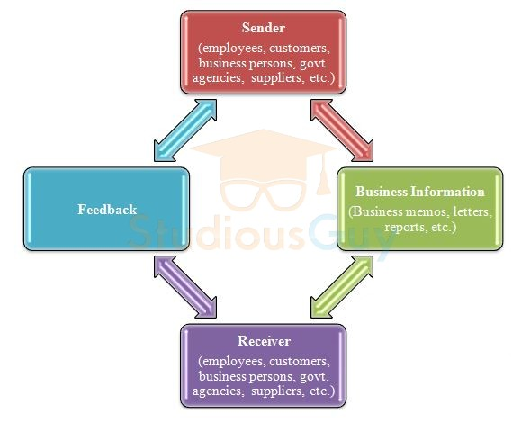
Importance of business communication
- Helps in increasing productivity: Effective business communication increases the productivity of staff by boosting up teamwork. It creates a trustworthy and understanding environment among employers and employees. Effective communication is related to cooperating with employees and understanding their needs and desires. By doing so, employees are able to accomplish their tasks more effectively and efficiently. Also, the scope of doing mistakes or errors during their work minimizes due to effective communication.
- Helps in increasing customers: Customers are an important part of any business and effective business communication can facilitate in attracting new customers and retain the current customers. A well-defined marketing strategy and public relations campaign run by an organization generates the interest of customers in its goods or services and helps in building the corporate image in customers.
- Enhances business partnerships: Business Communication also improves partnerships in business. It plays a significant role in dealing with external business clients or vendors. Vendors may be required to communicate on products regularly for improvements. Also, an effective and harmonious relationship with other businesses determines the further success of an organization. A business unit that has developed its image as an entity for easy partnership through its effective communication can attract other business units for forming business relationships with them.
- Facilitates innovations in business: Effective business communication helps in business innovations as well as it facilitates employees to convey their ideas and suggestions openly. Similarly, at the time of launching any new product in the market, effective communication ensures the performance of the sales team, market acceptance of the product, fast delivery of products in the market, etc.
- Information exchange: Business communication is required by an organization for exchanging information with internal and external stakeholders. This helps in achieving its goals effectively.
- Preparation of plans and policies: Through effective business communication, organizations can make their plans and policies properly. Relevant information is required for preparing these plans and policies. Through communication, different managers source information through reliable channels.
- Helps in solving problems or issues: Through different communication channels, managers get information about different routine and non-routine issues and based upon that they can take required actions to sort out those issues.
- Facilitates decision-making: Effective decisions require up-to-date information. Using effective communication, managers can acquire information from different sources and can utilize it for making correct decisions.
- Reduces chances of conflicts: Through effective communication different business parties can exchange information in a smooth way. This results in fewer conflicts, controversies, arguments between them.
Business Communication Methods
Different methods of communicating in a business are as below:
- In-person (Face-to-Face) Business Communication: In-person communication is the most common and preferred method of business communication. As it is generally in the form of meetings or conferences which is face to face communication format. This requires refined in-person skills. This method also includes non-verbal communication i.e. body language. While having a conversation between two or more people in business, body language like gestures, facial expression, etc. also play a vital role in communicating a person’s attitude towards others.
- Communication by email system: An e-mail has become the most widely used communication system in any business. Due to its feature of sending and receiving mass or multiple messages at a time, email is considered as one of the preferred methods in business communication. It also increases efficiency as emails can be sent and responded in fast mode. The conversation through email can be among two or more than two people and is the best substitute for formal face to face meetings as discussions can be done in an email system.
- Web conferencing: In the web conferencing method of business communication, the internet is being used for communication in meetings, conferences, presentations, seminars, and imparting training. It includes features like sharing of files, screens, real-time chatting, recording, etc. This can be considered as the most effective way of interacting with people sitting at different locations. Web conferencing is done by using the phone (teleconferencing) or video equipment (videoconferencing).
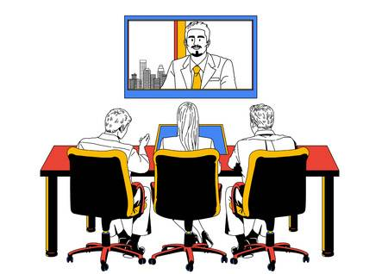
- Written communication: Written business communication is a formal and detailed form of communication than other methods. Different written communication tools include formal letters, brochures, posters, etc.
- Other methods: There are other business communication methods like an instant messaging system. This technology is easy to use as one can easily connect with people while working offsite and have conversations without waiting so long. They also include WhatsApp, phone calls.

  - Production of goods and services
Production: Refers to the creation of goods and services or increasing their usefulness through activities such as transporting them to where they are required. People who are involved in production of goods and services are referred to as producers.
İndependence
Importance of Production
- To produce is independence.
If you don’t produce, you will have to consume what has been produced.
In this case, you have no choice but to the available options. People choose to be free and independent.
- The need for various goods
- Availability of goods and services: Production helps to ensure that goods and services are made
- Increase in wealth of people: Production assists people to accumulate wealth as a result of continuous employment. importance of production
- Increase in export potential: Production also assists a state or nation to boost her export of goods and services to other nations.
- Acquisition of skills: The engagement of people in production leads them to acquire special skills
Characteristics of Factors of Production
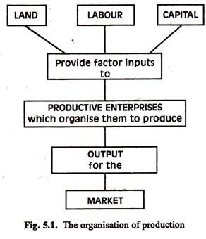
Meaning: Factors of production refer to agents, components or resources which are combined together to produce goods and services. There are four factors of production. These are:
- Labour - is skillful: Labour becomes skillful through education and training.
- Labour is a human factor: Labour is a human factor hence its supply can easily be controlled== importance of production
- Labour requires motivation: For labour to perform efficiently and increase its productivity, it must be motivated in one way or the other. importance of production
- Labour is not predictable: Labour as a factor of production cannot be easily predicted.
- Labour is not fixed: The supply of labour, unlike land, is not fixed as it varies in quantity and quality.
- Labour is perishable: Knowledge can diminish overtime as a result of continued unemployment, under-employment, age and death.
- Labour controls other factors of production: Labour controls and combines all other factors of production to make them more meaningful to the society.
- Labour has initiative: Labour can act on its own initiative.
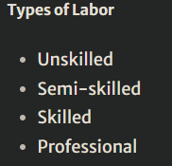
Classification of factors of production
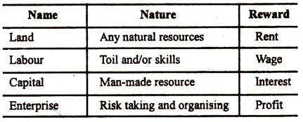
Characteristics of land as a factors of production
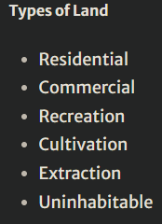
- Fixed supply: The total land area of earth (in the sense of the surface area available to men) is fixed. Therefore, the supply of lands is strictly limited. It is, no doubt, possible to increase the supply of land in a particular region to some extent through reclamation of land from sea areas or deforestation.
- No cost of production: Since land is a gift of nature, it has no cost of production. Since land is already in existence, no costs are to be incurred in creating it. In this sense, land differs from both labour (which has to be reared, educated and trained) and capital (which has to be created by using labour and other scarce resources or by spending money).
- Differences in fertility: Another important feature of land is that it is not homogeneous. All grades (plots) of land are not equally productive or fertile. Some grades of land are more productive than others. And Ricardo argued that rent arises not only due to scarcity of land as a factor but also due to differences in the fertility of the soil.
- Mobility:Land is not geographically mobile. But, it is occupationally mobile. In most parts of India, for example, land has many alternative uses. It might be used for farmland, roads, rail­ways, airlines, public parks, playgrounds, resi­dential housing, office buildings, shopping complex, and so on. Some of the land, for example, in hill area, of say, Shillong, or Darjeeling, has an extremely limited degree of occupational mobility, being useful perhaps for sheep grazing, golf course or as a centre of tourism.
- Return: The income received by the owner of land is known as rent. It may be noted that rent is usually paid for something more than the use of land or another natural resource, but includes also an element of payment for another factor which is involved in making the resource available in a usable form.
Characteristics of Capital as a factor of production
- Capital is manmade factor of production
- Its mobile
- It’s a passive factor of production
Types of capital
- Fixed
- Working
- venture
Characteristics of an entrepreneur
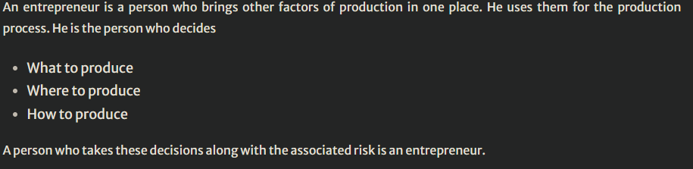
X-tics of an entrepreneur
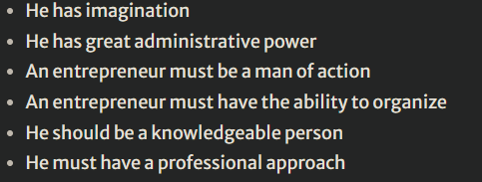
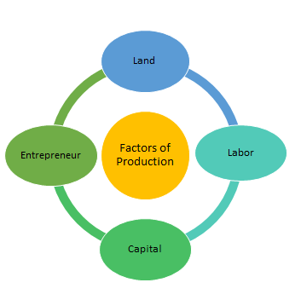
Consumer concerns addressed in the production of goods and services
Learners to check on this
  - Marketing of Goods and Services
- A market can be defined as a place where buyers and sellers meet to exchange goods, services and other relevant information is called a market. Both these parties can meet in a city, state, province, country and region. The market may be a physical or virtual.
- The one party (seller) sells a product or service to a buyer for money benefits. Most of the time there are more than single buyers and seller in the marketplace. The value and prices of product and service are based on the law demand and supply in the market.
Types of Markets
Physical Markets. Any physical market is a place where buyers and sellers physically meet that involve both parties in a transaction in exchange for money. Few good examples are departmental stores, shopping malls and retail stores
Virtual Markets / Internet Markets. Todays’ business environment such type of markets are increasing on a fast track. It is a place where the seller offers goods and services via online platform i.e. internet. Buyers and sellers are not required to physically meet or interact. Examples are Freelancer.com, Amazon.com.
Auction Market. An auction market is a place where sellers and buyers indicate the lowest and highest prices they are willing to exchange. This exchange takes place when both the sellers and buyers agree on a price. A good example is the New York Stock Exchange (NYSE).
What is Market Size
Market size refers to the total number of people in a specific market who has the potential to buy and sell products and services. Whenever companies launch a new product they are very interested to know the market size. For any market, two factors are very important
- Total number of buyers and sellers
- Total money in the market on the annual basis
Marketing
Marketing is a process by which a product or service is introduced and promoted to potential customers. Without marketing, your business may offer the best products or services in your industry, but none of your potential customers would know about it. Without marketing, sales may crash and companies may have to close.
Types of Marketing
Where your marketing campaigns live depends entirely on where your customers spend their time. It's up to you to conduct market research that determines which types of marketing -- and which mix of tools within each type -- is best for building your brand. Here are several types of marketing that are relevant today, some of which have stood the test of time:

- Internet marketing: Inspired by an Excedrin product campaign that took place online, the very idea of having a presence on the internet for business reasons is a type of marketing in and of itself.
- Search engine optimization: Abbreviated "SEO," this is the process of optimizing content on a website so that it appears in search engine results. It's used by marketers to attract people who perform searches that imply they're interested in learning about a particular industry.
- Blog marketing: Blogs are no longer exclusive to the individual writer. Brands now publish blogs to write about their industry and nurture the interest of potential customers who browse the internet for information.
- Social media marketing: Businesses can use Facebook, Instagram, Twitter, LinkedIn, and similar social networks to create impressions on their audience over time.
- Print marketing: As newspapers and magazines get better at understanding who subscribes to their print material, businesses continue to sponsor articles, photography, and similar content in the publications their customers are reading.
- Search engine marketing: This type of marketing is a bit different than SEO, which is described above. Businesses can now pay a search engine to place links on pages of its index that get high exposure to their audience. (It's a concept called "pay-per-click" -- I'll show you an example of this in the next section).
- Video marketing: While there were once just commercials, marketers now put money into creating and publishing all kinds of videos that entertain and educate their core customers.
The 4 Ps of Marketing
Essentially, these 4 Ps explain how marketing interacts with each stage of the business.
Consumers
A consumer is any individual or group that uses goods or services. Generally, this means an individual who pays for goods or services, although sometimes the good or service is not paid for, but is instead received as a gift or favor. Usually, the term is used when referring to the demand side of the market. For example, in economics, it is often said that consumers are influenced by price when they make their buying decisions.
Following are the things that customers look at for before buying a product.
1) Price: The price of the product is the first thing that almost 80% of the customers look at before buying a product. Because every customer has their own budget and they usually tend to spend within the budget unless they get some extraordinary quality.

2) Experience: Nowadays, everyone is busy and they want to buy things which are easily available and also there are so many alternatives available in the market for a certain product. Therefore, it is important to make the shopping experience as well as the quality of the product excellent. So, they don’t move to some other product.
3) Design: Design of the product should be attractive.
4) Functionality: The product should have all the functionalities that a customer expects while buying a product.
5) Convenience: The product and services should be convenient for the customer, otherwise, he/she will not buy the product.
6) Reliability: The product should be reliable and it should meet the customer’s needs every single time.
7) Compatibility: The product should be compatible with the other products that the customer is already using.
Following is a list of different types of customers.
    - Need-based customers :
These customers shop for only specific products when they need them. They already know the section they are heading to when they enter a store. They usually don’t require an assistant to choose a product because they usually have knowledge about the product they want to buy. Therefore, it is very important to approach them with a planned strategy.
    - Loyal customers :
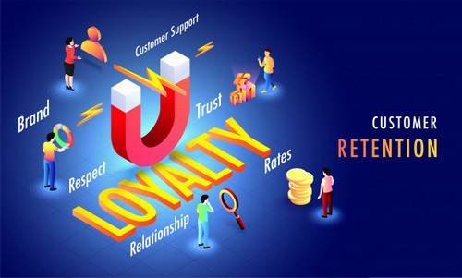
These types of customers are very important for a business. This segment of the customers should be kept satisfied. They not only stay loyal to the company but also praise and recommend the product to their family and friends. Therefore, they also help the company to market its product by “word -of – mouth” free of cost. Usually, this segment of customers is small and they hardly make 20% of the total customers, but they are responsible for generating the maximum part of the total revenue of the company.
3) Discount customers :
These are the types of customers who never buy a product on full price. They always look for a discount on the product they want to buy. Such customers never shop for anything off-sale. These types of customers make the biggest portion of total customers of a company. Discount customers are the least loyal customers and they easily move on when getting better offers by some other company.
    - Impulsive customers :
Impulsive customers’ segment is a bonus segment for any business, as these customers don’t shop as per their need or because of ongoing sale. The shopping of these types of customers is highly influenced by their current mood. They usually tend to buy a product, if, at the time of shopping, they find it useful and good at that point in time.
    - Potential customers:
Potential customers are not your customer yet, but they just need a little bit of convincing and assistance to make a purchase. These types of customers need a little bit of encouragement and attention before buying your product. To deal with such customers, you should show them some value and assist them by providing information about the products they are interested in.
Factors to consider when selecting a suitable market for goods and services
- The product to be sold or produced
- Personnel to manage the business
- Amount of finance and other resources required
- The market to be served (customers)
- Types of employees required
- Projection (level of achievement in future in terms of profit)
- The name for the business
An attractive market has the following characteristics:
- It is sizeable (large) enough to be profitable given your operating cost. Only a tiny fraction of the consumers in China can afford to buy cars. However, because the country’s population is so large (nearly 1.5 billion people), more cars are sold in China than in Europe (and in the United States, depending on the month). Three billion people in the world own cell phones. But that still leaves three billion who don’t (Corbett, 2008).
- It is growing. The middle class of India is growing rapidly, making it a very attractive market for consumer products companies. People under thirty make up the majority of the Indian population, fueling the demand for “Bollywood” (Indian-made) films.
- It is not already swamped by competitors, or you have found a way to stand out in a crowd. IBM used to make PCs. However, after the marketplace became crowded with competitors, IBM sold the product line to a Chinese company called Lenovo.
- Either it is accessible or you can find a way to reach it. Accessibility, or the lack of it, could include geographic accessibility, political and legal barriers, technological barriers, or social barriers. For example, to overcome geographic barriers, the consumer products company Unilever hires women in third-world countries to distribute the company’s products to rural consumers who lack access to stores.
- The company has the resources to compete in it. You might have a great idea to compete in the wind-power market. However, it is a business that is capital intensive. What this means is that you will either need a lot of money or must be able to raise it. You might also have to compete with the likes of T. Boone Pickens, an oil tycoon who is attempting to develop and profit from the wind-power market. Does your organization have the resources to do this?
- It “fits in” with your firm’s mission and objectives. Consider TerraCycle, which has made its mark by selling organic products in recycled packages. Fertilizer made from worm excrement and sold in discarded plastic beverage bottles is just one of its products. It wouldn’t be a good idea for TerraCycle to open up a polluting, coal-fired power plant, no matter how profitable the market for the service might be.
ICT platforms for marketing Goods and services
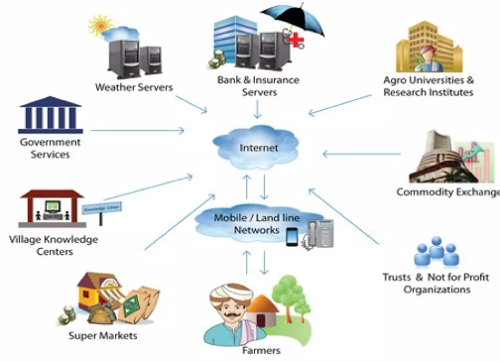
They include:
- Online advertising – many businesses advertise through banners on websites. It provides to the customers quickly and easy response.
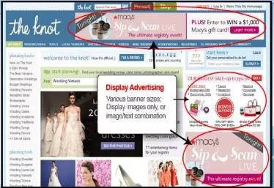
- Email marketing – it’s a form of direct marketing. It’s very fast and less expensive.
- Social media marketing – it’s a collection of online communication channels. It’s a community based input, interaction, content sharing and collaboration. Examples include: Facebook, Twitter, WhatsApp, Tiktok
- Blogging –
- Target marketing- it’s about attracting a customer who will buy what you are selling.
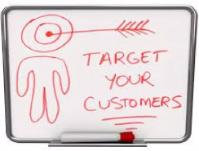
Advantages
- Anywhere, anytime marketing
- Cost effective
- Fast
By using ICT, we can market anywhere, anytime in the world without being their physically.
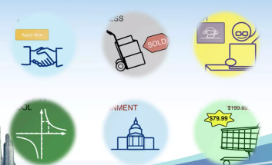

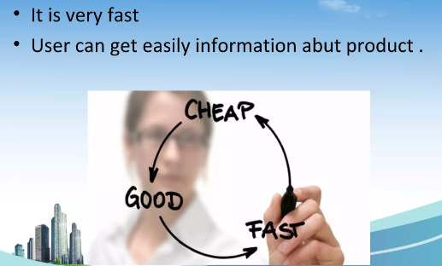

STRAND THREE
GOVERNMENT AND GLOBAL INFLUENCE IN BUSINESS
- Government and business
- Government involvement in business activities is one of the commercial duties it owes its citizens. It is the one that provides the necessary environment for investments to be undertaken by itself, or by the local and foreign investors. This, the government may do in various ways, these include;
a) Producing goods and services
b) Distributing goods and services
c) Advising producers and traders
d) Promoting trade and economic development
e) Protecting consumers against exploitation by producers and traders
f) As a consumer of goods and services
Reasons for Government involvement in business
The following are the major reasons for the government’s involvement and participation in business activities;
1) To prevent exploitation of the public by private businesspersons especially in the provision of essential goods and services such as sugar, transport, communication etc. the Kenya Bureau of standards (KEBS) regulates the quality of goods consumed in Kenya.
2) To provide essential goods and services in areas where private individuals and organizations are unwilling to venture because of low profits/ high risks involved.
3) To provide essential goods and services which private organizations and individuals are unable to provide due to the large amount of initial capital required b e.g. generation of electricity, establishment of airlines etc.
4) To attract foreign investment by initiating major business projects
5) To stimulate economic development in the country e.g. by providing social services
6) To provide goods and services which are too sensitive to be left in the hands of the private sector e.g. provision of firearms.
7) To create employment opportunities by initiating projects such as generation of electricity.
8) To prevent foreign dominance of the economy by investing in areas where the locals are not able to
9) To redistribute wealth where returns are very high
10) To prevent establishment of monopolies.
Roles/METHODS OF GOVERNMENT INVOLVEMENT IN BUSINESS
The government gets involved in business activities through the following methods:
(i) Regulation
This refers to Rules and restrictions the government requires business units to follow in their business activities. Through this method, the government ensures high quality goods and services and puts in control measures to protect consumers from exploitation. The government regulation measures
include;
a) Licensing
A license is a document that shows that a business has been permitted by the government to operate. It is usually issued upon payment of a small fee. Licensing is the process of issuing licenses to businesses. Some of the reasons why the government issues licenses include;
• Regulating the number of businesses in a given place at any given time to avoid unhealthy competition.
• To control the type of goods entering and leaving the country.
To ensure there are no illegal businesses.
• To ensure that traders engage only in trade activities that they have been licensed for.
• To ensure that those who engage in professional activities meet the requirements of the profession.
• To raise revenue for the government.
b) Ensuring standards/ enforcing standards; The government regulates business activities by setting standards that businesses should and ensuring that the standards are adhered to. To achieve this purpose, the government has established bodies such as;
✓ Kenya bureau of standards (KEBS) whose main responsibility is to set standards especially for the manufactured goods and see to it that the set standards are adhered to/ met. Goods that meet such standards are given a diamond mark of quality, to show that they are of good quality.
✓ The ministry of public health to ensure that businesses meet certain standards as concerning facilities before such businesses can be allowed to operate. Such standards may include clean toilets, clean water and well aerated buildings.
c) Legislation; The Government may come up with rules and regulations (laws) that regulate business activities e.g. banning hawking in certain areas, matatus required to carry certain number of passengers e.t.c.
(ii) Training
The government takes keen interest in training and advising people in business about business management strategies and better ways of producing goods and services. The government offers these services through seminars and courses. This is mainly done by the Kenya Business Training Institute
(K.B.T.I).
(iii) Trade promotion
This is a government initiated and supported policy to encourage local business people to enter into business. This is aimed at increasing the volume and variety of goods and services traded in. Trade promotion is classified as either external trade promotion or internal
trade promotion.
Legal Requirements for Starting and operating a simple business in Kenya
- Business Permit
A business permit indicates that you are licensed to operate by the local county government.
- KRA PIN
A Kenya Revenue Authority PIN is among the legal requirements that you need to start a business in Kenya. It is used to facilitate tax compliance with all Kenyans and businesses required to file their tax returns yearly.
TAXATION IN KENYA
Tax: is a compulsory payment by either individuals or organizations to the
government without any direct benefit to the payer.
Taxation-refers to the process through which the government raises revenue by collecting taxes.
Purposes/reasons for taxation
i. Raising revenue for government expenditure. This is the main reason for taxation.
ii. Discouraging /controlling consumption of certain commodities e.g. alcohol and cigarattes which are considered to be harmful.
iii. Discouraging importation of certain commodities in order to protect local industries. This is done by imposing heavy taxes on such commodities.
iv. Controlling inflation. Taxation reduces money supply by reducing peoples ‘disposable’ income thereby controlling inflation.
v. Reducing inequality in income distribution; this is done by taxing the rich heavily and using the finances raised in provision of goods and services that benefit the poor.
vi. Influencing locations of businesses. This is done by taxing businesses located in urban areas heavily and those in rural areas lightly hence businesses moving to rural areas.
vii. Correcting unfavorable balance of payments. High taxes are imposed on imported commodities thereby discouraging their importation leading to an improvement in the balance of payments.
viii. To protect the key selectors of the economy such as the agricultural sector, by stimulating their growth.
Factors that determine the amount of money raised through taxation
i. Distribution of incomes
ii. Social and political factors
iii. Honesty and efficiency of tax authorities
iv. Citizens level of real income
v. Economic structure of the country i.e. relative size of the country’s commercial and subsistence sectors.
Principles of taxation
These are the characteristics that a good tax system should have. They are also referred to as the cannons of taxation.
A good tax system should be;
- Equitable/principle of equity-Every subject of the state should pay tax in proportion to their income.
- Certain/principle of certainty-The tax that an individual should pay should be clear in terms of the amount, time and manner in which it should be paid. The government should also be fairly certain of the amount of tax expected so that planning can be easier.
- Convenient/principle of convenience-Tax levied ought to be convenient to both the contributor and collector, it should be levied at a time when the payer has money and mode of payment should be convenient to both the payer and the payee
- Economical/principle of economy-The cost of collecting and administering
the tax should be lower than the tax so collected.
- Flexible/principle of flexibility-It should be readily adaptable to changing economic times i.e. when the economic conditions of the people improve it should give raised revenue e.g. VAT
- Ability to pay/non-oppressive-A tax system should be designed in a way that the amount charged is not too high to the extent that the contributors are unable to pay or is discouraged from working hard.
- Diversified/principle of diversity-There should be different types of taxes so that the tax burden is on different groups in the society. This also ensures that the government has money at all times.
- Simplicity-A good tax system should be simple enough to be understood by each tax payer. This will motivate them to pay tax.
- Elastic/principle of elasticity-The tax system should be able to generate more revenue for the government by targeting items of mass consumption.

STRAND FOUR
FINANCIAL RECORDS IN BUSINESS
- Business Transactions
- A business transaction is a deal between two or more people involving exchange of goods and services in terms of money.
- Business transaction may take place on cash basis; in which case goods are paid for before or on delivery or a short while after delivery
- Business transaction may also take place on credit basis; which means payment is made after a specified period from the date of delivery of the goods or the provision of the services
a) Documents used at the inquiry stage
This is the first stage in transaction. An inquiry is a request by a prospective buyer for information on available goods and services. It is aimed at establishing the following;
• Whether the goods or services required are available for sale
• The quality or nature of the products available
• The prices at which the goods or services are being sold
• The terms of sale in respect to payment and delivery of goods or services Some of the documents used at this stage include;
i) Letter of inquiry;
This is a letter written by a potential buyer to the seller to find out the goods and services offered by the seller.
A letter of inquiry can be general or specific. A specific letter of inquiry seeks for information about a particular product.
Reply to an inquiry
The seller may reply to the letter of inquiry by sending any of the following documents;
-Price list
-A catalogue
-Quotation
-A tender

i) A price list
This is a list of items sold by the trader together with their prices. The information contained in a price list is usually brief and not illustrated and may include;
-Name and address of the Seller-List of the goods and services
-The recommended unit prices of the products -Any discounts offered
Price list show the prices of the commodities at that time.
ii) A catalogue; A catalogue is a basket which briefly describes the goods a seller stocks.
It is normally sent by the seller to the buyer when the buyer sends a general letter of inquiry. It usually carries illustrations on the goods stocked, and could be in the form of attractive and colorful pictures
The content of a catalogue includes the following;
• Name and address of the seller
• Details of the products to be sold; inform of pictures and illustrations
• The prices of the products
• After-sales services offered by the seller
• Packaging and posting expenses to be incurred
• Delivery services to be used
• Terms of sale
-Catalogues carry more information than the price list and they are more expensive to print.
iii) Quotation; This is a document sent by a seller to a buyer in response to a specific letter of inquiry. It specifies the conditions and terms under which the seller is willing to supply the specified goods and services to the buyer.
The content of a quotation includes the following;
-Name and address of Seller-Name and address of the buyer
-Description of goods to be supplied -Prices of the commodities
-Terms of sale i.e. discounts, time of supply, delivery
-Total of the goods to be supplied
Quotations are normally in form of letters, but many large-scale businesses have pre-printed quotations forms which they readily send to the potential customers.

iv) A Tender
This is a document of offer to sell sent by a seller to a buyer in response to an advertised request
Tenders contain the following;
-Date when the tender advertisement was made -Mode of payment
-Date of making document -Discounts given
-Name and address of prospective seller called the tenderer
-The prices at which the goods can be provided
-Period of delivery -Mode of delivery
-Tenders are delivered in sealed envelopes which are opened by the buyer on a specified date
The winning tender is usually awarded on the of the lowest quoted price although the buyer is not obliged to accept this especially if quality is likely to be low
Tenders are not binding unless accepted by the buyer.
b) Documents used at the order stage
After receiving replies to inquiry in form of price list, catalogue or Quotation, a prospective buyer will study the terms and conditions stated in them, and then may decide to buy products or not.
i) An Order
If a prospective buyer decides to purchase an item(s), he or she then places an order
An order is a document sent by a potential buyer to a seller requesting to be provided with specified products under specified terms and conditions
-An order issued for goods is called a local purchase order (LPO)
An order issued for services is called a local service order (LSO)
Ways of making an order
i) Filling an order form. This is a pre-printed document that is used for making orders
ii) Writing an order letter
iii) Sending an e-mail, faxing or sending a short text message
iv) Giving a verbal order. Verbal orders have the disadvantage in that they can be misunderstood and there would be no record of items ordered
-Where written orders are made, the potential buyer keeps a copy of the order for use in verifying the goods ordered when they are delivered.
-A written order may contain the following;
• Name and address of the buyer
• Name and address of the seller
• The number of the order
• Quantities ordered and total amount to be paid
• Description of the goods ordered
• Price per item
• Special instructions on such matters as packaging and delivery
ii) Acknowledgement note
On receiving the order, the seller sends the buyer an acknowledgement note An acknowledgement note is a document sent by the seller to the prospective buyer to inform him/her that the order has been received and it is being acted upon.
After sending the acknowledgement note, the seller has to decide whether to extend credit to the buyer or not. At this stage, the seller has the following options;
i) If the seller is convinced that the buyer is credit worthy, arrangements are made to deliver the ordered goods or services to the buyer.
ii) If the seller is not sure of credit worthiness of the buyer, a credit status inquiry can be issued to the buyer’s bankers or to other suppliers who deal with the buyer to ascertain the credit worthiness.
iii) If the buyer is not credit worthy then a polite note or a pro forma invoice can be sent to him/her
A proforma invoice
This is a document sent by the seller to the buyer requesting the buyer to make payment for goods or services before they are delivered. It indicates that the seller is not willing to grant the buyer credit.
Functions of a proforma invoice
i) A polite way of asking for payment before the goods are delivered
ii) Sent when the seller does not want to give credit
iii) Used by importers to get customers clearance before goods are delivered
iv) Issued to an agent who sells goods on behalf of the seller
v) Show what the buyer would have to pay if the order is approved
vi) Can be used to serve as a quotation
Circumstances under which a pro-forma invoice may be used
• If the seller does not want to give credit
• If the seller wants to sell goods through an agent
• If the seller wants to get clearance for imported goods
• If the seller wants it to function as a quotation
• If the seller wants to inform the buyer what he/she pay if the order is approved e.t.c
Documents used at the Delivery stage
After the seller has accepted the order sent an acknowledgement note and where necessary the pro-forma invoice, the seller then prepares the goods for delivery to the buyer. This can be done in the following ways;
• The seller can ask the buyer to collect the goods
• The seller can deliver the goods to the buyer using his/her own means of transport
• The goods can be delivered to the buyer through public transport
• The services(s) can be rendered to the buyer at the sellers or the buyer’s premises or at any convenient place.
The main documents that are used at this stage are;
i) Packing note; Before delivery goods are packed for dispatch. This is a document prepared by the seller showing the goods contained/packed in every container, box or carton being delivered to the buyer
-A copy of the packing note is packed with the goods to make/help the buyer have a spot check.
The contents of a packing note include;
-Description of goods packed
-Quantities of goods packed
-The means of delivery
NOTE: A packing not does not contain prices of goods. This ensures that those people involved in checking and transporting goods do not know the value of goods. This is done as a precaution against theft.
ii) Advice note; This is a document sent by the seller to the buyer to inform the buyer that the ordered goods have been dispatched. It is usually sent through the fastest means possible.
-It contains the following;
-The means of delivery -A description of the goods
-The quantity dispatched -Date
-Name and address of buyer and seller
Functions of an advice note
a) Informing the buyer that the goods are on the way so that in case of any delay in delivery, the buyer can make inquiries
b) Alerting the buyer so that necessary arrangements can be made for payments when the goods arrive
c) Can serve as an acknowledgement note, where one is not sent/
iii) Delivery note; This is a document sent by the seller to the buyer to accompany the goods being delivered.
-A delivery note is always made in triplicate (3), one copy remains with the seller and two sent to the buyer.
-When the goods reach the buyer, he/she confirms that the goods are the ones ordered for and that they are in the right condition by comparing the delivery note, the order and the goods. If the buyer is satisfied with the goods, he/she signs the two copies, retains the original and send the copy back to the seller.
This serves as evidence that the goods have been received in the right condition and in the right quantities.
-Some businesses keep delivery books in which the buyer signs to indicate that goods have been received in good condition. A delivery book is used by the seller if he/she delivers goods by himself/herself as an alternative to a delivery note
The content of a delivery note includes the following;
a. Name and address of the seller
b. Name and address of the buyer
c. Date of delivery
d. Delivery note number
e. Description of the goods delivered
f. Quantities of the goods delivered
g. Space for the buyer to sign and comment on the condition of the goods received.
iv) Consignment note
This is a document prepared by a transporter to show that he/she has been hired to deliver specified goods to a particular buyer. This document is used when goods are delivered to the buyer by public means of transport e.g. by trains.
-The seller is the consignor, the buyer is the consignee and the goods the consignment
-The transporting company prepares the consignment note and gives the seller to complete and sign. The seller then returns the note to the transporter (carrier) who takes it together with the goods to the buyer.
-On receiving the goods, the buyer signs the consignment note as evidence that the goods were actually transported.
The content of a consignment note includes the following;
• Details of the goods to the transported
• Name address of seller (consignor)
• Name and address of buyer (consignee)
• Terms of carriage and conditions of transporting the goods
• The transportation cost
• Handling information
• Destination of goods
v) Goods Received note; This is a document sent by the buyer to the seller to inform him/her that goods sent have been received. It usually prepared in duplicate, the original is sent to the seller and the copy
retained by the buyer.
The contents of the goods received note include;
• Date of the document
• Name and address of the buyer
• Name and address of the seller
• Corresponding purchase order
• Details of goods received
• Date the goods were received.
vi) Returned goods note/Damaged goods note; If goods are damaged on the way, the buyer may return them to the seller. The buyer may also return goods for other reasons e.g.
• Wrong type of goods
• Excess goods
• Wrong quality goods
-When the goods are returned, the buyer informs the seller of the return by sending a goods returned note.
-A goods returned note is a document sent by a buyer to a seller to inform him/her that certain goods are being returned to the seller.
-Where the goods are returned because of damage, the note may be referred to as the damaged goods note.
The contents of the goods returned note include;
• Details of goods that have been returned to the seller
• Date goods are returned
• The number of (GRN)
• Order number
• Delivery number
• Name and address of both buyer and seller
-When the seller receives the note together with the goods, he issues a credit note
d) Documents used at the invoicing stage
This stage involves the seller requesting or demanding for payment from the buyer for the goods or services delivered.
Some of the documents used at this stage include:
a) Invoice
This is a document sent to the buyer by the seller to demand for payment for goods delivered or services rendered.
There are two types of invoices namely:
a) Cash invoice-This is sent when payment is expected immediately after delivery thus acting as a cash sale receipt
b) A credit invoice-This is sent when a buyer is allowed to pay at a later date.
Functions of an invoice
i) It shows the details of goods sold i.e. quantity delivered, unit price, total value of the goods and terms and conditions of sale.
ii) It is a request to the buyer to make payment
iii) It serves as an evidence that the buyer owes the seller a certain amount of money
iv) It is used as a source document in recording the transaction in the book of accounts.

The contents of an invoice include the following:
• Invoice number
• Name and address of the seller
• Name and address of the buyer
• Date document is prepared
• Details of goods repaired
• Unit prices of goods delivered
• Total value of goods
• Discounts offered
• E and O.E printed at the bottom
The letters E and O.E (Errors and Omissions Excepted) means the seller reserves the right to correct any errors and omissions made in the invoice.
-On receiving the invoice, the buyer verifies the contents using the local purchase order and the delivery note. If the invoice is in order, the buyer makes arrangements to pay the amount stated.
Businesses which offer services issue a document called a bill, which serves the purpose of an invoice.
b) Credit note
This is a document sent by the seller to the buyer (credit buyer) to correct an overcharge. It is used to inform the buyer that the amount payable by him/her has been reduced
An overcharge is an excess amount charged beyond the right price. Causes of overcharge may include;
• Arithmetical errors like wrong addition
• Price overcharges
• Inclusion of wrong or unordered items in the invoice
• Failure to deduct the allowable discounts
• Return of goods (damaged goods)
• Failure to note the return by the buyer of packing cases or containers used to deliver goods to him/her
• Use of wrong price list.
-The purpose of the credit note is to reduce the total invoice amount by the amount of the overcharge.
-A credit note is usually printed in red to distinguish it from other documents.
-Contents of a credit note include;
• Name and address of the seller and the buyer
• Credit note number
• Date document is prepared
• Description and value of goods returned by buyer (in case that was done)
• Total overcharge
Reasons why a seller would send a credit note to a buyer/circumstances under which a credit note is sent to a buyer.
-When there is an overcharge in an invoice
-When the original invoice had indicated items that were not supplied
-When the buyer returns empty cases/crates that had been charged in the invoice.
-When the buyer returns some goods to the seller
-If the buyer was entitled to a discount which was not given or taken care of in the invoice.
c) Debit note
This is a document sent by the seller to the buyer to correct an undercharge on the original invoice. It is used to inform the buyer that the amount payable by him has been increased.
-A debit note acts as an additional invoice.
-An undercharge arises when amount charged on products is less than their right price.
Causes of undercharge include:
• Price undercharges on items
• Arithmetic errors/mistaken in calculation
• Omission of items in the invoice
• Retention of crates and containers that were not involved by the buyer
• Deductions of more discount than what was give/intended
Circumstances under which a debit note will be sent to the buyer
a) When there is an undercharge in the invoice
b) If the buyer had been given a discount that was not due to him
c) If some items had been omitted in the original invoice
d) If the buyer decides to retain some empty containers or crates

Differences Between a debit note and a credit note
DEBIT NOTE | CREDIT NOTE
1) Issued to correct an underchargeon the invoice. | 1) Issued to correct an overchargeon the invoive.
2) Written on blue or black. | 2)Usually written in red
3) Issued when containers have notbeen returned | 3) Issued when containers have been returned.

Documents used at the payment stage
This is the final stage of a credit business transaction. It takes place after the invoice has been received and ascertained to be correct or where necessary, corrections made.
The documents used at the payment stage include;
i) Receipt
This is a document issued to the buyer by the seller as proof that payment has been made.
-Payment can be done in cash, cheque, other forms of money or in kind
-The receipt also serves as a source document for making entries in books of accounts.
Contents of the receipt include;
• Date of payment
• Name of the person making payment
• Name of person/institution receiving payment
• Amount paid in words and figures
• Means of payment
• Receipt number
• Signature of person issuing the receipt.
-The issuance of a receipt by the seller to the buyer after receiving payment marks the end of the credit transaction between the seller and the buyer (where payment has been done in full)
-A receipt serves the same purpose as the cash sale slip
ii) Statement of Account
This is a document prepared by the seller and sent to the buyer, giving a summary of all the dealings/transactions between them during a particular period of time, usually a month. It has the following details;
• Date when it was prepared
• Name and address of the seller
• Name and address of the buyer
• Account number
• Date column-where the date of each transaction is recorded
• Particulars (Details)column-where the explanation of each transaction is shown
• Money column
-Debit column-increases in the amounts payable due to credit sales or under charge correction.
-Credit column-Decrease in the amounts payable due to overcharges corrected or payments recorded.
-Balance column-Amount owing after each transaction (Balance outstanding)
• Any discounts allowed to the buyer
• Date when the buyer is expected to clear the balance
• Terms of credit e.t.c.
-The statement of account enables the buyer to ascertain the correctness of the transactions which have taken place with the seller over the stated period.
iii) IOU
An IOU (I owe you) is a document written by the buyer and sent to the seller to acknowledge a debt.
-It does not specify date when settlement will be made.
-It acts as evidence that a debt exists.
Methods of payments for goods and services
These are the methods or ways the buyer may use to settle debts arising from
a business transaction. These are various means of payments that can be used.
These means of payments can be put into the following groups;
i) Cash
ii) Means of payment provided by the post office
iii) Means of payments provided by the commercial banks
iv) Means of payments which arise from private arrangements between sellers and buyers
v) Other means of payment. E.g. Mobile transaction, Online payments like paypal

i) Cash
This refers to the use of notes and coins to make payments. Currency notes and coins are issued by the central Bank of Kenya and are therefore legal tender
-Legal tender means everyone is obliged by law to accept them as a means of payment i.e. no one can refuse to accept them as they are backed by the law.Notes and coins are available in different denominations as follows; Coins; 5cents, 50cents, sh.1, sh.5, sh.10 and sh.40
Notes; sh.10.sh.20, sh.50, sh.100, sh.200, sh.500 and sh.1000.
-Coins are suitable for settling small debts and are acceptable as legal tender up to a certain maximum e.g. 50cents coins the maximum is sh20 and sh.1 the maximum is ksh.100.
Advantages of cash as a means of payment:
i) It is the only means of payment which is a legal tender
ii) Convenient for settlement of small debts
iii) Convenient to people with or without bank accounts
iv) Cash is readily usable
Disadvantages of cash as a means of payment
i) Not convenient to carry around
ii) Cash can be lost or stolen easily as it is readily usable
iii) Payment is difficult to prove unless a receipt is issued
Circumstances under which cash payment is appropriate
i) Where the amounts involved are small
ii) Where the payee (receiver) does not accept other means of payment
iii) Where cash is the only means available
iv) Where the payee requires cash(money) urgently
v) Where there is need to avoid expenses associated with other means of payments
ii) Means of payments provided by the banks
Commercial banks are financial institutions that accept deposits to and withdrawals from them.
They also lend money to customers. Examples of commercial banks include:
Commercial bank of Kenya, National bank of Kenya, Barclays bank, and
Co-operative bank e.t.c
-There are various means of payments provided by the commercial banks.
They are:
a. Cheques
b. Bank drafts/bankers cheques
c. Credit transfers
d. Standing orders
e. Travellers cheques
f. Telegraphic transfers
g. Debit cards
h. Electronic fund Transfer(E.F.T)
a) Cheques
This is a written order by an account holder with the bank (drawer) to the bank (drawee) to pay on demand a specified amount of money to the named person (payee) or the bearer
Parties to a cheque
i) Drawer-This is the person or institution who writes and issues the cheque.He is usually a current account holder with the bank
ii) Payee-The person or institution to be paid
iii) Drawee-The bank (where the drawer has an account)
Details on a cheque; they include:
• Date when it is issued
• Name of the drawer
• The name of the payee, except in bearer cheques
• The name of the drawee(bank)and branch from where it is issued
• Amount to be paid in figures and in words
• The account number of the drawer
• The signature of the drawer
• The cheque number and bank code
• The appropriate revenue stamps

Types of cheques
i) Open cheques
ii) Crossed cheques
iii) Bearer cheques
iv) Order cheques
i) Open cheques
This is acheque that can be presented for payment over the counter. You
present it and cash is paid to you.
ii) Crossed cheques
This is acheque that bears two parallel lines on the face. This means the cheque cannot be cashed over the counter. The cheque is deposited in an account (payee’s account)
The payee then withdraws the money from his/her account
A crossed cheque can be opened by the drawer signing twice on its face.
-A crossing can be general or special
-General crossing-general crossings only contains the two parallel lines. This implies that the cheque will be paid through any bank in which it is deposited.
-Special crossings-Has other instructions included in the crossing i.e;
• Not negotiable-Means the cheque can be transferred by the payee to a third party, but he third cannot transfer the cheque (only the original payee can transfer the cheque)
• Account payee only-Means the cheque should be deposited in the account of the payee.
• Not transferable-Means there is no negotiation or transfer of the cheque
iii) Bearer cheques-This cheque does not have the name of the payee written on it. The person presenting it to the bank is the one who is paid.
iv) Order cheque-The cheque bears the name of the payee. The bank pays this particular payee the amount stated in the cheque after proper identification
Dishonouring a cheque
A cheque is dishonored if the bank refuses to pay and returns the cheque to the drawer.
-A cheque can be dishonored due to the following reasons:
i. Insufficient funds in the account
ii. If the signature on the cheque differs from the drawers specimen signature in the bank.
iii. If the cheque is stalc i.e. presented for payment after six months from the date of issue.
iv. If the cheque is post dated-meaning the cheque is presented for payment earlier than the date on the cheque
v. If the amount in figures is different from the amount in words
vi. If there are alterations on the cheque which are not countersigned by the drawer
vii. If the cheque is torn, dirty or defauld making it illegible
viii. If the account holder(drawer) is dead and the bank is aware of the fact
ix. If the drawer instructs the bank not to pay the particular cheque
x. If the cheque contains errors which need to be corrected
xi. If the drawer becomes bankrupt or insane
xii. If the drawer has closed his/her account.
Advantages of using cheques
i) They are more secure than notes and coins because if they are lost or stolen, they can be traced to the person who cashed them.
ii) They are convenient to carry and can be used to pay large sum of money which would be otherwise inconvenient to pay using cash
iii) They can be transferred to a third party to make payment/cheques are negotiable
iv) Payment can be made by cheque without the need to travel to make payment
v) They provide a record of payment because of the counterfaits.The counterfaits acts as proof that payment has been made.
vi) Under special circumstances, they can be cashed or discounted before maturity.
Disadvantages of using cheques
i) Cheques can be dishonored
ii) Requires the payee to go to the bank and in some cases to have an account
iii) The drawer pays some charges e.g. charges for the cheque book
iv) Can only be issued by an account holder/the drawer must have an account
v) They are not readily acceptable by everybody
vi) They do not provide immediate cash

Circumstances under which a cheque is appropriate as a means of payment
• Where the amount of money involved is large
• Where the policy of the business demands so
• Where a cheque is the only means available
• Where there is need to avoid other risks associated with other means of payments
b) Bank drafts/Banker’s cheques
-This is a cheque drawn on a bank i.e. a cheque drawn by one bank to another requesting the latter bank to pay a named person or institution a specified sum of money and charge it to the drawing bank
-It can also be drawn by a bank on the request of a customer. The customer fills in an application form obtained from a bank and hands it over to the bank together with the money she wants to transfer and a commission for the service.
-The bank then prepares the cheque and gives it to the applicant who can then send it to the payee
-A bank draft has the drawing bank’s guarantee for payment. It is therefore more readily acceptable than personal cheques.
-It is suitable when urgency is desired in the payment as it is more readily acceptable.
c) Credit transfer
This is a means of payment provided by commercial banks to their current accounts holders who want to pay many people using one cheque/at the same time
-One cheque is drawn and is usually accompanied by a list of the people to be paid, the amount to be paid to each person and the addresses of the bank branches where the payment is to be made.
-The bank then ensures that a credit transfer is affected to the various bank branches and each payee is paid
-A credit transfer is usually used by employers to pay salaries to their staff members.
d) Standing order
This is an instruction to a bank by an account holder to pay a named person or an organization a fixed amount of money at regular intervals over a specified period of time or until stopped
-It is a very useful means of payment for business people as it enables them to regularly pay their recurrent bills e.g. water, insurance, electricity, loan payment, hire purchase payment e.t.c

e) Traveler’s cheques
This is a cheque drawn by one bank to another requesting the latter to pay a specified sum of money to a named bearer, who usually would have bought that cheque from issuing bank. The cheque holder pays the value of the cheque plus the charges for the services to the issuing bank.
-Travellers cheques are usually issued in fixed denominations and are very convenient for travel purposes, hence their name. They enable a person to travel without having to carry a lot of cash. The cheques are also readily acceptable as a means of payment.
f) Telegraphic Transfers
This is a method /means of transferring money offered by commercial banks to anybody who wants to send money to another. The sender is required to fill an application form and provide the following
information among others:
-His/her name -The amount of money to be remitted
-Name of the payee -The bank where the money would be paid. The applicant is charged a commission and telegraph fee. The paying bank sends a telegram to the payee who has to identify himself/herself before the payment is made
The method is fast and safe.
g) Debit cards
These are plastic cards issued by financial institutions e.g. banks that enables a person to purchase goods and services from any business that accepts them.
Debit cards are used to make payments from money held in ones accounts and are therefore an alternative to cash payments. Examples are ATM cards.
h) Electronic Fund Transfer (E.F.T)
EFT is a method of transferring money from one account to another where computers are used. The sender is required to fill an electronic fund transfer form provided by the bank which instructs the bank to transfer money from his/her account to a named account.
Information is then sent to the payee’s bank electronically and the amount in the account is increased accordingly. The method is very fast.
iii. Means of payments provided by the post office
The post office provides means of payments that can be used to transfer money from one person to another.
The means of payments provided by the post office to facilitate payments
includes,
a. Money orders
b. Posta pay
c. Postal orders
d. Postage stamps
e. Premium bonds
a) Money orders
A money order facilitates the transfer of money from one person to another through the post office (and/or bank)
A money order is usually for a specified sum of money usually purchased with cash from the post office
A person wishing to send money using this method visits a post office and completes an application form. Some of the details contained/given in the form include:
• The amount of money to be remitted
• Name of the payee
• The name of the post office where the money order will be cashed
• Name and address of the sender
• Whether the money order is to be ordinary or sent by telegraph
• Whether the sender wishes to be informed if the money has been paid
• Whether the money is to be paid through a bank account or at the post office counter.
The application form, money to be remitted and commission for the service is handed to the post office cleark who prepares the money order and gives it to the sender who may post it or send it to the payee.
-Telegraphic money orders, the post office sends a telegram to the payee informing him/her to go to the post office and claim the money.
-Before payment is made, the payee must;
• Identify himself/herself by producing an ID card
• Identify the person who sent the money.
-The sender of the money is left with a counterfoil which serves as evidence that money was sent and it can be used to reclaim the money if it did not reach the payee
-Money order may be open or crossed. A crossed money order bears two parallel lines drawn diagonally on its face and must be deposited in the bank account of the payee. It cannot be cashed over the counter at the post office.
-An open money order can be presented for payment at the post office
counter.
Circumstances under which money order is appropriate
a) Where it is the only means available
b) Where other means are not acceptable
c) Where there is need to avoid inconveniences or risks associated with other means
b) Posta pay
This is an Electronic Fund Transfer (EFT) service offered by the postal corporation of Kenya, for sending and receiving money instantly from various destinations both locally and internationally.
-The person sending money fills in a form called ‘send form’ giving the following details;
• Name, address and telephone number of sender
• Name, address and telephone number of receiver
• Pay city, town and location of the receiver
• Signature of the sender
• Amount to be sent
-The sender hands over the form, the amount of money to be sent and the commission to the post office clerk for processing
-The transfer is done via the internet through a machine that gives a twelvedigit number for the transaction called the ‘Transaction control number’(TCN).The sender then conveys this number, amount sent and pay location to the recipient and instructions to the recipient to visit the named
post office for payment. This message is usually conveyed through the quickest means possible such as a telephone call
-The sender is given a copy of the processed ‘send form’ as proof that money has been sent. The post office retains the original for record purposes.
-When the receiver visits the post office, he/she will fill a ‘receiver form’ giving the following details;
i) The transaction number(i.e. the twelve-digit number)
ii) The expected amount
iii) The name, address and telephone number of the sender
iv)The city town or location of the sender
v) Signature of the receiver
The receiver then identifies himself or herself by producing an ID card or passport before receiving the money.
Advantages of using Posta pay as a means of payment
i) Accessibility-Posta pay outlets (post offices) are located countrywide to eliminate movement over long distances to get money
ii) Ease of use-Sending or receiving money is easy as one only needs to fill a form which is processed immediately
iii) Speed-the transfer of money is instant (fast)
iv)Security-Confidentiality in the transmission of money is provided and money is only paid to the person intended
v) Convenience-Posta pay services are offered for long hours during the day and pay locations are conveniently located
vi)Affordability-Posta pay services are relatively affordable as large amounts can be sent at reasonable costs.
c) Postal orders
-Postal orders are sold by the post office for the purpose of remitting money
-They are available in fixed denominations of sh.5, 10.20,40,60,80,100 and 200
-On buying a postal order, the sender pays for both the face value of the postal order and a commission charged for the service
-Postal orders just like money orders are issued with counterfoils that the sender will keep as evidence of remittance in case the person to whom he/she remits the money does not receive it.
The sender writes the name of the payee on the postal order as a safety measure.
Payment to the bearer can be made in any post office with postal order facilities
Postal orders may also be crossed or open (see crossed and ordinary money orders)
iv) Other means of payment
a) Credit cards
b) Mobile money transfer services e.g. M-pesa.
a) Credit cards(plastic money)
-These are plastic cards that enable a person to purchase goods or services on credit from any business willing to accept the card
-They are both a means of payment and a term of payment
b) Mobile money transfer services e.g. M-pesa
-This is a means of money transfer services provided by mobile phone service providers to their customers (subscribers)
-It can only be used to transfer money between people subscribed to the same mobile phone network e.g. from one safaricom subscriber to another safaricom subscriber, Airtel to Airtel e.t.c
-The sender must register for the money transfer service and is issued with a PIN (personal identification number)
-When money is sent, both the sender and the receiver will receive a message confirming the transfer.
-A person can send money anytime anywhere so long as he/she has value in his/her m-pesa, pesa pap account.
-Each mobile service provider has a range of value that can be transferred using this method.
-A small transaction fee is charges for the transfer i.e. for sending and withdrawing
Benefits of mobile money transfer services
i. Confidentiality-The secret PIN protects the value in the customer’s account
ii. Ease of use-The service is easy to use as the agents assists to carry out transaction
iii. Speed-Money transfer is an instant service conveyed to the receiver via the short message service(SMS)
iv. Convenience-The service is convenient to both the sender and the receiver, as they only need to go to the nearest agent (money can be sent/deposited or received anywhere)
v. Accessibility-The agents e.g. m-pesa agents are located in most parts of towns and also in rural areas. Money can hence be sent and received anywhere and anytime.
vi. Affordability-The service charges are very low for registered users and very affordable for non-registered users
vii. Security-Relatively secure when the sender uses the correct phone number of the receiver
Importance of financial documents in record keeping in business
- Knowing Your Financial Situation - You need to know where your company stands daily, weekly, monthly, quarterly, and annually. Are you making money, is your client base increasing or decreasing, do you have enough money in the bank to meet your obligations, are you meeting the goals you set for your business? Without this knowledge, you have little or no control over your business. You need to know how much inventory you have on hand, how much you need to order when you need to order, the credit terms your suppliers offer, the balance in your bank account to cover your payments for running your business such as rent, utilities, office supplies, inventory, employees’ wages, and payroll taxes. Also, you are likely to be in non-compliance with local, state, and federal regulations without proper controls on your finances.
- Meeting Your Tax Obligations
- helps to maximize all the expenses you claim and reduce your tax obligations
- makes it quicker to prepare your accounts at year-end
- gives you the information you need to run your business and help it grow
- helps you plan for tax payments
- helps identify the strengths and weaknesses in your business
- helps manage changes and improvements in your business
- will help you plan to meet financial commitments such paying creditors or employees
- makes it easier to get a loan or sell your business
- avoids over/under tax payments
- helps identify if your business is liable for paying VAT to KRA
- makes it easier to distribute profits to shareholders as dividends or for partnerships where both profits and losses have to be shared.

