BUSINESS STUDIES
END TERM 2 2024 EXAM
PAPER 2 FORM 3

MARKING SCHEME

1a)Internal economies of scale that may be experienced by the firm
- Managerial economies of scale-a firms productivity can be increased by employing qualified staff who offer better organization structures
- Marketing economies- A firm that sells in large quantities incurs fewer costs in advertising and distribution
- Financial economies- A firm with strong financial base can expand their business
- Risk bearing economies- Large firms reduce risks in market failure through diversification of products or markets
- Technical economies- These are benefits to a firm due to specialization of labour and machinery
- Research economies-Research in new methods of production,new market and new products is necessary for firms that are large because it is affordable
- Welfare economies-Workers incentive do motivate their workforce eg welfare like recreation , health, housing and education
- Buying economies
- Division of labour and specialization
Any 5 points @2mks =10mks
- Factors considered when setting up an office layout for a business organization
- Work flow -this refers to the continuous flow of work in a particular section for example accounts office
- Minimum movement -movement of staff need to be saved this reduce noise and distractions
- Supervision- the arrangement of office should provide opportunity for ample supervision
- Working space- the layout should allow each worker to have enough working space
- Proximity to equipment -equipment harness to the work is needed in order to avoid unnecessary movement
- Communication -office arrangement should promote effective communication in the business organization
- Office appearance -there should be attractive and good appearance of the of the layout chosen for the business organization
- Legal requirement -the rules and regulations set should be adhered to for ample lighting, ventilation, etc
- Staff to be accommodated -office arrangement should take into account the job type and grade of the office staff
- Cost of setting the layout- the cost of setting the layout should be affordable \\\\\
2. a) The assumptions that will make circular flow of two sector economy to hold

i) Household spend all their income in buying the goods and services from the firms and none is saved
ii) The firms spend all income received on production of goods and services
iii) The economy is closed that it does not benefit from imports or export
iv) There are only two sectors that is firms and households
v) There is no leakage or withdrawals from the closed economy
vi) There is no government intervention in the circular flow
vii) The firm sell all their goods to the households
2 x 5 = 10mks

b) Ways of improving the efficiency of a warehouse

i) Ideal location - it should be located in a location where receipt and issue of goods can be done efficiently and conveniently
ii) Suitable building - the building or stock yards should be well designed and appropriate for the type of goods stored. The design should facilitate safety, security and ease of handling goods that have been stored
iii) Appropriate handling equipment - a warehouse should be equipped with handling equipment that is appropriate and suitable for handling the type of goods stored
iv) Efficient staff - the staff operating the warehouse should be well trained and efficient in handling the type of goods stored
v) Appropriate transport - the transport system and network should be suitable and appropriate to the type and nature of goods stored. There should be easy access to and from the warehouse
vi) Precaution against risks - precaution should be taken against various risks such as fire by
providing appropriate equipment and

3.a)Explain six ways which the government of Kenya can use to influence the supply of maize in Kenya (12mks)
-price control- fixing the price level low discourage supply while high encourage supply
-quotas- limit quantities dictates the amounts to be availed in the market
-subsidies- assist producers in production cost through provision of inputs at affordable prices
-taxes- imposing high taxes on inputs like fertilizers making difficult for maize farmer to engage in production
-embargo-zero rating the amount of maize imported by dealer into the country
b)The following balance relate to the business of Roba traders during the period ended 31st March 2014.
Cash at bank 680,000
Premises 500,000
Machinery 175,000
Creditors 190,000
Furniture 85,000
Motor van 200,000
Cash in hand 50,000
ADS5y loan 630,000
Extract the trial balance of Roba traders as at 31st March 2014 (8mks)
ROBA TRADERS
TRIAL BALANCE
AS AT 31ST MARCH 2010
ITEM | DEBIT | CREDIT
Cash at bank | 680,000
Premises | 500,000
Machinery | 175,000
Furniture | 85,000
Motor van | 200,000
Cash in hand | 50,000
Creditor |  | 190,000
ADB 5y loan |  | 630,000
Capital |  | 870,000
Total | 1,690,000 | 1,690,000
4a)Discuss any four importance’s of a balance sheet with special reference to the interested parties to a balance sheet (8mks)
-finances –uses the balance sheet to know whether the business is in a position to meet their claims
-shareholders- they use it to asses & determine whether their funds are invested wisely
-government- one of the document that the government require for taxation
-management- know strength / weakness of business / making decision
-potential investors- compare performance
b)Highlight any six types of an employment and disclose a remedy (solution) for each type (12mks)
-seasonal unemployment- brought by variation in seasons can be solved through diversification of the economy
-structural unemployment –comes about as a result of changing methods of production can be solved through
-frictional- brought by lack of awareness of existing job opportunities –solved through interest in print and mass media advertisement on available new job openings
-cyclical unemployment –caused by altering cycles of economic activities can be solved through government increasing its speeding to spur more economic activities
-open unemployment-absolute non-existence of job opportunities – can be solved by encouraging proper utility of available resources and building a formidable entrepreneurial culture
-real wage unemployment- people not willing to work at prevailing wage rate as it is low, government can come up with wage guidelines to avoid exploitation of employees by employers and vise- versa
5a) Circumstance under which an insurance company would not the insured
- when the insured had no insurable interest any financial loss
- when the insured did not disclose all the relevant facts
- when the property has been destroyed by natural disaster as the risks are not insurable e.g. earthquake
- when the policy was not in force at the time of loss
- when the loss occurred due to willful action of the insured / when the insured purposely caused the loss

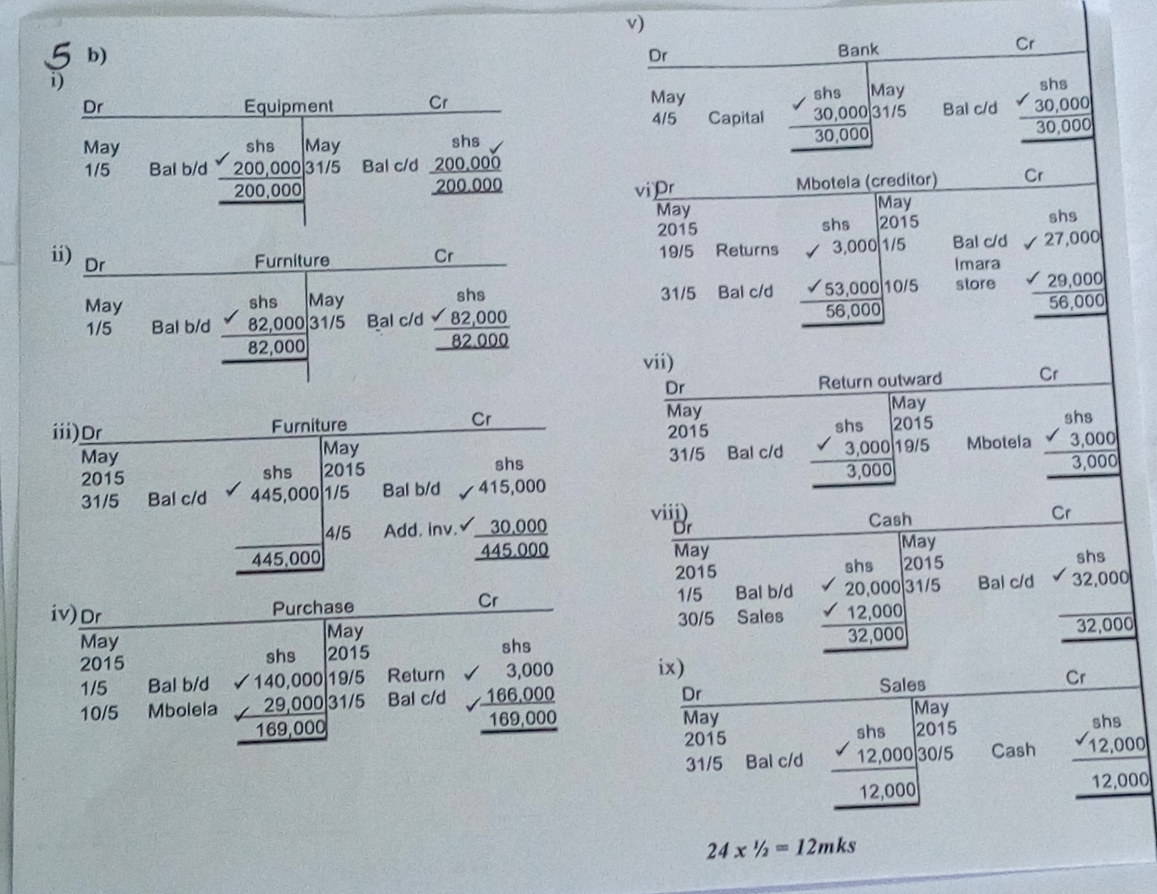

6a)
Public limited company | Public corporation
Owned by share holders | Ownership is by government
Capital sourced from sale of shares | Vote head by parliament on financing the corporation
Main aim is to make profit | Aimed at providing efficient services to the general public affordability
Formed through a company act | Formation is through an act of parliament
Managed by directors appointed by share holders | Management is by political appointees

b) –presence of a large number of buyers and sellers
-product dealt with is homogeneous
-No government intervention
-Firm said to be located in one area (no transport costs)
-free entry and exit of firms
-buyers and sellers have perfect knowledge of the market
-no excess demand or excess supply
Any 5 points @2mks =10mks

