NAME.............................................................ADM......................CLASS.........

231/3
END TERM 2-2024
BIOLOGY PAPER 3
(PRACTICAL)
TIME: 1 ¾ HRS

Question | Maximum  Score | Candidate’s  Score
1 | 10
2 | 17
3 | 13
TOTAL SCORE | 40

- You are provided with a visking tubing, a solution labeled K, Iodine solution labeled solution H, Benedict's solution labeled solution J and a piece of thread.

(a)Using the reagents provided, put 2ml of the solution K in a test - tube in each case, test for the food substances present. (6mks)

Food substance | Procedure | Observations | Conclusion
Starch
Reducing sugars

Tie one end of the visking tubing tightly using the thread provided. With the help of a dropper, put 10ml of the solution labeled K into the visking tubing. Tie the other end of the visking tubing tightly.

Ensure that there is no leakage at both ends of the visking tubing.

Wash the outside of the visking tubing with water. Place the visking tubing upright in a 100ml beaker. Add distilled water into the beaker to reach the level of the liquid in the visking tubing. Allow the set up to stand for 30 minutes.

(b)Using 2ml in a test - tube in each case, test for the food substances in the liquid outside the visking tubing . (2mks)

Food substance | Procedure | Observations | Conclusion
Starch
Reducing sugars

- Account for your results in (a) and (b) above. (2mks)

- You are provided with specimens labelled P and Q and a photograph labelled L in two views. All are bones obtained from a mammal. Examine them.

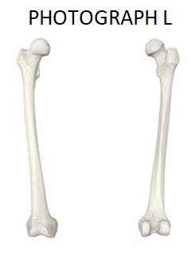
- Identify the bones and name the part of the mammalian body from which each was obtained. (6mks)

Bone | Identity of the bone | Where found
P
Q
L

- Draw and label the anterior view of specimen Q. (5mks)

- State two differences between specimen P and Q. (2mks)
P | Q
- Name the bone(s) that form a joint with bone L at its anterior and posterior end and in each case name the type of join they form. (4mks)
Anterior end
- Bone(s) -
- Type of joint –
Posterior end
- Bone(s)-
- Type of joint.
3.The photograph labelled D and E show two types of leaves

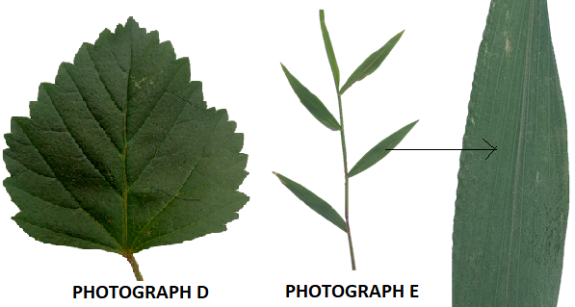
- I) with a reason, state the class of plants from which the leaf in photograph E was obtained. (2mks)
Class:

Reason:

ii)State two features in the leaf shown in photograph D that adapt it to its functions. (2mks)

- Study photographs K, L, and Q provided below and then answer the questions that follow.
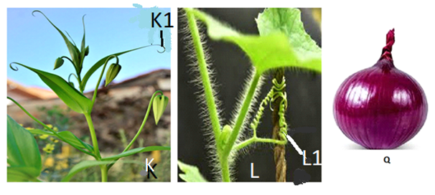
- Identify the part of photograph labelled K1 and L1. (2mks)
K1 –
L1 –
- State the role played by parts K1 and L1 in a plant (1mk)

- Name the type of response used by the structures K1 and L1 to play the role you have mentioned in (ii) above. (1mk)

- Name the hormone involved in the response you mentioned in (iii) above. (1mk)

(c) (i) Name the type of evolution demonstrated by photograph K and Q. (1mk)

(ii) What type of structures are represented by your answer in c(i) above. (1mk)

- Give reasons for your answer in c(ii) above. (2mks)

