NAME: ………………………………………………..INDEX NO:…………………….
SCHOOL: ……………………………………………..SIGNATURE :…………………
DATE: …………………………………………………

231/2
BIOLOGY
THEORY
Paper 2
July/August, 2024
Time: 2 Hours

INSTRUCTIONS TO CANDIDATES
- Write your name, index number and school in the spaces provided
- This paper consists of two sections, section A and section B. Answer ALL the questions in section A in the spaces provided on the question paper. In section B, answer question 6 (compulsory) and either question 7 or 8 in the spaces provided after question 8
- Be brief and precise. Unnecessary information and wrong spellings especially of technical terms shall be penalized
- This paper consists of 8 questions on 7 printed pages. Candidates are advised to check the question paper carefully to ensure that all the pages are printed as indicated and no questions are missing
FOR EXAMINER’S USE ONLY
QUESTION | MAXIMUM SCORE | CANDIDATE’S SCORE
1  2  3  4  5  6  7 0R 8 | 8  8  8  8  8  20  20

This paper consists of 8 printed pages Check the Question paper to ensure that all pages are printed as indicated and no question are missing.

SECTION A (40 MKS)
Answer ALL the questions in this section in the spaces provided on the question paper.
- The diagram below shows the internal structure of a bean seed.
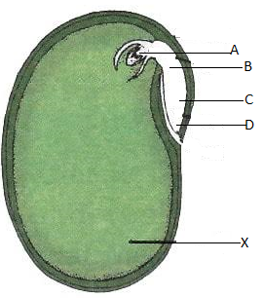
- Name parts labelled A-D. (4mks)
A
B
C

D

- What is the role of structure labeled X. (1mk)

- What is the main difference between epigeal and hypogeal germination. (1mk)

- Why is important that the radicle develops first during germination. (2mks)

- The photograph below shows components of blood from a ruptured blood vessel. Study it and answer the questions that follow.
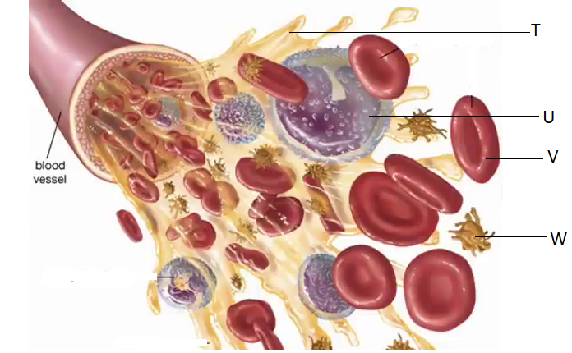
- Suggest the identity of the above blood vessel if a lot of digested food substances were found dissolved in part T. (1mk)

- Identify cell U and suggest its function. (2mks)

- i) name three types of antigens that are likely to be present on the surface of the membrane of cell V (3mks)

ii) Where in the human body is cell V produced? (1mk)

- What role does structure W play in blood clotting? (1mk)

- (a) During a lesson, students observed the structure of a bat, cat and human forelimbs to determine their evolutionary relationship.
- State the term used to describe the structure of the limbs observed by the students.
(1mk)

- Name the type of evolution illustrated by the structure of the limbs observed. (1mk)
- What evidence of evolution is illustrated by the limbs. (1mk)

- State the significance of the type of evolution illustrated by the limbs. (1mk)

(b) Explain how comparative embryology is an evidence for organic evolution in vertebrates.
(2mks)

(c)Explain the theory of evolution by natural selection. (2mks)

- In an experiment to investigate an aspect of digestion, two test tubes P and Q were set up as shown in the diagram below.
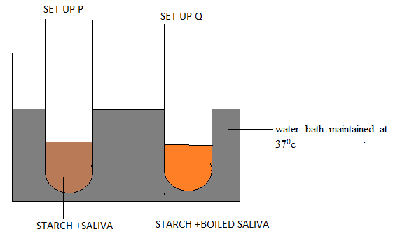
The test tubes were left in the water bath for 30 minutes. The contents of each test tube was then tested for starch using iodine solution.
- What was the aim of the set-up P? (1mk)

- What results were expected in test tubes P and Q. (2mks)

- Account for the results obtained in (b) above for test tubes P and Q. (2mks)

- Explain why the set up was maintained at 37ºc. (1mk)

- Name the carbohydrate stored in. (2mks)
- Mammalian liver.

- Potato tuber

- Haemophilia is a genetic disease which is transmitted through a recessive gene linked to the X chromosome. The normal gene may be represented by H and the gene for haemophilia may be represented by h.
- A woman who is a carrier for haemophilia married a normal man. Work out the expected genotypic and phenotypic ratio of their children. Show your working. (6mks)

- Hemophilia is more common in men than in women. Explain. (2mks)

SECTION B(40 MKS)
Answer question 6 (Compulsory) and either question 7 or 8 in the spaces provided after question 8.
6. The table below shows how quantities of sweat and urine vary with external temperatures
External temperature (⁰c) | Urine cm³/h | Sweat cm³/h
0  5  10  15  20  25  30  35 | 100  90  80  70  60  50  40  30 | 5  6  10  20  30  60  120  200

(a) Using the same axes, draw a graph of quantity of urine and sweat against the external
temperature. (7 marks)

(b) (i) State the quantity of urine and sweat produced when external temperature was 12.5⁰c. (2mks)
.
(ii) State the physical process through which the body was cooled by sweating as temperature was rising. (1mk)

(iii) Account for the quantity of urine produced as the temperature increased. (4mks)

.
(c) State three nitrogenous wastes that could be eliminated in urine or sweat in human beings. (3mks)

(d) State three behavioral mechanism that poikilotherms use to regulate their body temperature under hot conditions. (3mks)

7.Describe causes and methods of controlling water pollution. (20mks)
8.a)Name the tissues involved in support in plants. (4mks)
b).Explain how the ear brings about balance in relation to movement of the head. (16 mks)

