**MARKING SCHEME**

**FORM 4 BIOLOGY PAPER 2**

1. The diagram below shows the internal structure of a bean seed.

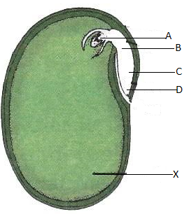

1. Name parts labelled A-D. (4mks)

A – Plumule;

B – Epicotyl;

C – Hypocotyl;

D – Radicle;

1. What is the role of structure labeled X. (1mk)

Food storage;

1. What is the main difference between epigeal and hypogeal germination. (1mk)

In epigeal the cotyledons are brought above the soil surface while in Hypogeal the cotyledon remains below the soil surface;

1. Why is important that the radicle develops first during germination. (2mks)

For anchorage;

For absorption of water and mineral salts;

1. The photograph below shows components of blood from a ruptured blood vessel. Study it and answer the questions that follow.

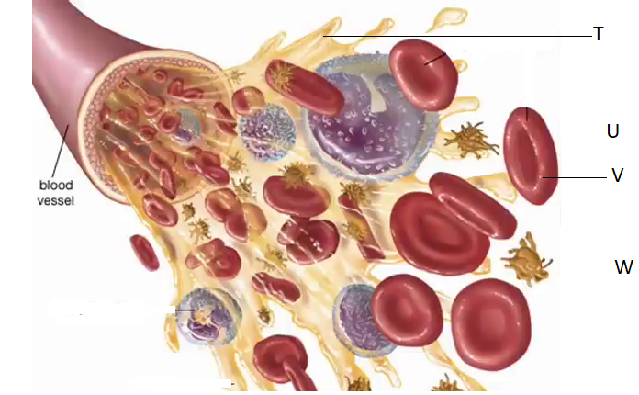

1. Suggest the identity of the above blood vessel if a lot of digested food substances were found dissolved in part T. (1mk)

Hepatic portal vein/hepatic portal venule;

1. Identify cell U and suggest its function. (2mks)

White bloodcell/leucocyte/granulocyte/phagocyte/polymorph

Function- protect the body against diseases; by destroying/engulfing and digesting pathogens

1. i) name three types of antigens that are likely to be present on the surface of the membrane of cell V (3mks)

antigen A; antigen B; Rhesus antigen

ii) Where in the human body is cell V produced? (1mk)

Bone marrow of short bones/ribs/sternum/vertebrae

1. What role does structure W play in blood clotting? (1mk)

When exposed to air it rupture to release thromboplastin/thrombokinase enzyme which intiate clotting process

1. (a) During a lesson, students observed the structure of a bat, cat and human forelimbs to determine their evolutionary relationship.
2. State the term used to describe the structure of the limbs observed by the students. (1mk)

Pentadactyl structure/limb;

1. Name the type of evolution illustrated by the structure of the limbs observed. (1mk)

Divergent evolution;

1. What evidence of evolution is illustrated by the limbs. (1mk)

Comparative anatomy;

1. State the significance of the type of evolution illustrated by the limbs. (1mk)

Shows that divergent forms have a single ancestry/common embryonic origin but are modified to perform different functions to allow organisms exploit different environments/ecological niches;

(b) Explain how comparative embryology is an evidence for organic evolution in vertebrates. (2mks)

It shows that vertebrate embryos have similar morphological features during their early development;. This indicates a common ancestral origin;

(c)Explain the theory of evolution by natural selection. (2mks)

This is the process where nature selects organisms with favourable characteristics/traits well adapted to prevailing environmental conditions survive; reach adulthood and reproduce giving forth offspring that inherit the favourable characteristics; Those with unfavourable characteristics do not survive competition; hence die young and their genes are eliminated;(mark either of the converse for 2mks)

1. In an experiment to investigate an aspect of digestion, two test tubes P and Q were set up as shown in the diagram below.

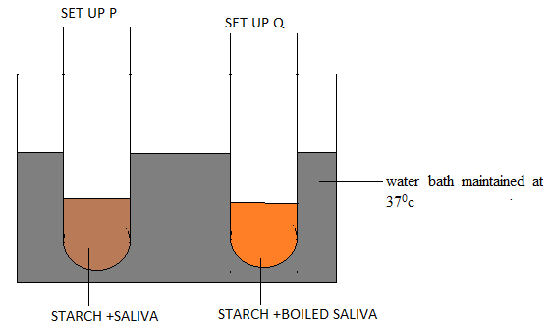

The test tubes were left in the water bath for 30 minutes. The contents of each test tube was then tested for starch using iodine solution.

1. What was the aim of the set-up P? (1mk)

To investigate whether saliva has an enzyme that digests starch;

1. What results were expected in test tubes P and Q. (2mks)

P: brown colour of iodine remains brown/did not change

Q: brown colour of iodine turned blue-black/blue/black

1. Account for the results obtained in (b) above for test tubes P and Q.(2mks)

P. Saliva contains salivary amylase enzyme which digests starch(to maltose);(hence negative starch test)

Q: When starch was boiled salivary amylase was denatured, hence no starch digestion took place; (c) tied to (b)

1. Explain why the set up was maintained at 37oc. (1mk)

This is the optimum/most suitable temperature for enzyme/salivary amylase activity;

1. Name the carbohydrate stored in. (2mks)
2. Mammalian liver.

Glycogen;

1. Potato tuber

Starch;

1. Haemophilia is a genetic disease which is transmitted through a recessive gene linked to the X chromosome. The normal gene may be represented by H and the gene for haemophilia may be represented by h.
2. A woman who is a carrier for haemophilia married a normal man. Work out the expected genotypic and phenotypic ratio of their children. Show your working. (6mks)

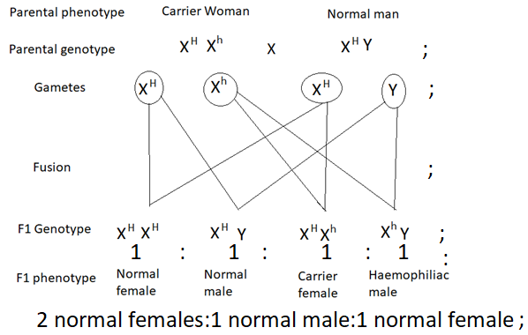

1. Haemophilia is more common in men than in women. Explain. (2mks)

Male require to have only one haemophiliac gene to have the condition, which they get from a carrier mother; however, females must have two of the genes (one from mother and one from father) haemophiliac males rarely breeds and hence very little chance of females inheriting the disease; OWTTE

6. The table below shows how quantities of sweat and urine vary with external temperatures

|  |  |  |
| --- | --- | --- |
| External temperature (0c) | Urine cm3/h | Sweat cm3/h |
| 0  5  10  15  20  25  30  35 | 100  90  80  70  60  50  40  30 | 5  6  10  20  30  60  120  200 |

(a) Using the same axes, draw a graph of quantity of urine and sweat against the external

temperature. (7 marks)

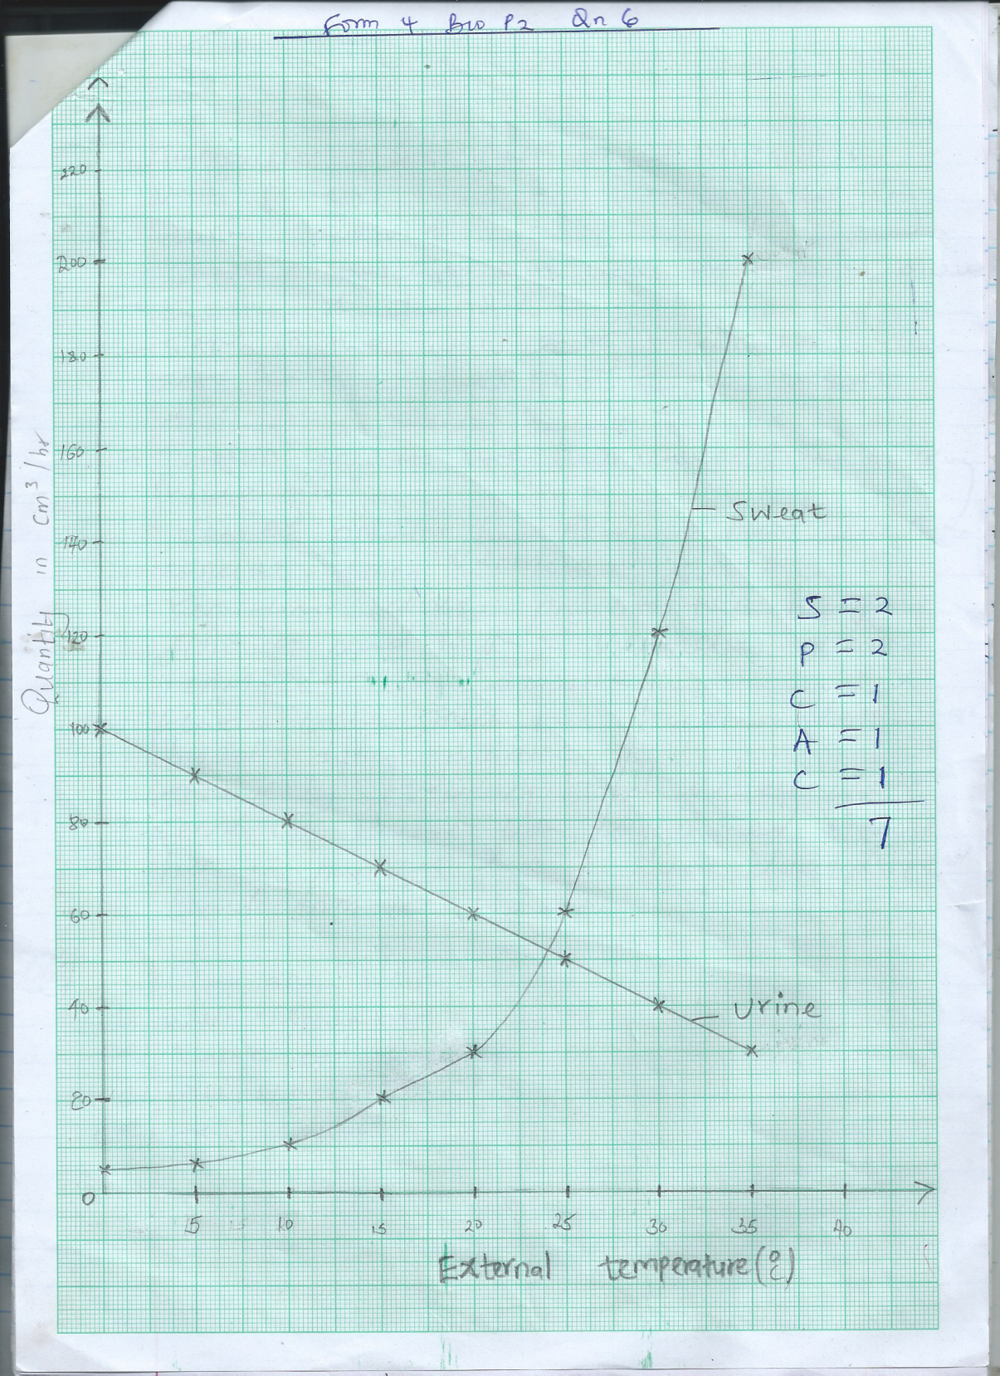

(b) (i) State the quantity of urine and sweat produced when external temperature was 12.50c. (2mks)

.Urine 74 cm3/h ± 1

Sweat 14 cm3/h ± 1

(ii) State the physical process through which the body was cooled by sweating as temperature was rising. (1mk)

Evaporation

(iii) Account for the quantity of urine produced as the temperature increased. (4mks)

An increase in temperature decreases the amount of urine produced. this is due to increased sweating which increases osmotic pressure of blood, hence more water is reabsorbed back into the blood stream at the kidney tabules.

(c) State three nitrogenous wastes that could be eliminated in urine or sweat in human beings. (3mks)

Urea

Uric acid

Ammonia

(d) State three behavioral mechanism that poikilotherms use to regulate their body temperature under hot conditions. (3mks)

Aestivation

Burrowing

Staying under shaded places.

7.Describe causes and methods of controlling water pollution. (20mks)

* Water pollution is addition of substances into water bodies that may cause harm to organisms and may be disruptive to aquatic ecosystem;
* The cause and control of water pollution include:

Industrial effluents that contain toxic chemicals such as heavy metals eg mercury, lead, Zinc, Copper, Chromium; hot effluent which pollutes water and may kill aquatic organisms; It can be controlled by treating the effluents before discharging them; cooling industrial wastes; carrying out environmental impact assessment before establishing industries;

* Hot water that reduces concentration of dissolved oxygen in water, killing aquatic animals; it can be controlled by imposing high penalties on factories discharging hot water;
* Oil spillage from oil tankers /ship accidents reduce oxygen in water; penetration of light; and clog feathers of marine birds; It can be controlled by regular servicing of oil tankers; Use of pipeline to transport oil; cleaning spilled oil; placing heavy penalties on companies;
* Domestic effluents that include untreated sewerage that cause water-borne diseases; raw sewage broken by saprophytes using dissolved oxygen in water bodies; leading to death of other aquatic organisms; can be controlled by treating sewage before being discharged/use of biotechnology; and recycling of wastes/garbage;
* Detergents that cause eutrophication causing reduced oxygen concentration; It can be controlled by banning use of phosphate based detergents;
* Agro-chemicals that include pesticides, fungicides and herbicides that are non-biodegradable; They may accumulate along the food chains killing higher animals;
* Control: Biological control of pest; Use of biodegradable pesticides; educate farmers on the correct amount of agro-chemicals;
* Inorganic fertilizers that have nitrates and sulphates cause eutrophication; Control: Use of organic fertilizers/manure that are biodegradable;
* Silting due to soil erosion reduces penetration of light to the plants; and clog respiratory surfaces of animals; Control: Proper methods of prevention of soil erosion; and proper farming methods eg use of terracing/gabions; Contour farming; Reafforestation; (max : 20)

8.a)Name the tissues involved in support in plants. (4mks)

Xylem;

Parenchyma;

Sclerenchyma;

Collenchyma;

b).Explain how the ear brings about balance in relation to movement of the head. (16 mks)

The semicircular canal are responsible for maintain body balance and posture in relation to movement of the head;

The canals lie at right angles to each other; and occupy the three planes of space;

Two lie vertically and at right angles to one another while the third is horizontal;

Each semicircular canal has a swelling called ampulla at one end;

The ampulla contains sensory hairs; projecting into a gelatinous material called cupula;

When the head moves; the fluids in the inner ear moves; and this stimulating the sensory hairs; an impulse is triggered; and transmitted to the brain; by the auditory nerve for interpretation;

In the brain the information is relayed to the motor nerve; which carries motor impulses to the muscles of the body; to restore the body balance;

(16 marks max 15 marks)