NAME: ………………………………………………..INDEX NO:…………………….
SCHOOL: ……………………………………………..SIGNATURE :…………………
DATE: …………………………………………………

231/1
BIOLOGY
THEORY
Paper 1
July/August, 2024
Time: 2 Hours

INSTRUCTIONS TO CANDIDATES
- Write your name, index number and school in the spaces provided
- Be brief and precise. Unnecessary information and wrong spellings especially of technical terms shall be penalized

This paper consists of 9 printed pages Check the Question paper to ensure that all pages are printed as indicated and no question are missing.

- Distinguish between anatomy and morphology. (2mks)
Anatomy | Morphology

- State the characteristics of living things that is being demonstrated by seeds producing heat during germination (1mk)

- a) During a field study. A form one student at kabai School observed the organism below. Name one appropriate tool the student would use to collect the specimen. Give a reason for your answer. (2mks)

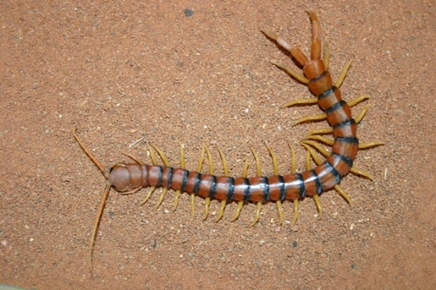

b) State three precautions the students should take during the collection of the above specimen.
(3mks)

- The diagram below represents a cell as seen under an electron microscope.

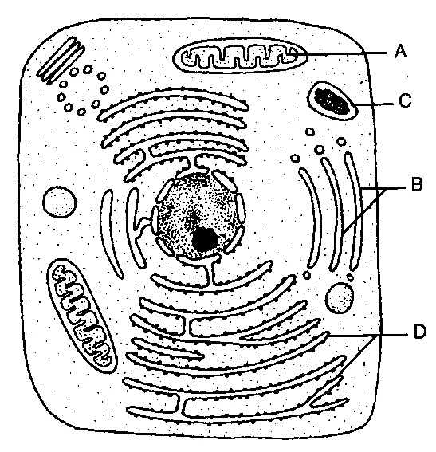
- Identify the parts labeled A and D. (2mks)
- A -
- D -

- State the function of the structures found on the part labeled D. (1mk)

- Equal amounts of three different sugar solutions were placed in the visking tubings M, N and L. the tubings were placed in a beaker of water containing 5% sugar solution. The set up was left for two hours. The results were as shown in the diagram below

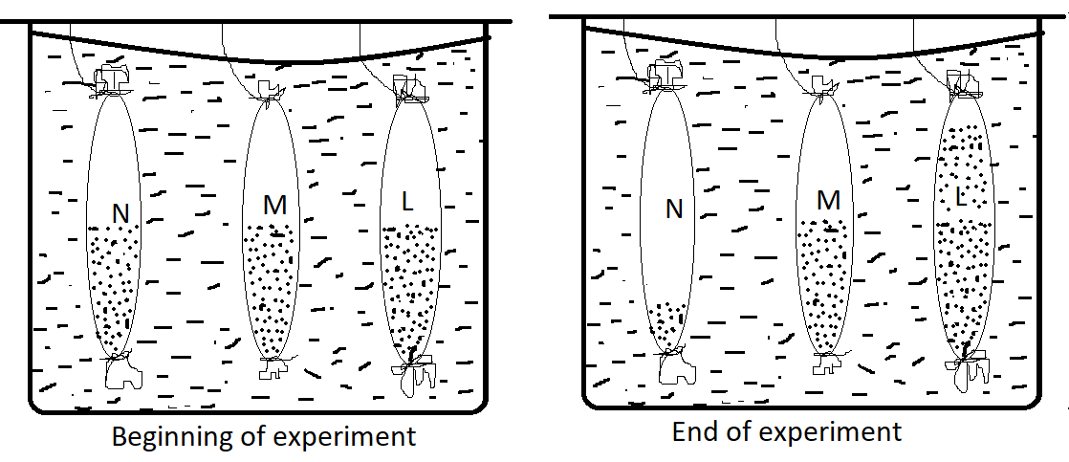
- Which process was being investigated. (1mk)

- State the nature of solution M and L as compared to the 5% sugar solution in the beaker.
(2mks)
M –
L –
- Account for the results obtained in visking tubing N. (3mks)

- a) Name one process that brings about
- The translocation of manufactured food in plants. (1mk)

- Transport of water from the epidermal cells of the root to the cells at the center of a monocotyledonous root.
(1mk)

- Absorption of soluble products of digestion from the alimentary canal into the blood stream.
(1mk)

- The following is the dental formula of a certain mammal.
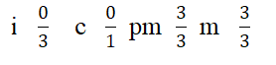
- (i) State the likely mode of feeding for the mammal. (1mk)

(ii) Give a reason for your answer in (a)(i) above. (1mk)

- Explain how the carnassial teeth of a carnivore are adapted to their function. (2mks)

- A patient with blood group A was involved in a road accident and required urgent blood transfusion. His relatives were invited to donate blood.
(a) Name the compatible blood groups. (2mks)
(b)State why other blood groups were not compatible (1mk)

- Most carbon (IV) oxide is transported from tissues to the lungs within the red blood cells and not in the blood plasma. Give two advantages of this mode of transport. (2mks)

- Name three forces involved in transportation of water and mineral salts up the stem (3mks)

- State three differences between anaerobic and aerobic respiration (3mks)
Anaerobic | Aerobic

- The oxidation state of a certain food is represented below by a chemical equation.
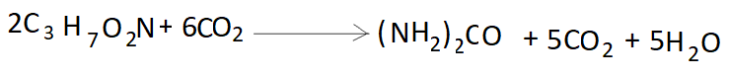
([a) Calculate the respiratory quotients [RQ] of the food substance. (2mks)

(b) Identify the food substrate (1mk)

- State the function of the following in mammalian trachea. (3mks)
- Rings of cartilage

- Mucus

- Cilia.

- a) Name the fluid that is produced by sebaceous glands. (1mk)

(b) What are the roles of sweat on the human skin? (2mks)

- In an investigation, equal amounts of water was placed in three test tubes labelled J, K, and L. Pond weeds of equal length were dropped in each test tube. The test tubes were then placed in identical conditions of light and carbon (IV) oxide at different temperatures for five minutes. After five minutes, the bubbles produced in each test tube were counted for a minute. The results were as shown in the table below.
Test tube | Temperature(ºc) | Number of bubbles.
J  K  L | 20  35  55 | 28  42  10
- Name one requirement for this process that is not mentioned in the investigation. (1mk)

- Name the gas responsible for the bubbles produced. (1mk)

- Account for the results in test tubes K and L (2mks)
K-

L-

- (a) A student collected an organism and observed the following features: Simple eyes, four pairs of legs and two body parts.
- State the class to which the organism belongs. (1mk)

- Give an example of an organism in this class. (1mk)

(b)Name the kingdom to which plasmodium belongs. (1mk)

- What happens to excess fatty acids and glycerol in the body. (1mk)

- Name two tissues in plants which are thickened with lignin. (2mks)

- Name the part of a flower that develops into:
(i) Seed (1mk)

(ii) Fruit (1mk)

- The diagrams below show changes in the life cycle of flowering plants.
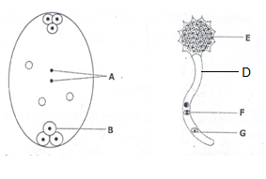
Complete the table below by choosing the letters from the diagram which refers to each of the given structure. (4) marks
STRUCTURE | LETTER
Pollen tube
Tube nucleus
Egg cell
Male gamete nucleus

- Name the causative agent of the following diseases. (2mks)
- Trichomoniasis.

- Amoebic dysentery

- (a)What is the relationship between leguminous plants and bacteria found in their roots. (1mk)

(b)Give two reasons why primary productivity in an aquatic ecosystem decreases with depth.
(2mks)

- State one survival value for each of the following in plants.
- Thigmotropism in stems. (1mk)

- Geotropism in roots. (1mk)

- a) Give two sex linked genes found on the Y-chromosome. (2mks)

b) Below is a nucleotide strand
A | A | G | T | C
i) Identify the type of nucleic acid. (1mk)

- Give a reason for your answer in (a) above. (1mk)

- (a) What are vestigial structures. (1mk)

(b)Name a vestigial structure in human beings. (1mk)

- (a) Name the evidence of organic evolution exhibited by occurrence of similar amino acid
molecules in a range of organisms. (1mk)

(b)Why are some bacteria able to resist the effect of antibiotics. (2mks)

- (a) Name the type of skeleton that makes up each of the following animals
- Locust – (1mk)
- Bird- (1mk)
(b)Name the fin(s) in tilapia fish responsible for the following: (2mks)
(i) Steering

(ii) Pitching

