NAME:……………………………………………………………………………………………..ADM:………………….CLASS:…….
BIOLOGY PAPER 3
FORM 3
END TERM 2 2024
TIME: 1³/₄ HOURS
INSTRUCTIONS TO CANDIDATES
- Answer all the questions.
- Answers must be written in the spaces provided in the question paper.
- Additional pages must not be inserted.
- Candidates may be penalized for recording irrelevant information and for incorrect spellings.

1. Study the photographs below and answer the questions that follow.

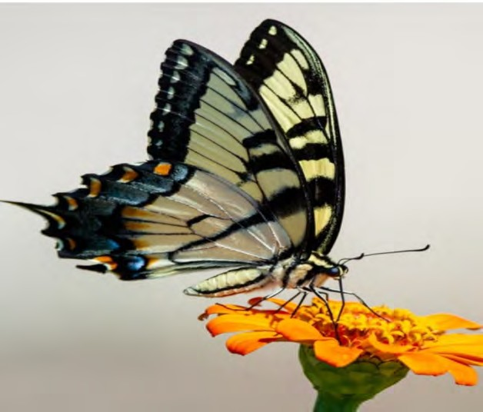
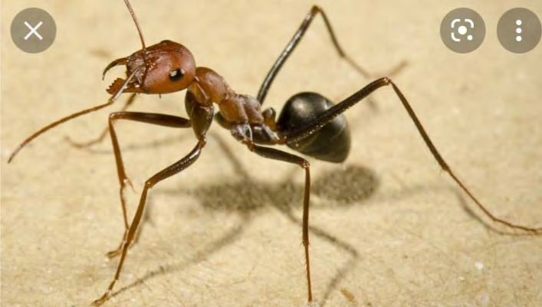

SPECIMEN Q SPECIMEN R
a) The two specimen belong to the same Phylum. Giving two reasons, name the phylum of the specimen. ( 3 marks)
i) Phylum………………………………………………………………………

ii) Reasons
……………………………………………………………………………………………………………………………………………………………………………………………………………………………………………………………………………………………………………………………………………………………….
b i) Name the class to which the specimen belong. (1mark)

……………………………………………………………………………………….
ii) State three characteristic features common to both specimens that support your answer. (3 marks)

………………………………………………………………………………………………………………………………………………………………………………………………………………………………………………………………………………………………
- Based on observation from the photos, state how the mouthparts of specimen Q

and R are adapted to their functions. (4 marks)
Specimen Q
……………………………………………………………………………………………………………………………………………………………………………….
Specimen R
………………………………………………………………………………………………………………………………………………………………………………
- Citing visible features, state two modes of locomotion for specimen Q.
(2 marks)
……………………………………………………………………………………………………………………………………………………………………………….

2. You are provided with a 7cm visking tubing. Immerse it in water for 1 minute. Remove it from water, rub it between your fingers to open it. Using one piece of cotton thread, tie one end tightly.Put 4cm3 of solution X in the visking tubing and tie the other end tightly using a piece of the other cotton thread. Rinse off the visking tubing using distilled water. Immerse it in iodine solution contained in a 100ml beaker. Leave the set up to stand for 10 minutes. Make observation and answer question that follow.

(a) Suggest the likely food substance contained in solution X. (1mk)
………………………………………………………………………………………………
(b) State the physiological process under investigation. (1mk)
……………………………………………………………………………………………
(c) Account for the observation made at the end of the process. (4mks)
…………………………………………………………………………………………………………………………………………………………………………………………………………………………………

(d) Using the reagents provided, carry out tests to determine the food substances present in solution X. Write the procedure, observation and conclusion in the table below; (9 mks)
Food tested | Procedure | Observation | Conclusion
Reducing sugar
Non-reducing sugar

Protein

3. Study the photographs below and answer the questions that follow.
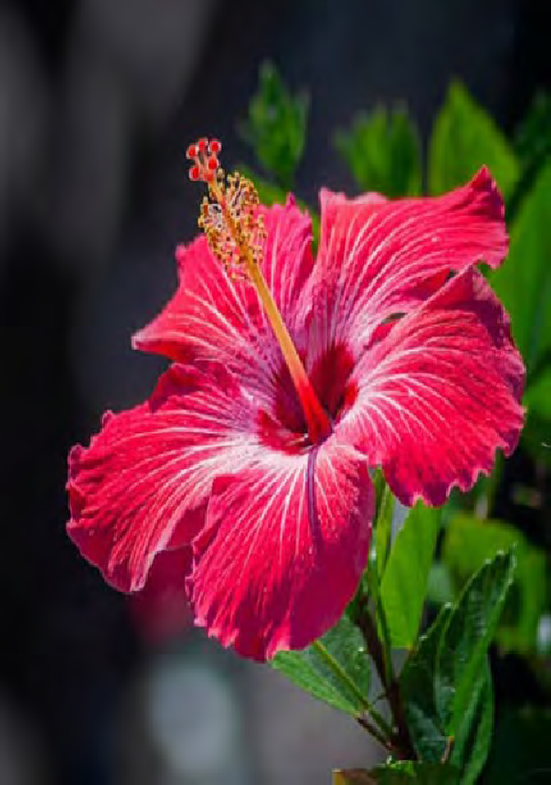
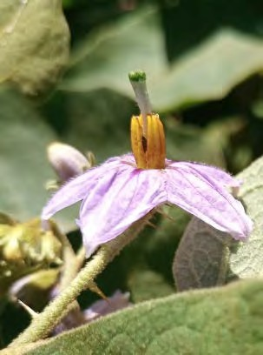

K
Q

a i) Suggest the agent of pollination for specimen Q. ( 1 mark)

…………………………………………………………………………………

ii) Give three adaptations of the flower that support your answer in a (i) above.
(3 marks)
………………………………………………………………………………………………………………………………………………………………………………………………………………………………………………………………………
- State five differences between specimen Q and K. (5 marks)

Specimen Q | Specimen K

- On the photograph of specimen K, label the following:- ( 3 marks)

Stigma
  - Anther

  - Style

