BIOLOGY PAPER 3
FORM 3
END TERM 2 2024
MARKING SCHEME

1. Study the photographs below and answer the questions that follow.

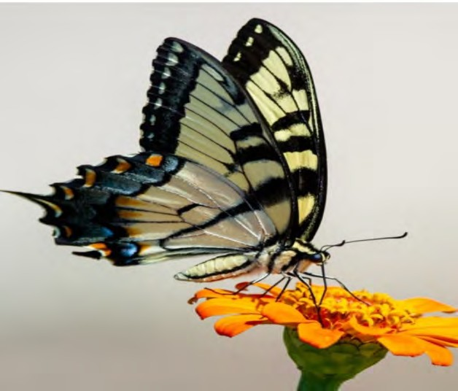
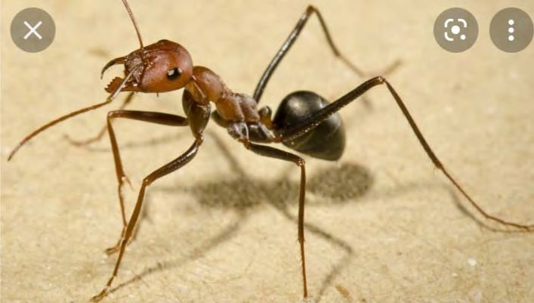

SPECIMEN Q SPECIMEN R
a) The two specimen belong to the same Phylum. Giving two reasons, name the phylum of the specimen. ( 3 marks)
i) Phylum arthropoda

ii) Reasons
- segmented body
- jointed appendages
- prescence of exoskeleton
b i) Name the class to which the specimen belong. (1mark)

class insecta
ii) State three characteristic features common to both specimens that support your answer. (3 marks)

- segmented body
- jointed appendages
- prescence of exoskeleton

- Based on observation from the photos, state how the mouthparts of specimen Q

and R are adapted to their functions. (2 marks) Specimen Q
has proboscis and stlyle for sucking nectar
Specimen R

Small mandibles for chewing and biting

ii) Citing visible features, state two modes of locomotion for specimen Q.
(2 marks)
wings

limbs

2. a) Starch1
b) Diffusion 1
c) Iodine molecules are highly concentrated; moves into the Visking tubing by diffusion; reacting
with solution x; thus blue-black colour observed in the Visking tubing; confirming x to be starch;
d)
 | Procedure | Observation | Conclusion
Reducing sugar | 2 ml of solution x in a test tube, add equal volume of Benedicts’ Solution and boil (Accept specified number of drops of reagent). | Blue colour of Benedicts’ Solution retained. | Reducing sugar absent.
Non-reducing sugar | 2 ml of x in a test tube, add 5 drops of dilute HCl, warm over hot waterbath, remove cool, and NaHCO₃ solution dropwise, shaking after every drop until fizzling stops. Add 5 drops of Benedicts’ solution and boil. | Colour changes from blue, green, yellow and finally orange.  NB: The sequence of the colour changes must be correct. | Non – reducing sugar present.
Protein | 2 ml of x in a test tube, add 5 drops of NaOH solution and shake, add 5 drops of CuSO₄ solution and shake. | Purple/violet colour observed. | Protein present.

3. Study the photographs below and answer the questions that follow.
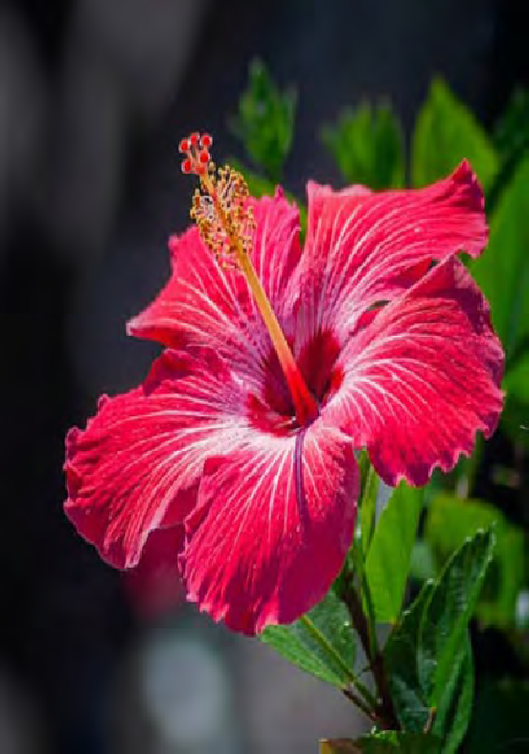
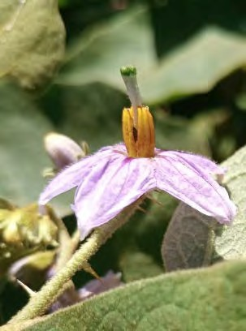

K
Q

a i) Suggest the agent of pollination for specimen Q. ( 1 mark)

insects

ii) Give two adaptations of the flower that support your answer in a (i) above.
(2 marks)
Brightly coloured
Funnel shaped petals
Small bract
State five differences between specimen Q and K. (5 marks)

Specimen Q | Specimen K
Brightly coloured | dull
smooth | hairy
red | Purple
Large and conspicuous | Small and inconspicuous
Many anthers | Few anthers

- On the photograph of specimen K, label the following:- ( 2 marks)
  - Stigma
  - Anther

