NAME::………………………………………………………CLASS:……………..ADMISSION NO:……
231/2
BIOLOGY
PAPER 2
FORM THREE
END TERM 2 2024
TIME: 2 HOURS

INSTRUCTIONS TO CANDIDATES
- This paper consists of two sections A and B.
- Answer All the questions in Section A in the spaces provided
- In section B answer question 6. (compulsory) and either question 7 or 8 in the spaces provided after question.

SECTION A ( 40 MARKS)
- The diagrams below represents two plants cell A and B placed in two different solutions. Study the diagrams and answer questions that follow.

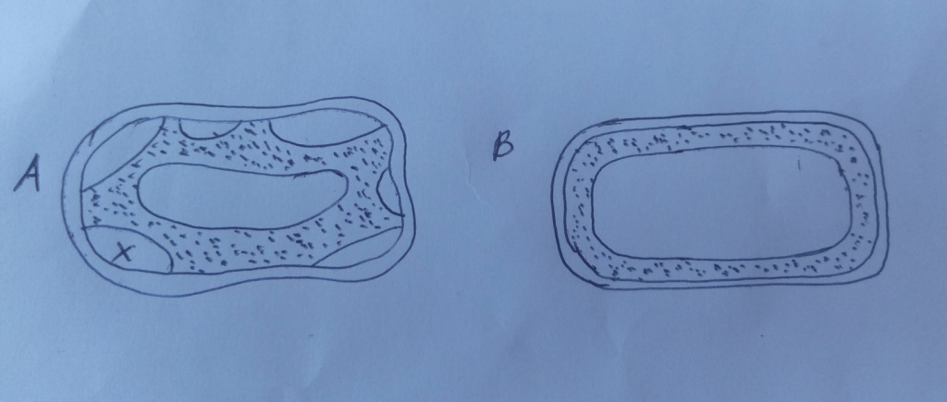

- Identify the nature of solution into which each cell was placed. (2mks)
A

B

- Name the physiological process responsible for the observed results. (1mk)

- Give the correct biological term used to describe cell A. (1mk)

- Describe what would happen if a red blood cell was placed in the solution in which cell B was placed. (2mks)

- Explain why freshwater amoeba do not burst when placed in distilled water. (2mks)

- Explain the fate of glucose after assimilation. (2mks)

- (a) Distinguish between the terms homodont and heterodont. (2mks)

(b) What is the function of carnassial teeth? (1mk)

(c) The diagram below represents the lower jaw of a mammal.

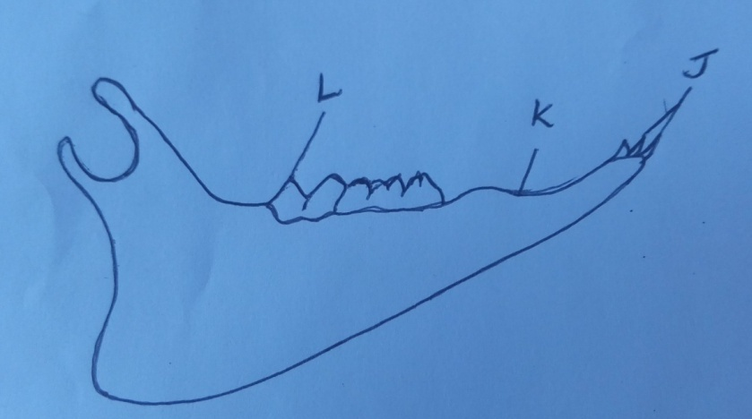

(i) Name the mode of nutrition of the mammal whose jaw is shown above. (1mk)

(ii) State one structural and one functional differences between the teeth labeled J and L. (2mks)

(iii) Name the toothless gap labeled K. (1mk)

(iv) State the function of the gap. (1mk)

(v) Name the substance that is responsible for hardening of teeth. (1mk)

(v) What do you understand by the term ‘dental formula’. (1mk)

- The diagram below represents a food web in a terrestrial ecosystem.
Green plants
Hawks
Snakes
Lions
Antelopes
Cane toad
Grasshopper
Mice
Lizards

- Which organism has the highest number of preys? (1mk)

- Construct food chains with snakes as tertiary consumers. (2mks)

- State the trophic level occupied by hawks in the food chains constructed in (b) above (1mk)

- Describe how capture-recapture method can be used in estimating the population of fishes in a lake. (4mks)

- Name the process through which:
- Producers convert chemical energy into heat energy lost to the environment. (1mk)

- Living organisms convert chemical energy into heat energy lost to the environments. (1mk)

- The figure below shows the embryo sac before fertilization.

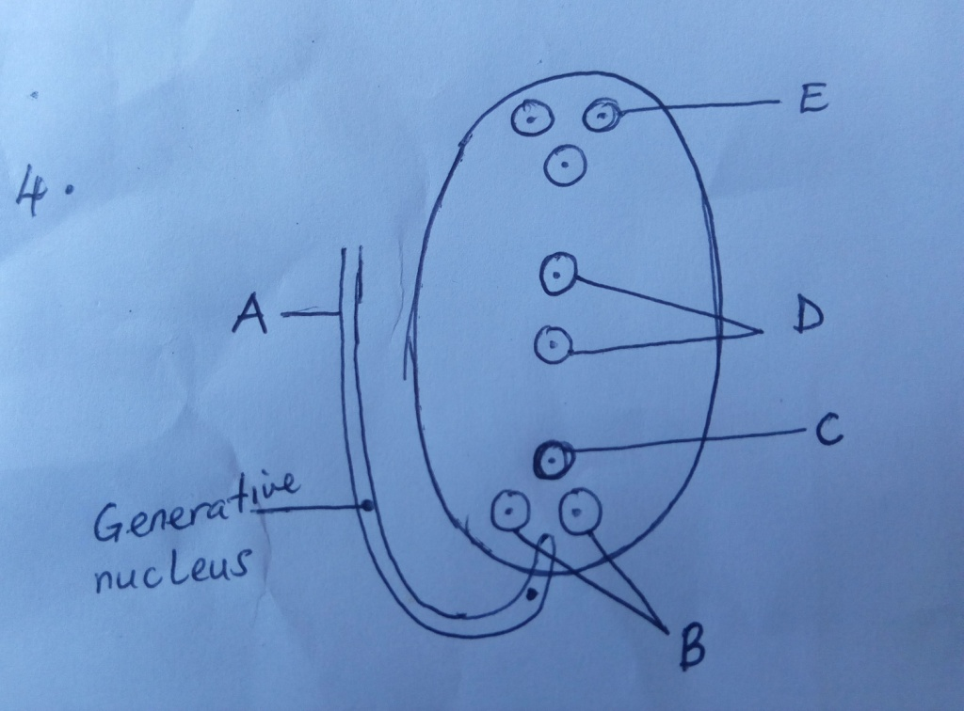

- Identify the structures labeled A and B (2MKS)

- Identify the structures labeled in the diagram that will develop into the following after fertilization.
- Embryo (1mks)

- Endosperm (1mk)

- State the ploidy of each of the following nuclei after fertilization
- C (1mk)

- D (1mk)

- Briefly outline the process of ‘double fertilization’ in flowering plants. (2mks)

- Name two substances which are found in the intercellular air spaces in a green leaf during a hot sunny day. (2mks)

- The diagram below represents a state in cell division. Study it and answer the questions below.
A
B
C

- Name the stage of cell division illustrated in the diagram above. (1 mark)
………………………………………………………………………………………………………………………………………………………………………………………………………………………………
- Name the parts labelled A, B and C (3 marks)
A
………………………………………………………………………………………………………………
B
………………………………………………………………………………………………………………
C
………………………………………………………………………………………………………………

- State THREE differences between mitosis and meiosis. (3 marks)
 | Mitosis | Meiosis
(i)
(ii)
(iii)

- Name the process during which the exchange of genetic materials occur at prophase 1 of meiosis.
(1 mark)
………………………………………………………………………………………………………………………………………………………………………………………………………………………………

SECTION B(40 MARKS)
Answer question 6(compulsory) and either 6 or 7 in the spaces provided.

- An experiment was carried out in which red blood cells were but in salt solutions of different concentrations. The table below show the percentage of cells which were destroyed by haemolysis in different salt concentrations.

Salt concentration (g/dm³) | % RBC destroyed by haemolysis
0  1  2  2.5  3.0  3.5  3.7  4.0  4.5  4.7  5.0  6.0 | 100  100  100  100  100  96  80  60  16  0  0  0

a) Draw a graph of percentage of red blood cells haemolysis againt salt concentration. (7mks)

b) Explain haemolysis of red blood cells (3mks)
………………………………………………………………………………………………
………………………………………………………………………………………………
………………………………………………………………………………………………
c) From the graph, state:
i) the salt concentration at which 50% red blood cells were haemolysed(1mk)
………………………………………………………………………………………………
………………………………………………………………………………………………
- The highest salt concentration when the highest number of red blood cells were haemolysed (1mk)
………………………………………………………………………………………………
………………………………………………………………………………………………
d) i) Suggest the normal salt concentration in the blood of the mammal from which the
red blood cells were obtained (1mks)
………………………………………………………………………………………………
………………………………………………………………………………………………
ii) Give a reason in d(i) above. (1mk)
………………………………………………………………………………………………
………………………………………………………………………………………………
iii) What term is used to describe the solution with equal solute concentration as that of the cells (1mk)
………………………………………………………………………………………………
………………………………………………………………………………………………
e) Name the process in the human body that ensures that haemolysis of red blood cells is prevented. (1mk)
………………………………………………………………………………………………
………………………………………………………………………………………………
f) State the role of osmosis in organism (4mks)
………………………………………………………………………………………………
………………………………………………………………………………………………
………………………………………………………………………………………………

7. a) Describe how insect pollinated flowers are adapted to pollination (10mks)
b) Explain how seeds and fruits are adapted to wind and animal dispersal (10mks)

8 Describe causes and methods of controlling water pollution. (20 marks)

