NAME:……………………………………………………………..ADM:……….CLASS:……..

BIOLOGY PAPER 1
FORM 3
END TERM 2 , 2024
TIME: 2 HRS
INSTRUCTIONS:
- (a) Define the term species. (2mks)
……………………………………………………………………………………………………………………………………………………………………………………………………………………
(b) Which taxonomic group has the largest number of members? (1mk)
………………………………………………………………………………………………………

2. During a field trip, a student collected a specimen that had the following characteristics
- 2 body parts
- More than 4 pairs of limbs
-had a carapace
(a) Identify the class into which the organism belongs. (1mk)
………………………………………………………………………………………………
(b) Other than the head, name the other body part. (1mk)
………………………………………………………………………………………………
3. (a) State two functions of a microscope. (2mks)
……………………………………………………………………………………………………………………………………………………………………………………………………………………
(b) A cell magnified 800 times using a light microscope whose eye piece was x20. What was the magnification of the objective lens? (1mk)
……………………………………………………………………………………………………………………………………………………………………………………………………………..
4. Give two functions of the endoplasmic reticulum. (2mks)
……………………………………………………………………………………………………………………………………………………………………………………………………………………
5. (a) Define the following terms
(i) Cytology (1mk)
………………………………………………………………………………………………………

(ii) Mycology (1mk)
………………………………………………………………………………………………
(b) State the importance of irritability in living organisms. (1mk)
…………………………………………………………………………………………………………
6. Name the gaseous exchange structures in;
(a) Insects (1mk)
…………………………………………………………………………………………………………
(b)Frogs (1mk)
…………………………………………………………………………………………………………
7. Two species in an ecosystem cannot occupy the same niche. Explain. (1 mark)
................................................................................................................................................................................................................................................................................................................................................................................................................................................................................................................................................................................................................................................................................................
8. The diagram below represents a stage during cell division
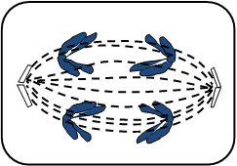
a) Name the stage of cell division. (1 mark)
.....................................................................................................................................................
b) Give two reasons for your answer in ( a) above. (2 marks)
........................................................................................................................................................................................................................................................................................................................................................................................................................................................................................................................
c) State the significance of this stage of cell division in living organisms. (1 mark)
............................................................................................................................................................................................................................................................................................................
9. Name the causative agent for the following diseases;
a) Typhoid (1 mark) .......................................................................................................................................................
b) Syphilis (1 mark)
......................................................................................................................................................
10. A process that occurs in plants is represented by the equation below.
C₆H₁₂O₆ 2C₂H₅OH + 2CO₂ + Energy
(glucose) (ethanol) (carbon (iv)
Oxide)
a) Name the process. (1mk) ………………………………………………………………………………………………
b) State the economic importance of the process named in (a) above. (1mk) ……………………………………………………………………………………………………………………………………………………………………………………………………
11. In a class activity, a group of students from Star secondary school caught 50 grasshoppers and marked them using blue ink. They then released them. The following day they repeated the activity. They caught 100 grasshoppers out of them, 25 had a blue mark. Calculate the estimated population of grasshoppers in the area. (3mks) ………………………………………………………………………………………………………………………………………………………………………………………………………………………………………………………………………………………………………………………………………………………………………………………………………………………………

12. Study the diagram below and answer the questions which follow.
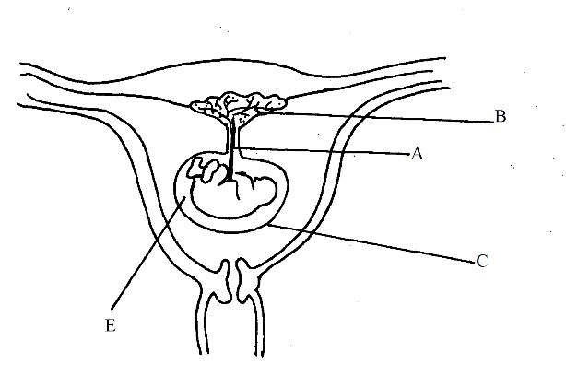
a) Name the parts labelled C and E (2mks)
C ……………………………………………………………………………………………
E……………………………………………………………………………………………
b) State two function of part B. (2mks) ………………………………………………………………………………………………………………………………………………………………………………………………………………………………………………………………………………………………

13. study the organelle below and answer the questions that follow.
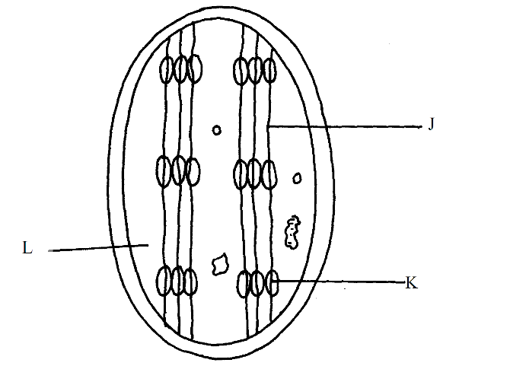
a) Name the organelle. (1mk) ………………………………………………………………………………………………
b) Identify the structure labelled J and K. (2mks)
J……………………………………………………………………………………………
K……………………………………………………………………………………………
c) State the function of the part labelled L. (1mk) ………………………………………………………………………………………………………………………………………………………………………………………………………………
14. a) Name the antigens that determine human blood groups. (2mks)
………………………………………………………………………………………………………
………………………………………………………………………………………………………
b) State the adaptation that enables the red blood cells to move into blood capillaries. (1mk) ………………………………………………………………………………………………………………………………………………………………………………………………………………

15 (a) Name the kingdom into which the prokaryotes are placed. (1 mark)

………………………………………………………………………………………………….
(b) State two characteristics used to classify arthropods in classes. (2 marks)

……………………………………………………………………………………………………………………………………………………………………………………………………………...

16. A certain plant had the following characteristics:
  - Presence of roots, stem and leaves.
  - Found with sori on the under surface.
  - Life cycle in sporophyte and gametophyte generations.
  - Sporophyte generation being dominant.
Name the division to which the plant belongs. (1 mark)
………………………………………………………………………………………………….

17. Name the causative agent of the following diseases. (2 marks)
(i) Cholera.
…………………………………………………………………………………………………….
(ii) Candidiasis.
…………………………………………………………………………………………………….

18. The diagram below represents part of the human digestive system.
Name the organs labeled L and M. (2mks)
L:………………………………………………………………………………………………
M:……………………………………………………………………………………………….. 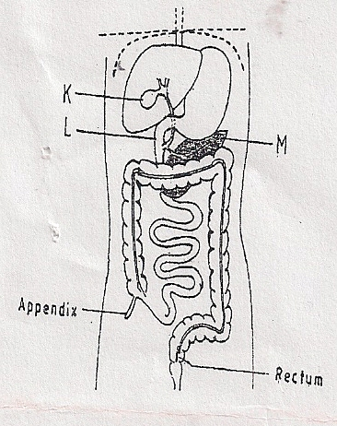

- (a) State two functions of the blood other than transport. (2mks)
…………………………………………………………………………………………………
…………………………………………………………………………………………………
(b) Name one defect of the circulatory system in humans. (1mk)

…………………………………………………………………………………………………
- Form One student set up an experiment shown below to investigate a certain physiological process. The set up was left for 30 minutes.
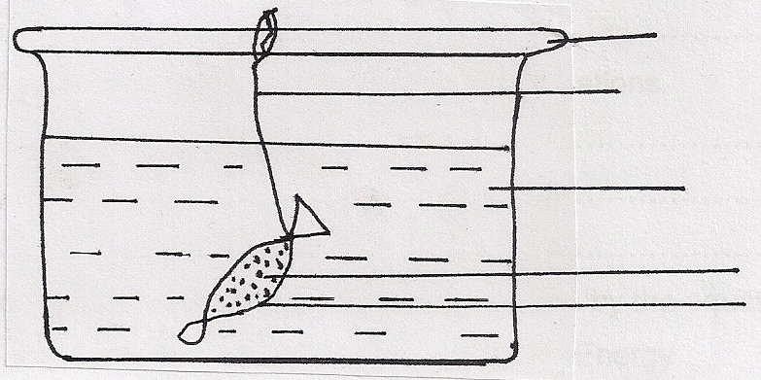
Glass rod
Thread

Distilled water

Sucrose solution
Visking Tubing

- Name the process under study. (1mk)
………………………………………………………………………………………………
- State the expected results after 30 minutes. (1mk)
………………………………………………………………………………………………
- Explain your answer in (b) above. (3mks)
………………………………………………………………………………………………………………………………………………………………………………………………………………………………………………………………………………………………
- (a) Give another name of the oviduct. (1mk)
……………………………………………………………………………………………….
(b) Name the hormone responsible for production of milk after perturation. (1mk)
……………………………………………………………………………………………….
- Below is an example of a food chain.

Nappier grass Mouse Snake Hawk

Identify the trophic level occupied by:
    - (i) Nappier grass (1mk)
…………………………………………………………………………………………
(ii) Hawk (1mk)
……………………………………………………………………………………………….
    - What would happen if snakes are removed from the food chain? (2mks)
………………………………………………………………………………………………………………………………………………………………………………………………
- a) State three characteristics of a wind pollinated flower. (3mrks)
………………………………………………………………………………………………………………………………………………………………………………………………………………………………………………………………………………………………………………………………………………………
b) Explain why sexual reproduction is important to organisms. (1mrk)
…………………………………………………………………………………………………………………………………………………………………………………………………………………………………………………………………………………………………………………………
- The table below shows the energy use per day in kilojoules
Age(years) | Male | Female
2 | 5,500 | 5,500
5 | 7,000 | 7,000
8 | 8,800 | 8,000
11 | 10,000 | 9,200
14 | 12,500 | 10,500
18 | 14,200 | 9,600
25 | 12,100 | 8,800
a).From the table, explain why after age 8 males require more energy than females. (1mrk)
………………………………………………………………………………………………………………………………………………………………………………………………………………
b). Other than sex and age, name three other factors that determine energy requirements in human beings (3mrks)
……………………………………………………………………………………………………………………………………………………………………………………………………………………………………
- The diagram below represents a simplified Nitrogen cycle
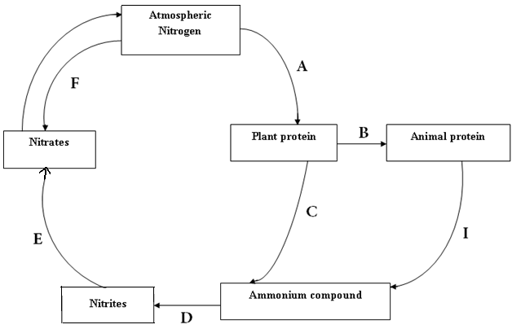

Name the organisms that cause the following process (4mks)
A……………………………………………………………………………………………
D……………………………………………………………………………………………
E……………………………………………………………………………………………
ii) Name the process presented in I above
I……………………………………………………………………………………………

- The diagram below represent transverse section of an ovary of a certain flower
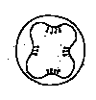

i) Identify the type of placentation illustrated in the diagram above (1mk)
………………………………………………………………………………………………

- Name the type of competition exhibited by the following relationship. (2 marks)
- Second generation of tobacco plant and the parent plant.
…………………………………………………………………………………………….......
- Different types of herbivores in an enclosed grass paddock.
……………………………………………………………………………………………...
- a) State three advantages of cross — pollination. (3mks)
................................................................................................................................................................................................................................................................................................................................................................................................................................................................................... b) State two ways by which plants avoid self— pollination. (2mks)

