BIOLOGY PAPER 1
FORM 3
END TERM 2, 2024
1. (a) Define the term species. (2mks)
- A group of organism that can freely interbreed; to produce viable/fertile offspring’s
(b) Which taxonomic group has the largest number of members? (1mk)
Kingdom
2. During a field trip, a student collected a specimen that had the following characteristics
- 2 body parts
- More than 4 pairs of limbs
-had a carapace
(a) Identify the class into which the organism belongs. (1mk)
Crustacea
(b) Other than the head, name the other body part. (1mk)
Caphalothorax
3. (a) State two functions of a microscope. (2mks)
Magnification
Resolution
(b) A cell magnified 800 times using a light microscope whose eye piece was x20. What was the magnification of the objective lens? (1mk)
800 = x40
20
4. Give two functions of the endoplasmic reticulum. (2mks)
- Synthesis and transport of lipids/steroids;
- Secretion/transport of packaged materials;
- Transport proteins;
- Provide surface for attachment of ribosomes
5. (a) Define the following terms
(i) Cytology (1mk)
Study of the cells
(ii) Mycology (1mk)
Study of fungi ………………………………………………………………………………………………
(b) State the importance of irritability in living organisms. (1mk)
Enables organisms to detect and adjust to changing environmental conditions/stimuli

6. Name the gaseous exchange structures in;
(a) Insects (1mk)
tracheoles
(b)Frogs (1mk)
skin
7. Two species in an ecosystem cannot occupy the same niche. Explain. (1 mark)
A stiff competition for available resources sets in, resulting in the elimination of one species
8. The diagram below represents a stage during cell division.

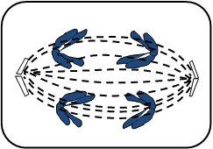

a) Name the stage of cell division. (1 mark)
Anaphase I
b) Give two reasons for your answer in ( a) above. (2 marks)
Homologous chromosomes separate at the equator/homologous chromosomes start migrating to the opposite poles; sister chromatids attached at the centromeres;
c) State the significance of this stage of cell division in living organisms. (1 mark)
It is the reduction phase that results in haploid sex cells/gamete cells
9. Name the causative agent for the following diseases;
a) Typhoid (1 mark) Salmonella typhi;
b) Syphilis (1 mark)
Treponema palladium
10. A process that occurs in plants is represented by the equation below.
C₆H₁₂O₆ 2C₂H₅OH + 2CO₂ + Energy
(glucose) (ethanol) (carbon (iv)
Oxide)
a) Name the process. (1mk) ) Anaerobic respiration/ Fermentation.
b) State the economic importance of the process named in (a) above. (1mk) - Making milk products e.g cheese, butter, yoghurt.
- Manufacture of beer and spirits.
- Production of biogas.
- Bread baking
- Making manure
- Sewage treatment
11. In a class activity, a group of students from Star secondary school caught 50 grasshoppers and marked them using blue ink. They then released them. The following day they repeated the activity. They caught 100 grasshoppers out of them, 25 had a blue mark. Calculate the estimated population of grasshoppers in the area. (3mks) P = = 200
12. Study the diagram below and answer the questions which follow.
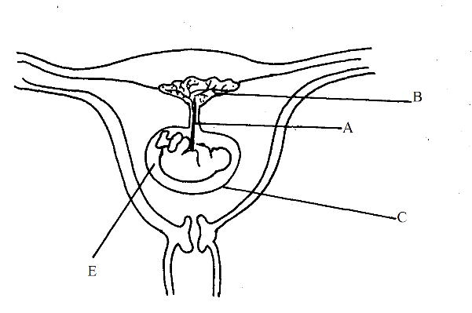
a) Name the parts labelled C and E (2mks)
C Amnion
E Amniotic fluid/ Amniotic cavity
b) State two function of part B. (2mks) - Production of progesterone
- Removal of excretory products from foetus
- Gaseous exchange between foetus and the mother.
- Supply nutrients from the mother to the foetus.
- Prevent infection of the foetus
13. study the organelle below and answer the questions that follow.
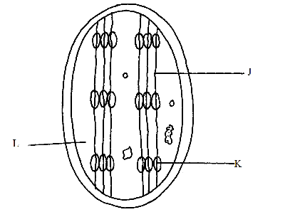
a) Name the organelle. (1mk) Chloroplast

b) Identify the structure labelled J and K. (2mks)
J Intergrana/lamellae
K Granum
c) State the function of the part labelled L. (1mk) - Provide medium for enzyme reaction
- Contain enzymes that speed up photosynthesis
14. a) Name the antigens that determine human blood groups. (2mks)
Antigen A, antigen B
b) State the adaptation that enables the red blood cells to move into blood capillaries. (1mk) Ability to change shape

15 (a) Name the kingdom into which the prokaryotes are placed. (1 mark)

MONERA
(b) State two characteristics used to classify arthropods in classes. (2 marks)

- Number of body parts;
- Number of limbs;
- Presence or absence of antennae;

16. A certain plant had the following characteristics:
  - Presence of roots, stem and leaves.
  - Found with sori on the under surface.
  - Life cycle in sporophyte and gametophyte generations.
  - Sporophyte generation being dominant.
Name the division to which the plant belongs. (1 mark)
………………………………………………………………………………………………….

17. Name the causative agent of the following diseases. (2 marks)
(i) Cholera.
Vibrio cholerae
(ii) Candidiasis.
Candida albicans
18. The diagram below represents part of the human digestive system.
Name the organs labeled L and M. (2mks)
L Duodenum
Mpancreas………………………………………….. 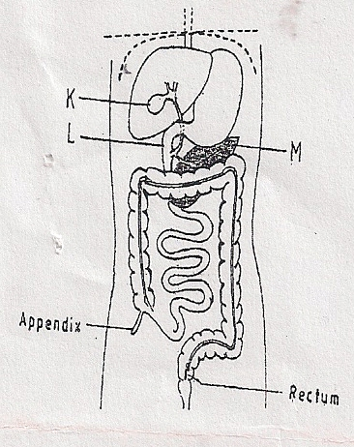

- (a) State two functions of the blood other than transport. (2mks)
- Regulation of body temperature.
- Regulation of pH of fluids;
- Defence against disease-causing micro-organism / pathogens; rej. diseases;

(b) Name one defect of the circulatory system in humans. (1mk)

Arteriosclerosis
- Form One student set up an experiment shown below to investigate a certain physiological process. The set up was left for 30 minutes.

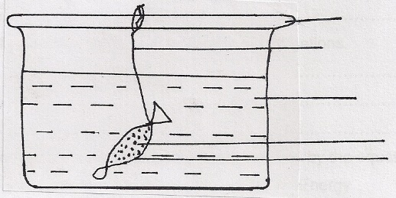
Glass rod
Thread

Distilled water

Sucrose solution
Visking Tubing

- Name the process under study. (1mk)
osmosis
- State the expected results after 30 minutes. (1mk)
- The visking tubing will become turgid / increase in volume / bulge / become big / expand
;
- Explain your answer in (b) above. (3mks)

Water moves from beaker into visking tubing; by osmosis; the semi-permeable tubing;
making tubing turgid, big, expand / bulge, increase in volume;

- (a) Give another name of the oviduct. (1mk)
Fallopian tube
(b) Name the hormone responsible for production of milk after perturation. (1mk)
Prolactin
- Below is an example of a food chain.

Nappier grass Mouse Snake Hawk

Identify the trophic level occupied by:
    - (i) Nappier grass (1mk)
producers
(ii) Hawk (1mk)
Tertiary consumers.
    - What would happen if snakes are removed from the food chain? (2mks)
Mouse will increase in numbers; Hawks would migrate / look for alternative source of food;/starve;

- a) State three characteristics of a wind pollinated flower. (3mrks)
Inconspicuous petals; large anthers loosely attached to filament;
Long feathery stigma;
Small/smooth and light pollen grains;
b) Explain why sexual reproduction is important to organisms. (1mrk)
Brings about change in genetic materials which lead to variations that enable organisms to exploit new environment/ resistance to disease/ high yields in plants;
- The table below shows the energy use per day in kilojoules
Age(years) | Male | Female
2 | 5,500 | 5,500
5 | 7,000 | 7,000
8 | 8,800 | 8,000
11 | 10,000 | 9,200
14 | 12,500 | 10,500
18 | 14,200 | 9,600
25 | 12,100 | 8,800
a).From the table, explain why after age 8 males require more energy than females. (1mrk)
Males are more mascular than females who have more fat
b). Other than sex and age, name three other factors that determine energy requirements in human beings (3mrks)
Basal metabolic rate; Rej (BMR)
Occupation
Body size
- The diagram below represents a simplified Nitrogen cycle
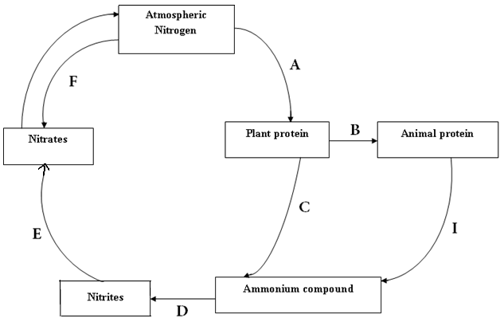

Name the organisms that cause the following process (4mks)
A rhizobium
D nitrococcus/nitrosomonus
E nitrobacter…
ii) Name the process presented in I above
I decay,death,decomposition,excretion
- The diagram below represent transverse section of an ovary of a certain flower
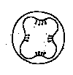

i) Identify the type of placentation illustrated in the diagram above (1mk)
parietal

- Name the type of competition exhibited by the following relationship. (2 marks)
- Second generation of tobacco plant and the parent plant.
Intraspecific competition
Different types of herbivores in an enclosed grass paddock.
Interspecific competition
28 a) State three advantages of cross — pollination. (3mks)
Mixing of genetic material leading to hybrid vigour
Resistance to diseases/increased chances of survival;
New strains appear
b) State two ways by which plants avoid self— pollination. (2mks)
Male part maturing at different time from female/protandry/protogyny.

