NAME: ………………………………. ADM NO: …………... CLASS: ………..
BIOLOGY
FORM TWO
END-TERM 2 EXAM 2024
TIME: 1 ¾ HOURS

INSTRUCTIONS:
Answer all the questions in the spaces provided.

1. (a) Define the term growth. (1 mk)

(b) Name the tissue in plant responsible for:
(i) Primary growth (1 mk)

(ii) Secondary growth (1 mk)

2. The potato cylinders were carefully divided on a blotting paper and weighed. Each piece
weighed 2 grams. One was placed in each test as shown in the diagram below.

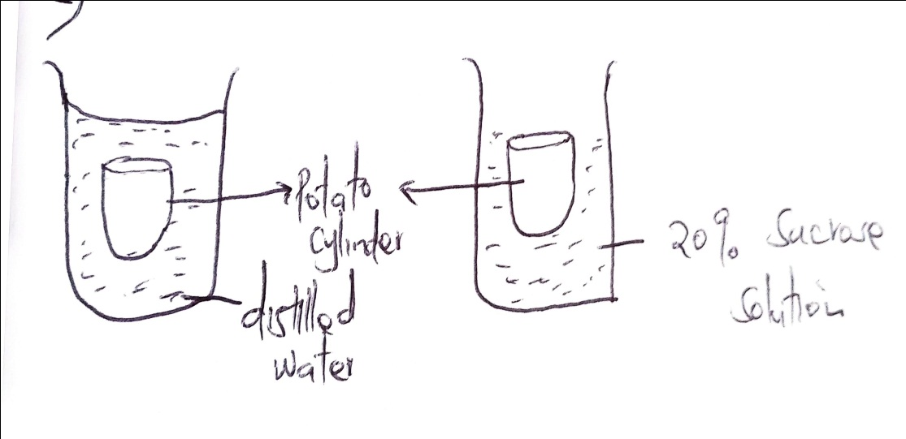
(a) After 48 hours, which potato cylinder will be heavier. Explain. (2 mks)

(b) Name the substances whose movement was responsible for the weight changes in the
potato cylinder you identified in (a) above? (1 mk)

(c) Name the process which was responsible for the movement of the substance you
identified in (b) above. (1 mk)

3. Why are the following steps taken when preparing a cross section of a leaf for viewing under
the microscope?
(a) Cutting thin section. (2 mks)

(b) Placing the section in water. (2 mks)

4. Below is a dental formula of a mammal

I $\frac{O}{4}$ C $\frac{0}{0}$ PM $\frac{3}{3}$ M $\frac{2}{3}$

(a) What is the total number of teeth (1 mk)

(b) (i) What is the mode of feeding in the mammal? (1 mk)

(iii) Give one reason for your answer above. (1 mk)

5. The figure below shows a structure used in gaseous cells

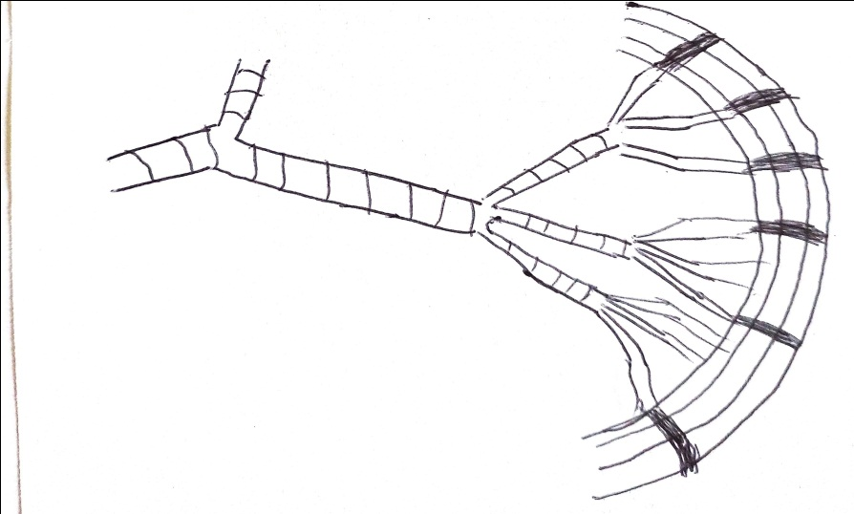

(a) What do guard cells lie in close contact with epidermal cells? (1 mk)

(b) Identify the structure,. (1 mk)

(ii) Explain one observable texture on the figure that adapts the structure to its function.
(2 mks)

6. The diagram below represents an organ of gaseous exchange.

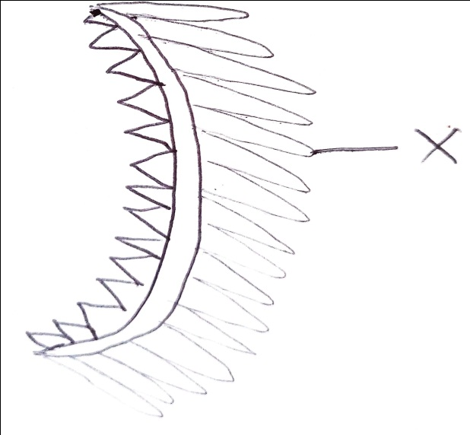

(a) What is the name of the organ? (1 mk)

(b) State two ways in which structure X is adapted to gaseous exchange. (2 mks)

7. How does carboxyhaemoglobin lead to death? (2 mks)

8. Name the cell structures that synthesize the following cell organelles:-
(a) Lysosomes - (1 mk)

(b) Ribosomes - (1 mk)

9. What is the importance of the strona in the Chloroplast? (2 mks)

10. State three adaptations that enables prey to evade predators. (3 mks)

11. Study the diagram below and answer the questions that follow.
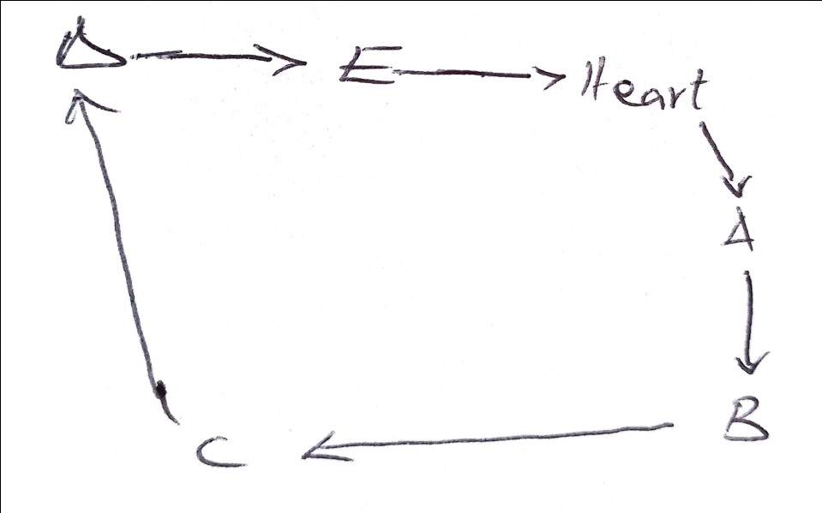

(a) Name the blood vessels labeled A to E. (2 mks)

A ______________________________

E_______________________________

(b) State two differences between blood vessel B and D. (2 mks

(c) State two adaptations of the blood vessel labeled C to its functions. (2 mks)

12. (a) Name three factors affecting the rate of breathing in human beings. (3 mks)

(b) Define the following terms as used in gaseous exchange. (2 mks)
(i) Tidal volume –

(ii) Residual volume -

13. Draw a well labeled diagram of the guard cells. (3 mks)

14. State three properties of lipids. (3 mks)

15. The diagram below represents a cross section obtained from a plant. Use it to answer the
questions that follow.
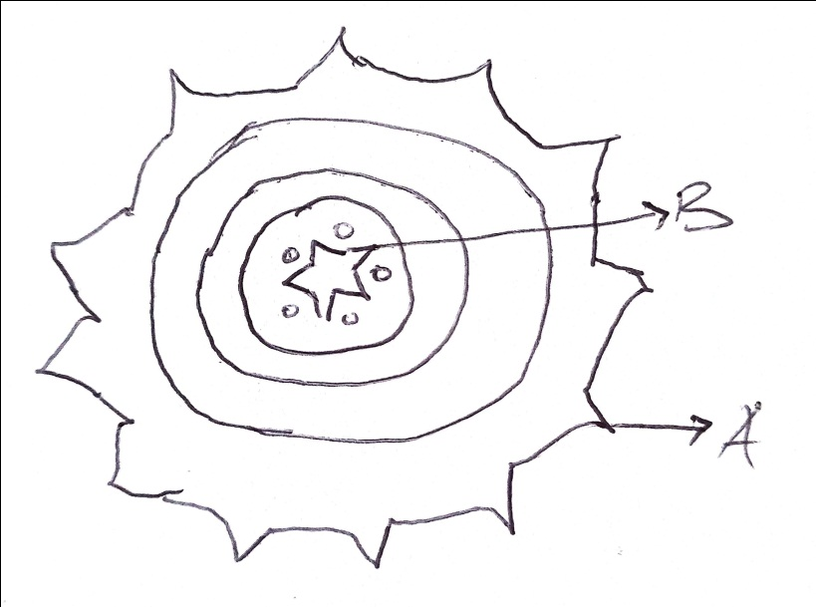

(a) From which part of the plant was the section obtained from? (1 mk)

(b) Give a reason for your answer in(a) above. (1 mk)

(c) Name part B. (1 mk)

(d) Name the material that strengthens the part you named in (c) above. (1 mk)

16. Name the conditions under which urine production increases in animals. (2 mks)

(b) What is diabetes insipidus? (1 mk)

17. Describe the structure of the skin to its functions. (5 mks)

18. (a) What is photosynthesis? (1 mk)

(b) Discuss three factors affecting the rate of photosynthesis. (6 mks)

19. Explain the economic importance of plant excretory products. (5 mks)

