BIOLOGY
FORM TWO
END-TERM 2 EXAM 2024
TIME: 1 ½ HOURS

INSTRUCTIONS:
Answer all the questions in the spaces provided.

1. (a) Define the term growth. (1 mk)
It is the irreversible increase in size and mass of an organism.

(b) Name the tissue in plant responsible for:
(i) Primary growth (1 mk)
Apical meristem

(ii) Secondary growth (1 mk)
Cambium meristem

2. The potato cylinders were carefully divided on a blotting paper and weighed. Each piece
weighed 2 grams. One was placed in each test as shown in the diagram below.

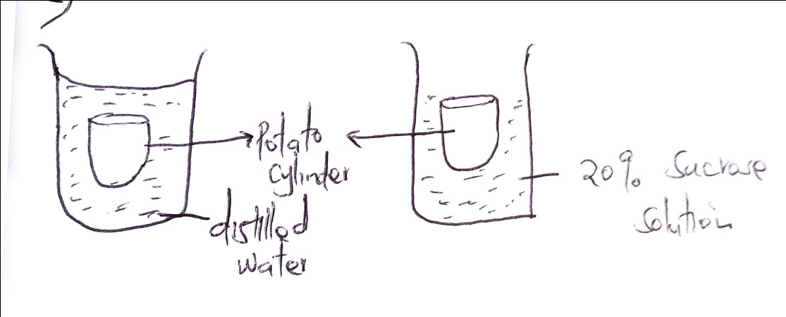
(a) After 48 hours, which potato cylinder will be heavier. Explain. (2 mks)

- Potato cylinder in tube A/ distilled water; as water molecules moved into the
potato cylinder by osmosis.

(b) Name the substances whose movement was responsible for the weight changes in the
potato cylinder you identified in (a) above? (1 mk)
Water

(c) Name the process which was responsible for the movement of the substance you
identified in (b) above. (1 mk)
Osmosis
3. Why are the following steps taken when preparing across section of a leaf for viewing under
the microscope?
(a) Cutting thin section. (2 mks)
Allows light to pass through; making it easy to observe the tissue

(b) Placing the section in water. (2 mks)
To maintain the turgidity; and hence the shape of the cells prevent drying.

4. Below is a dental formula of a mammal
O, CO, PM 3, M2

4 O 3 3

(a) What is the total number of teeth (1 mk)
(5 + 10)² = 30

(b) (i) What is the mode of feeding in the mammal? (1 mk)
Herbivorous, herbivore

(iii) Give one reason for your answer above. (1 mk)
Lack upper incisors/lack canine teeth

5. The figure below shows a structure used in gaseous cells
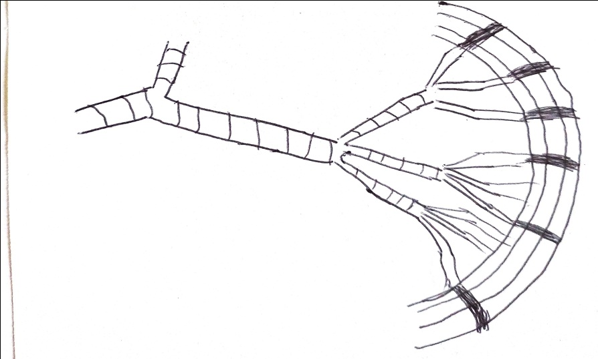

(a) What do guard cells lie in close contact with epidermal cells? (1 mk)
To be able to draw water from the neighbouring epidermal cells/regulating opening and closing of stomata

(b) Identify the structure,. (1 mk)

Tracheal system;( reject without system)
(ii) Explain one observable texture on the figure that adapts the structure to its function.
(2 mks)
Have bands of chitin on tracheole to allow diffusion of gases.

6. The diagram below represents an organ of gaseous exchange.
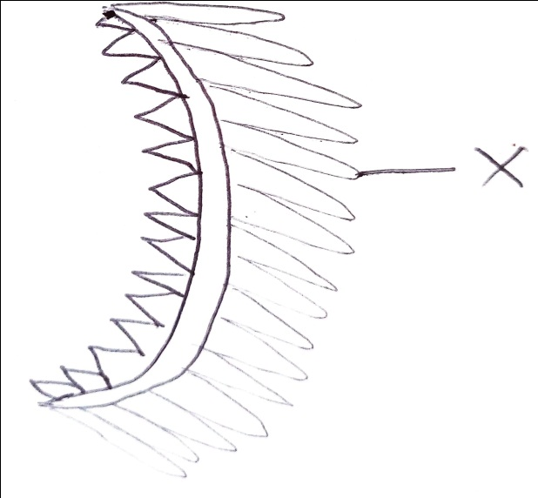
(a) What is the name of the organ? (1 mk)
Gill

(b) State two ways in which structure X is adapted to gaseous exchange. (2 mks)
X is highly folded to provide a large surface area for gaseous exchange

7. How does carboxyhaemoglobin lead to death? (2 mks)
Carboxyhaemoglobin does not readily dissociate and therefore reduces the capacity of haemoglobin to transport O2 to tissue. This makes it poisonous when breathed over a considerable length of time.

8. Name the cell structures that synthesize the following cell organelles:-
(a) Lysosomes - Golgi body (1 mk)

(b) Ribosomes - The nucleolus (1 mk)

9. What is the importance of the stoma in the Chloroplast? (2 mks)
It provides a volume around the different structures inside of the chloroplast for
protection.
Light – Independent reaction process of photosynthesis takes place in stoma.

10. State three adaptations that enables prey to evade predators. (3 mks)
- Camouflage
- Highly developed senses
- Staying out of sight

11. Study the diagram below and answer the questions that follow.
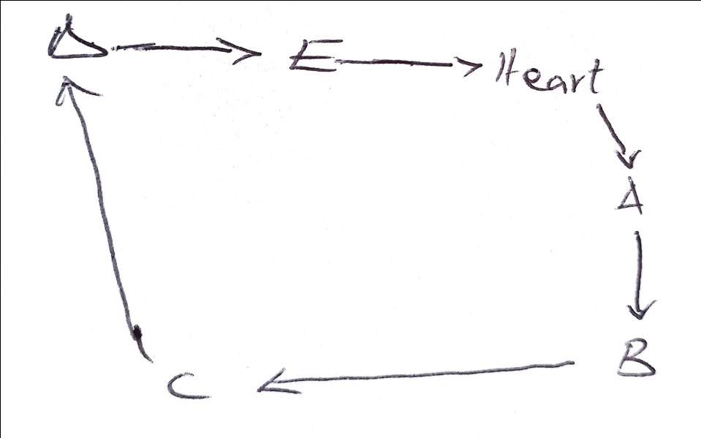

(a) Name the blood vessels labeled A to E. (2 mks)

A ____Aorta

E ____Vena cava

(b) State two differences between blood vessel B and D. (2 mks
B D
Carries blood that is oxygenated Carries Deoxygenated blood

Carries blood under high pressure Carries blood under low pressure
as it lacks valves as it has valves

(c) State two adaptations of the blood vessel labeled C to its functions. (2 mks)
- Have valves to prevent backflow of blood.
- Have thinner walls and larger lumen to prevent backflow of blood

r
12. (a) Name three factors affecting the rate of breathing in human beings. (3 mks)
- Exercise
- Age
- Emotions
- Temperature

(b) Define the following terms as used in gaseous exchange. (2 mks)
(i) Tidal volume – Small volume of air taken in and out of the lungs during normal
breathing.

(ii) Residual volume – Air that normally remains in the lungs.

13. Draw a well labeled diagram of the guard cells. (3 mks)

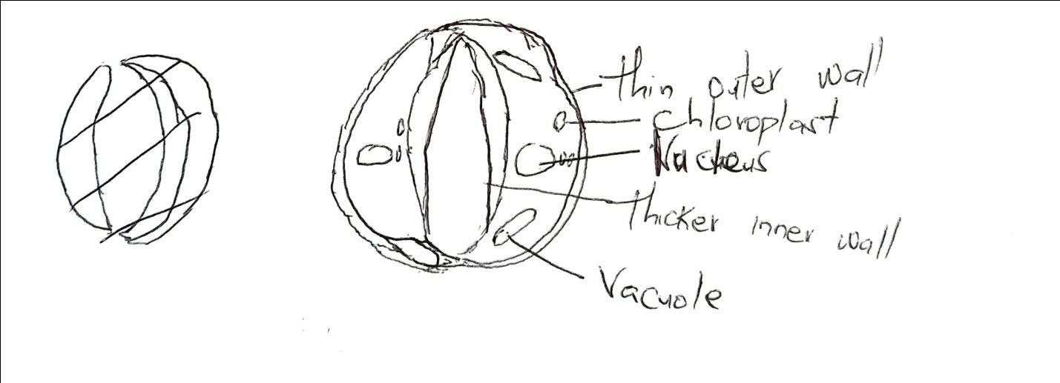
14. State three properties of lipids. (3 mks)
- Both fats and oils are insoluble in water
- Lipids readily dissolve in organic solvents; such as alcohol forming suspensions
and emulsions
- Lipids are quite inert.

15. The diagram below represents a cross section obtained from a plant. Use it to answer the
questions that follow.

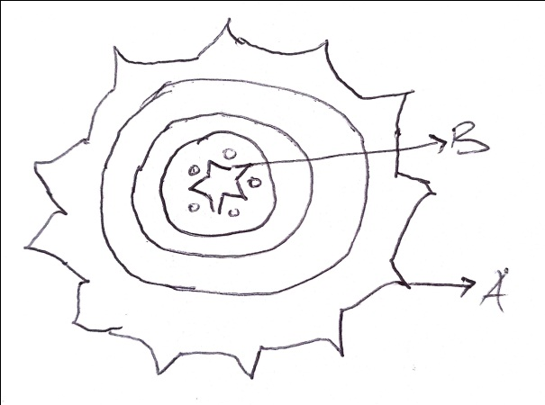
(a) From which part of the plant was the section obtained from? (1 mk)
Dicotyledonous root

(b) Give a reason for your answer in(a) above. (1 mk)
Have a star-shaped xylem

(c) Name part B. (1 mk)
Xylem

(d) Name the material that strengthens the part you named in (c) above. (1 mk)
Lignin

16. Name the conditions under which urine production increases in animals. (2 mks)
- Decrease in environmental temperature
- Increase liquid intake e.g. alcohol
- Increase caffeine intake

(b) What is diabetes insipidus? (1 mk)
It is a condition that is characterized by passing out large quantities of
dilute urine.

17. Explain the structure of the skin to its functions. (5 mks)
- The skin is the largest body organ, it o=covers the whole body surface
- The skin is composed of:
The upper layer called the epidermis and the inner layer called the dermis
The epidermis is made up of three layers namely the; Cornfied layer, granular layer and Malpighian layer.
(1) Cornfied layer – Outermost layer of epidermis
- Made up of dead cells that become filled with a tough, flexible substance called Keratin
- Which provides protection against mechanical damage and invasion of micro-organisms

(2) Granular layer -Middle layer of epidermis consisting of living cells
- They give rise to the cornfied layer when they die.

(3) Malphagian layer –
Innermost of epidermal layer and I made up of actively dividing cells
Have pigment called melanin to giver colour to skin and also give protection against harmful effects of ultra-violent rays from the sun.

(4) The dermis – thicker than the epidermis
(5) Blood vessels
(6) Sweat glands
(7) Hair
(8) Sebaceous glands

18. (a) What is photosynthesis? (1 mk)
It’s the process by which plants make their own food using energy through light.

(b) Discuss three factors affecting the rate of photosynthesis. (6 mks)
Light intensity
CO₂ concentration
Temperature

19. Explain the economic importance of plant excretory products. (5 mks)
Caffeine - Stored in coffee berries and tea leaves
- Taken as a mild stimulant that increases mental activity and reduces fatigue

Quinine - Waste product stored in the back of Cinchoma tree and aloe leaves
- Used for the treatment of Malaria

Cannabis - Stored in fruits, flowers and leaves of cannabis saliva
- Used in manufacture of drugs.

Nicotine - Found in leaves of tobacco plant
- Manufacture of insecticides and narcotic drugs

Rubber - Made from latex of rubber plant
- Used in shoe industry

