NAME:………………………………………………………………..ADM:…………………….CLASS:…
BIOLOGY
FORM ONE
END TERM 2 EXAM - 2024
TIME: 1 ¼ HOURS

INSTRUCTIONS:
Answer all the questions in the spaces provided.

- State three factors affecting the rate of photosynthesis. (3mks)

- Name two plant process in which diffusion plays an important role. (2mks)

- Define the following terms.
- Osmosis (1mks)

- Active transport (1mk)

- Give the terms that describe the following

- Bursting of red blood cells………………………………………………….. (1mk)

- Outward pressure on the cell wall ……………………………………………. (1mk)

- Process by which plant cells lose water, shrink and become flaccid (1mk)

- List three characteristics of living things that are not shown by a motor vehicle. (3mks)

- Give the functions of the following parts of a microscope.
- Body tube. (1mks)
- Condenser (1mk)
- Diaphragm (1mk)`

- Use the equation below to answer the questions
Light energy

Water Hydrogen atom + Oxygen
Chlorophyll

- State the name of the above process (1mk)

- Where does the process occur within the chloroplast? (1mks)

- State the names of branches of biology dealing with the study of the following.

- Study of living things in their surrounding……………………. .(1mk)

- Study of insects …………………………………… (1mk)

- Study of inheritance and variation……… (1mk)

- The scientific name for lion is Panthera leo
- To which kingdom does it belong………. (1mk)

- Which taxonomic group does the name leo refer to …………………………… .(1mk)

- Use the diagram below to answer the questions.
- On the diagram, label part A and B. (2mks)
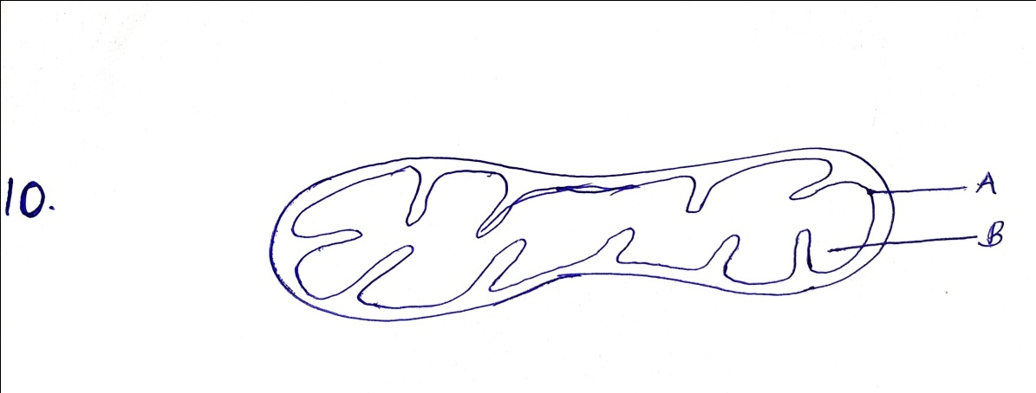

- Give the name of the cell organelle above. (1mk)

- Name two types of cells with high concentration of the above cell organelle. (2mks)

- Differentiate between Autotrophism and Heterotrophism. (2mks)

- Give the names of apparatus used in collection of the following specimen.
- Small animals from rock surface or barks of trees,

(ii) Crawling animals (1mk)

- Stinging insects (1mk)

- Name the five kingdoms into which the living things are grouped. (5mks)

- The seven taxonomic units of classification are Order, Genus Class, Species, Phylum (Division), Kingdom and Family.
- State the taxonomic unit with the largest number of organisms (1mk)

- Give the name of the fourth taxonomic unit (1mks)

- State the name of taxonomic unit who’s some members can interbreed to produce infertile off-spring. (1mk)

- State function of the following cell organelles.
- Lysosomes (1mk)

- Centrioles (1mk)

- Ribosomes (1mk)

- State four factors that affect the rate of diffusion (4mks)

- Use the diagrams below to answer the questions that follow

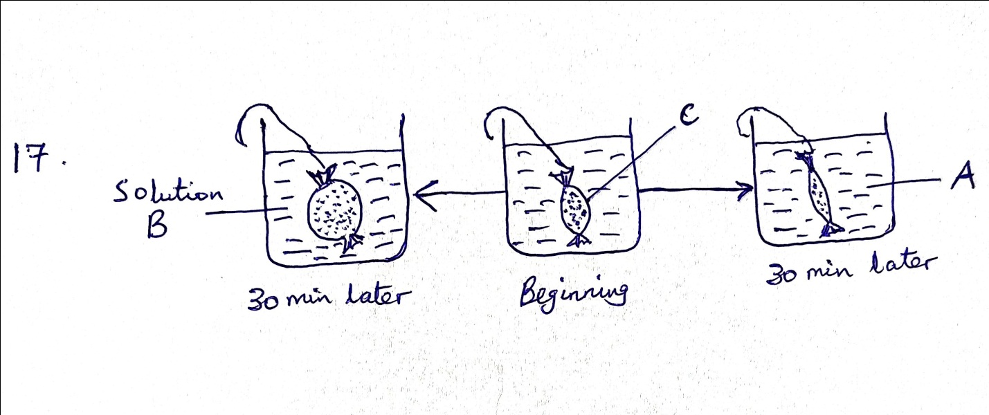
- Name the physiological process shown above. (1mk)

- Give the name that describe the concentration of solution A and B. (1mk)

- Name one property of ( c) that enhance the above process. (1mk)

- The diagram below represents part of a plant. Use it to answer the questions that follow.

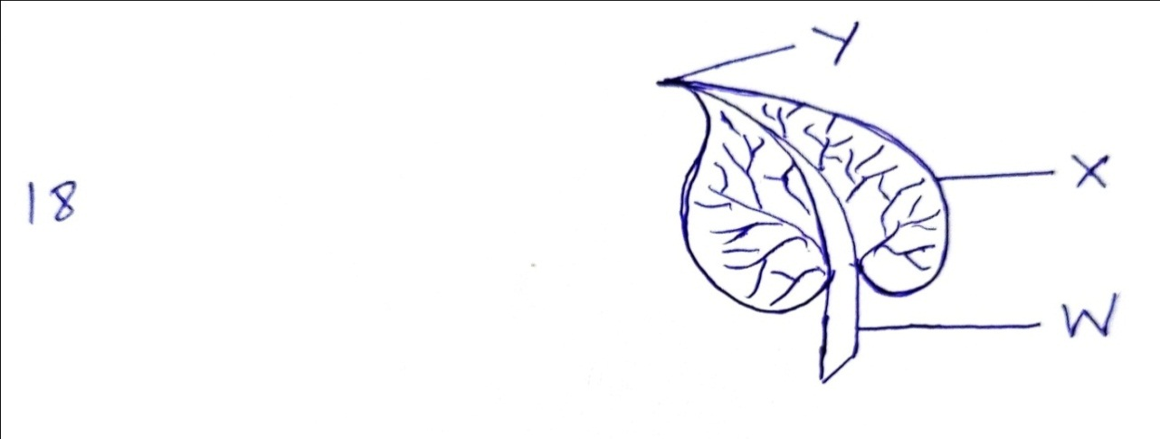
- Name the parts labelled W, X and Y. (3mks)

- Name any three internal parts of the part shown above. (3mks)

- Name the six organ systems that make up an animal. (6mks)

- Give the examples in each of the following.
- Monosaccharide. (2mks)

- Disaccharides (2mks)

- Polysaccharides (2mks)

