BIOLOGY
FORM ONE
END TERM 2 EXAM 2024
TIME: 1 ½ HOURS

INSTRUCTIONS:
Answer all the questions in the spaces provided.

- State three factors affecting the rate of photosynthesis. (3mks)
Light intensity
Carbon (iv) oxide conc
Temperature
Water

- Name two plant process in which diffusion plays an important role. (2mks)
- Absorption of materials
- Gaseous exchange

- Define the following terms.
- Osmosis (1mks)
- Process where solvent molecules (water) move from a lower concentration to a highly conc solution across a semi-permeable membrane.

- Active transport (1mk)
- Movement of substances against conc gradient using energy.

- Give the terms that describe the following

- Bursting of red blood cells…Haemolysis (1mk)

- Outward pressure on the cell wall …Turgor (1mk)

- Process by which plant cells lose water, shrink and become flaccid (1mk)
Plasmolysis

- List three characteristics of living things that are not shown by a motor vehicle. (3mks)
- Growth and development
- Reproduction
- Irritability

- Give the functions of the following parts of a microscope.
- Body tube. - Holds the eye-piece and revolving nose-piece (1mks)

- Condenser - Concentrate light on the stage (1mk)

- Diaphragm Regulation amount of light passing through (1mk)`

- Use the equation below to answer the questions
Light energy

Water Hydrogen atom + Oxygen
Chlorophyll

- State the name of the above process (1mk)
Photosynthesis

- Where does the process occur within the chloroplast? (1mks)

Grana

- State the names of branches of biology dealing with the study of the following.

- Study of living things in their surrounding…Ecology .(1mk)

- Study of insects …Ecology (1mk)

- Study of inheritance and variation…Genetics (1mk)

- The scientific name for lion is Panthere leo
- To which kingdom does it belong…Animalia (1mk)

- Which taxonomic group does the name leo refer to …Species .(1mk)

- Use the diagram below to answer the questions.
- On the diagram, label part A and B. (2mks)
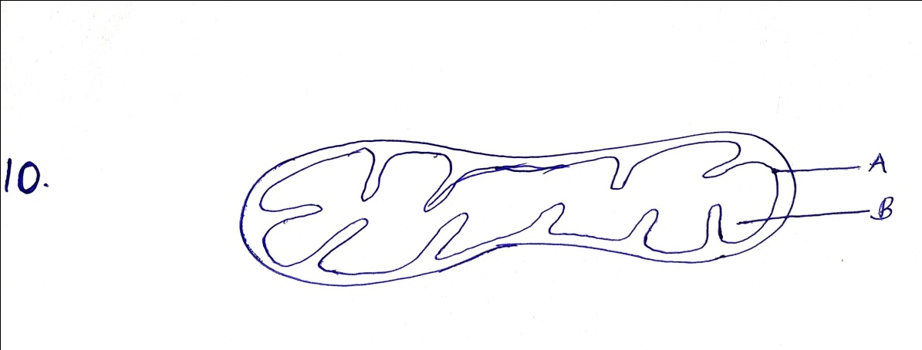

- Give the name of the cell organelle above. (1mk)
Mitochodrion

- Name two types of cells with high concentration of the above cell organelle. (2mks)

Muscle cells, sperm cells, apical meristerus, kidney cell.

- Differentiate between Autotrophism and Heterotrophism. (2mks)
- Autotrophism – Mode of nutrition where organisms manufacture their own food.
- Heterotrophism: Mode of nutrition where organisms take in manufactured food

- Give the names of apparatus used in collection of the following specimen.
- Small animals from rock surface or barks of trees,
Pooter

(ii) Crawling animals (1mk)

Pitfall trap

(iii) Stinging insects - Pair of forceps

- Name the five kingdoms into which the living things are grouped. (5mks)
Stinging insects (1mk)
Monera Plantae
Proticeista Animalia
Fungi

- The seven taxonomic units of classification are Order, Genus class, Species, Phylum (Division), Kingdom and Family.
- State the taxonomic unit with the largest number of organisms (1mk)
Kingdom

- Give the name of the fourth taxonomic unit (1mks)
Order

- State the name of taxonomic unit who’s some members can interbreed to produce infertile off-spring. (1mk)
Genus

- State function of the following cell organelles.
- Lysosomes – destroying worn out organelles or cells (1mk)

Centrioles (1mk)
Cell division; formation of cilia and flagella

- Ribosomes (1mk)
Protein synthesis

- State four factors that affect the rate of diffusion (4mks)
- Diffusion gradient
- Surface area to volume ratio
- Thickness of membranes
- Size of molecules
- Temperature

- Use the diagrams below to answer the questions that follow

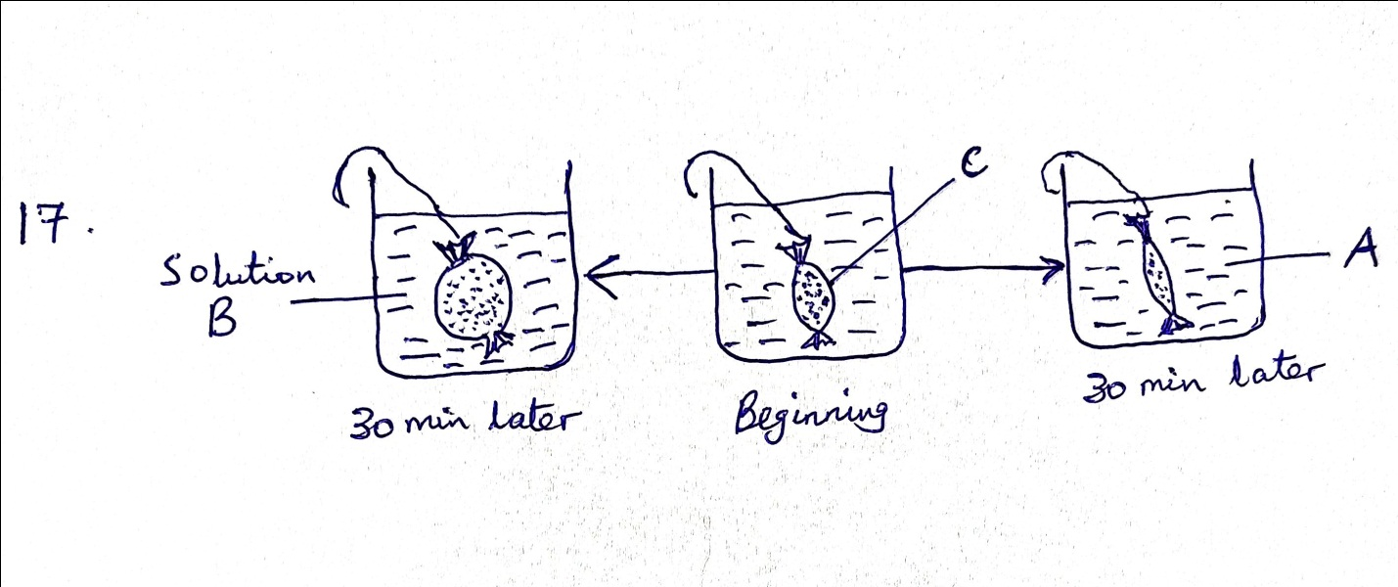

- Name the physiological process shown above. (1mk)

Osmosis

- Give the name that describe the concentration of solution A and B. (1mk)
A – Hypertonic
B - Hypotonic

- Name one property of ( c) that enhance the above process. (1mk)
- Semi-permeability

- The diagram below represents part of a plant. Use it to answer the questions that follow.

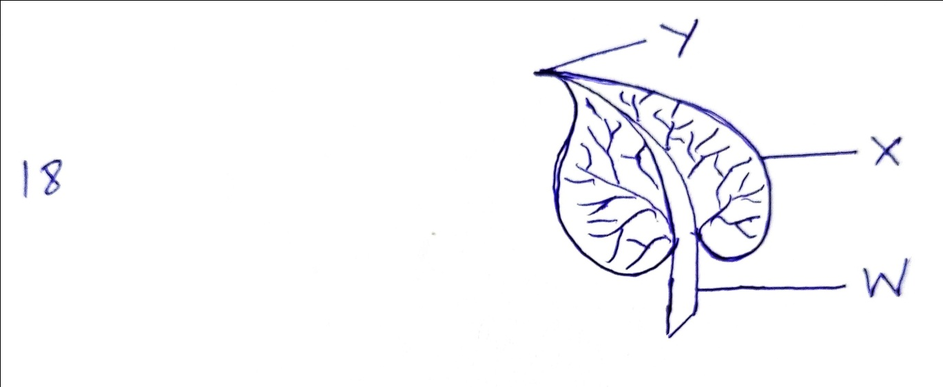

- Name the parts labelled W, X and Y. (3mks)
W – Petiole
X – Leaf margin
Y – Leaf apex

- Name any three internal parts of the part shown above. (3mks)
- Epidermis
- Spongy mesophyll
- Palisade layer
- Veins

- Name the six organ systems that make up an animal. (6mks)
- Digestive
- Circulatory
- Excretory
- Nervous
- Respiratory
- Reproductive

- Give the examples in each of the following.
- Monosaccharide. (2mks)
Glucose, fructose, galactose

- Disaccharides (2mks)
Sucrose, Lactose, maltose

- Polysaccharides (2mks)
Starch. cellulose, Glycogen

