GRADE 7 LESSON NOTES TERM1,2,3
STRAND ONE
CONSERVING AGRICULTURAL ENVIRONMENT
Soil pollution control
Def: Soil pollution - refers to anything that causes contamination of soil and reduces the soil quality.
- It occurs when the substances causing the pollution reduce the quality of the soil and convert the soil inhabitable for microorganisms and macro organisms living in the soil.
- Soil contamination or soil pollution can occur either because of human activities or because of natural processes.
- However, mostly it is due to human activities. The soil contamination can occur due to the presence of chemicals such as pesticides, herbicides, ammonia, petroleum hydrocarbons, lead, nitrate, mercury, naphthalene, etc. in an excess amount.
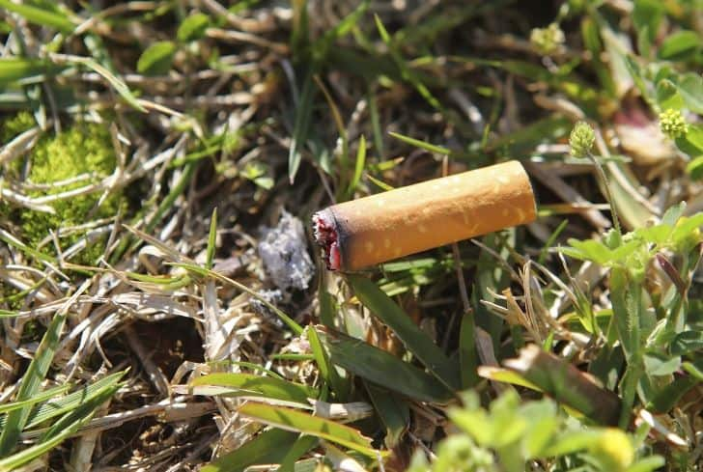

Causes of Soil Pollution
- Soil pollution is a complex occurrence, and it can be triggered by a variety of things and activities, from the littering of cigarette butts to excess use of chemical fertilizers.
- Every cause is linked with another. It is quite difficult to pinpoint one particular cause. However, the leading causes are listed below.
- Industrial Activity - Industrial activity has been the biggest contributor to the problem of soil pollution, especially since the amount of mining and manufacturing has increased. Most industries are dependent on extracting minerals from the earth. As a result, the industrial waste lingers on the soil surface for a long time and makes it unsuitable for use.
- Agricultural Activities - The utilization of chemicals has gone up tremendously since technology has provided us with modern pesticides and fertilizers. They are full of chemicals that are not produced in nature and cannot be broken down by it. As a result, they seep into the ground after they mix with water and slowly reduce the fertility of the soil.
- Waste Disposal - While industrial waste is sure to cause contamination, there is another way in which we are adding to the pollution. Every person excretes a certain amount of personal waste in the form of urine and feces. While much of it moves into the sewer system, there is also a large amount that is dumped directly into landfills in the form of diapers. Even the sewer system ends at the landfill, where the biological waste pollutes the soil and water.
- Accidental Oil Spills - Oil leaks can happen during the storage and transport of chemicals. This can be seen at most of the fuel stations. The chemicals present in the fuel reduces the quality of soil and make it unsuitable for cultivation. These chemicals can enter into the groundwater through the soil and make the water undrinkable.
- Acid Rain - Acid rain is caused when pollutants present in the air mix up with the rain and fall back on the ground. The polluted water could dissolve away some of the essential nutrients found in the soil and change the structure of the soil.
Effects of soil pollution
Soil influences almost all aspects of our daily lives. Sometimes we fail to understand it. As a result of this, we sometimes fail to understand the effect that soil pollution has on our daily lives. Polluted soil means stunted crops or even a toxic underground water table. Some major effects of soil pollution are:
- Effect on Health of Humans - Considering how soil is the reason we are able to sustain ourselves, the contamination of it has major consequences for our health. Crops and plants that are grown on polluted soil absorb much of the pollution and then pass it on to us. This could explain the sudden increase in small and terminal illnesses. The soil pollution can even lead to widespread famines if the plants are unable to grow in it.
- Effect on Growth of Plants - The ecological balance of any system is affected due to the widespread contamination of the soil. Most plants are unable to adapt when the chemistry of the soil changes so radically in a short period of time. Fungi and bacteria found in the soil that bind it together begin to decline, which creates an additional problem of soil erosion.

The fertility of the soil slowly diminishes, making land unsuitable for agriculture and any local vegetation to survive. The soil pollution causes large tracts of land to become hazardous to health. Unlike deserts, which are suitable for their native vegetation, such land cannot support most forms of life.
- Decreased Soil Fertility - The toxic chemicals present in the soil can decrease soil fertility and therefore decrease the soil yield. The contaminated soil is then used to produce fruits and vegetables, which lack quality nutrients and may contain some poisonous substances to cause serious health problems in people consuming them.
- Poisoning of the Underground Water Table - Soil pollution also leads to the poisoning of the underground water table. Since this water is stored beneath the layers of the soil, the toxins in the soil could easily percolate slowly and steadily into the water table.
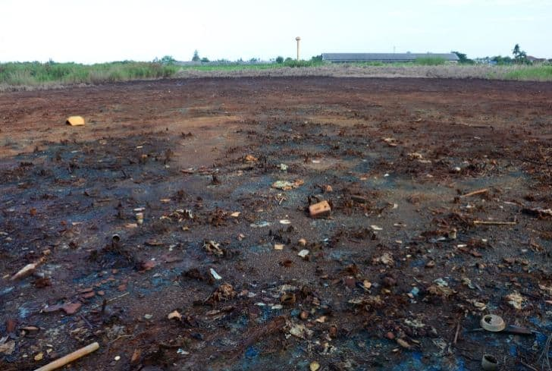
Possible Solutions to Soil Pollution
Soil pollution is a complex problem that ought to be solved. It is essential that we all realize how important soil is to us.
The earlier we realize this, the better we will be able to solve the problem of soil pollution. It is a complex problem, and thus, it requires everyone, from an individual to the government, to work in complete unison. Listed below are a few things that could help in reducing soil pollution.
- Reduced Use of Chemical Fertilizers - Chemical fertilizers do more harm than good. While proper amounts could enhance the fertility of the soil, an excess of it actually poisons the soil. The excess of chemical fertilizers could pollute the soil in several ways. It could mess with the pH levels of the soil. It could also destroy the good microorganisms in the soil. Not only that, but the runoff from such soils also causes water pollution as well. Thus, using chemical fertilizers is like a double-edged sword.
- Reforestation and Afforestation Should Be Promoted - One of the major causes of soil pollution is soil erosion, which is caused due to deforestation.

It is natural that, with an ever-growing population, humankind needs more and more space to expand their civilization. Often, it is achieved at the cost of the health of the soil.

To prevent this from happening, reforestation of a deforested area should be promoted. Also, afforestation should be promoted and encouraged in the barren lands.
The roots of the plants bind the soil particles together and even capture good microorganisms in the soil. It also ensures the maintenance of the underground water table.
- Recycle and Reuse Products - These steps not only reduce waste generation but also ensure that soil pollution is reduced. At present, plastic forms a significant portion of the generated waste. More often than not, this wastes are buried in landfills.

In these landfills, these plastics and other materials decompose slowly and release toxic materials into the soil. These toxic substances are very harmful to the health of the soil and are a major source of soil pollution.

By reusing and recycling things, we would ensure that lesser wastes are dumped in these landfills, and this, in turn, would reduce soil pollution.
- Promote Use of Natural Manure - Natural manure is one of the best sources of nutrients for the soil. It is harmless and completely organic. It adds essential nutrients to the soil and restores the health of the soil. It has no harmful by-products that could harm the soil or the environment in any way.
- Create awareness - In order to ensure that a problem like soil pollution is solved, it is essential that every individual must get involved. It is with their involvement that things can work out better. Awareness programs could be designed so that people understand soil pollution better. If people are aware, they will help, even subconsciously.
Safe farming practices that prevent soil pollution
Different types of soil conservation methods ensure long-term usage of land and keep it productive for future generations. Let’s consider their benefits in regard to soil conservation.
- Conservation Tillage - The conservation tillage aims at addressing wind and water erosion by covering the earth with vegetation (either crops or their residues) and limiting the number of tilling operations. Another significant aspect is to choose the proper time for field operations, depending on the soil types. For example, clay ones are better to till after harvesting while other types are better to plow before seeding.
- Contour Farming - The soil conservation method proves efficient in slope territories and suggests planting species along the contour. Rows up and down the slope provoke soil erosion due to water currents while rows along the contour restrain it. An impact of terracing is similar: it also helps to conserve soil and reduce its degradation processes.
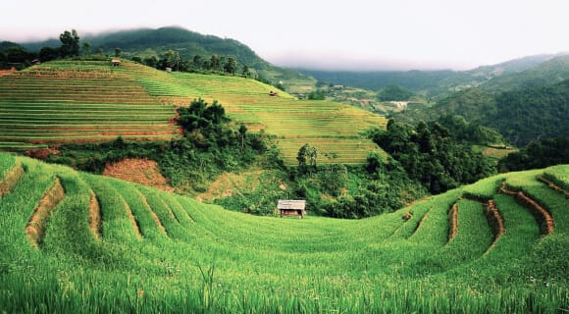

- Strip Cropping - In this case, farmers combine high-growing crops with low-growing ones for the sake of wind protection, like when corn grows in strips with forage crops. The strip cropping practice works even better when high-growing crops are intensified in the sides where winds blow most frequently. An extra benefit is the organic matter material from the low crops.
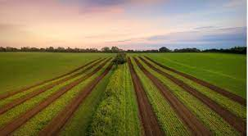
- Windbreaks - As the name suggests, this soil conservation practice is used to reduce the power of winds and its disruptive effect on soil. These are trees or bushes to shelter crops from snow and winds planted in several rows. Depending on the number of rows, we can distinguish windbreaks properly (up to five rows) and shelterbelts (six and more).
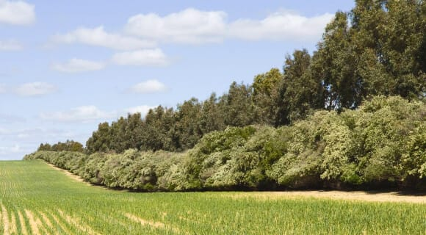

- Crop Rotation - Crop rotation vs. mono-cropping farming suggests changing agro species instead of planting one and the same for many subsequent seasons.

Farmers applying this soil conservation method reap numerous benefits. Crop rotation helps them improve the earth structure with diverse root systems, to mitigate pest establishments, and to add nitrogen to the land with legumes known as nitrogen-fixing plants.
- Cover Crops - This soil conservation technique is another way to avoid bare soils and additionally benefit from planting cover crops – secondary species – in-between growing cash crops for different reasons like to:
- produce forage and grazing material for cattle;
- provide green manure;
- assist in weed control;
- retain moisture;
- ensure a natural environment for microorganisms and minor animals;
- balance nitrogen concentration (either releasing or accumulating it with certain plants).
- Buffer Strips - These are trees and bushes on the banks of water bodies to prevent sediment, water wash offs. Their roots fix the soil to avoid slumping and erosion, canopies protect from excessive sunlight to water inhabitants and falling leaves are a source of organic matter and food of minor aquatic animals.
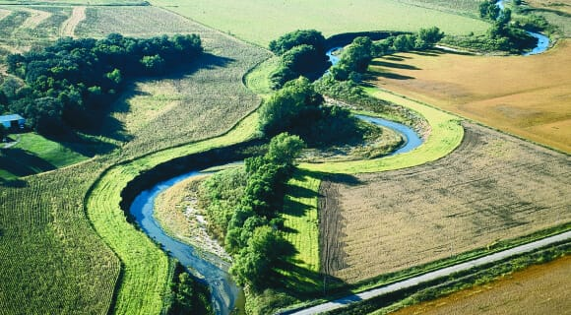
- Integrated Pest Management - Pests are a great nuisance to agriculturalists and have been a major issue to tackle while chemicals poison nature leaking to water and the atmosphere. It is important to eliminate synthetic herbicides replacing them with organic ones or establishing biological enemies of pests whenever possible, rotating crop species to minimize increasing pest populations in the same field for years, and using alternative techniques in complex.
Benefits of Soil Conservation
Humankind in general and farmers in particular benefit from numerous advantages of soil conservation. This agricultural practice contributes to sustainability in a number of ways:

Boosts earth quality and productivity. Maintaining the natural environment for earth-dwelling organism’s increases fertility and reduces the necessity of chemical fertilizing, thus boosting yields and saving costs at the same time.

Mitigates erosion. Soil conservation methods to reduce erosion and depletion help agriculturalists to avoid the expansion of new lands when territories become infertile.

Promotes water infiltration and increases its storage. The soil conservation technique of minimum tillage vs. conventional plowing affects soil moisture
by reducing cracking and evaporation as well as rising the infiltration rate.

Aids air and water purification. The importance of soil conservation relates to water supplies, and the earth functions as a natural filter to purify water. Soil conservation mitigates the concentration of pollutants and sediments. In its turn, water is the basic condition to dissolve nutrients for plants. Soil carbon sequestration and reduced chemical applications contribute to air purity, too.

Gives food and shelter for wildlife. Land with growing vegetation is a living environment for animals; it is not only the source for nourishment but their home as well.
“When the well is dry, we know the worth of water.”
– Benjamin Franklin, Poor Richard’s Almanack for 1733

Water conservation methods in farming
- Mulch - We cannot overemphasize the importance of mulching. Mulch is something laid on the surface of the soil to protect the soil from the air, water and the sun.
To mulch, first weed the soil then spread a thick layer of organic mulch on the soil. Examples of organic mulches are:
- Chopped leaves
- Straw
- Grass clippings
- Wood chips
- Shredded bark
- Pine needles
Mulching helps save time and labour as it discourages weeds and pests and conserve water through reduced evaporation.
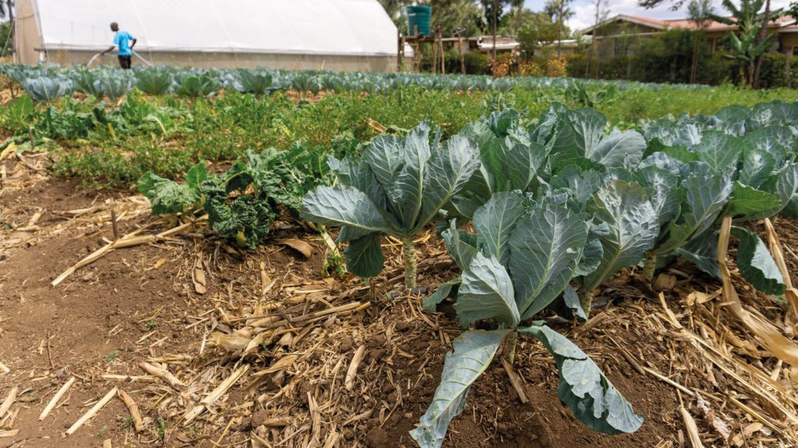
- Irrigate early morning or dusk - At the hottest and driest time of the year it is most efficient to water your crops in the morning or in the evening. This avoids water loss from evapotranspiration (water evaporating from the land and leaves of plants). Evaporation happens most in the midday sun.
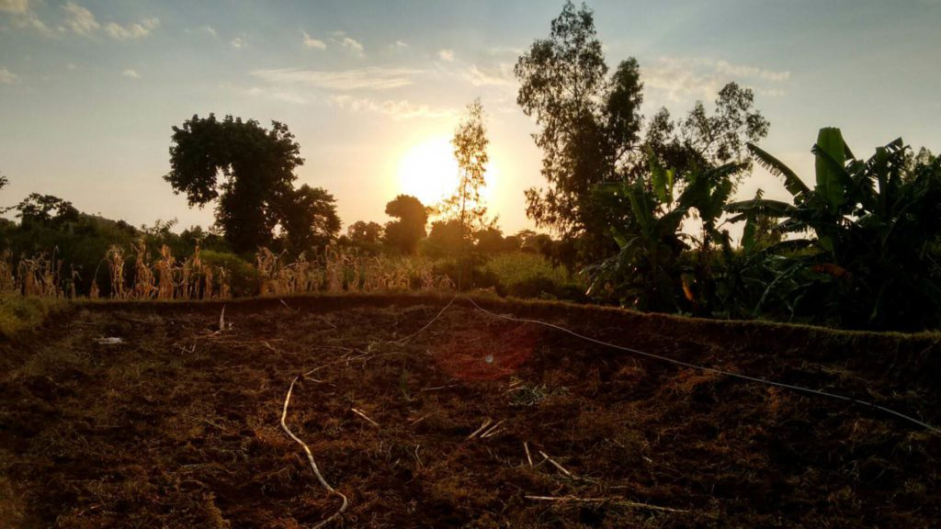
- Don’t over-water - It’s a common misconception that plants would be happy with lots of water all of the time. But often farmers are over-watering crops unnecessarily. Save water! Plants will only take what they need and then all that extra water goes to waste through evaporation, run-off or infiltration.
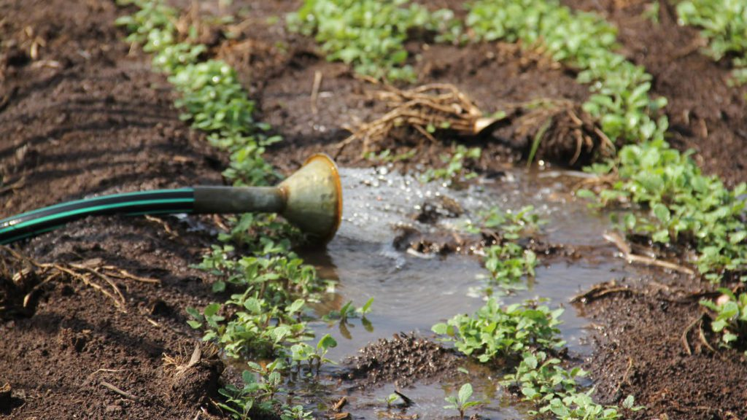
- Check for leaks and damage - If you’ve already invested in an irrigation system, make sure you’re not losing any water before it reaches the crops. Irrigation pipes and equipment can become damaged or blocked which causes leaks. Thoroughly check your equipment for leaks and repair them so that all the water you have gets to the crops.
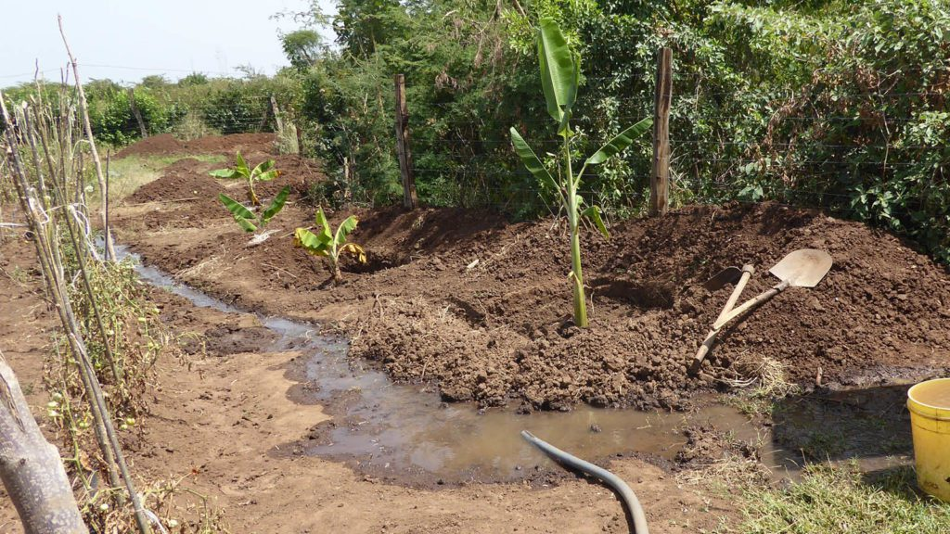
- Drip Irrigation - Drip irrigation systems deliver water directly to a plant’s roots, reducing the evaporation that happens with spray watering systems. Timers can be used to schedule watering for the cooler parts of the day, further reducing water loss.
Importance of water conservation in farming
- It minimizes the effects of drought and water shortages. By reducing the amount of water we use, we can better protect against future drought years.
- It helps to preserve our environment. Reducing our water usages reduces the energy required to process and deliver it to homes, businesses, farms, and communities, which, in turn, helps to reduce pollution and conserve fuel resources.
- It helps to preserve our environment. Reducing our water usages reduces the energy required to process and deliver it to homes, businesses, farms, and communities, which, in turn, helps to reduce pollution and conserve fuel resources.

Water retention structures to conserve surface runoff
Water Retention Structures means a structure designed to retain a large volume of water
There are various methods of water retention to conserve surface runoff, this include:
- Water retention Ditches -Ditches are man-made waterbodies that are used mainly to drain the land.
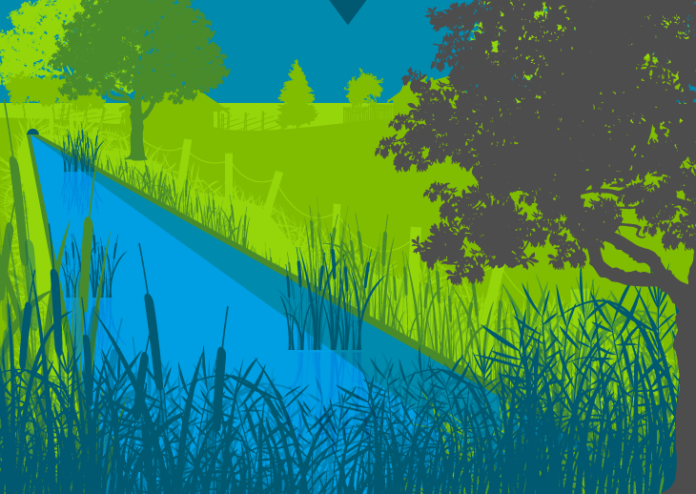
- Earth Basins - is an area of land where all flowing surface water converges to a single point
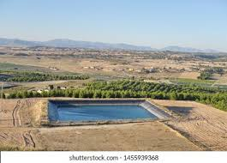
- Water retention pits – is an artificial pond with vegetation around the perimeter and a permanent pool of water in its design.
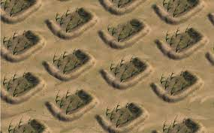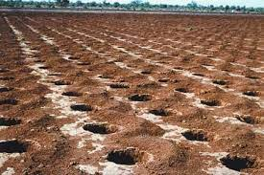

Minimum tillage practices that conserve water in farming
Tillage practices refer to the tillage operations carried out between the harvest and following sowing/cultivation operation. Tillage, crop rotation and soil cover are practices related to pesticide and nutrient runoff, soil erosion, soil compaction etc. Some of the minimum tillage practices include:
- ​Use of herbicides;
- Uprooting/slashing;
- Use of cash crops;
- Limiting cultivation to the point planting;
- Proper timing of cultivation;
- Mulching
There are other different tillage practices distinguished are:
- Conservation tillage
- Conventional tillage
- Zero tillage
Conservation tillage can include the following systems:
- Strip tillage or zonal tillage refers to a system where strips 5 to 20 cm in width are prepared to receive the seed whilst the soil along the intervening bands is not disturbed and remains covered with residues. The system causes more soil disturbance and provides less cover along the rows than zero tillage.
- Tined tillage or vertical tillage refers to a system where the arable land is prepared with equipment which does not invert the soil and which cause little compaction. For this reason, the surface normally remains with a good cover of residues on the surface.
- Ridge tillage is a system of ridges and furrows. The ridges may be narrow or wide and the furrows can be parallel to the contour lines or constructed with a slight slope, depending on whether the objective is to conserve moisture or to drain excess moisture. The ridges can be semi-permanent or be constructed each year which will govern the amount of residue material that remains on the surface.
Conventional tillage
Refers to the arable land treated by conventional tillage which involves inversion of the soil, normally with a moldboard or a disc plough as the primary tillage operation, followed by secondary tillage with a disc harrow.
Zero tillage
Refers to the arable land on which no tillage is applied between harvest and sowing. Zero tillage is a minimum tillage practice in which the crop is sown directly into soil not tilled since the harvest of the previous crop. Weed control is achieved by the use of herbicides and/or appropriate mulching and stubble is retained for erosion control.
Agroforestry
It’s the cultivation and use of trees and shrubs with crops and livestock in agricultural systems.

Characteristics of Agroforestry
While selecting tree species for agroforestry systems, the following desirable characteristics should be taken into consideration. Though all desirable characters are not found in a single species, but their multiple uses are taken care of.
- Tree species selected should not interfere with soil moisture
  - Tree species selected for agroforestry should have very less water requirement
  - Should not compete with main agricultural crops for water.
  - Tree species should be deep tap rooted so that they can draw water from deep strata of the soil.
- Tree species should not compete for plant nutrients
  - Tree species should not utilize more plant nutrients
  - They should help in building soil fertility,
  - Leguminous tree species which fix atmospheric nitrogen in their roots should be prefered.
  - The root system and root growth characteristics should ideally result in to exploration of soil layers that are different to those being trapped by agricultural crops.
- Tree species should not compete for sunlight
  - Tree species should not interrupt sunlight falling on the crops.
  - Tree species should be light branching in their habit.
  - Trees permit the penetration of light into the ground and promote better crop, pasture growth and yield.
  - Tree species can withstand pruning operation if it possess dense canopy.
- Tree species should have high survival rate and easy establishment
  - Trees species should have high survival percentage,
  - Leave little or no gaps after transplanting.
  - Hardy tree species are easy to establish.
  - They have less mortality percentage because they can tolerate transplanting shocks easily.
  - Trees should have the ability to regenerate lateral roots within a short period of time after transplanting.
- Tree species should have fast growing habit and easy management
  - Tree species for agroforestry system should be essentially fast growing,
  - Rapid growth, especially in the early years,
  - Tree should have short rotation (the period between planting and final harvesting)
  - Fast growing species
- Tree species should have wider adaptability
  - A tree species selected for agroforestry combinations must have a wider adaptability.
- Tree species should have high palatability as a fodder
  - Most of the Indian farmer’s rear livestock separately and cut and carry method of fodder production is quite prevalent.
  - Therefore, in agroforestry, farmer must select those tree species which are palatable to livestock and had a high digestibility.
- Tree species should have shelter conferring and soil stabilization attributes
  - Some tree species, because of their inherent growth habit and adaptability, are especially helpful in providing protection for soils, crops and livestock.
- Tree species should have capability to withstand management practices
  - Many agroforestry systems demand extensive pruning and lopping of the trees in order to maximize production. In such cases, the trees must be able to withstand such treatment without drastically restricting growth rate.
- Tree species should have nutrient cycling and nitrogen fixation attributes
  - Within an agroforestry system, trees can play an important role in recycling nutrients, leached down through the soil profile and minerals released from weathering parent material such as rocks and sediments.
  - These nutrients are used in the growth and development of the tree, many returning to the top-soil in form of dead leaves, twigs, flowers and seeds which slowly decompose on the surface, or are eaten by animals.
  - Although all trees play some role in maintaining the nutrient status of the soil through recycling.
  - Deciduous trees drop most of their leaves in autumn leaving a thick mat of leaves on the ground, whereas most evergreen species maintain some level of litter fall throughout the year.
  - Another important factor is the ability of many tree species to convert atmospheric nitrogen into organic nitrogen for their own use through complex symbiotic relationship between Rhizobium bacteria and their fine roots.
  - The bacteria form nodules on the roots which can convert nitrogen gas, as it is in the atmosphere, into usable nitrogen for the plant.
  - The litter of these nitrogen fixing trees is generally high in nitrogen, thus increasing the nitrogen status of the soil.
- Tree species should have thin bark
  - Species selected for agroforestry combinations should not shed its bark regularly but it should retain for longer period as bark shedding creates unhygienic conditions for under-ground crop.
- Tree species should be free from chemical exudations
  - The species selected for agroforestry combination must be free from chemicals as these chemicals affect the growth of under-ground crops.
- Tree species should have easily decomposable leaves
  - The suitable tree species for agroforestry will be that one in which fallen leaves decompose with fast rate.
  - The leaves of most of the legume tree species are small in size, decompose quickly and easily, and add a large quantity of organic matter and nutrients to the soil.
  - Tree species having broad leaves such as teak, mango and banyan should not be preferred for agroforestry system.
  - They contain more fibre matter and also require longer time for decomposition. Further, broad leaves when fall on the tender crop plants, block their photosynthetic activities.
- Tree species should have their multiple uses
  - The selected tree species should have multiple uses.
  - The tree should yield more than one of the main produce like fuelwood, leaf fodder, edible fruit, edible flower and fibre.
- Tree species should have high yield potential
  - High yield potential is the most important criterion of selection of tree species for agroforestry systems as the main aim is to obtain overall more output per unit area. Care should be taken before collection of seeds and seedlings that they are being procured from reliable source.
Suitable tree species for agroforestry
• Leucaena leucocephala
• Gravillea robusta
• Calliandra catothrysus
• Mangifera indica
• Sesbania sesban
• Lantana camara
• Cajanus cajan
CHARACTERISTICS OF AGRICULTURAL CROPS FOR AGROFORESTRY
a) Agricultural crops should be short duration and quick growing.
b) They should be at least partially tolerant to shade.
c) Most of them should belong to Leguminous family.
d) They should respond well to high density tree planting.
e) They should bear some adverse conditions, like water stress and/or excess of watering;
f) Crops should return adequate organic matter to soil through their fallen leaves, root system, stumps, etc.
g) Crops should appropriately be fitted in intensive or multiple cropping system.
Advantages/Importance of agroforestry
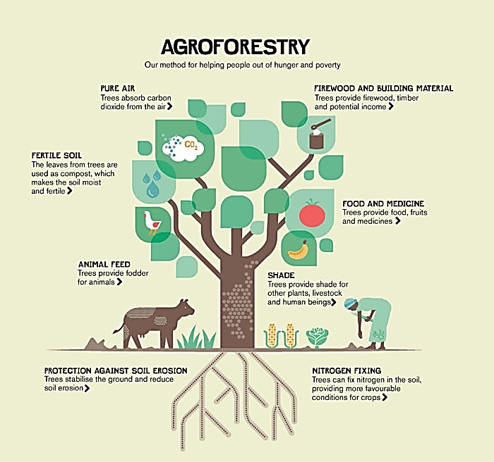
- Saves labour since some operations can be done at once for both plants and trees
- Gives higher combined yield
- Provide wide variety of agricultural produce
- Reduces the risks of total failure
- Crops benefit from nitrogen fixing trees.
- Trees help in holding the soil firmly
- Some trees act as livestock fodder.
- Provides a wider variety of agricultural produce.
Disadvantages of Agroforestry
- Mechanization is difficult.
- Use of pesticides and fertilizer may be difficult.
- Productivity may suffer because the skills for managing the different trees

STRAND TWO
CROP PRODUCTION
Preparation of planting site
Preparing land for planting is one of the most important parts of cultivating abundance. Whether you're planting fruit trees, wildlife corridors, or an annual garden, prepping the soil in the first place is the best way to set yourself up for success over the long haul.
There are numerous methods that you can use for preparing land for planting that will help me make the living world around me come alive.
- One-Time Tilling
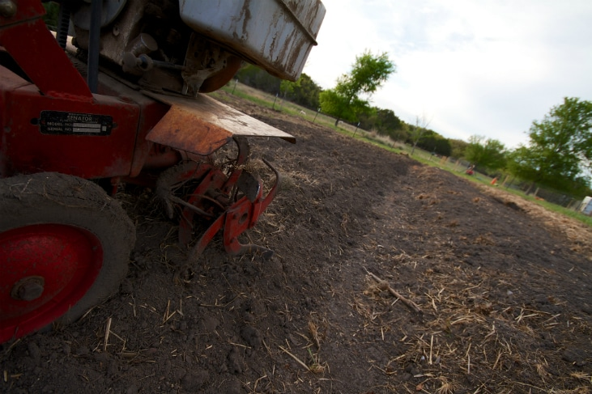
- Mulch Alone
- Sheet Mulching
- Double Digging
- Solarizing
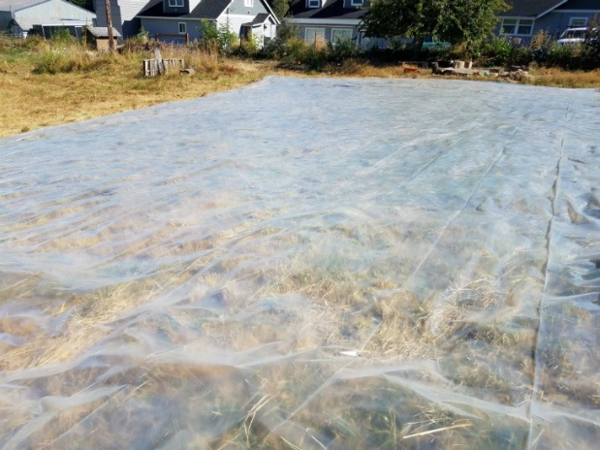
- Animals (focus on chickens and pigs)
Crop establishment
- Categories of planting materials
Types of Planting Materials
• Seeds (seasoning herbs, legumes, corn)
• Seedlings (most vegetable crops)
• Cuttings (cassava, potato, yam, ginger, dasheen, tannia, eddoes)
• Suckers (banana, plantain)
• Budded/ grafted plants (fruit trees)
Certain Factors need to be considered when you are choosing planting matter or seedlings from nurseries or plant shop.
Environmental Factors
• The surroundings should be free from overgrown bushes, generally clean, no waterlogged conditions
• Seedlings should be in conditions that are free from excess shade. If seedlings have too much shade they do not “harden off” and they have difficulties when they are transplanted.
Seedling Characteristics
The seedlings should:
1. Be of the appropriate age (seedlings with 4-6 healthy green leaves)
2. Be free from pests and diseases
3. Have healthy white roots (good root development, with no balling of roots)
4. Show vigorous, healthy growth
5. Be of uniform appearance
6. Have the proper Shoot to Root ratio (2:1)
Methods of planting various crops
- Broadcasting: Generally, the seeds are broadcast-sown and later planked. This method of sowing is easier and area coverage is quick. However, uniform population cannot be maintained since the seeds are not placed in uniform depth and germination may not be uniform. The skill of the labour is important to sow the seeds evenly covering the entire field. Broadcast-sowing is normally practiced under dryland condition. Seed requirement is generally high for broadcast sowing.
- Sowing behind the country plough: In this method, sowing is taken up behind the country plough operation. Seeds are dropped in the furrow opened during ploughing and subsequently covered while the next adjoining furrow is formed. Bold seeded crops like groundnut are sown by this method in drylands. It is important to take up sowing at the appropriate soil moisture so that the depth of sowing is uniformly maintained.
- Drill sowing or drilling: Drill sowing is one of the best methods that provides uniform plant population since seeds are uniformly dropped in the furrows. Animal drawn or power operated seed drills are used for this purposes; seed cum fertilizer drill can also be used. By this way, depth of sowing can be maintained; fertilizer can also be applied simultaneously. Pelleting of small sized seeds may reduce the risk of irregular dropping. Since sowing is taken up in lines, intercultural operations can be easily practiced. It is possible to take up sowing of intercrops also.
- Dibbling: In the method, a seed or few seeds are put in a hole and covered. Under irrigated condition, seeds are dibbled in lines or on the sides of the ridges maintaining optimum intra- row spacing, e.g. maize and cotton. Though this method is laborious and time consuming, it gives rapid and uniform germination and the requirement of seed is less than in broadcasting.
Methods of Plant Propagation
- Cutting
This is cutting the vegetative part of the plant (leaf, stem, and root) and then planting it again to regenerate the whole plant. The three types of cutting are named after the plant part being detached/cut:
- Stem cutting
- Leaf cutting
- Root cutting
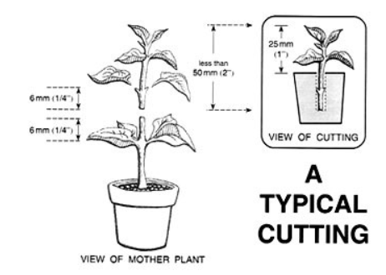
2. Division
This is a suitable technique for perennials (plants that live for more than two years). It involves dividing the plant by digging and moving it to an already prepared site. This helps the plant to rejuvenate and reduce water and nutrient competition.

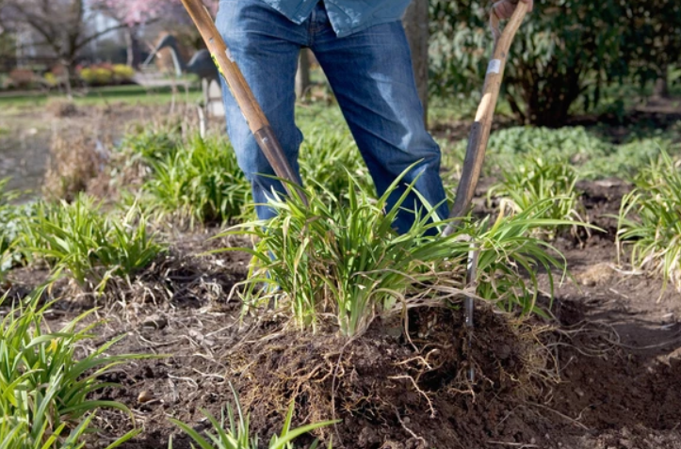
3. Layering
In this technique, the attached and bent branch of the plant is covered with soil and allowed to root. After the emergence and development of roots that specific part of the plant is cut and allowed to grow as a new plant. This is called ‘layering’.
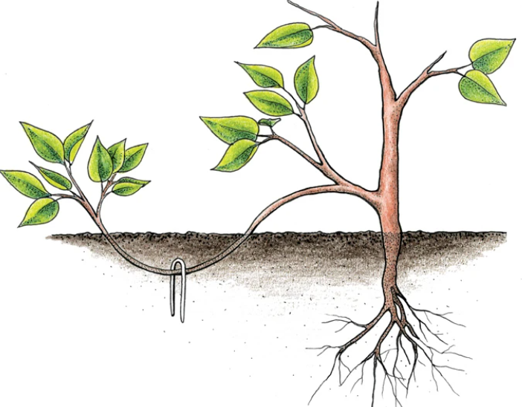
4. Grafting
This involves cutting a twig of one plant and joining it with the stem of another plant in such a manner that they form a unit and function as one plant. It is a bit of a complex process but allows you to bring the desired character to your plant. However, be sure to sterilize your hands and tools to make sure you don’t transfer any infections during the process.

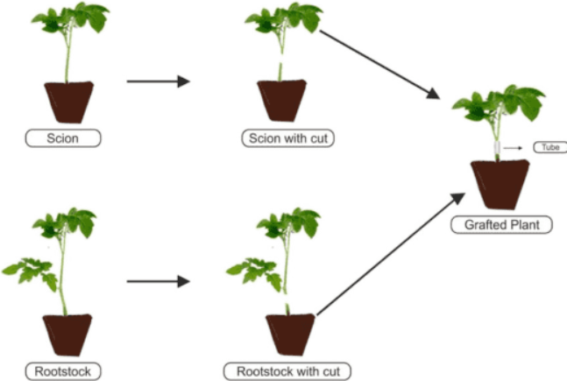
5. Budding
In this method, a cut is made in the rootstock and a single bud with little or no wood is inserted into it in such a way that they unite and grow as a new plant.
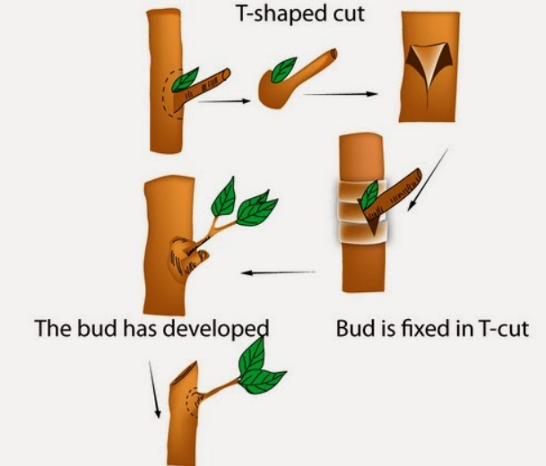
Time of planting depends on the following factors
- Soil and weather conditions
- The kind of crop to be planted.
- The time the produce is desired.
CROP MANAGEMENT
- Adoption of best crop management practices improves crop productivity and can contribute to greater yields with improved quality.
- Crop management is the set of agricultural practices performed to improve the growth, development and yield of crops.
- It begins with a seedbed preparation, sowing of seeds and crop maintenance; and ends with crop harvest, storage and marketing.
- The timing and sequence of agricultural practices depend upon several factors, such as winter or spring crops; harvested products such as grain, hay and silage; sowing methods-broadcast and row-crops; and, plants age, soil, climate and weather conditions.
Physical methods of weeding
Manual control
Manual control is the use of the hands or handheld tools to deal with. An advantage of manual control is that it minimizes soil disturbance, and decreases the likelihood of erosion and seed germination.

Hand pulling
Hand pulling aims to remove the entire plant, including its roots, from the soil. This method is useful for small-scale infestations. It is best to hand-pull weeds after rain, when soil is moist. Sturdy gloves should be worn to avoid prickles, blisters or sap burns to the skin. It is not appropriate for all weed species, such as those with underground bulbs.
Hand tools such as broad knives and trowels can be used to remove underground parts of weeds (such as bulbs) that may reshoot. In some cases it is necessary to dig out the crown of the plant. This requires the growing part of the plant to be cut beneath the ground using a knife.
Grubbing or chipping
This method requires weeds to be dug out using a mattock or chip hoe. Depending on the plant, it may be important to expose the root system, and remove the crown.
In some cases, the mattock or chip hoe is used to cut the stem of the plant below the ground. This method is useful when the ground is hard. Gloves should be worn to avoid blisters.
Mechanical control
Mechanical control is the use of powered tools and machinery to manage weeds and is best suited to larger infestations. Care should be taken to minimise soil disturbance.

Slashing, mowing, dozing, pushing and felling
At times, controlling weeds using mechanical methods is preferred. However, care should be taken when machinery is used in the process.
Disturbing the soil with mechanical control can:
- increase the likelihood of seed germination
- damage native vegetation.
Bulldozers and chainsaws can be used on woody and tree weeds where they are pushed or felled and finally snigged (dragged away). These methods are only suitable in certain situations, as they create high levels of soil and vegetation disturbance. Also, shoots and seedlings require follow-up attention.
Grading or scalping the top layer of soil is an effective method of removing a seedbank. As this method greatly disturbs the soil, it is best suited for areas that are to undergo complete rehabilitation.
Earth Up
Earthing up refers to the act of heaping soil around the root zone of the potato plant. It is one of the primary production practices that must be done to increase the potato yield.
Advantages of earthing up
- improves tuber formation/expansion/roots/pods formation
- Improves drainage around the crop
- Conserves water/soil
- Facilitates harvesting of tuber crops
- Root protection
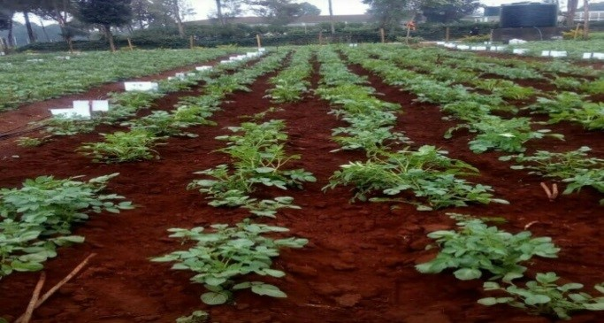
Managing plant spaces
Thinning
When the young seedlings are too close to each other, they do not grow well. They do not find enough nourishment in the soil and their leaves do not have enough room to develop.
Leave only the strongest plants and remove the others. This is called thinning.
When you take out the seedlings that are small, diseased or misshapen, be very careful not to damage the seedlings which remain in the beds.
At the end, pack down the earth around the base of the plants and water them.
Staking
Vegetables with long and weak stems, for example beans and tomatoes, need stakes.
A stake is a stick firmly embedded in the earth. It is best to use hard wood, which does not rot.
Pruning
Certain vegetables, like tomatoes, beans, eggplant, need pruning.
Nip off surplus buds. Then there will be more fruits and they will be bigger.
Gapping
When the seeds fail to germinate, empty spaces are seen within the rows. This if left unfilled can make the farmer incur losses as a result of low yields. The filling up of these spaces or the replacement of ungerminated seeds is called gapping.
Advantages of thinning and gapping
Both thinning and gap filling ensures ideal plant population and optimum utilization of sunlight, space, nutrients, moisture and other inputs which ultimately increases yield.
Crop hardening
- Hardening, or "hardening off," is the process of allowing a plant to transition from a protected indoor or greenhouse environment to the harsh outdoor conditions of fluctuating spring temperatures, wind, and full sun exposure.
- A gradual introduction of these outdoor stresses will cause the plant to accumulate carbohydrates, to trigger more root development, to reduce the amount of freeze-prone water in the plant, and to actually thicken its cell walls. Plant growth will change from soft and supple to much firmer and harder.
Hardening Timetable
- Start the process of moving plants outdoors about two weeks before the weather will be favorable enough for the particular plant to live outdoors.
- Check seed package instructions or inquire where you purchase seedlings as to when the plant can tolerate outdoor conditions. (Keep in mind that air temperature is often warmer than soil temperature.)
- This Vegetable Planting and Transplanting Guide provides guidance for when some popular crops can be planted outdoors.
Hardening Process
- When temperatures are at least 45-50ᵒ, move plants outdoors to a shady, protected spot.
- Initially place in the shaded, sheltered location for two to three hours.
- Gradually increase the amount of sunlight the plants receive over the two-week period. The last day or two, the plants can spend 24 hours outside.
- Reduce the amount of water plants receive, but do not allow them to wilt.

- Avoid placing seedlings outdoors on windy days.
- Cold frames are excellent places to harden plants, but another spot that provides protection, such as a porch, will work.
- Pay attention to the weather forecast; if temperatures will fall below 45ᵒ, be prepared to bring the plants inside.
Keep in mind that the overall goal of hardening is to slow the growth of the plants to allow them to adjust to a change in conditions. After proper hardening, even warmth-loving vegetables, such as tomatoes, can withstand an unexpected dip in spring temperatures.
Importance of crop management practices
Learners to work on them.

STRAND THREE
ANIMAL PRODUCTION
- Animal handling
Forms of animal handling (humane methods)
The objective of humane animal handling is to move animals with minimum stress to both the animals and handler. Considerate handling reduces the risk to the animal of pain, injury and suffering.
Planning the restraint procedure
When preparing to restrain a patient, always make sure the area has enough room, is clean, dry, and well lit
- A plan should be discussed:
- Move any costly equipment
- Nonslip area
- Temperature should be considered
- What should be done if animal happens to get away from restrainer
- Back up plan (Plan B!)
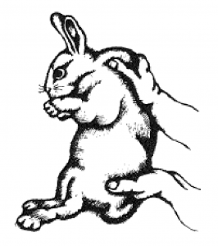
Rabbit Restraint & Handling
Picking Up
Grab scruff of the neck with one hand and lifting up while placing the other hand under the rump for support or wrap patient securely in a towel.
Holding
Use the same technique but the hand under the rump is moved to support the abdomen.
Rabbits seldom bite but many cause injury with their hind legs or may be injured if placed on a smooth surface
Rabbit’s foot pads are covered with fur which causes a lack of traction
Can lead to dislocation of their hip or spinal fracture, when they try to move or hop
Rodents Restraint & Handling
Mice
Grasp the tail close to the body with one hand
Use the other hand to grasp loose skin in the neck and shoulder area.
Larger Rodents and Ferrets
Make sure the animal is awake to avoid bites
Hold in one hand, cup other over its head
Wrap thumb and index
finger around neck and under chin
Do not over tighten fingers around chest as this can impair breathing
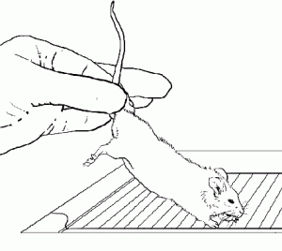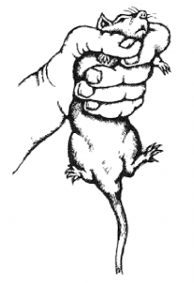
Avian Restraint
Birds
Highly trained personnel
Can stress easily
Do not squeeze thorax
Sensitive to overheating
Small to medium sized
Grasp from behind, finger and thumb on sides of head, others around body
Large birds require 2 hands
Towel can also be used
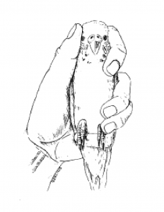
Cats Restraint & Handling
Cats tend to be one of the most difficult during restraint when they become upset and aggressive from stress
Safely restrain and have control over head
Cat bags: control the limbs and head
Squeeze cages: wire boxes with small slots that allow injections to be given
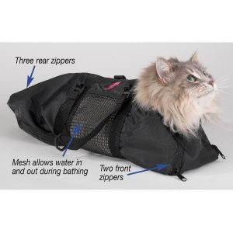

Inhuman handling of animals in the community
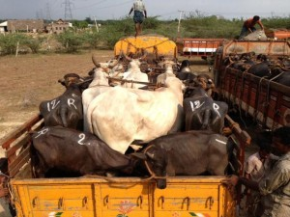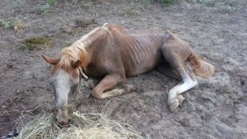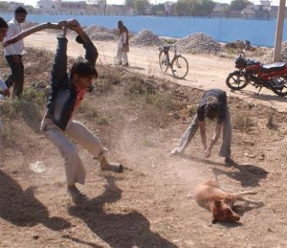
Solutions to animal’s mistreatment
- Be an example of kindness to other pets. ...
- Intervene if you witness animal cruelty, abuse or neglect. ...
- Report animal cruelty, abuse or neglect. ...
- Teach your children to have respect for animals. ...
- Demand stricter laws for the protection of animals. ...
- Shelter an animal in need.
Importance of Human treatment of animals
- Improved levels of animal health and care will deliver better animal welfare, more efficient livestock production, safer animal-sourced foods and healthier, improved livelihoods.

- Animals that are well fed and watered, kept in clean and comfortable conditions, and that are handled well with opportunities to express important behaviours are less likely to die prematurely or show poor growth than less well cared for animals.
- They are more productive with more efficient use of resources such as time, labour and feed for livestock production bringing benefits including improved food security and greater income.
- Furthermore, avoiding stress before slaughter reduces contamination of meat with harmful bacteria and affects the quality, and value of the meat.
- Animal welfare is therefore also environmental protection. However, it is not only animals in stables or private households that need to be protected, but also animals in the wild. There they need above all plenty of space, clean water, fresh air, and sufficient food and shelter.
- General Management of Pets
Characteristics of pets
- Dependent on Humans to Live – A pet needs to be given food, water, and shelter by its owner. Being domesticated means the animal depends on its owner for all of its care.
- Lives in a Home – A pet lives in a home. Some pets such as parakeets and hamsters live in cages. Alternatively, dogs and cats wander freely around a home and may have their own bed to sleep in.
- Needs a Veterinarian’s Care – Pets need care from a veterinarian. The type of healthcare a pet needs depends on what type of pet it is. An iguana and a beagle need completely different types of vet care!
- Some Pets Can Be Trained – A dog can learn how to sit, stay, and heel in a course of obedience training. Parrots can be taught to talk, and some cats can be taught by humans to do tricks.
- Devoted to Its Owner – Pets are often devoted to their owners. They can establish a trust with their owner over time. In fact, some pets want to be with their owners 24/7!
- Provides Companionship – A pet is meant to be a companion to its owner.
- Pets are Different from a Therapy Animal – A therapy animal receives specific training in order to provide support and care to its owner. As an example, some therapy dogs are trained to recognize the signs of a seizure in their owner. The dog responds by trying to get the person to a safe place. Alternatively, a pet is there strictly as a companion.
- Different from a Farm Animal – A cow or a chicken living on a farm serves a specific purpose. A cow provides milk while a chicken lays eggs to be eaten or sold. This makes farm animals a little different than traditional pets.
- Can Be Common or Uncommon – When you think of a pet you probably picture a dog, a cat, a bird, a fish, or a gerbil. Those are common choices for pets. Some people prefer less common or exotic pets such as snakes, iguanas, spiders, and ferrets. As long as an owner can offer appropriate care, many animals can live happily as pets.
- Cannot Survive in the Wild – One of the main characteristics separating pets from other animals is a pet can’t survive in the wild. It has been domesticated or raised under a person’s care. So, releasing a pet snake into the wild doesn’t mean it will know how to find food or shelter. In fact, it will likely die.
Different types of pets reared in the community
A pet is a domesticated animal that lives with an individual or family. There are popular, well-known pets like dogs and cats
- Dogs
- Cat
- Rodents
- Fish
- Birds
- Turtles
- Snake
Factors to consider when selecting a pet for rearing
Choose a pet that will suit your lifestyle and surroundings. For instance:
- How often are you home? If you work long hours, a dog may not be a good choice of pet, as all dogs require lots of companionship. In this case, pets such as fish might be more suitable.
- How large is your backyard, and do you have good fencing? If you have a small backyard or poor fencing, then a dog may not be a good choice. You could consider a pet such as a cat that lives indoors with you.
- Are you prepared to have more than one pet? Some types of animals, such as birds and rabbits, need the company of each other to stay happy and healthy.
- How much money can you afford to spend on your pet? All pets are expensive — even animals that are cheap to purchase, like fish, birds and guinea pigs, can cost a lot of money when it comes to buying and setting up tanks, cages and hutches. Some dog breeds will cost more to keep than others. Large dogs need more food, some breeds of dogs need regular clipping of their coats.
- Are you renting? Your landlord may not let you to own a cat or a dog. You may want to consider other pets such as fish.
- Do you live in an apartment? Some birds, such as parrots, can be very noisy, and may attract complaints from neighbours. You may want to consider a quiet pet such as a cat, or fish.
- Do you have young children? Some types of pets tolerate children better than others.
- Are you prepared to have your pet inside with you? Dogs should not be left in the backyard all day — they need to spend time inside the house with you, in order to remain happy and healthy.
- Does your council require cats to be confined to your property? If so, you must be prepared to have your cat live inside with you, or to buy or build cat proof fencing or a cat enclosure.
- How much time do you have to exercise your pet? Dogs need daily walks. Some breeds of dog are more energetic than others and may need longer or more frequent walks.
- How much time do you have to train your pet? Dogs, particularly puppies or young dogs, need time spent on toilet training and basic obedience training. Puppies and kittens also require lots of socialization, and regular small meals throughout the day, during the first 6 months of life. You may be better off adopting an adult dog or cat, who is already house trained and socialized.
Acquiring a pet for rearing
- Adoption is the best choice
Adoption of a pet from a shelter is the best way to find a new companion. There are many animals in shelters waiting for a new home to call their own, including a large variety of breeds, sizes, and ages of animals. Some shelters also rehome small mammals such as rabbits, guinea pigs and hamsters who are often sadly taken to shelters when the children they have been bought for have lost interest in caring for them. The benefit of rehoming from a reputable animal shelter is that the animals will have been assessed both in terms of their health and behaviorally
- Brokers,
- pet stores,
- neighbors,
- professional breeders,
- commercial kennels,
- puppy mills, and animal shelters

Management practices in rearing of pets
- Colostrum feeding
- Weaning
- Disbudding - Arresting the horn growth at an early age, when the horn root is in the bud stage is called disbudding.
- Ear tagging
- Castration
- Vaccination schedule for adult animals
- Disinfection
- Quarantine
- Isolation of sick animals
- Insuring the animals
- Disposal of carcass
- Record maintenance
- Preparation of Animal products
Different animal products include:
meat and meat products, poultry products (meat and eggs), fish, shellfish, dairy products (milk and cheese), and non-food products such as fiber (wool, mohair, cashmere, and leather)
Factors to consider when grading eggs
The grade is determined by the
- interior quality of the egg
- the appearance and condition of the egg shell.
- Eggs of any quality grade may differ in weight (size).
- Weight or Volume
- cleanliness
- Size,
- Colour

Factors considered in detecting defects when grading eggs
- blood spot,
- meat spot,
- mold,
- stuck yolk,
- addled egg and
- embryonic growth
Processing raw honey
The process of honey harvesting and extraction most likely happens on separate days. These are the tools required:
Honey Harvest
1) beekeepers suite - mesh helmet and folding veil would do it, with some layers of clothes
2) smoker with fuel (dry branches, leaves, etc.) and a lighter
3) frame super - where frames with honey combs will be put for transportation
4) sting resistant gloves
5) hive tool - to move the frames, scrape wax, etc.
Honey Extraction
1) heated knife - to unseal honey cells
2) uncapping fork - to unseal honey cells missed by the heated knife
3) tub for wax/honey
4) extractor! - fancy cylindrical piece of equipment, used to extract honey
5) food-grade bucket - to catch honey out of the extractor
6) double sieve - catches wax and impurities as honey is poured from extractor
7) containers - final destination of honey before consumption

The process of honey harvesting and extraction most likely happens on separate days. These are the tools required:
  - Harvesting
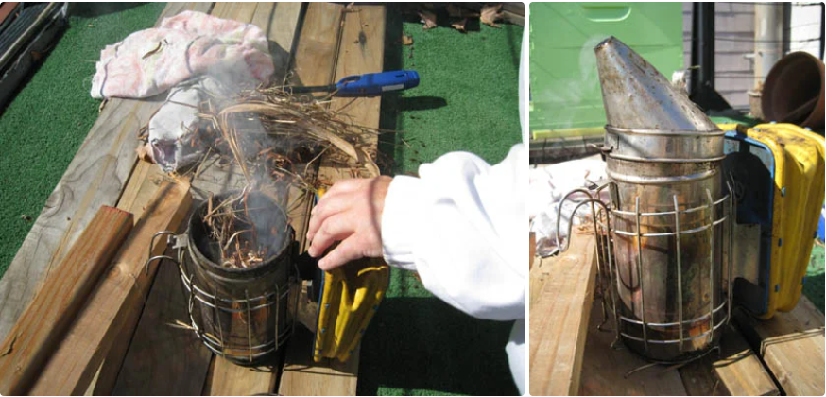
Light the smoker. Use dry branches, hay or newspaper. The smoke dulls the bees' receptors, and prevents them from releasing the alarm odor, a volatile pheromone. The smoke also makes bees gorge on honey, which further pacifies them
  - Prepare Supers
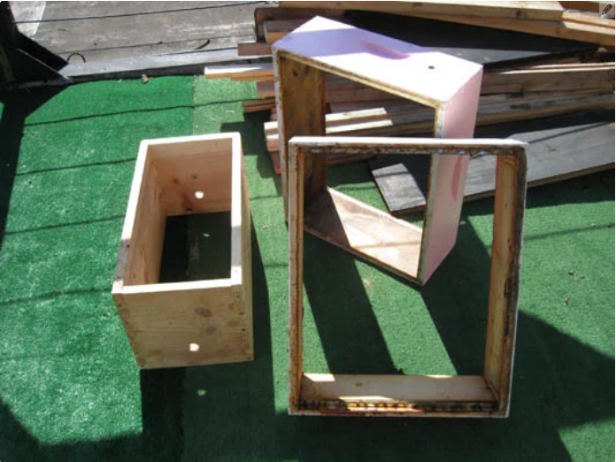
The frames with honey comb are transported in supers. Have them handy. You may also want to have a cloth to cover the super with frames full of honey to prevent bees or other insects from getting to them.
  - Open Sesame
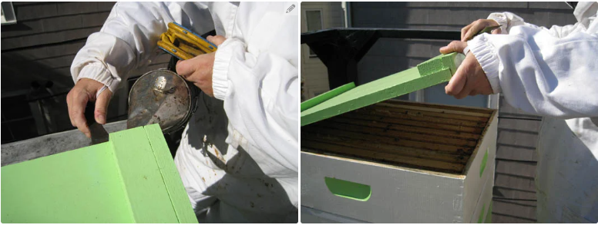
Using the hive tool, lift the hive lid and blow some smoke in the hive. Open lid slowly. Our bees were pretty calm, but that is not always the case!
  - Honey Frame Inspection
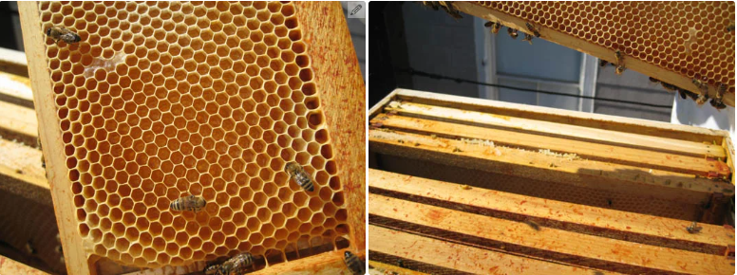
Pull the frames out of the super and inspect the honey combs. Depending on how busy the bees were, how warm it was and if the hive didn't swarm you will know how much honey you have.
  - Extraction
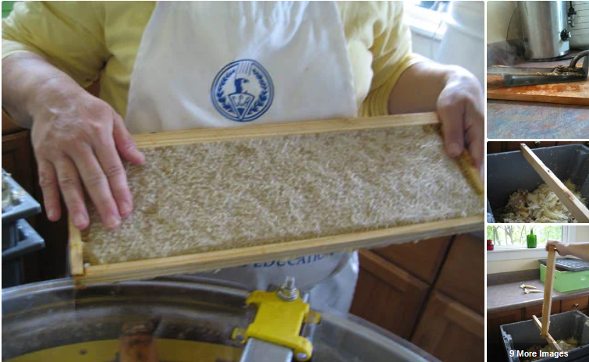
Now the best part! Take the frame of capped honey. Mount the frame above the tub for wax and honey. Use the heated knife to unseal the cells. Lean the heated knife on the edges of the frame and under 30 degree angle and move "fast" - don't linger too long, it burns the honey! Repeat for both sides of the frame.
The heated knife takes off most of the caps. For the leftover ones, use the uncapping fork and gently shave off the caps.
  - Pour Out Slowly!
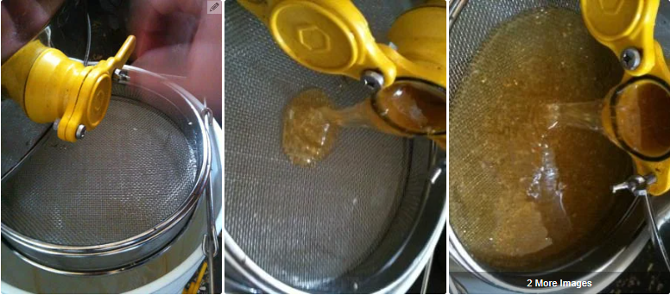
Place your food-grade bucket under the extractor spigot. Use a double sieve to catch the wax and impurities as the honey starts pouring out of the extractor.
  - Prepare Containers
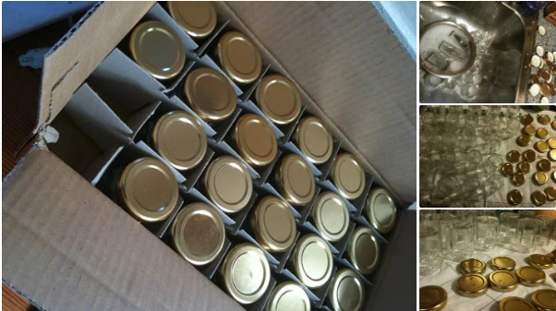
Wash your jugs, jars or whatever containers you will put the honey in. Air dry.

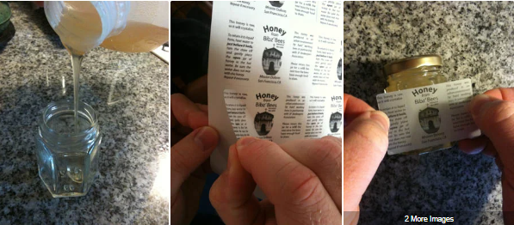
Extracting honey without a honey extractor
For small apiaries, harvesting honey without an extractor can be a fun and inexpensive option. We’ll cover two methods that do not require an extractor: the crush and strain method, and the cut comb method. Both of these extraction methods sacrifice comb, meaning your bees will need to draw out new comb before they can produce more honey — which can mean a smaller harvest the next year. This may factor into your decision about which method you use.
The crush and strain method is a low-cost honey processing technique. You simply scrape the honeycomb off of the frame into a bucket, then crush the comb. Place a sieve in another bucket or container, pour the crushed comb into the sieve, and strain it overnight. This process may be best suited for hobby beekeepers who only have one or two hives. The honey will move more quickly in a warm room, and you may be able to get more honey if you stir the crushed combs a few times and scrape large wax flakes off of the inside of the strainer.
Cut comb honey is an elegant way to package and use your harvest. There are tools available for cutting and packaging comb, but a good-quality kitchen knife does the job nicely, as well. This method works only for frames that contain wireless wax foundation or no foundation — you cannot use this method with frames that use plastic foundations, and wired wax foundation will limit the sizes and shapes of combs you can cut. Choose frames that are fully capped and sealed — this indicates that the honey will have the right amount of moisture to prevent spoiling.

Importance of sorting and grading eggs
- Sorted eggs bring more money to the investor than unsorted.
- It reduces wastage.
- separates eggs into grades of quality.
- A bad egg can be dangerous to consume and negatively affect someone's health.
Importance of processing raw honey
- improves the honey's appearance,
- increases its shelf-life, and
- kills yeast cells that can affect the taste of the honey.
- It can prevent fermentation.
- It delays crystallization.
- removes impurities.

STRAND FOUR
AGRICULTURE AND TECHNOLOGY
- off season cropping techniques
Off season cultivation refers to the production outside of their typical cropping cycle.
The main objective of off season cultivation is to produce and supply to the market during their lean period.
Importance/Advantages of off season cropping
- It helps in the more effective and efficient use of land and farm resources.
- The per-unit result of off-season planting is excellent.
- Consumers nowadays prefer fresh veggies even when they are not in season, and off-season vegetable cultivation can meet this need.
- It is sometimes feasible to gain foreign exchange by exporting fresh veggies.
- It is a great source of preventive food that also contributes to nutritional security.
- It's a good choice for seed production.
Technologies for off season cropping
- Drip irrigation
Crop yields can increase through improved water and fertility management and reduced disease and weed pressure. When drip irrigation is used with polyethylene mulch, yields can increase even further.
These benefits are only possible when a drip irrigation system is properly designed, managed, and maintained.
Advantages of drip irrigation
- Lower-volume water sources can be used because trickle irrigation may require less than half of the water needed for sprinkler irrigation.
- Lower operating pressures mean reduced energy costs for pumping.
- High levels of water-use efficiency are achieved because plants can be supplied with more precise amounts of water.
- Disease pressure may be less because plant foliage remains dry.
- Labor and operating costs are generally less, and extensive automation is possible.
- Water applications are made directly to the plant root zone. No applications are made between rows or other nonproductive areas, resulting in better weed control and significant water savings.
- Field operations, such as harvesting, can continue during irrigation because the areas between rows remain dry.
- Fertilizers can be applied efficiently through the drip system.
- Irrigation can be done under a wide range of field conditions.
- Compared to sprinkler irrigation, soil erosion and nutrient leaching can be reduced.
- Container gardening
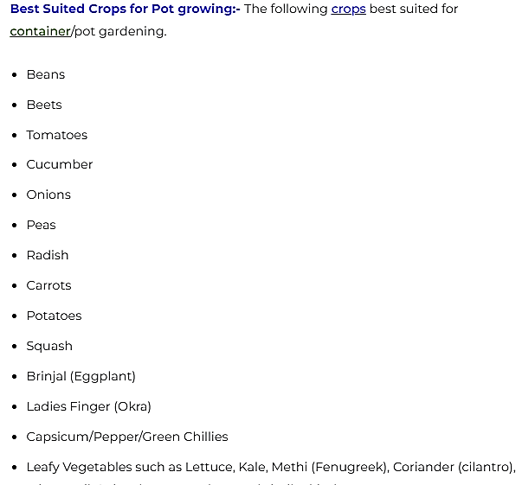
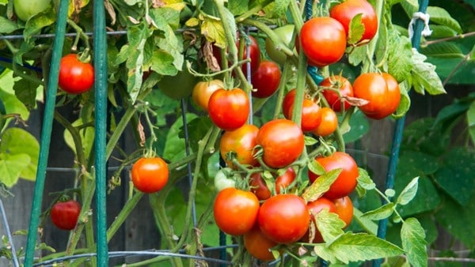
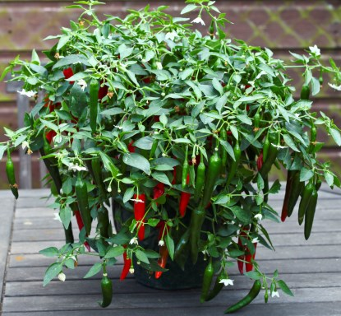
Factors to consider when establishing framed suspended gardening for off season crops
- Can it be established along pathways
- Can it enhance beauty
- Can it grow within a short period of time (not a perennial crop)?
- Is there space for the containers
- Mechanisms put in place to manage pests and diseases.
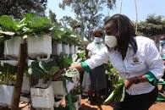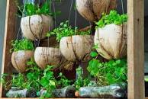
Off season production techniques
- Taking use of and utilizing various agro-climatic conditions.
- Improved varieties are chosen.
- Adjustment of planting time.
- Making plastic tunnels, polythene houses, and permanent glass houses to provide controlled environmental conditions.
- Staggered planting
- Succession planting – planting two different at different times in one farm- one with a faster maturity.
Construction of suspended garden design
Refer to learner’s book

VALUE ADDITION TECHNIQUES
Value-added agriculture generally focuses on production or manufacturing processes, marketing or services that increase the value of primary agricultural commodities, perhaps by increasing appeal to the consumer and the consumer's willingness to pay a premium over similar but undifferentiated products.
Benefits include:
- increased income,
- employment creation,
- improved food safety,
- food security,
- nutritional benefits and
- greater consumer confidence.
There are four major ways that value is added to crops along the value chain:
- product transformation, e.g. frying, drying
- distribution,
- storage, and
- added service.
The value of farm products can be increased by cleaning, cooling, cooking, combining, churning, culturing, grinding, extracting, drying, handcrafting, packaging and distributing, as well as by adding information, education or entertainment,
Adding value to groundnuts
Apart from just eating them raw or cooked, groundnuts can be used to produce oil, paste, flour or sauce used in cakes and cookies obtained by grinding nuts, and peanut butter.
Adding value to Potatoes
This can be done through boiling, frying, smashing.
Learners to check on how to add value on other products
Importance of addition on crop produce (explained)
- Increased revenue. Any addition adds a percentage of increased financial value to the produce and has the effect of improving the incomes of the local farmers.
- Value addition allows the farmer to focus on the consumer while producing and through meeting expectations, he can create a loyal market around the product.
- Increased shelf life is a benefit any farmer would want. The longer the product can stay without getting spoilt, the more the guarantee one has of a product selling at their preferred price and time. Milk for instance, hardly lasts over 24 hours but with boiling, it can last more days while with further processing into ghee, the same milk can last months.
- With value addition comes increased bargaining power. Brand Creation is one of the de facto results of value addition and a fact that your product can be directly identified with you or your farm which is important in an industry where customers exercise a lot of brand loyalty. It allows them to always and readily identify with you as well as win you more referral customers.
- value addition creates employment opportunities for people who work there like; industrial chemists, food processors, factory laborers
- Wastage and disposal of unwanted refuse is curtailed since they can be made into different quality products. This helps to ensure zero waste and protect the environment.

