COMPETENCE BASED CURRICULUM
7
2024
JUNIOR SCHOOL
AGRICULTURE AND NUTRITION Question paper
TIME
2 HRS 15 MINS
SCHOOL: …………………….……….………………………………………..…
NAME: …………………………….…………………………..…………………..
ASSESSMENT NO: ………….……. SIGN: …..……..... DATE: ………..….
RUBRICS (for official use)
MARK SCORE RANGE | Below 40 | 40-59 | 60-79 | 80-100
PERFORMANCE LEVEL | Below expectation | Approaching expectations | Meeting expectations | Exceeding expectations

OUT OF | 100%
LEARNERS SCORE
PERCENTAGE SCORE
PERFORMANCE LEVEL

FOR FACILITATOR’S USE ONLY

INSTRUCTIONS TO CANDIDATES
- Answer all the questions in the spaces provided.
- Ensure your work is neat.

Explain two problems facing water conservation in agricultural environment. (2 mks)
- ………………………………………………………………………
- ………………………………………………………………………
    - Explain the meaning of the term agroforestry in conserving the environment.( 2 mks)
……………………………………………………………………………………………………………………………………………………..

State two ways in which agroforestry conserve the environment. (2 mks)
- …………………………………………………………………………
- …………………………………………………………………………

State four importance of agroforestry trees in conserving the environment. (4 mks)
- ……………………………………………………………………..
- ……………………………………………………………………..
- …………………………………...………………………………

Give three types of planting materials used for establishing agroforestry. (3 mks)
- ……………………………………..
- ……………………………………..
- ……………………………………..

Name three structures used for conserving surface runoff.( 3 mks)
- ………………………………………………….
- …………………………………………………
- ………………………………………………….

Name four practices carried out when caring for established agroforestry trees.( 4mks)
- …………………………………………………
- …………………………………………………
- …………………………………………………
- …………………………………………………

    - Give four types of sites that can be used for planting crops.(4 mks)
- ………………………………………..
- ………………………………………..
- ……………………………………….
- ………………………………………

What is soil tilth? (2 mks)
………………………………………………………………………………………………………………………………………………

Give three categories of soil tilth in relation to the size of planting materials. (3 mks)
- …………………………………………………..
- …………………………………….…………….
- ……………………………………………………
    - Describe three ways of how a ground seedbed is prepared.( 3mks)
a. …………………………………………………………………………
- …………………………………………………………………………
- …………………………………………………………………………..

Give two categories of planting materials. ( 2 mks)
  - …………………………………………………….
  - …………………………………………………….
    - Study the pictures below and then answer the questions that follow.
Identify planting materials (3 mks)
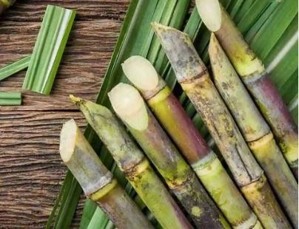
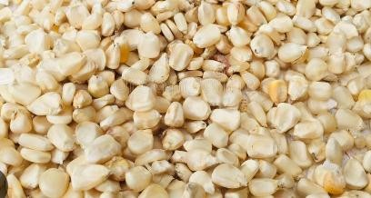
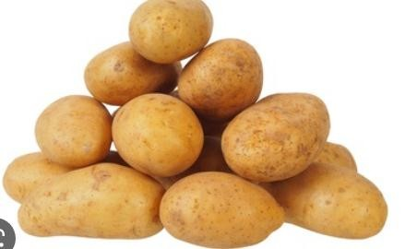

    - Name three types of vegetative planting materials.( 3 mks)
  - ……………………………………….
  - ………………………………………..
  - ………………………………………..

Give three methods of planting. (3 mks)
  - ……………………………………
  - ……………………………………
  - …………………………………….

Give one way of predicting time of planting. (2mks)
………………………………………………………………………………………………………………………………………………………..

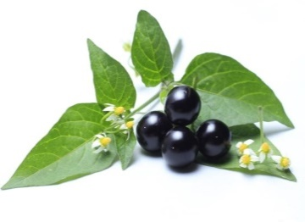
    - Name the following weeds.( 3mks)
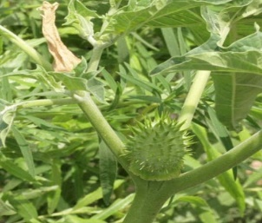
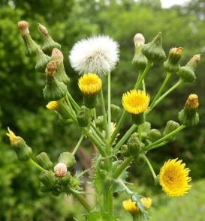

    - Explain two factors that determine time of planting. (2mks)
  - …………………………………………………………………
  - …………………………………………………………………
- State four role of home science education. (4 mks)
- …………………………………………………………………………
- …………………………………………………………………………
- ………………………………………………………………………….
- …………………………………………………………………………..

Name the equipment below. ( 3 mks)
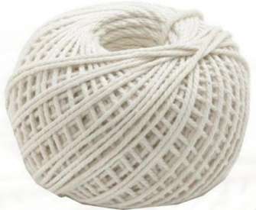
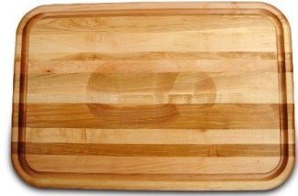

- Mention three guidelines for cooking food by roasting. ( 3mks)
- …………………………………………………………………………
- ………………………………………………………………………..
- …………………………………………………………………………

- State three Safety measure during Roasting. (3 mks)
  - …………………………………………………………………………
  - …………………………………………………………………………
  - ………………………………………………………………………..
- Outline four Factors to consider when buying goods and services. (4 mks)
- ……………………………………………………………………..…….
- ……………………………………………………………………….…..
- …………………………………………………………………….……..
- ………………………………………………………………….………..

- State some kitchen tools and equipment that can be used by; (2 mks)
- Re-using ………………………………………………………..
- Re-cycling ……………………………………………………….
- Write the name of the following nutritional deficiency disease.(3 mks)
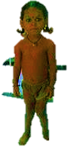
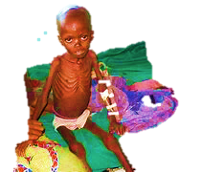
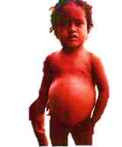

- Why is it important to improvise equipment for the preparation and cooking of food?(2 mks)
- …………………………………………………………………………..
- …………………………………………..………………………………
- Name four sale outlets for household goods and services.( 4 mks)
- …………..………………………………
- …………………………………………..
- ………………………………………….
- …………………………………………..
- Mention four Methods of Buying various household goods and services.( 4 mks)
- …………………………………………………..
- …………………………………………………..
- …………………………………………………..
- …………………………………………………..
- State five Ways of Saving Income when buying household goods and services. ( 5 mks)
- …………………………………………………………………………...
- …………………………………………………………………………...
- …………………………………………………………………………...
- …………………………………………………………………………...
- …………………………………………………………………………...

- State five Challenges experienced or faced when buying household goods and services.( 5 mks)

- …………………………………………………………………………...
- …………………………………………………………………………...
- …………………………………………………………………………...
- …………………………………………………………………………...
- …………………………………………………………………………...

- Identify the following plants. ( 2 mks)
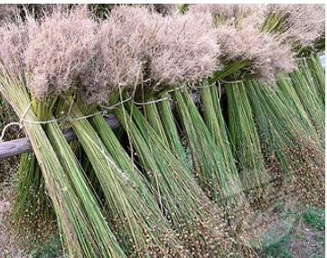
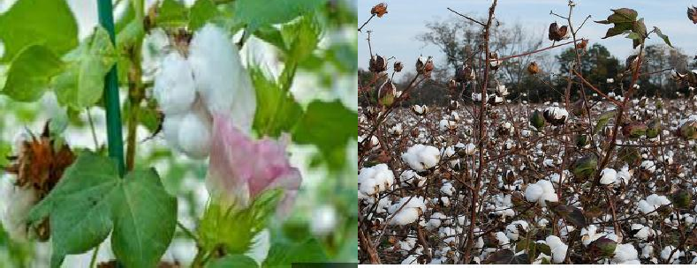

- Fibres form yarn which is used to make fabric through different ways. Name three ways of using fibres( 3mks)
- ………………………………………….
- ………………………………………….
- …………………………………………..

- Mention the activity demonstrated below. ( 1mk)
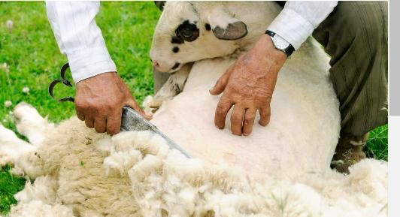

- State two properties of Cotton. ( 2 mks)
  - …………………………….………………………………………………..
  - ………………………………………………………………………………

THIS IS THE LAST PRINTED PAGE

