COMPETENCE BASED CURRICULUM
7
2024
JUNIOR SCHOOL
AGRICULTURE AND NUTRITION MARKING SCHEME
Please Note: Facilitators are advised to go through the marking scheme as answers given could not be exhaustive.

Explain two problems facing water conservation in agricultural environment.( 2 mks)
- Lack of skills in water conservation due to lack of training.
- Negative attitude by members of the community due to lack of awareness on the importance of water conservation.
- Water pollution from other human activities such as using excess fertilisers and agricultural chemicals.
- Lack of enough resources to carry out some water conservation measures.
    - Explain the meaning of the term agroforestry in conserving the environment.( 2 mks)
Agroforestry is growing of trees and shrubs in combination with crops and keeping livestock on the same piece of land for conserving the environment.

State two ways in which agroforestry conserve the environment. (2 mks)
- Reducing the speed of wind to control soil erosion.
- By recycling nutrients back to the soil through addition of organic matter.
- Providing shade which reduces water loss from the soil.
- Providing habitat to wild animals and birds.

State four importance of agroforestry trees in conserving the environment. ( 4 mks)
- They control soil erosion.
- They provide food for livestock and human beings.
- Their leaves decompose to add nutrients to the soil.
- They provide shade for livestock and shelter for crops.
- They provide habitat to wild animals and birds.
- They act as windbreaks.
- They absorb carbon dioxide from the air and increase oxygen supply.

Give three types of planting materials used for establishing agroforestry.( 3 mks)
- Seeds.
- Cuttings.
- Seedlings.

Name three structures used for conserving surface runoff.( 3 mks)
- Water retention ditches.
- Earth basins.
- Water retention pits.

Name four practices carried out when caring for established agroforestry trees.( 4mks)
- Mulching.
- Watering.
- Weeding.
- Protecting from animal damage.
- Removing diseases and pest infected parts.
- Pruning.
    - Give four types of sites that can be used for planting crops.(4 mks)
- Ground sites.
- Containers sites.
- On walls.
- Along the fence.
- Along the driveways.

What is soil tilth? (2 mks)
It is the degree of fineness or coarseness of the soil in relation to its suitability for planting a specified planting material.

Give three categories of soil tilth in relation to the size of planting materials. (3 mks)
- Fine soil tilth.
- Medium soil tilth.
- Coarse soil tilth.
    - Describe three ways of how a ground seedbed is prepared.( 3mks)
  - Mark the area to be prepared with pegs.
  - Clear the vegetation at the site using a slasher or panga.
  - Dig the land using a jembe or a forked jembe.
  - Break the large soil clods until the appropriate soil tilth is attained.
  - Level the land.

Give two categories of planting materials. ( 2 mks)
  - Seeds.
  - Vegetative materials.
    - Study the pictures below and then answer the questions that follow.
Identify planting materials (3 mks)
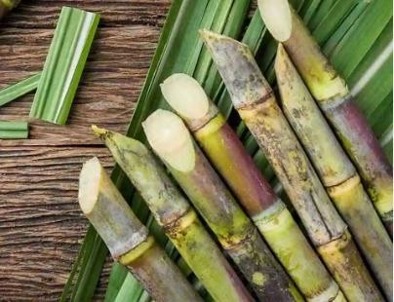
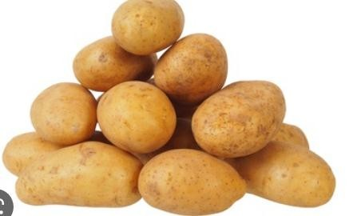
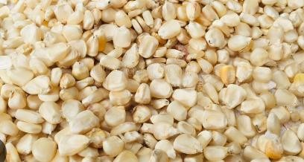
Maize grains Sugar cane cuttings Irish potato tubers
    - Name three types of vegetative planting materials.( 3 mks)
  - Cuttings.
  - Suckers.
  - Vines.
  - Bulbils.
  - Splits.
  - Tubers.
  - Crowns.

Give three methods of planting.( 3 mks)
  - Broadcasting.
  - Row planting.
  - Drilling.
  - Dibbling.

Give one way of predicting time of planting. (2mks)
In rain fed agriculture, time of planting is determined by the onset of rain. If the rains start early, planting is done early. If the rains delays, planting will be delayed as well.
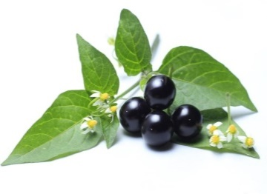
    - Name the following weeds.( 3mks)
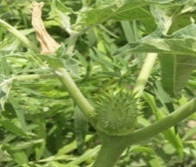
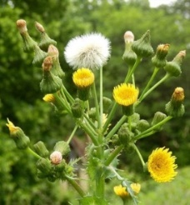

Sow thistle Double thorn Black nightshade

    - Explain two factors that determine time of planting. (2mks)
  - Soil moisture-soil moisture is needed for the germination of planting materials. Planting is done when the soil moisture for most of crops. This moisture is either from rain or irrigation.
  - Onset of rains-rain makes the soil moist. Most crops are planted when the rain is expected or start or has started.
  - Timed market-crops grown for certain markets are planted at such a time when their maturity and harvesting will coincide with the time the produce is needed in the market.
  - Need for continuous supply of produce in the market-different portions of the field are planted at different time to ensure that the crop will mature at different time and therefore provide continuous supply of the produce in the market. This is what is referred to as staggered planting.
  - Time of harvesting-some crops are planted at a time when their harvesting will coincide with a dry spell or with a certain market demand.
- State four role of home science education. (4 mks)
- Home science education forms the foundations for learners who want to pursue related subjects as senior secondary school and careers at tertiary levels.
- As a subject, home science covers aspects of caring for self and the family.
- It also covers foods, nutrition, textile, and clothing, housing the family, home care, laundry work, maternal health care and consumer education.
- Home science exploits the use of scientific knowledge to manage human home life in aspects such as nutrition, health, housing and other skills.
- It also sharpens individual preparing them for a healthier personal life.
- Home science educations have equipped consumers with ability to be aware of their duties and rights preventing producer or supplier exploitations.
- Skills learnt in home science will enable us to developed healthy hygiene habits at home.
- Home science will help us adapt to a healthy lifestyle.
- Home science will also give us knowledge on financial management.
- Home science will lead us to choose good careers.

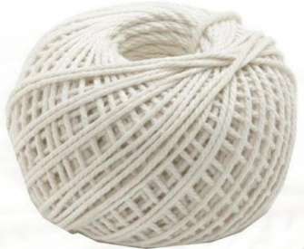
Name the equipment below. ( 3 mks)
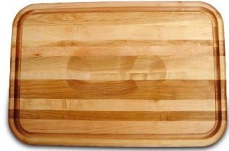
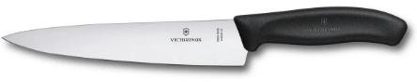

Carving knife. Carving board Kitchen thread.
- Mention three guidelines for cooking food by roasting. ( 3mks)
- The meat to be roasted should be seasoned before putting it in the roasting pan.
- The food to be roasted should be of good quality.
- Frequent basting is necessary to keep meat moist and ensure even cooking. Basting involves the application of fat, oil or any other juices on meat during roasting to keep it moist.
- Do not prick the surface of meat as this will allow juices to drain out and leave the roasted meat dry.
- The kitchen thread is used to tie the meat to maintain its shape during roasting.
- State three Safety measure during Roasting. (3 mks)
  - Wear oven gloves when putting food in and removing it from the oven.
  - Place the hot roasting pan on a heat proof mat after removing it from the oven.
  - When cutting the hot meat, hold it firmly with a fork.
  - Be careful when using hot ash to roast to avoid burns.
- Outline four Factors to consider when buying goods and services. (4 mks)
- Time and energy
- The family income.
- Inflation
- The specific household needs of the family
- Complementary products

- State some kitchen tools and equipment that can be used by; (2 mks)
- Re-using oil containers
- Re-cycling old kitchen basin
- Write the name of the following nutritional deficiency disease.(3 mks)
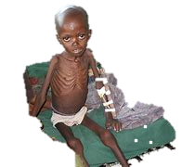
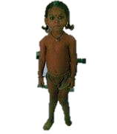
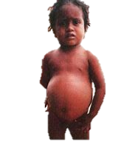
Marasmus
Rickets

Kwashiorkor

- Why is it important to improvise equipment for the preparation and cooking of food?(2 mks)
- To save time that could otherwise be used to buy the equipment
- To save on cost of the equipment.
- To avoid possible damages on the real items

- Name four sale outlets for household goods and services.( 4 mks)
- Online outlets.
- Malls.
- Super markets.
- Retail shops.
- Grocery shops.
- Kiosks.
- Mention four Methods of Buying various household goods and services.( 4 mks)
- Use of Cash.
- Through credit.
- Use of Mobile money.
- Through barter trade.
- Use of cheque.
- Use of credit card.
- Use of Debit card.
- State five Ways of Saving Income when buying household goods and services. ( 5 mks)
- Bargaining.
- Shopping in bulk.
- Buying household goods and services during promotions.
- Comparing prices before buying goods and services.
- Using a shopping list.
- Buying goods and services from exhibitions and trade fairs.
- Improvising some items, you intended to buy using locally available materials.
- State five Challenges experienced or faced when buying household goods and services.( 5 mks)
- Increase in prices.
- Scarcity of goods and services.
- Transport challenges.
- Expired goods.
- Cheating on weights of goods and other measurements.
- Poor Quality of goods.
- Network problems for on-line shops and services.
- Incompetent service provides.
- Availability of fake online outlets that are fraudsters.
- Lack of market information to consumers.

- Identify the following plants. ( 2 mks)
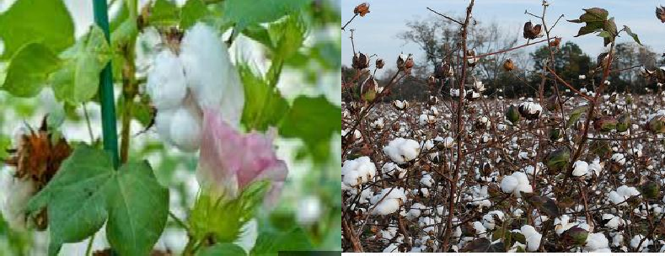 Cotton plant

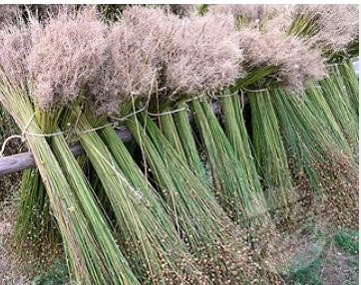

Flax plant

- Fibres form yarn which is used to make fabric through different ways. Name three ways of using fibres( 3mks)
- Weaving.
- Knitting.
- Crocheting.
- Felting.
- Bonding.
- Netting.
- Laminating.

- Mention the activity demonstrated below. ( 1mk)

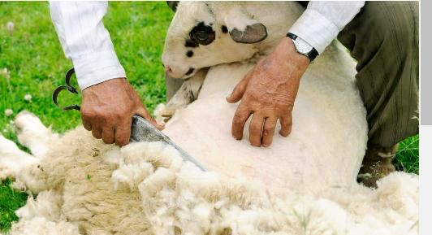

Wool shearing

- State two properties of Cotton. ( 2 mks)
  - Cotton is a strong fibre.
  - Cotton is resistant to high temperatures.
  - It is absorbent.
  - It is moth proof.
  - It is flammable hence burns readily when exposed to flame.
  - It does not generate or hold static charges.
  - It is light and dull in appearance.
  - It creases easily.
  - It is a good conductor of heat.
  - Cotton can withstand mild alkalis, washing detergents and stain removing agents.
THIS IS THE LAST PRINTED PAGE
……………….Every learner counts …………

