Name …………………………………………….....………… Adm No…………… Class…………

FORM 3 END TERM 2 2024
443/2
AGRICULTURE
PAPER 2
JULY/AUGUST 2024
TIME: 2 HOURS

INSTRUCTIONS TO CANDIDATES
- Write your name, index number and class in the spaces provided above.
- This paper consists of THREE SECTIONS, A, B and C.
- Answer all questions in sections A and B and any two questions in section C.
- All your answers must be written in the spaces provided in this question paper.
FOR EXAMINERS USE ONLY
SECTION | QUESTIONS | MAXIMUM SCORE | CANDIDATES SCORE
A | 1-19 | 30
B | 20-23 | 20
C | 24-26 | 40
TOTAL |  | 90

This paper consists of 7 printed pages. Candidates should check the question paper to ascertain that all pages are printed as indicated and that no pages are missing

SECTION A : 30 MARKS
- Name three types of specialized feeding carried out in livestock management (1½ mks)

- Name two methods used in identification of livestock in the farm. (1mk)

- Name the breed of sheep adapted to wet and marshy conditions of the Kenyan highlands (1mk)

- Give two reasons for keeping poultry house clean. (1mk)

- What are the terms used to describe the young ones of the following livestock (2mk)

- Rabbits

- Fish

- Goat

- Donkey

- Name the causal organisms of the following diseases in livestock (2mk)

- Anthrax

- Rift Valley fever

- Anaplasmosis

- Milk fever

- State four management practices carried out in sheep during preparation for tupping (2mks)

- Name three plumbing tools in a farm (1½mks)

- Name two exotic breeds of dairy goats (1mk)

- Name four advantages of natural methods of breeding. (2mks)

- Give four disadvantages of using thatch in construction of farm buildings (2mks)

- State four factors that determine digestibility of a feed (2mks)

- Give any two measures that should be taken to control tapeworms in livestock (1mk)

- Give four reasons why farm tools should be maintained and repaired (2mks)

- Name three dual purpose sheep breeds (1½mks)

- Name two groups into which vitamins are classified (1mk)

- State four advantages of spay race over a plunge deep. (2mks)

- State four cultural uses of livestock (2mks)

- Name three enzymes contained in the pancreatic juice (1½mks)

SECTION B : 20MARKS
- Study the diagram below and answer the questions that follow

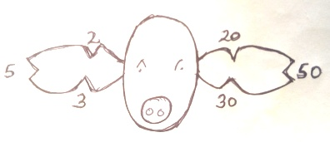
- Name the practice illustrated above (1mk)

- Name the type of method illustrated above (1mk)

- Give the identification number of the pig illustrated above (1mk)

- Using a diagram, illustrate how animal number 85 can be identified using the above diagram (2mks)

- (a) The illustrations below labeled V,W, and X show three different ways some hens were debeaked.
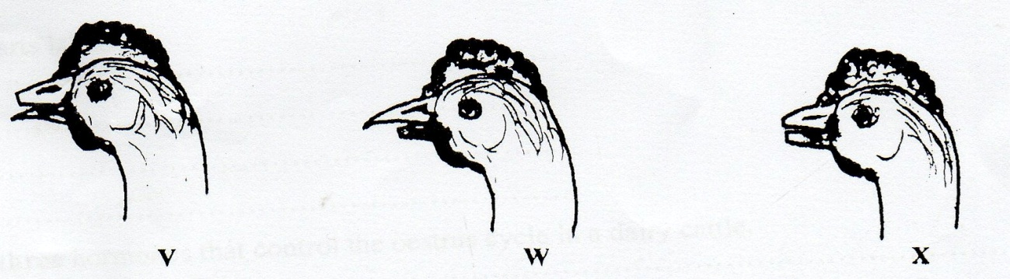
- Which hen was correctly debeaked ?

(1mk)
ii) state two reasons for your choice in (i) above (2marks)

(b) Name any two tools which would be used for debeaking. (2mks)

- The diagram below shows an external parasite in livestock

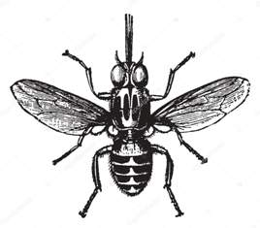

- Identify the parasite (1mk)

- State two effects of the parasite in cattle (2mks)

- Give two control measures of the parasite (2mks)

- Study the following tools and equipment then answer the questions that follow:

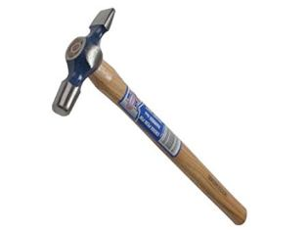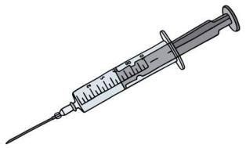
W
Y

X

- Identify the tools labeled W, X and Y (3mks)

- State the function of the tool labeled W (1mk)

- State one maintenance practice carried out on tool Y (1mk)

SECTION C : 40MARKS

- a). Discuss anthrax disease under the following sub headings:
- Animals affected (1mk)
- Causal organism (1mk)
- Symptoms observed in affected animals (4mks)
- Control measures (4mks)

b). (i). State four problems associated with artificial methods of service in cattle production (4mks)

(ii). Give six factors that affect productivity in livstock (6mks)

- a). Describe the life cycle of a three host tick (12mks)

b). Discuss the effect tick to livestock health. (8mks)

- a). Describe any five general effects of parasites on livestock (10mks)

b). Outline the general characteristics of beef cattle breeds (10mks)

