Name ……………………………………………... ………… Adm No…………… Class…………
FORM 3 END TERM 2 2024
443/1
AGRICULTURE
PAPER 1
TIME: 2 HOURS

INSTRUCTIONS TO CANDIDATES
- Write your name, index number and class in the spaces provided above.
- This paper consists of THREE SECTIONS, A, B and C.
- Answer all questions in sections A and B and two questions in section C.
- All your answers must be written in the spaces provided in this question paper.
FOR EXAMINERS USE ONLY
SECTION | QUESTIONS | MAXIMUM SCORE | CANDIDATES SCORE
A | 1-15 | 30
B | 16-19 | 20
C | 20-22 | 20
 |  | 20
TOTAL |  | 90

This paper consists of 10 printed pages. Candidates should check the question paper to ascertain that all pages are printed as indicated and that no pages are missing

SECTION A (30MKS)
Answer all the questions
- Name three diseases that attack cabbages. (1 ¹/₂ mks)

- List four factors that causes loss in soil fertility. (2mks)

- Give four reasons for seed selection in crop production. (2mks)

- Give four reasons why a well-drained soil is suitable for tomato production .(2mks)

- State three conditions that would necessitate irrigation. (1¹/₂ mks)

- Highlight four harmful effects of crop pests (2mks)

- Name a method of breaking seed dormancy in (2mks)
- Calliandra

- Rice.

- Give four benefits of processing certificate of land ownership (title deed). (2mks)

- State four advantages of communal land tenure system? (2mks)

- State four activities that a farmer should carry out on a storage facility before storing farm produce. (2mks)

- Explain the following terms as used in fertilizer chemistry. (2mks)
- Fertilizer grade

- Fertilizer ratio

- Give four climatic factors that influence crop production and distribution. (2mks)

- Give two ways in which land consolidation helps to improve farm management. (3mks)

- State four benefits of organic manures in crop production. (2mks)

- Define the following terms as used in crop production. (3mks)

- Staking

- Hardening off

- Organic farming

SECTION B (20 MKS)
Answer all questions

- The diagram below illustrates a field management practice. Study it carefully and answer the questions that follow.

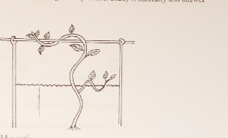

- Identify the field practice (1mk)

ii) Name one type of crop trained using the above method. (1mks)

iii) Give two reasons for carrying out the practice. (2mks)

17. The illustration below shows a cropping programme.
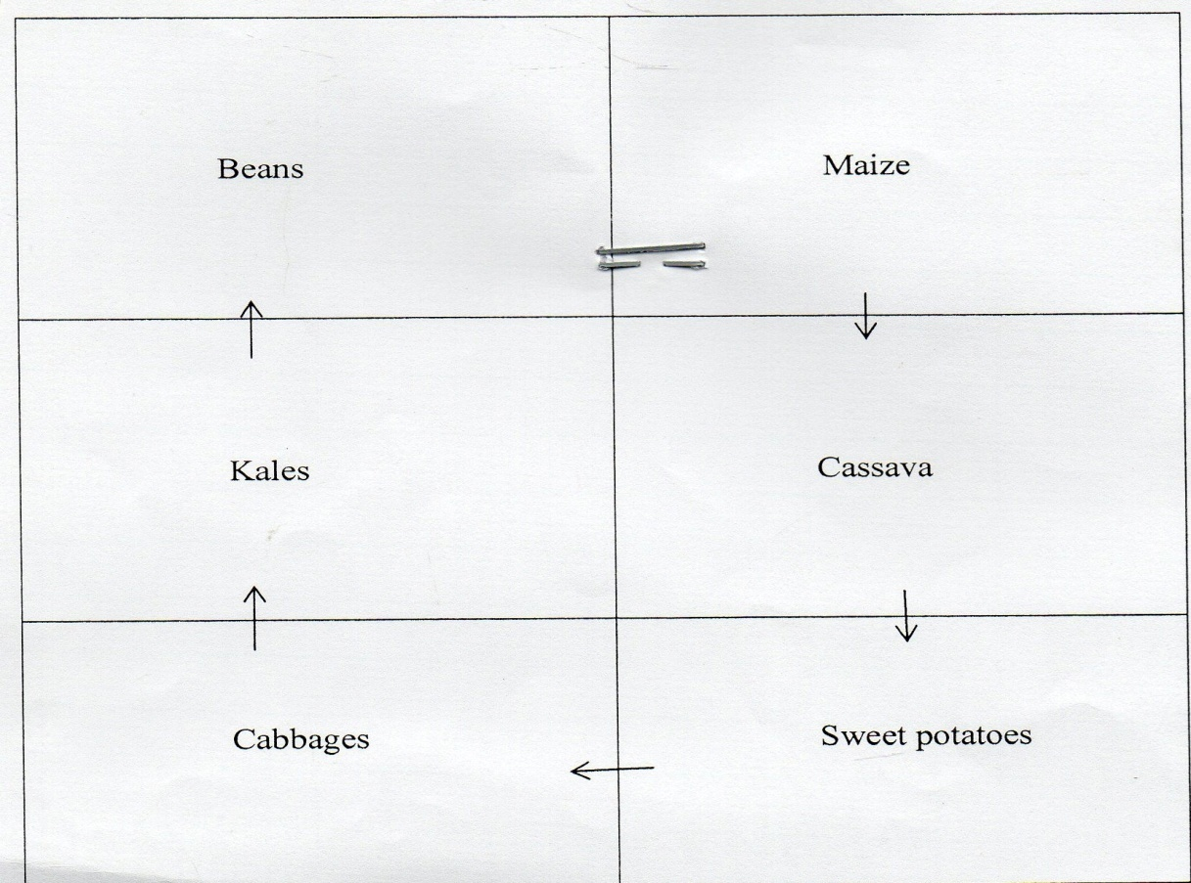

- Identify the cropping programme (1mark)

- Giving a reason identify one mistake the farmer made when designing the above programme (1mark)

- State two ways the above programme help in control of weeds (2marks)

- State two advantages of this programme (1mk)

18. Below is an illustration of a method of frames formation in tea. Answer the question that follows.
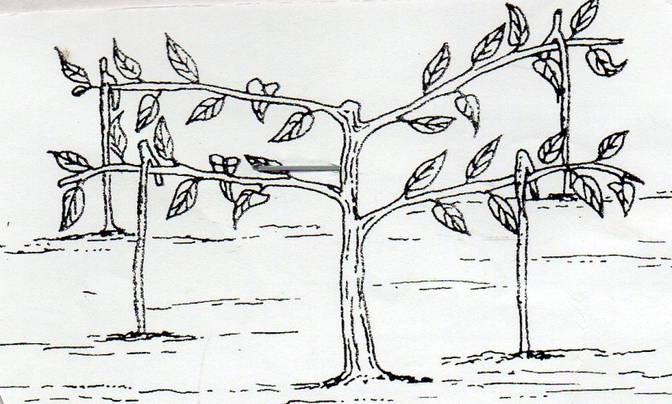
- Identify the above method. (1mk)

- Describe the procedure followed in (a) above (4mks)

19. Students were to apply compound fertilizer 5:20:10 on there agriculture projects, measuring 3m by 4m., at the rarte of 200kg per hectare.
(a). Calculate the amount of fertilizer they would require for each plot. (Show your working.) 4marks

(b). What does the figures 20 and 10 in the fertilizer stand for? 1mark

(c). Give two methods can be used to determine soil pH. 1mark

SECTION C (40 MARKS)
Answer any two questions from this section
- (a) Describe the process of transplanting a cabbage seedling. (5mks)

- Outline five problems that farmers encounter when marketing vegetables (5mks)
(c) Outline the advantages of using organic mulch in cabbage production farming (10mks)

21.(a)State and explain how soil loses fertility (12mks)

- Outline four problems associated with use of manure in agricultural production (4mks)

- Give four characteristics of plants suitable for green manure (4mks)

- a) Explain six advantages of mulching in crop production. (6 marks)

b) Explain six factors that should be considered when setting a nursery bed. (6 marks)

c) Describe various biotic factors influencing agricultural production. (8 marks)

