FROM 3 END TERM 2 AGRIC PAPER 1 M/SCHEME
Section A. (30mks)
- Diseases that attack cabbages. (1.5 mks)
- Damping off
- Black rot
- Downing mildew
- List four factors that causes loss in soil fertility. (2mks)
- Over cultivation
- Overgrazing
- Continuous use of agricultural chemicals
- Through soil erosion
- Burning of vegetation cover to clear the land
- Monocroping for a long period of time; over the years.
- Reasons for seed selection in crop production. (2mks)
- To obtain seed suitable to ecological conditions
- To obtain pure planting material
- To increase germination percentage
- To remove pests and diseases infected planting material.
- Reasons why a well drained soil is suitable for tomato production .(2mks)
- Has improved soil structure
- Has reduced leading
- Has improved water holding capacity
- Has increased caution exchange capacity
- Has high micro organisms
- Conditions that would necessitate irrigation. (1.5 mks)
- Inadequate rainfall
- In reclaiming and semi arid land
- In paddy rice
- In green house
- Four harmful effects of crop pest (2mks)
- Spread diseases to crops, since some are host to disease causing organisms
- Some feed on leaves therefore reducing the production capacity of the crop
- Some feed on the fruits therefore lowering it quality
- Those that feed on grain reduces the production levels

- Method of breaking seed dormancy in (1mks)
- Calliandar
- Heat treatment/light burning
- Rice. (1mks)
- Soaking in cold water
- Benefits of processing certificate of land ownership (title deed). (2mks)
- Can be used to secure credit/loan
- Gives security of tenure
- Encourages long term investment
- Enables leasing of part or whole land.
- State four advantages of communal land tenure system? (2mks)

- There is no land conflict since land belongs to everyone
- No problem of landlessness
- There is no land fragmentation
- It allows free movement of livestock
- Land is sometimes left fallow to allow pasture to regenerate and regain etility.

- Activities that a farmer should carry out on a storage facility before storing farm produce. (2mks)
- Clean
- Check for any damage e.g. leaking root and repairs
- Clear the surrounding
- Check the storage capacity
- Treat the store with appropriate pesticides/dusting
- Check the security of the store and fire safety
- Meaning of terms as used in fertilizer chemistry. (2mks)
- Fertilizer grade
Amount of each nutrients in a fertilizer bag of a given heights.
- Fertilizer
The relative proportion of nutrients in relation to one another
- Climatic factors that influence crop production and distribution. (2mks)
- Temperature
- Wind
- Light
- Rainfall
- Relative humidity
- Ways in which land consolidation helps to improve farm management. (2mks)
- Saves time and money
- Makes it easy to have a sound farm plan
- Eases soil conservation
- Ease supervision of farm
- Facilitates mechanization
- Uses of organic manure in crop production (2mks)
- Conserves water
- Reduces soil erosion
- Suppress weeds
- Improve soil structure upon decomposition
- Add fertility to soil after decomposition.
- Definition of terms as used in crop production. (3mks)
- Weak fall plants in tomatoes – practice of supporting
- Hardening off – practice of training seedlings to adapt the ecological conditions prevailing in the main seedbed
- Organic farming – growing of crops and rearing of animals without using agrochemicals

SECTION B 20 MKS
- Naming the field practice.
- Trellising
- Passionfruits
- Two reasons for carrying out the practice. (2mks)
- To obtain clean fruits
- Easy harvesting, weeding
- Easy penetration of light
- Control soil borne tests and diseases
- Easy penetration of spray
17a) The illustration below shows a cropping programme.
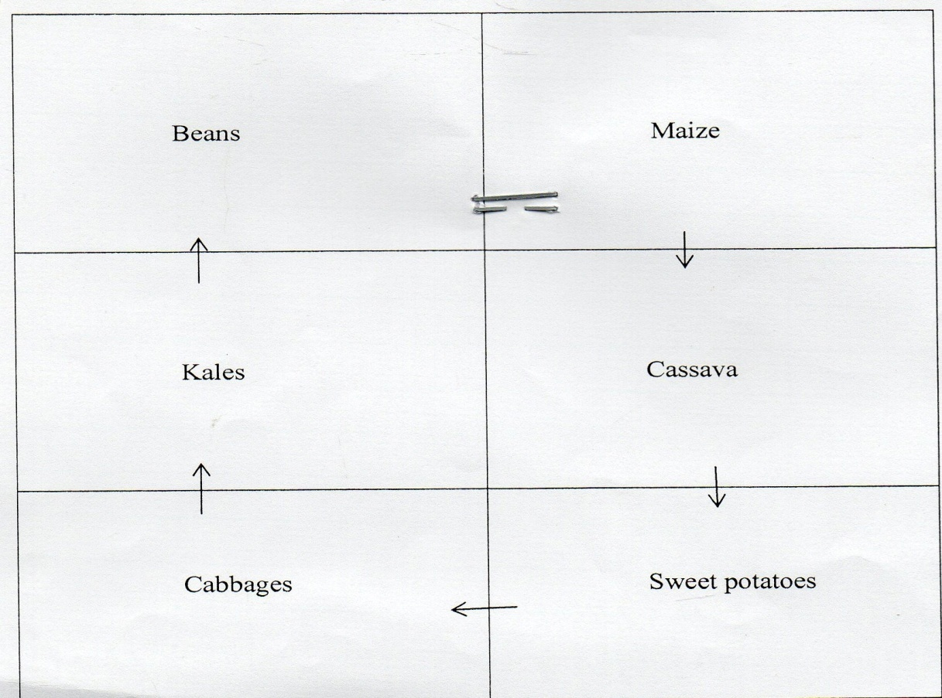
- Identify the cropping programme (1mark)
Crop rotation
- Giving a reason identify one mistake the farmer made when designing the above programme (1mark)
Plating kales after cabbage
- State two ways the above programme help in control of weeds (2marks)
-Parasitic weeds specific to certain crops are specific to certain crops of different
families.
- Providing soil cover to smoother weeds.

- Avantages of this programme
– Maximise utilization of nutrients in soil.
- Control soil borne pest and diseases.
- Control weeds.
- Improves soil fertility – Control soil erosion .
- Improve soil structure.
18. a) Identify the method above
Individual hooked pegs.
(1x 1mk = 1mk)

b) Describe the procedure followed in (a) above
-Tea is planted and hollowed to grow for one year to reach a height of 25-30 cm and
then cut back to 15cm above the ground level.
-This encourages development of more branches which are left to grow to an angle of 30⁰
45⁰ by use of pegs and tips are nipped off .
-This stimulates dormant buds to grow into shoots.
(1mk for each correct step , 4 steps x 1mk each = 4mks
Note: procedural marking.)

19. (b). What does the figures 20 and 10 in the fertilizer stand for? 1mark
- Ratio of phosphorus pentoxide
- Ratio of potassium oxide
(c). Give two methods can be used to determine soil pH. 1mark
- use of litmus paper
- use of of pH meter
- use of universal indicator with and printed colour charts
- use of BDH universal soil indicator with printed standard colour charts

SECTION C (40 MARKS)
20.(a).Process of transplanting a cabbage seedling. (5mks)
- Water nursery thoroughly before transplanting
- Dig the planting holes at the appropriate depth
- Only health and vigorously growing seedling are selected.
- Lift the seedlings with a ball/lump of soil attached to the roots using a garden trowel or with the help of stick uproot the seedlings
- Transport the seedlings carefully to the field using appropriate means i.e. a wheelbarrow
- Place insecticide in the hole to control soil borne pests such as nematodes
- Add/tea spoonful of phosphate fertilizers to the planting hole, mix the fertilizers with the soil.
- Add one handful of humus and also mix thoroughly with the soil
- Transplant and place the seedling in the planting hole at the same depth they were in the nursery.
- Ensure the roots spread well
- Fill the hole with soil and firm around the base of seedling to the level it was in the nursery
- Apply mulch or erect a shade if necessary
- Water the seedling thoroughly
- Transplanting should be done on a cloudy day or late in the evening when it is not too hot.
( Emphasis to be on flow of order)
b. Five factors that influence supply of cabbages in a market (10mks)
- Number the sellers in the market
- Prices of related goods i.e. kales, spinach, manage etc.
- Price expectation
- Weather conditions
- Change in prices
- Increase in the supply of associated goods i.e. kales.
- Cost of production
- Transportation system
- Government policy
- Peace and security
( Award for point and explanations)
(c) Ways in which farmers overcome risks and uncertainties in farming (5mks)
- Diversification
- Insurance
- Input rationing
- Flexibility in production molding
- Flexibility in production methods
- Adopting modern methods of production (5mks)
21(a). How soil loses fertility. (12mks)
- Soil erosion
- Leaching
- Monocropping
- Continuous cropping
- Burning vegetation cover
- Change in soil PH
- Accumulation of salts
(Stating 1×6=6mks, correct explanation 1×6=6mks)
(b) Four problems associated with use of manure in agricultural production. (4mks)
- Bulkiness
- Spread pests ,weeds and diseases
- Laborious in application and transport
- Loss of nutrients due to poor storage
- Should be used if fully decomposed to avoid scorching crops
- (first 4 points)
- Four characteristics of plants suitable for green manure. (4mks)
- highly vegetative /leafy
- fast growth rate
- quick rotting/decomposition
- hardy / ability to tolerates poor soil conditions
- High nitrogen content legumes
(First 4 points)
22. a) Six advantages of mulching in crop production. (6 marks)
- prevents water evaporation thus maintaining moisture in the soil for crop use
- act as an insulator thus modifies/ regulate soil temperature
- controls soil erosion by reducing the speed of running water intercepting rain drops and increasing the rate of infiltration
- controls the weeds by suppressing their growth
- organic materials are decomposed by soil micro-organism resulting into humus that improves soil structure and water holding capacity.
- organic materials improve soil fertility by releasing nutrients after decomposition
Any 6 x 1 = 6mks

b) Six factors that should be considered when siting a nursery bed. (6 marks)
- Nearness to water source – for easy watering
- Topography on gentle slope to prevent flood and erosion
- Type of soil: well drained deep and fertile
- Security – well protected from theft ad destruction by animals
- Well sheltered place wind breaks are necessary to prevent strong winds
- Previous cropping avoid areas where the same crop species had been planted to avoid buildup of pest/ diseases.
Stating ½ mk
Explanation ½ mk
Total 6 mks

c) Biotic factors influencing agricultural production. (8 marks)

Pests
- Feed on plant parts
- Transmit crop diseases
- Injure plant exposing the plant to secondary infection
- Increase cost of production
Parasite
- Suck blood from animals
- Cause irritation
- Increase cost of production
Decomposer
- Break down plant and animals materials to form manure
Pathogen
- Cause diseases in livestock
- Reduce quality and quantity of agricultural products
Predators
- Kill and feed on other animals
- Some reduce pest population
(Any 8 points=8mks)

