GRADE 7 VISUAL ARTS LESSON NOTES TERM 1
STRAND 1.0 THE ARTS AND ENTREPRENEURSHIP

CATEGORIES OF ARTS
ARTS - This is a general term used to describe expression of creative human skill, feeling and imaginations. This is mainly appreciated for beauty and emotional value.
The arts can be experienced through the following:
  - Sense of light
  - Hearing
  - Touch
  - Smell
  - Taste

Entrepreneurship
This is the process of setting up, developing and running a business with the aim of getting profit.
It requires marketing goods, services and new ideas in order to make profit.
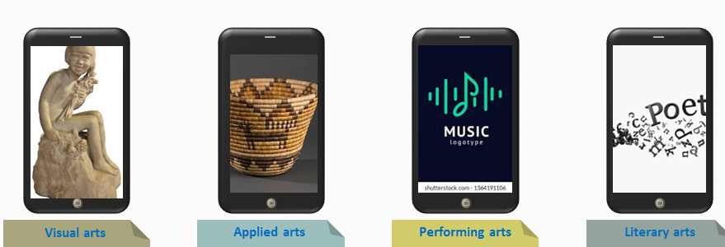

- Visual arts
- These are arts forms appreciated through the sense of sight.
- They are appreciated for their emotional power and beauty e.g.
- Drawing
- painting
- montage
- collage

- Applied Arts
Applied Arts are related to visual arts but involved making and decorating of everyday items.
These items are for practical use or utilitarian purposes

- Performing Arts
Performing arts involves performance or presentation to the audience.
Artist use the following in performing arts
- Body movement
- Facial expression
- Voices artistic expression
It can be done live to an audience or recorded for future use

- Written or Literacy art
- This writing of stories that have artistic and cultural value.
- They display the beauty of speech and language to convey meaning.
- It may be inform of stories novels, script writing and spoken films and poetry.
- The main reason for doing research is to get new information about a specific area.
- It also help you get different views and what people think about an issue.
- Researching on the categories of art will enable you find out about a wide area in the Art.

Importance of doing research of art
Preparation for a presentation
Factors to consider when making preparation and presentation of art research .
- Relevance of the content
- It is important that the information in the presentation is relevant to the main topic.
- This help in preventing the speaker and the audience from talking about things not related to them.
- The information should be well organized starting from what the audience knows to providing new information
- Oral presentation
- When making oral presentation, use appropriate language and expressions. Remember also to maintain eye contact with the audience.

3. Team work
- Every member of the group should actively participate in the activities. All members should take part in carrying out tasks during presentations.
- These includes: preparations, organization sample artwork, operating the equipment and answering questions from the audience.
- All members should demonstrate respect for one another and unity when carrying out the group activity.
Guidelines to follow when making a presentation on categories of arts
- Introductions
- Introduce yourself and member of the group to the audience.
- Give the tittle of the presentation.
2. Body of the presentation
- Discuss the meaning of the arts
- Give as many examples of the arts as possible
- Show actual samples, pictures or drawing to emphasize your points
- Demonstrate where necessary

- Conclusion
- Ask the audience whether there are questions of contributions
- Answer the questions confidently, ask other group members, the audience of the teacher if you are not able to give a response to the question.
- When there are not more questions, thank the audience for the co- operation.
Presentation and appreciation categories of arts
- A presentation involves talking to an audience about the topic, an idea or a product. The main purpose of a presentation is to pass information and persuade an audience about a certain idea or topic.
Elements of presentation
- Speaker of the presenter
The role of the presenter is to communicate with the audience. The speaker also controls the presentation. The presenter should involve the audience and other members of the group during presentation.

- The audience
These are people the presenter will communicate with. It is important to maintain attention of the audience by involving them through questions and asking them to participate in some activities.
- The content
This is the information you will pass to the audience.
- The resources used in the presentation
These may include
  - samples of artwork
  - presentation software
  - charts
  - posters

Career pathways in the arts
Career pathways - is an area of study taken so as to lead and prepare someone for a specific career. The arts is a wide a field that has very many opportunities. Careers in the art range from traditional fine art emerging digital and media design. The artist therefore, has an opportunity to choose a career pathway that is interesting and suits their individual abilities in the world of work.

Careers Path in Secondary school
The arts are offered as two subjects in lower secondary: performing and Visual arts.
Performing arts include:
- music
- dance
- theatre and film

Visual and applied art:
- fine art
- applied art
- time based media

Pupil’s activities Pg. 10

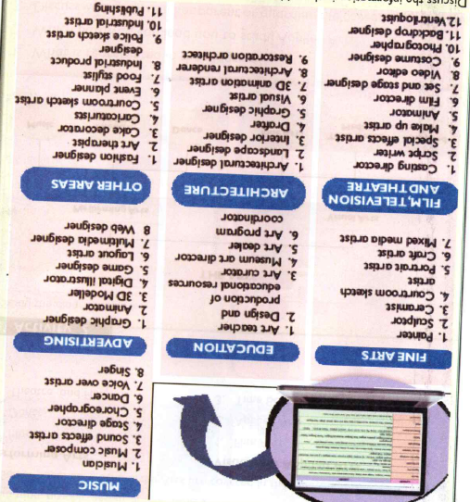

Presentation on career pathways in the Art
When making a presentation on the career in the arts, follow the same procedure as in the categories of the arts. Make sure you have done a good research and that you have enough point for the presentation. Present your points in a simple and clear language that everyone will understand. Present your points in the simple and clear language that everyone will understand. Be careful when talking in a simple and eye contact with your audience. Respect others and appreciate their contributions.

Categories of Visual Arts
The visual arts can be classified as either two dimensional or three dimensional. The two dimensional art forms can be also written as 2D, while three dimensional written as 3D.
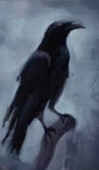
The 2D Forms
These are art forms that only have length and width. These artworks are done on flat surfaces and have no depth. Examples of 2D artwork are:
- Drawing
- Painting
- Montage

The 3D arts Forms
These are artwork with length, width and height
These types of artwork have volume
They can be turned around and viewed from more than one direction. Some examples of 3D artwork are:
- Pottery
- Basketry
- Ornaments

Presentation on the categories of 2D and 3d Arts
Pupils activities page 19.

2.0 PICTURE MARKING

  - One point perspective Drawing
- Perspective is the way objects appear it each other depending on the distance from and position of the viewer.
- Perspective drawing is therefore a technique of showing an illusion of depth and distance on a flat surface. When forms are drawn in perspective, those that are near the viewer appear larger and clearer than those further away from the viewer.
- Perspective drawing can be applied in all categories of drawing including landscape and still life drawing. Through perspective drawing, a 2d D drawing is made to appear 3 dimensional. This makes the drawing appear more realistic

Materials and tools required in drawing
- Pencil
- Rules
- Paper
- Eraser

Component of perspective
In order to draw in perspective. It is important to consider the projection lines or convergence lines, vanishing point and horizon. As described below.

- Projection or convergence lines
These are parallel lines on an object which appear to converge as they recede from the viewer. When projected further they will appear to meet at a point.

- Vanishing points
This is a point where the projected lines appear to meet. The vanishing point will always be found at the horizon.

- Horizon point
In nature, the horizon is the line along where the sky appear to meet the ground, however, in perspective drawing is used to refer to a horizontal lines drawn along the vanishing point.

Horizon line
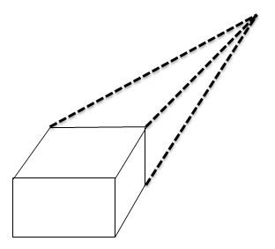

Projection lines

One point perspective
- A one – perspective is created in a drawing that has only one vanishing point. Where drawing a picture in one point perspective, the planes directly facing the viewer are flat and made up of horizontal and vertical lines.
- The planes facing the viewer are created by using projection lines that appear to meet at one vanishing point. For example, when you look at a straight road directly in front of you. It appears to narrow and converge at a point in a distance; a one point perspective can be created from different angles or eye view.

Eye view
- Eye view in a composition is determined by the position of the viewer; a drawing can be done from worm’s eye. Normal eye view or bird’s eye view.

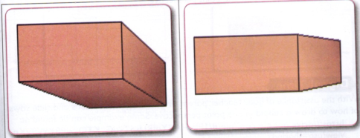
Worm’s eye view Normal eye view
Worm’s eye view
- This is a view of an object from below.
- When observing an object from the worm’s eye viewer will see mainly the bottom of the object.

Normal eye view
- At normal eye view, the object being observed is at the same level as the viewer’s eyes. In this view point, the observer will see mainly the sides of the objects.

Bird’s eye view
- This is a view of an object from above. In bird’s view, the viewer will see mainly top of an object. The vanishing point in the bird’s eye view can be at the side as shown in the table below.
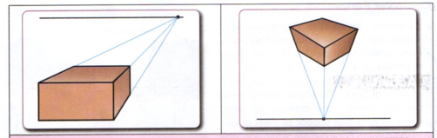

Drawing cuboid in one point perspective
- A cuboid is a three dimensional that has six rectangular faces.
- It can also have four rectangular and two square faces. Examples of cuboids are package boxes, books suitcases and building blocks.

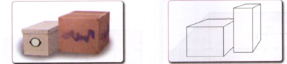

Drawing cuboid from Normal eye view
- At normal eye view the cuboid is at the same level with the viewer’s eyes.
- When observing a cuboid from the same level as the eyes, the viewer will see mainly the sides of the object.

Procedure of drawing a cuboid from normal eye view
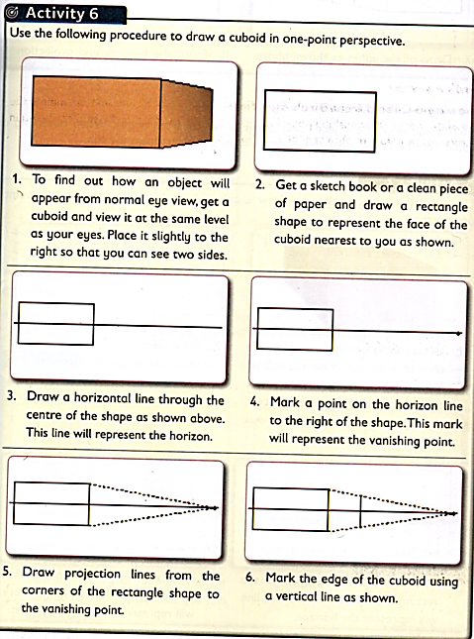

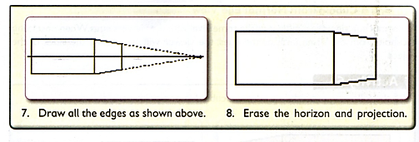

Drawing a Cuboid from Bird’s Eye view
- In bird eye view the object being drawn is viewed from above. When observing a cuboid from bird’s eye view, the viewer will see the object from the top.

Procedure of Drawing a Cuboid from Bird’s Eye view
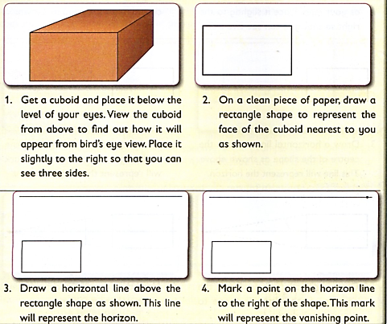

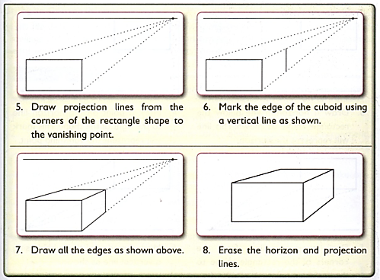

Drawing a cuboid from Worms’ Eye View
- In worms eye view, the object drawn is viewed from below. When observing a cuboid from worm’s eye view. The object will be above the viewer.
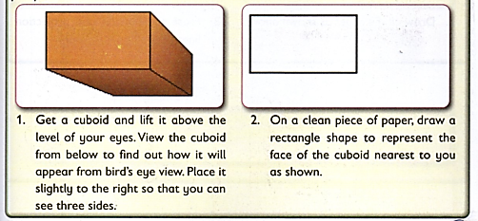

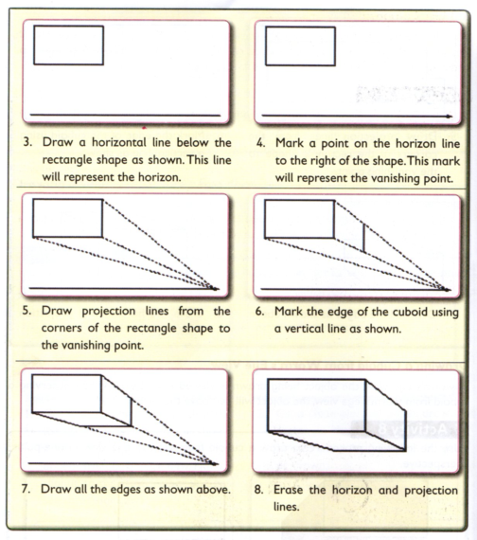

Still life composition
- A still life is a drawing of non- living objects arranged on a surface. Still life drawing can be done from observation, memory or imagination.
- A composition means arranging or placing different objects together.

Procedure of preparing a still life composition
- Prepare the surface where the object will be placed
- Select the object whose basic forms are cuboid from your environment. Examples of such objects are packaging boxes, large books, mathematic set and building blocks
- Place the objects that have a variety of colours, dimension and sizes to create a center of focus.
- Place the objects on the surface with some overlapping
- Place large object at the center
- Make the object parallel to other so that can be drawn In one point perspective.

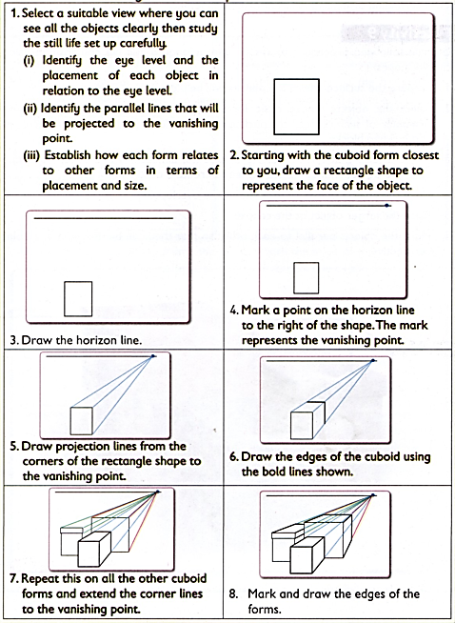
Procedure of making still life composition with a cuboid

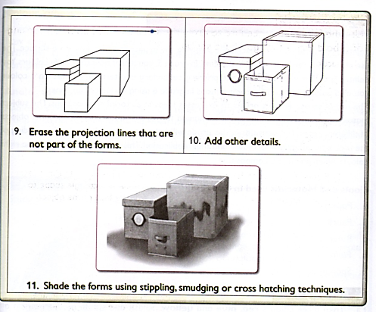
  - PAINTING
- Painting is a picture making technique involving the application of colour on a surface.
- The use of colour enables the artists to express ideas in pictorial compositions.
- The subject matter in these compositions could be human forms, animals, sceneries and also objects of different types.
Tools and materials used in painting
- Paper
- Pencils
- Ruler
- Paints
- Sponge
- Paint brush
- Pair of compass
- Protractor
- Palettes
Colour wheel
A wheel is an arrangement of colours on a circular diagram to show they related to each other.
It shows the relationship of colours including, primary, secondary and tertiary colours.
You can also identify analogous and complementary colours from a colour wheel.

Analogous colours
Analogous colours are colours that are next to each other on a wheel.
These groups of colours create harmony when used in a composition. This is because they have a colour in common.
Examples of analogous colours; Red, Red orange and Orange.
These colours are closely related since they all have red colour in common.

Complementary colours
Complementary colours are colours that are directly opposite to each other on a colour wheel.
These colours contrast when placed next to each other. They make each other to look more intense. This is because they do not have any colour in common.
Examples of complementary colours; red and green.

Procedure of creating a colour wheel

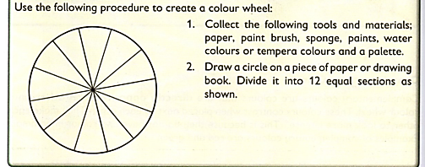

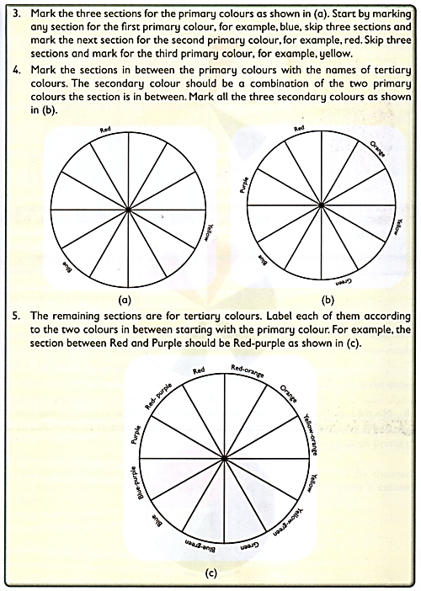

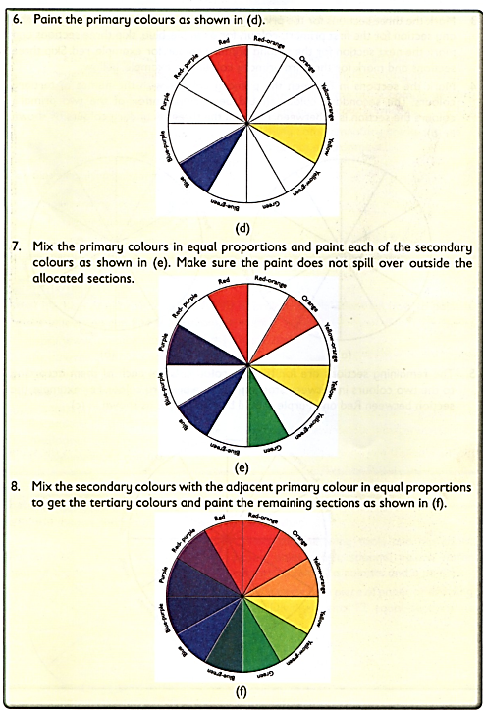

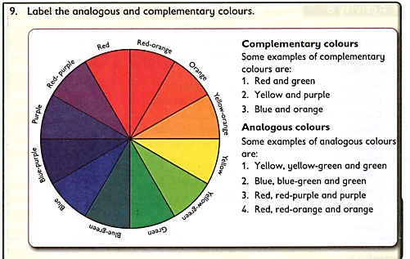

Properties of colour
It is important to understand the properties of colour to assist in painting.
There are three basic properties: hue, intensity and value.
Each of these properties is described below.
- Hue – hue is properties that differentiate one colour from another.
It is the same as name of a colour.
- Intensity – intensity of colour refers to the purity or saturation of colour.
It is the brightness or dullness of a colour. The intensity of a colour. The intensity of a colour is reduced by adding chromatic gray.
- Value – value refers to the lightness or darkness of a colour. It can be changed by adding black to make a colour darker or by adding white to make a colour lighter.

Intensity scale
The intensity colour can be further using a colour intensity scale.
This is a gradation strip showing how a colour gradually reduces or increases its intensity.

Procedure to paint an intensity scale

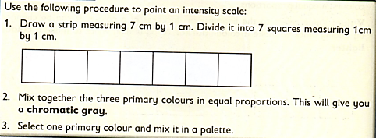
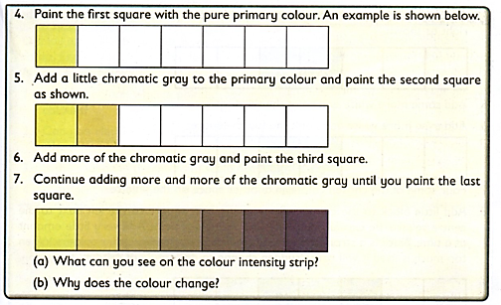

Value gradation strip
A value gradation strip is also known as a value chart.
It refers to a strip showing a colour reducing or increasing in darkness or lightness.
The value of a colour can be changed into two ways:
- By adding white to make the colour lighter. This is referred to as tinting.
- By adding black to make the colour darker. This is referred to as shading.

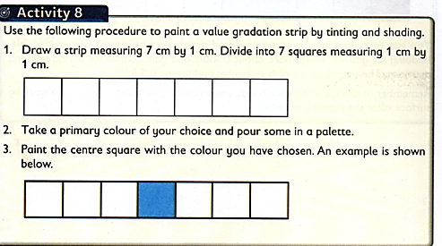
Procedure to paint a value gradation strip by tinting and Shading
