**Name…………………………………………………Adm No:…………………………….…….**

**School ………………………………………...…**Candidate’s Signature …………………

**232/2**

**PHYSICS**

**THEORY**

**PAPER 2**

**TIME: 2 HOUR**

**FORM 4**

**INSTRUCTIONS TO CANDIDATES:**

* *Write your* ***name*** *and* ***index number*** *in the spaces provided above*
* *This paper consists of* ***two*** *sections* ***A*** *and* ***B.***
* *Answer* ***all*** *the questions in section* ***A*** *and* ***B*** *in the spaces provided.*
* *All working* ***must*** *be clearly shown ; marks may be awarded for correct steps even if the answers are wrong*
* *Mathematical tables and silent electronic calculators may be used.*
* *Take gravitational acceleration =10m/s2 and π=3.142*
* ***This paper consists of 12 printed pages.***
* ***Candidates should check to ascertain that all pages are printed as indicated and that no questions are missing.***

**For Examiners’ Use Only**

|  |  |  |  |
| --- | --- | --- | --- |
| **Section** | **Question** | **Maximum Score** | **Candidate’s Score** |
| **A** | **1-14** | **25** |  |
| **B** | **15** | **13** |  |
| **16** | **14** |  |
| **17** | **11** |  |
| **18** | **13** |  |
| **19** | **8** |  |
| **Total Score** | | **80** |  |

**SECTION A (25marks)**

1. The figure below shows a beam of light incident of aparabolic reflector.

Beam

Complete the diagram to show the path of the rays after reflection. (1mark)

2.The figure below shows a horizontal conductor in a magnetic field parallel to the plane of the paper.

N

S

State the direction in which the wire may be moved so that the induced current is in the

direction shown by the arrow. (1mark)

………………………………………………………………………………………………………

………………………………………………………………………………………………………

3. The diagram below shows the position of the bright spot on the screen of a C.R.O when there is

no signal on both Y and X –plate. Indicate on the diagram (b) when the Y-plate is connected to

a.c signal and for (c) the X-plate is connected to d.c signal i.e the display on the screen.(2marks)

(+)

(c) (-)

(b)

•

(a)

4. ai)Define half-life of a radioactive substance. (1mk)

b)The half-life of radioactive substance is 4 years. How long will the sample take for the activity to decrease to 1/32 of its original value. (3mks)

1. The diagram below shows a wave travelling to the right . The time taken by the wave from O to B is 0.0025 seconds.

redraw for better waves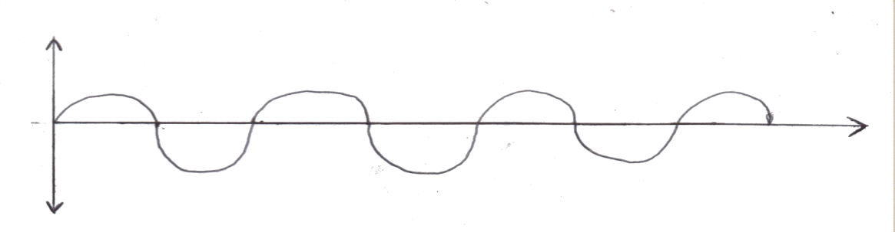

**A**

**B**

Calculate the frequency of the wave. (2marks)

1. State **one** difference between an image formed by a plane mirror and that observed through a pin hole camera. (1mark)

…………………………………………………………………………………………………………

…………………………………………………………………………………………………………

1. The figure below shows capacitors connected to a d.c supply.

**12V**

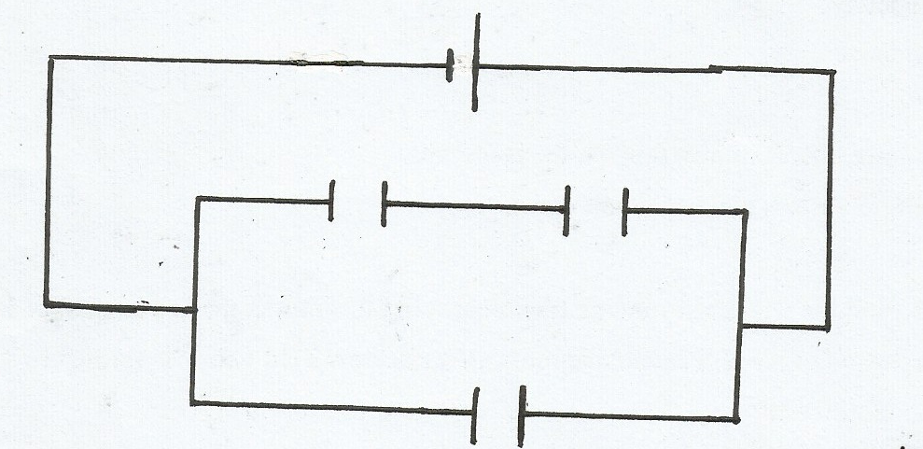

**2*µF***

**2*µF***

Calculate the charge stored in one of the **2*µF***capacitor. (3marks)

1. Give a reason why lecture theatre halls are covered with soft perforated materials. (1mark)

…………………………………………………………………………………………………………

…………………………………………………………………………………………………………

9. Arrange the following in order of decreasing wavelength: infrared, microwave, gamma rays visible light. (1mark)

…………………………………………………………………………………………………………

…………………………………………………………………………………………………………

10. The figure below shows plane waves approaching a very narrow slit S.

**S**

Complete the diagram to show the pattern after crossing the slit. (2marks)

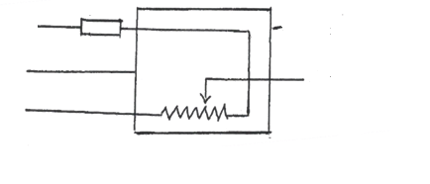11. The diagram below shows an electrical appliance connected to the mains.

**A**

**Fuse**

**Casing**

**B**

**Heating element**

**C**

Name the colour codes for leads A, B, and C and state the purpose of the fuse. (3marks)

A…………………………………………B……………………….…………… C……………………………………….

Purpose for fuse: (1mark)

…………………………………………………………………………………………………………

…………………………………………………………………………………………………………

12. The figure below shows a V-shaped magnet with a plotting compass placed between its

poles

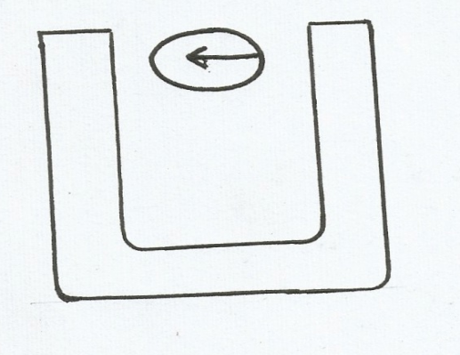

Draw a diagram indicating the magnetic field pattern around the U-shaped magnet. (2marks)

13. Each cell in the diagram below has an e.m.f of 2.0 v and zero internal resistance.

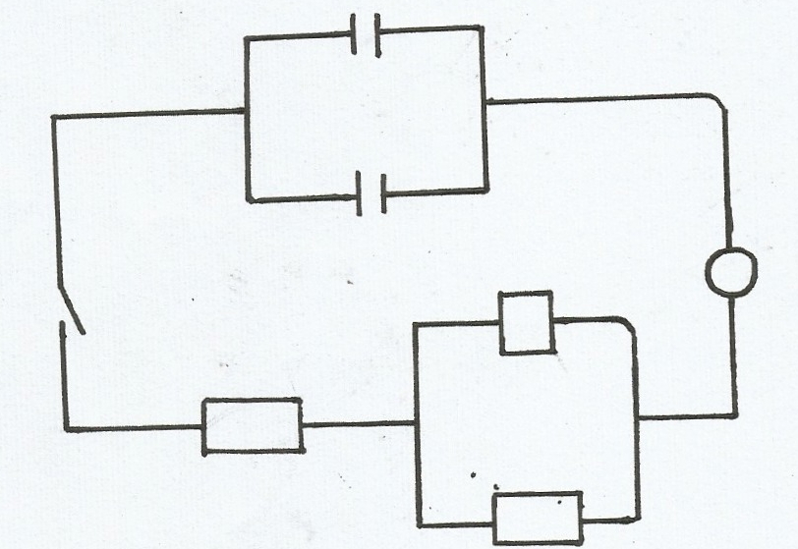

**A**

**4.2Ω**

**2.9Ω**

**4.2Ω**

Determine the ammeter reading when the switch is closed. (2marks)

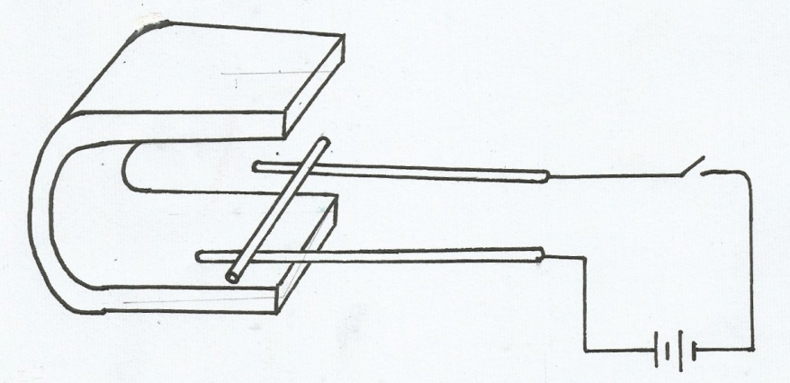14. A conductor XY is placed between the poles of a magnet as shown below. When the current is allowed to flow, the conductor rolls along the rod A and B

**X**

**A**

**Y**

**B**

Show with an arrow the direction in which it will move. (1marks)

**SECTION B (55 MARKS)**

15. (a)(i) Distinguish between threshold frequency and threshold wavelength. (1mark)

……………………………………………………………………………………………………………

……………………………………………………………………………………………………………

(ii) The maximum wavelength required to cover photoelectric emission on ametal surface

is 8.0 X10-7m. The metal surface is irradiated with light of frequency8.5 X1014Hz.

Determine:

(I)The threshold frequency (1mark)

(II)Maximum kinetic energy of the electrons (3marks)

(b) Below shows a plot of the graph of stopping potential Vs against reciprocal of the wave

length $\frac{1}{λ}$. The work function of the metal used was 2.08 X 10-19J and velocity of

electromagnetic waves is X 108m/s

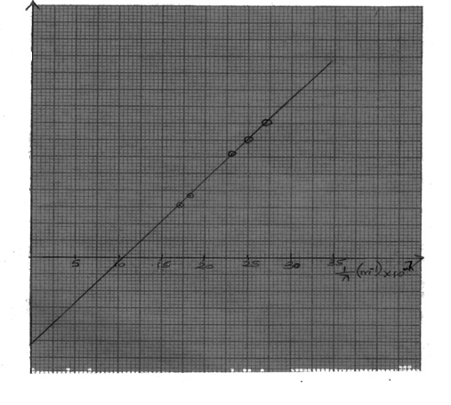

V s X 10-1(V)

0

30

25

20

15

10

-5

-10

-15

5

The equation of the graph is given by Vs= $\frac{hc}{eλ}$- $\frac{ѡo}{e}$

Use the graph to determine:

1. The threshold frequency (fo) (2marks)

…………………………………………………………………………………………………

…………………………………………………………………………………………………The charge of an electron (e-) (2marks)

……………………………………………………………………………………………………………………………………………………………………………………………………

The slope (2marks) ………………………………………………………………………………………………………

…………………………………………………………………………………………..…………The value of planks constant (2marks)

…………………………………………………………………………………………………

…………………………………………………………………………………………………

16(a) (i)Explain why carbon -14 $\frac{14}{6}$ C is radioactive while carbon is not. (2marks)

………………………………………………………………………………………………………

………………………………………………………………………………………………………

(ii) A radioactive isotope showed a count rate of 82 counts per second initially. After

a time of 210seconds, the count rates dropped to 19 counts per

second. The average background count remained constant at 10 counts per second.

What is the half life of the material? (2marks)

…………………………………………………………………………………………………………

…………………………………………………………………………………………………………

(b) The figure below shows the features of a diffusion cloud chamber used for detecting

Radiations from a radioactive source.

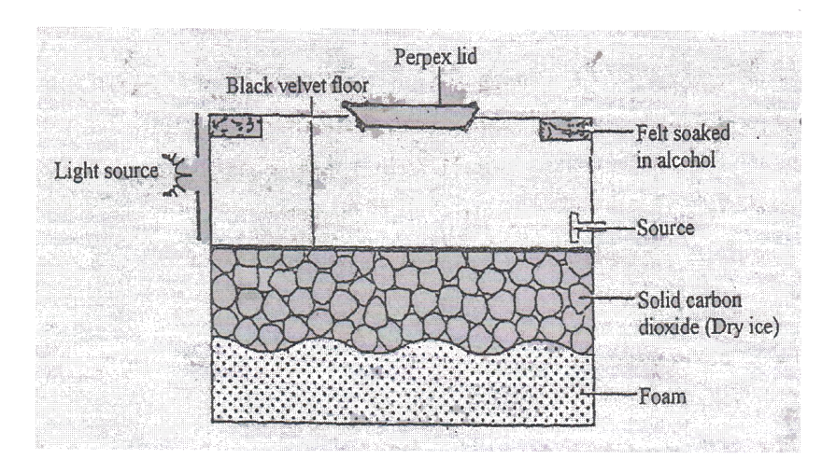

Explain how the chamber works when a radioactive particle is introduced at the

source (2marks)

…………………………………………………………………………………………………………

…………………………………………………………………………………………………………

(c ) (i)What is the purpose of solid carbon(iv) oxide? (1mark)

…………………………………………………………………………………………………………

…………………………………………………………………………………………………………

(ii) State **one** advantage of the cloud chamber over a G.M tube as a detector of radio

-active radiations. (1mark)

…………………………………………………………………………………………………………

…………………………………………………………………………………………………………

(d) (i) Using a diagram explain how doping produces a p-type semi-conductor (3marks)

…………………………………………………………………………………………………………

…………………………………………………………………………………………………………

…………………………………………………………………………………………………………

…………………………………………………………………………………………………………

(ii) What is biasing? (1marks)

…………………………………………………………………………………………………………

…………………………………………………………………………………………………………

(iii) The diagram below shows a circuit with a p-n junction and a very lower power

bulb

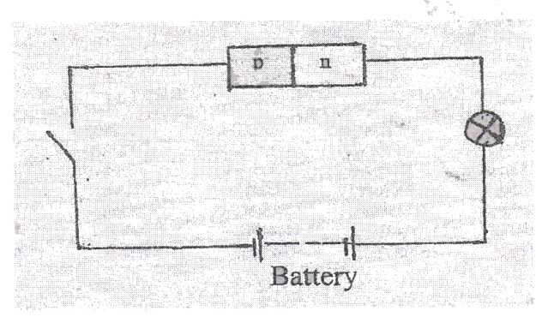

State with reason the observation made on the bulb when the switch is closed. (2marks)

…………………………………………………………………………………………………………

…………………………………………………………………………………………………………

17. a) The figure below shows the features of a cathode ray oscilloscope;-

**Filament**

**X-plates**

**Screen**

**Vacuum**

**Vacuum**

**B**

**A**

**Cathode**

**Anodes**

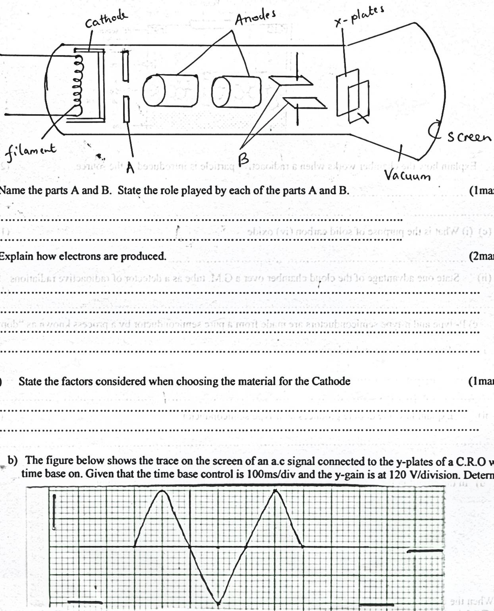

1. Name the parts A and B. State the role played by each of the parts A and B. (2 marks)

A ________________________________________________________________________

B _______________________________________________________________________

ii) Explain how electrons are produced. (2 marks)

_______________________________________________________________________________________________________________________________________________________________________________________________________________________________________

iii) State the factors considered when choosing the material for the cathode. (1 mark)

_______________________________________________________________________________________________________________________________________________________________________________________________________________________________________

b) The figure below shows the trace on the screen of an a.c signal connected to the y-plates

of a C.R.O with time base on. Given that the time base control is 100ms/div and the y-gain

is at 120V/division.

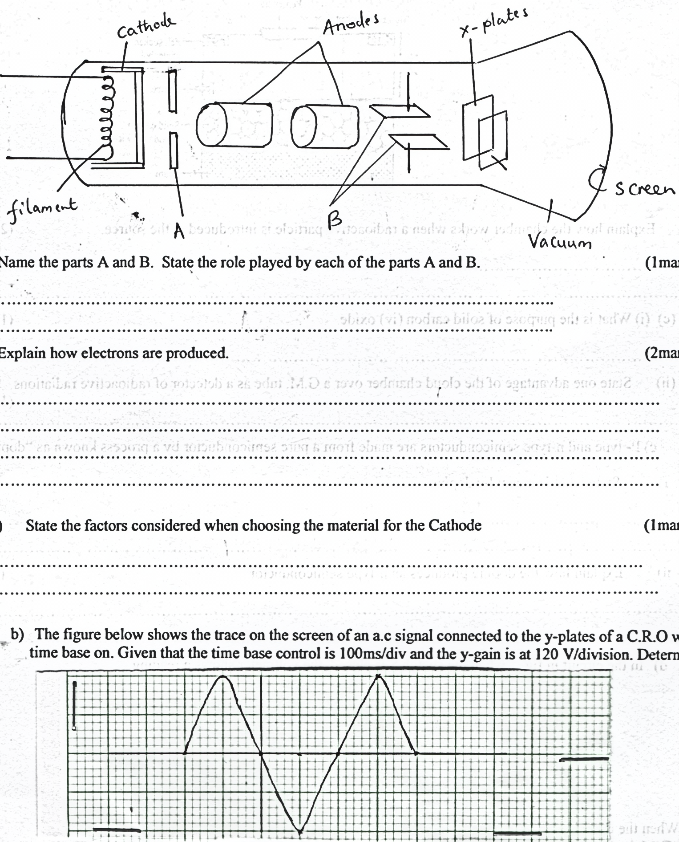

Determine:

i) The frequency of the a.c signal. (2 marks)

ii) The peak voltage of the input signal. (2 marks)

18. The figure below shows how an image is formed by a converging lens.

Redraw

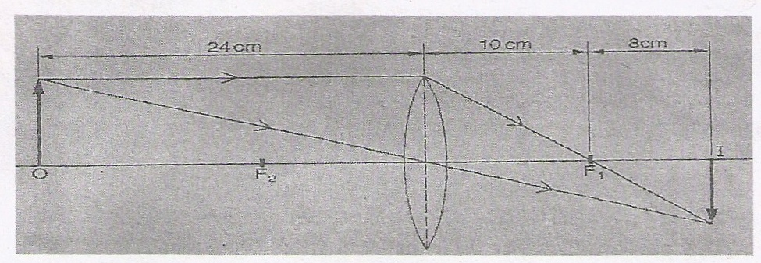

(i)State the value of the focal length of the lens. (1mark)

…………………………………………………………………………………………………………

…………………………………………………………………………………………………………

(ii) Calculate the magnification of the image produced (2marks)

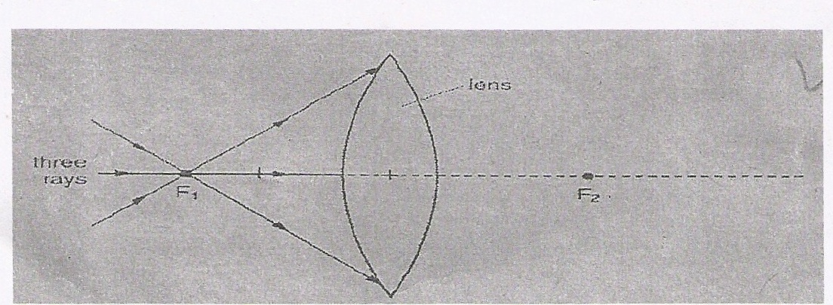 (b) The figure shows a glass lens in air and its two focal points F1 and F2.

Three rays of light pass through F1 to the lens.

(i) On the figure continue the three rays through the lens and into the air. (2marks)

(ii) State what happens to the speed of light on entering the glass lens from air. (1mark)

…………………………………………………………………………………………………………………….………………………………………………………………………………………………

(c ) A ray of light passes through one surface of a glass prism at right angles to surface. Given that the critical angle of the glass materials is 420, complete the ray to show how it travel until it leaves the prism. (2marks)

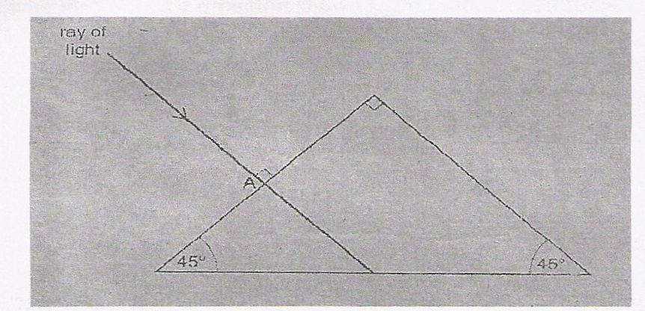

(d) An object is placed 30cm in front of a convex of focal length 20cm. Determine the image

distance. (2marks)

(e ) (i)State **two** possible causes of long sightedness. (2marks)

…………………………………………………………………………………………………………

…………………………………………………………………………………………………………

(ii) What type of lens is used to correct long sightedness? (1mark)

…………………………………………………………………………………………………………

…………………………………………………………………………………………………………

19). The figure below shows an induction coil used to step up voltage.

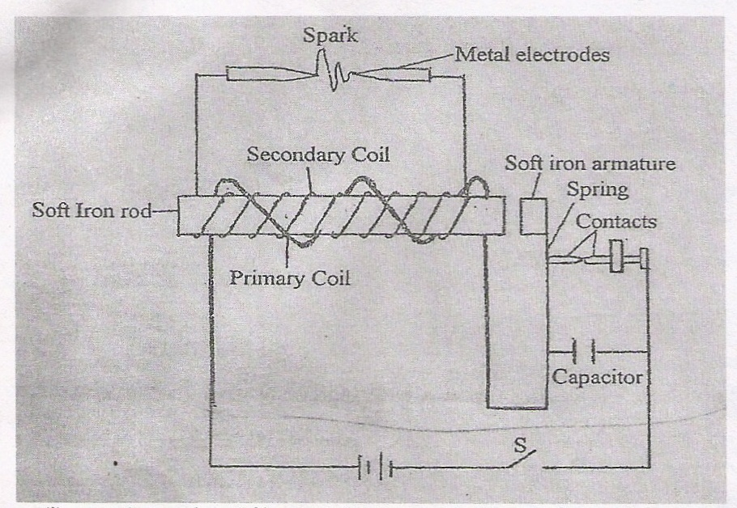

1. State the difference between the induction coil and step-up transformer.(1mark)

………………………………………………………………………………………………

………………………………………………………………………………………………

1. Explain how voltage is stepped up by the induction coil. (2mks)

………………………………………………………………………………………………

………………………………………………………………………………………………The voltage is stepped up from 12V to 15V. Determine the ratio of the secondary to primary coil in the induction coil. (1mark)

………………………………………………………………………………………………