NAME……………………………………….………………….ADM...............CLASS…………..
FORM 3
MID TERM EXAM -2024
PHYSCIS
SECTION A (25mks)
- According to Bernovill’s principle, how are the pressure and velocity of a fluid related. (1mk)

- Explain why it is dangerous for a bus to carry standing passengers. (2mks)

- Distinguish between mass and weight stating SI unit in each case. (2mks)

- Pure water at 0⁰c is heated up to 10⁰c sketch the graph of volume against temperature on the axes given below. (2mks)

- State one reason why alcohol is preferred over mercury for use in cold regions. (1mk)

- Calculate the critical angle of a material whose refractive index is 1.4. (2mks)

- State two factors, which would affect the resistance of a metal conductor other than the temperature. (2mks)

- Efficiency of a machine is always less 100% explain. (2mks)

- a) State ohms law (2mks)

b) Differentiate between ohmic and non – ohmic cuntucm. (2mks)

- The figure below shows a uniform 50cm rod. It is balanced horizontally by a load of 4N on one end. Calculate the weight of the rod. (2mks)

20cm

4N

- The figure below shows a pith ball in a container.
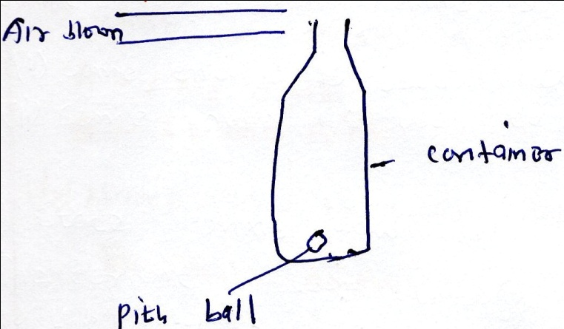
State and explain what would happens if air is blown over the mouth of the container. (2mks)

- A body whose initial velocity is 30ms⁻¹ moves with a constant retardation of 3ms⁻². Calculate the time taken for the body to come to rest. (2mks)

- In an experiment to determine how force and extension of a helical spring vary, the graph below was drawn from data obtained.

Force, F A
(n) E

O S Extension,e (m)
a) What do points A and E represents. (2mks)

b) Name the type of deformation that occurs along E A. (1mk)

SECTION B (55Mks)
- The figure below shows a pulley system.
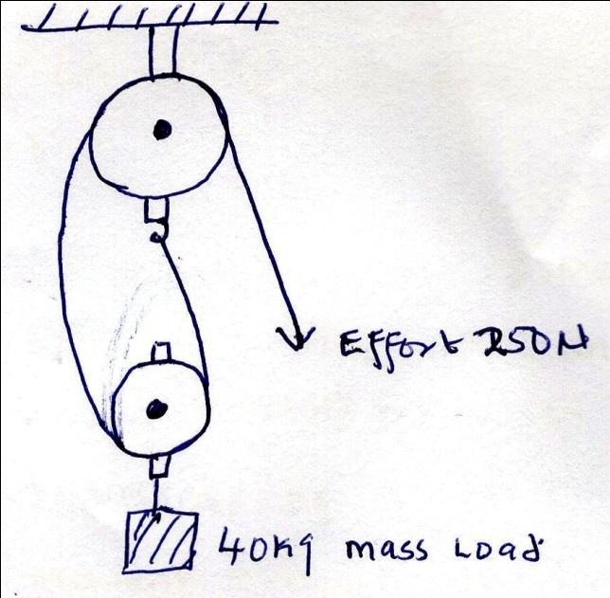
- What is the velocity of the system? (1mk)

- Calculate the efficiency of the system. (4mks)

- Draw a labeled diagram of a pulley system with a velocity ratio of 3 (2mks)

- a)i) Distinguish between inelastic and elastic collision. (2mks)

ii) A particle A of mass, M, is moving with an initial velocity u, makes a head – on collision with another particle B of mass 2m, B being initially at rest. In terms of U, calculate the final velocity of A if the collision is perfectly inelastic. (3mks)

b) The diagram below shows a sphere moving in a viscous liquid in a tall measuring cylinder.
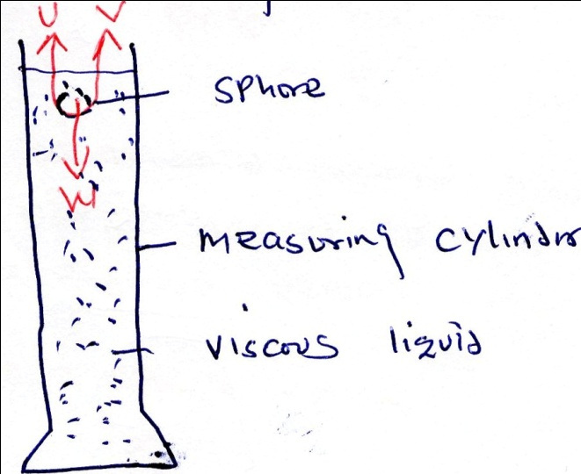
i) Show on the diagram the force acting on the sphere. (3mks)
ii) Sketch a graph showing the variation of velocity with time. Show on the graph the terminal velocity. VT. (2mks)
- A man uses the inclined plane to lift a 50kg load through a vertical height of 4.0M. the inclined plane makes an angle of 30⁰ with the horizontal. If the efficiency of the incline plane is 72%, calculate;

c

effort
50kg

30⁰
B
- Determine the velocity. (2mks

- The effort needed to move the load up the inclined plane at a constant velocity.(3mks)

- a) State any two factors that affect the speed of sound. (2mks)

b)A policeman standing between two high walls fires a gun. He hears the first echo after 3 seconds and the next 2 seconds later. What is the distance between the wall? (take velocity of sound 330mls. (4mks)

- An oil trop forms a circular patch of area 5 x10 ⁻³ m² . if the oil drop has a volume of 9x10⁻¹² m², estimate the diameter of the oil molecules. (3mks)

d)i) Define the term temperature and state its SI unit. (2mks)

ii) State three properties of mercury as a thermometric liquid over other liquid. (3mks)

- The work done against friction in raising the load through the height of 4.0m (take g = 10NKg⁻¹). (4mks)

- In the circuit below determine.
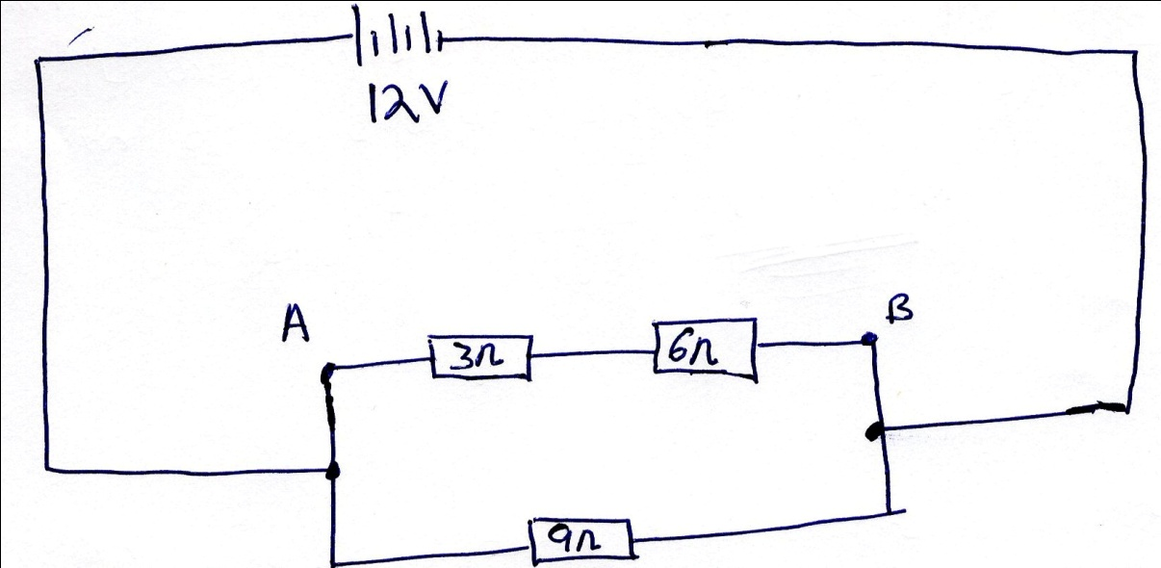

- The total resistance between A and B. (2mks)

- Total effective resistance in the circuit. (2mks)

- Total current in the circuit. (2mks)

- In an experiment to determine the focal length of a concave mirror, the following data was obtained.
Object distance u (cm) | 15 | 20 | 25 | 30 | 35 | 40 | 45
Magnification (m) | 2.0 | 1.0 | 0.668 | 0.500 | 0.400 | 0.333 | 0.289
Image distance, v (cm)
- Fill the table with values of v(cm) (1mk)
- Draw a graph of m (y – axis) against v(cm) x – axis (5mks)

(iii) Given the following as the equation of the graph m = ^{v}/_{f} - 1 use your graph to determine the focal length of the lens. (3mks)

