PHYSICS FORM 1
TERM II-2024 MID- TERM EXAM
TIME: 1HR 30MIN

NAME……………………………………………… CLASS…………ADM ….……..
Answer all questions in the spaces provided

- Name two branches of Physics and how they are related to Mathematics. (4mks)

- Convert each of the following from Kelvin to ^{O} C. (4mks)
- 0 k

- 167 k

- State three properties of a liquid that is suitable for use in a thermometer. (3mks)

- Study the diagram below and answer the questions that foll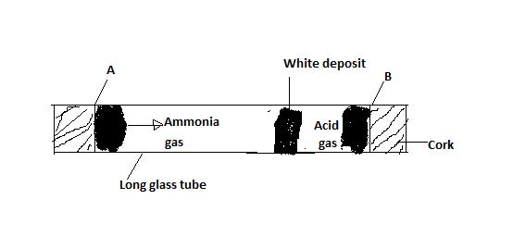
(a) State which gas diffused faster (1mk)

- Explain how the rate of diffusion depends on the density of a gas (2mks)

- If the experiment was performed at a higher temperature, what would you expect? (2mks)

- (a) What do you understand by the term Anomolous Expansion of water. (2mks)

(b) Give 3 effects of Anomolous Expansion of water. (3mks)

- Explain two applications of Expansion and Contraction in Solids. (4mks)

- Explain why the smell of rotten eggs broken at one end of the room soon spreads throughout the room. (2mks)

- Name the difference between Solids, Liquids and Gases in terms of;
- The arrangement of molecules. (2mks)

- Distance separating the molecules. (2mks)

- The movement of molecules. (2mks)

- The figure below shows a liquid ice pail.
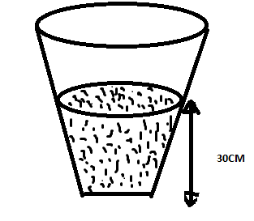
If the liquid has a density of 1.20 gcm³, determine the pressure exerted at the bottom of the container by the liquid. (3mks) (g=10N/kg density of water = 1gcm⁻³

- Convert the following: (2mks)
- 1000kg into grams

- 0.00001m to mm

- Explain how a syringe draws; (2mks)
Injectable drug from a bottle

- The figure below shows a U- tube filled with Water, Mercury and another liquid.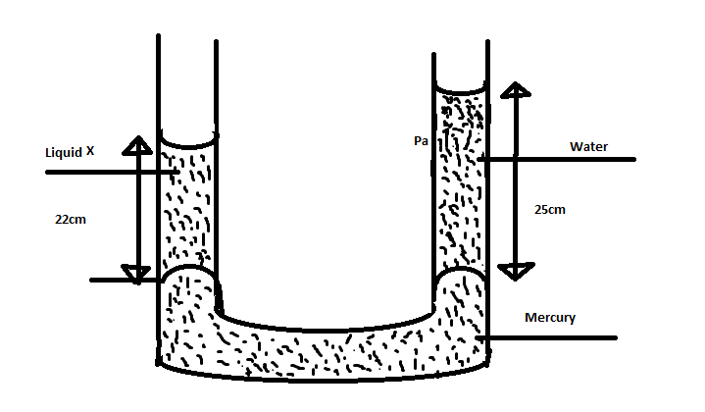
- Determine the density of the liquid X. (3mks)
(Density of Mercury 13,600Kgm-3
g= 10N/Kg, density of water 1000kg-3

- State the possible reason why mercury is used. (2mks)

- Name three types of forces. (3mks)

- The air pressure at the base of a mountain is 75.0 cm of mercury while at the top it is 60.0 cm of Mercury. Given that the average density of air is 1.25 Kgm⁻³ and the density of Mercury is
13600 Kgm-³, calculate the height of the mountain. (3mks)

