TERM TWO MID TERM EXAMS 2024
FORM TWO GEOGRAPHY
TIME: 1HR 30MINS
NAME……………………………………………….CLASS……….ADM No………..
ATTEMPT ALL QUESTIONS.
1.Distinguish between direction and bearing. (2mks)

2.The diagram below is an illustration of the Grid reference system. Use it to answer questions that follow. 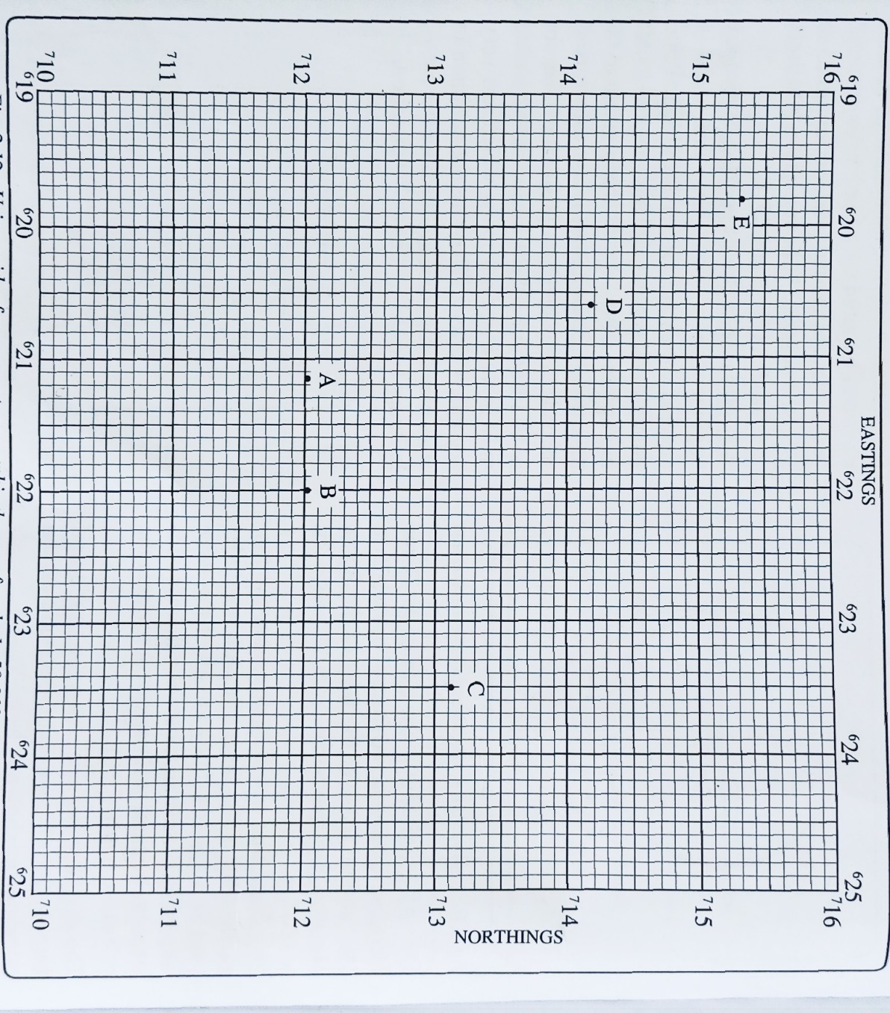

- Give the FOUR figure grid reference of points B and D. (2mks)

- Give SIX figure grid reference of points C and E. (4mks)

- Give the direction and bearing of point D from point B. (3mks)

3.Identify two Traditional methods of indicating direction. (2mks)

4.Identify methods of representing Relief on Topographical maps. (5mks)

5.Identify two types of Aerial Photographs. (2mks)

6.What is a photograph? (2mks)

7.Identify three causes of Earthquakes. (3mks)

8.Explain any three constructive consequences of Vulcanicity to Human Activities. (6mks)

9.Identify two features that results from fissure eruption. (2mks)

10.Name two areas studied in Human and Economic Geography. (2mks)

11.Identify the marginal information found on a Topographical map. (5mks)

12.State methods of Recording Statistical Data. (5mks)

13.Identify the instruments for measuring the following elements of weather. (5mks)
- Temperature-
- Humidity-
- Air Pressure-
- Wind speed-
- Sunshine-

